**AIR QUALITY MONITERING**

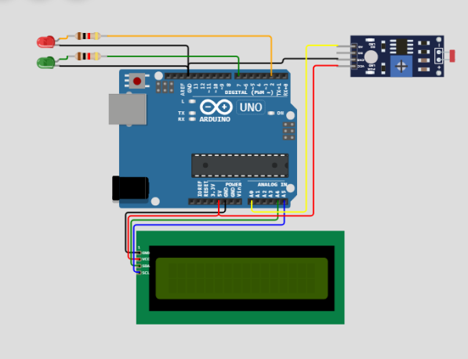

**STEP BY STEP FOR AIR QUALITY MONITERING USING RAW SENSOR:**

Monitoring air quality using a raw filter involves collecting and analyzing air samples for various pollutants. Here's a step-by-step guide:

1. \***Define Objectives and Purpose:\***Determine the specific objectives of your air quality monitoring project. Are you interested in measuring particulate matter (PM), gases like CO2 or NO2, or other pollutants? Define the purpose and scope of your study.

2. \***Select Monitoring Locations:\***Choose appropriate locations for monitoring. Consider factors like proximity to pollution sources, urban vs. rural areas, and locations of interest (e.g., near schools, industrial sites, or residential areas).

3. \***Select Monitoring Equipment**:* For raw filter-based monitoring, you will need air quality monitoring equipment. Common instruments include particulate matter samplers (e.g., PM2.5 or PM10 samplers), gas analyzers, and data loggers. Ensure they are properly calibrated.

4. \***Sample Collection:\*** Place the raw filter in the air sampler at your chosen location. Ensure that the sampler runs for a specified period to collect air samples. This period may vary based on your objectives (e.g., 24 hours for daily averages).

5. \***Sample Handling and Preservation**:*After sampling, carefully handle the raw filter to avoid contamination. Seal it in an airtight container to prevent further exposure to the environment. Preserve the samples in suitable conditions.

6. \***Transport and Storage**:* Transport the sealed samples to a designated laboratory for analysis. Ensure they are stored at appropriate conditions (e.g., low temperature and humidity) to maintain sample integrity.

7. \***Laboratory Analysis:\*** In the lab, the raw filters will undergo analysis. For particulate matter, the filters will be weighed before and after sampling to determine the mass of collected particles. For gas analysis, various techniques like gas chromatography or spectrometry may be used.

8. \***Quality Control and Calibration**:* Perform quality control checks on the equipment and calibration of instruments. Regular maintenance is crucial to ensure accurate results.

9. \***Data Interpretation:Analyze** the data obtained from your air quality monitoring. Compare results to air quality standards or guidelines to assess the level of pollution and potential health risks.

10. \***Data Reporting:\*** Present your findings in a clear and accessible manner, using charts, graphs, and reports. Make the data available to relevant stakeholders and the public if necessary.

11. \***Take Action**:*If your findings indicate poor air quality, collaborate with local authorities or organizations to develop strategies for improvement or mitigation.

12. \***Continuous Monitoring:\*** Consider establishing a continuous air quality monitoring system to track changes over time and evaluate the effectiveness of any interventions.

**CODE:**

#include <LiquidCrystal_I2C.h>

LiquidCrystal_I2C lcd(0x27, 16, 2);  //define I2C address 0x27, 16 column and 2 rows

float flamelevel = 0; // mapped and inverted % of sensor range

#define greenLED 7 // fire okay or firing

#define redLED 2 // warning or flashing alert

// empirically relate flame % to actual fire condition (TBD)

const int minSurvive = 15; // minimum level for idle, below is outfire

const int idleLow = 20; // lowest reading for healthy idle

const int idleTarget = 30; // target reading for resting idle

const int firingLow = 70; // lowest reading for actively firing

const int firingHigh = 90; // reading for full firing

void setup() {

  lcd.init();

  lcd.clear();

  lcd.backlight();

**Serial**.begin(9600);

  pinMode(greenLED, OUTPUT); // set green pin led as output

  digitalWrite(greenLED, LOW); // turn off green led

  pinMode(redLED, OUTPUT); // set red led pin as output

  digitalWrite(redLED, LOW); // turn off red led

}

void loop() {

  float analogValue = analogRead(A0);

**Serial**.print("Sensor RAW: ");

**Serial**.println(analogValue, 0);

  flamelevel = map(analogValue, 0, 1024, 100, 0);

**Serial**.print(flamelevel, 0);

**Serial**.println("%");

  // disabling the lcd commands makes serial print work

  lcd.setCursor(0, 0);

  lcd.print(F("Flame: "));

  if (flamelevel >= firingHigh) { // stoker is fully firing

    lcd.print("Full Fire");

    digitalWrite(greenLED, HIGH); // turn on green led

    digitalWrite(redLED, LOW); // turn off red led

    delay(300);

    digitalWrite(greenLED, LOW); // turn off green led for flash

  }

  if ((flamelevel >= firingLow) && (flamelevel < firingHigh)) { // stoker is firing

    lcd.print("Firing   ");

    digitalWrite(greenLED, HIGH); // turn on green led

    digitalWrite(redLED, LOW); // turn off red led

  }

  if ((flamelevel < firingLow) && (flamelevel > idleLow) ) {  // idle fire

    lcd.print("Idle fire ");

    digitalWrite(greenLED, HIGH); // turn on green led

    digitalWrite(redLED, HIGH); // turn off red led

  }

  if ((flamelevel <= idleLow) && (flamelevel >= minSurvive) ) {  // low fire

    lcd.print("Low fire  ");

    digitalWrite(greenLED, LOW); // turn on green led

    digitalWrite(redLED, HIGH); // turn off red led

    // trigger stoker run timer = 2 mins?

  }

  if (flamelevel < minSurvive) {  // fire out

    lcd.print("FIRE OUT! ");

    digitalWrite(greenLED, LOW); // turn on green led

    digitalWrite(redLED, HIGH); // turn off red redLED

    delay(300);

    digitalWrite(redLED, LOW); // turn off red led for flash

    // send alert

  }

  lcd.setCursor(0, 1);

  lcd.print("   Level: ");

  lcd.print(flamelevel, 0);

  lcd.print("%    ");

  delay(200);

}

OUTCOME:

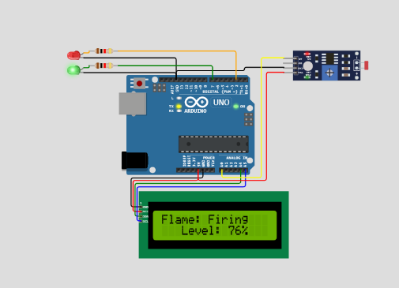

**Our Goal in Air quality monitoring Applications:**

1. **\*Data Collection*:** Continuously collect data on various air pollutants, such as particulate matter (PM2.5 and PM10), gases (e.g., NO2, CO, SO2), and volatile organic compounds.

2. \***Environmental Health*:** Protect public health by identifying and communicating air quality issues that could pose health risks, especially to vulnerable populations.

3**. *Regulatory Compliance*:** Ensure compliance with air quality regulations and standards set by governmental agencies.

4. **\*Early Warning*:** Provide early warning systems for severe air quality events, like smog, wildfires, or industrial accidents.

5. **\*Research and Analysis*:** Support research and analysis to understand the sources and impacts of air pollution, as well as the effectiveness of pollution control measures.

6. **\*Public Awareness*:** Educate and inform the public about air quality conditions through real-time data and forecasts, empowering individuals to make informed decisions.

**OPERTAION IN AIR QUALITY MONITIRING:**

1. \***Sensor Deployment*:** Specialized air quality sensors are strategically placed in various locations, such as urban areas, industrial zones, or near pollution sources. These sensors can measure parameters like particulate matter (PM2.5, PM10), gases (e.g., NO2, CO, O3), temperature, humidity, and more.

2. \***Data Collection*:** IoT sensors continuously collect data on the chosen air quality parameters. These sensors are equipped with data communication capabilities, often using wireless technologies like Wi-Fi, cellular, or LoRaWAN.

3. \***Data Transmission*:** The collected data is transmitted to a central server or cloud platform using the internet. The use of IoT ensures real-time or near-real-time data transmission.

4**. *Data Storage*:** The data is stored in a central database or cloud storage, making it accessible for analysis and visualization.

5. **\*Data Analysis*:** Data analysis algorithms process the incoming data to calculate air quality indices, detect trends, and identify anomalies. This analysis can be used to assess compliance with air quality standards and to provide insights into pollution sources.

6. **\*Visualization*:** The processed data is presented in user-friendly dashboards or mobile apps, allowing users, such as government agencies, researchers, or the general public, to access and interpret air quality information.

7. **\*Alerts and Notifications*:** When air quality parameters exceed predefined thresholds, the system can send alerts and notifications to relevant stakeholders, including authorities and the public.

8. **\*Historical Data Storage*:** Historical data is archived for trend analysis and research purposes. This helps in identifying seasonal patterns and long-term trends in air quality.

9. **\*Remote Monitoring and Control*:** Some IoT systems allow for remote monitoring and control of sensors, enabling calibration and maintenance without physical intervention.

10. **\*Scalability*:** The IoT system can be easily scaled by adding more sensors in different locations, making it adaptable to changing air quality monitoring needs.

11. **\*Integration*:** Data from air quality IoT systems can be integrated with other environmental monitoring systems, weather data, or geographic information systems (GIS) to provide a comprehensive view of the environment.

12. **\*Data Sharing*:** Some systems allow for data sharing with other platforms, researchers, and organizations to foster collaboration and improve the understanding of air quality issues.

**CONCLUSION :**

The conclusion of air quality monitoring depends on the specific data and findings of the monitoring efforts. It typically involves summarizing key observations, identifying trends, and assessing the impact of air quality on human health and the environment. Conclusions may also suggest recommendations for mitigating air quality issues, such as reducing emissions, implementing regulatory measures, or promoting public awareness and action to improve air quality. The specific conclusion will vary depending on the location, time frame, and purpose of the air quality monitoring study.