
OPERATIONS RESEARCH https://pubsonline.informs.org/journal/opre
Vol. 00, No. 0, Xxxxx 0000, pp. 000–000
Submitted to Operations Research
ISSN 0030-364X, EISSN 1526-5463
Bootstrap Enhanced Scenario Optimization, a
Case Study in Two-Echelon Logistics
Authors are encouraged to submit new Abstract. We introduce the Bootstrap Enhanced Scenario Optimization (BESO)
papers to INFORMS journals by means framework, a novel methodology for prescriptive analytics under uncertainty. BESO
of a style ﬁle template, which includes addresses the critical challenge of generating reliable demand scenarios from volatile,
the journal title. However, use of a tem- short, and non-stationary time series data. The core innovation lies in delegating the
plate does not certify that the paper modeling of uncertainties to the Maximum Entropy Bootstrap (MEB) integrated with
has been accepted for publication in the bagging, a technique that uniquely preserves the complex autocorrelation structure
named journal. INFORMS journal tem- of empirical time series forecasts, enabling the generation of statistically coherent
plates are for the exclusive purpose of scenarios. We further extend MEB through an objective-augmented formulation that
submitting to an INFORMS journal and incorporates downstream recourse signals into the resampling mechanism. These
are not intended to be a true representa- statistically rich scenarios are then integrated into a deterministic equivalent model
tion of the article’s ﬁnal published form. to derive accountable and optimized prescriptions. We demonstrate the framework’s
Use of this template to distribute papers power using a real-world case study in tactical inventory allocation. Our ﬁndings, also
in print or online or to submit papers validated against an extensive set of artiﬁcial benchmarki nstances, demonstrate the
to another non-INFORM publication is eﬀectiveness of MEB-enhanced forecasting in optimization. BESO establishes a new, prohibited. generalizable paradigm for robust decision-making derived from noisy univariate data
series.
Key words: Distributionally Robust Optimization, Stochastic programming,
forecasting, Two-echelon logistics, Maximum Entropy Bootstrap, Short time
series, Combinatorial optimization
1. Introduction
Decision-making under uncertainty is a pervasive challenge in operations research, particularly in
complex systems such as logistics networks. Scenario-based optimization has long been used to
address this challenge by capturing the variability of future events through a ﬁnite set of possible
outcomes. However, the reliability of such methods depends heavily on how accurately these
scenarios represent the underlying stochastic processes.
In this paper, we propose a novel method — Bootstrap Enhanced Scenario Optimization (BESO)
— that integrates bootstrap-based forecasting with scenario-based linear optimization to improve
the robustness and realism of stochastic modeling. This work can be framed within the Distribu-
tionally Robust Optimization (DRO) area, but unlike mainstream moment- or ambiguity-set-based
1

X.XX, Y.YY: Bootstrap Enhanced Scenario Optimization
2 Article submitted to Operations Research
approaches, it leverages statistical models of the available empirical data to construct scenarios. In
addition, BESO introduces a decision-aware extension of the Maximum Entropy Bootstrap (MEB),
allowing the bootstrap mechanism to incorporate objective-related elements so that the generated
scenarios remain statistically coherent while becoming more aligned with optimization-relevant
patterns. Its eﬀective application is proposed for predictive contexts where reliable forecasts of
historical time series are available.
The resulting data-driven methodology for empirically estimating the distribution of stochastic
variables and embedding it in scenario generation for robust and stochastic optimization may oﬀer
signiﬁcant advantages over standard distribution-aware approaches. Traditional methods often rely
on strong assumptions about the underlying probability distribution — typically normality or other
parametric forms — which may not accuratelyreﬂect the true behavior of real-worlduncertainties. In
contrast, data-driven techniques directly leverage historical or observed data to construct empirical
distributions, capturing nuances such as asymmetry, multimodality, or heavy tails that standard
models might overlook. This increased ﬁdelity can lead to more realistic and eﬀective scenario
generation, improving both the robustness and relevance of the resulting optimization solutions.
Furthermore, by adapting to the structure present in the data, data-driven approaches are naturally
more ﬂexible and can better accommodate nonstationarities or structural changes in the stochastic
environment, providing better alignment with real operational environments.
The BESO framework leverages bootstrapped time series scenarios, generated through the
enhanced MEB mechanism, which are then embedded within a constrained stochastic linear opti-
mization problem, in which an objective function is optimized, possibly subject to robust, stochastic
constraints. Unlike traditional stochastic programming methods that may rely on assumptions of
distributional form or limited scenario diversity, BESO incorporates the empirical structure and
seasonality of historical data to generate richer and more representative scenario sets.
To demonstrate the practical value and performance of BESO, we apply it to a real-world two-
echelon logistics network problem. In this setting, uncertain outbound freight demands must be
satisﬁed across multiple depots and customer zones. By using BESO to deﬁne demand scenar-
ios and solve for optimal allocation decisions and related inventory requests, we show how the
method improves the solution robustness compared to conventional techniques, while remaining
conceptually transparent, computationally eﬃcient and straightforward to implement.
The remainder of the paper is structured as follows: Section 2 reviews previous works related
to the diﬀerent research areas intersected by this study. Section 3 describes the case study that

X.XX, Y.YY: Bootstrap Enhanced Scenario Optimization
Article submitted to Operations Research 3
motivated our research. Section 4 and 5 present the BESO methodology in detail. Section 6 discusses
the computational results obtained, and Section 7 concludes with key insights and future research
directions.
2. Literture review
The paper intersects diﬀerent research threads, both in terms of the theoretical contribution and the
application use case.
2.1. Predictive Prescriptions and Distributionally Robust Optimization
Stochastic programming has long served as a fundamental framework for modeling decision-making
under uncertainty, primarily through expected-value models and recourse formulations (Beale
2018, Dantzig 1955). As the ﬁeld matured, methods evolved to address model robustness. Robust
optimization (Ben-Tal and Nemirovski 1998, Bertsimas and Sim 2004) proposes a deterministic
reformulation considering worst-case outcomes within a deﬁned uncertainty set. A major develop-
ment is Distributionally Robust Optimization (DRO), which seeks a solution most resilient against
the worst-case probability distribution for uncertain parameters, typically within an ambiguity set
(Delage and Ye 2010).
The ambiguity set (P) in DRO is a carefully constructed set of probability distributions that the
true, but unknown, distribution of the uncertain parameters is assumed to belong to. The core of
DRO is to optimize the worst-case performance over all distributions within this set, thus making
the resulting solution robust to distributional uncertainty. Mainstream DRO approaches deﬁne this
ambiguity set in several ways. Some utilize speciﬁc distance metrics to construct an ambiguity
set centered around the empirical distribution, such as those based on the ꢀ-divergence (or ꢁ -
divergence) (Bertsimas and Kallus 2019). Others, such as in the work of Esfahani and Kuhn (2017),
deﬁne the set based on measurable moment constraints (e.g., bounds on the mean and covariance)
of the uncertain parameters. This methodology provides strong theoretical guarantees but requires
the designer to make a post-hoc choice on the ambiguity set’s structure and size, which may not
fully reﬂect the true statistical dynamics of the input data.
A primary technique for applying both stochastic programming and DRO is Scenario-Based
Optimization. This approach discretizes the continuous probability distribution of uncertain param-
eters into a ﬁnite set of speciﬁc scenarios. The Sample Average Approximation (SAA) method is
a pivotal technique here (Shapiro and Homem-de Mello 1998), approximating the true underlying

X.XX, Y.YY: Bootstrap Enhanced Scenario Optimization
4 Article submitted to Operations Research
distribution with an empirical distribution derived from a sample of independent and identically
distributed realizations.
The integration of forecasting and scenario-based optimization—often termed predict-then-
optimize —is a growing body of literature (Römisch 2018, Fairbrother et al. 2018, Bertsimas
and Kallus 2019). The typical workﬂow follows a two-stage paradigm: a forecasting model (e.g.,
SARIMA, GARCH, LSTM) ﬁrst estimates future parameters, and a separate scenario genera-
tion phase simulates or samples future paths based on the forecast’s predictive distribution. This
sequential paradigm has been questioned because prediction errors, even small ones, can lead to
severely suboptimal decisions when their impact on the downstream optimization problem is large.
This realization motivated the development of methods that explicitly incorporate the optimization
objective into the forecasting model’s loss function (Donti et al. 2017, Wilder et al. 2019), leading
to the “Smart Predict, then Optimize” (SPO) framework (Elmachtoub and Grigas 2022), besides
the aforementioned contributions.
Unlike these traditional DRO and predict-then-optimize approaches, our work introduces a novel
framework that fundamentally links the statistical modeling of input data to the generation of
the uncertainty set. Our Bootstrap Enhanced Scenario Optimization (BESO) framework leverages
bootstrapped time series to generate future scenarios. This approach is conceptually aligned with
DRO, as it seeks robustness across a set of statistically plausible distributions. However, by using the
Maximum Entropy Bootstrap (MEB), BESO generates scenarios that directly preserve the complex
autocorrelation and non-stationarity observed in the historical data, eliminating the need for post-
hoc parametric ambiguity set design. Scenarios are not a post-processing step but emerge directly
from a statistically robust model of the input data’s empirical structure. Furthermore, we show how
the MEB objective function can be extended to incorporate the downstream optimization’s recourse
objective, thereby aligning the statistical model directly with the desired prescriptive outcome,
similar to SPO methods (see Section 4).
This uniﬁcation of forecasting and scenario generation is an innovatory feature, oﬀering a viable
alternative to moment-based and distance-based DRO methods in predictive contexts where reliable
forecasts of historical time series are available. The resulting optimization framework, where we
seek to minimize expected costs while ensuring constraints are satisﬁed across the statistically
derived scenarios, provides an accountable and data-driven prescriptive solution.

X.XX, Y.YY: Bootstrap Enhanced Scenario Optimization
Article submitted to Operations Research 5
2.2. 2-echelon logistics networks
Multi-echelon inventory management is a supply chain control strategy that coordinates inventory
across multiple levels, called “echelons,” of the chain (Clark and Scarf 1960). The objective is to
optimize inventory and routing costs across all levels of the supply chain rather than addressing each
level in isolation. The literature on this strategy has expanded signiﬁcantly, covering various aspects
such as inventory control policies, replenishment strategies, and inventory risk management.
The successful implementation of eﬀective management policies hinges on sound forecasting and
optimization processes. Speciﬁcally, in the context of 2-echelon logistics, prescriptions grounded
in predictive analytics are essential for reﬁning demand forecasting, inventory allocation, and
transportation planning (Van Kampen et al. 2012, Kim and Kim 2010, Aviv 2001). Considerable
attention has been paid to demand forecasting (Shenstone and Dekker 2001, Syntetos and Boylan
2005, Keneley and Van Der Zwaan 2002, Ma et al. 2015), however, precise demand forecasting,
especially within the context of dynamic retail environments characterized by ﬂuctuating trends and
seasonal variations, remains a signiﬁcant obstacle. Multi-echelon demand forecasting commonly
incorporates a variety of models that frequently rely on assumptions of stationarity and speciﬁc
parametric distributional characteristics. These assumptions are often violated in dynamic retail
environments characterized by short-horizon, non-stationary demand series, leading to model
mismatch and suboptimal prescriptions.
The application of prescriptive analytics in 2-echelon logistics systems thus faces a critical
challenge: how to robustly model the underlying uncertainty to support eﬃcient management
decision processes. Most documented multi-echelon inventory policies in the literature rely on
instances with generic demand, often generated according to parametric distributions (Escorcia-
Caballero et al. 2020, Eppen and Schrage 1981). Our work addresses this methodological gap.
By introducing the BESO framework, we provide a statistically-grounded approach to tactical
logistics planning. BESO leverages the MEB to generate demand scenarios that accurately preserve
the complex autocorrelation and non-stationary structure of empirical demand data. This novel
method directly counters the limitations of traditional approaches that fail to capture the nuances
of real-world volatility, enabling the distribution centers (DCs) to update their market forecast
and anticipate the structural attributes of the model, ultimately providing valuable management
insights (Papier 2016). We demonstrate this capability using a comprehensive real-world case study
where all instance elements, from demand series to network conﬁgurations, are derived from actual
records. This application provides a validation of how BESO improves both solution robustness
and operational eﬃciency in multi-echelon inventory management.

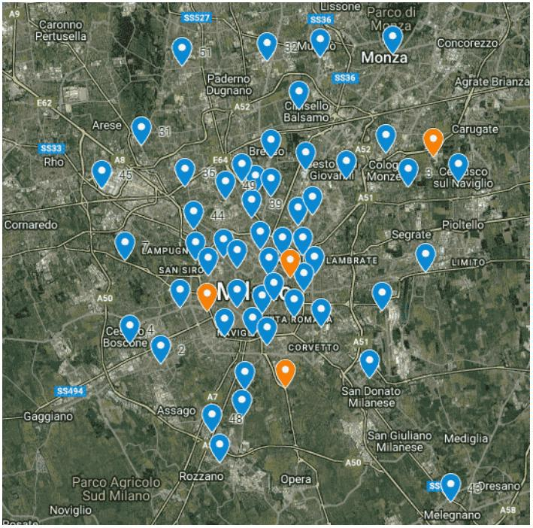
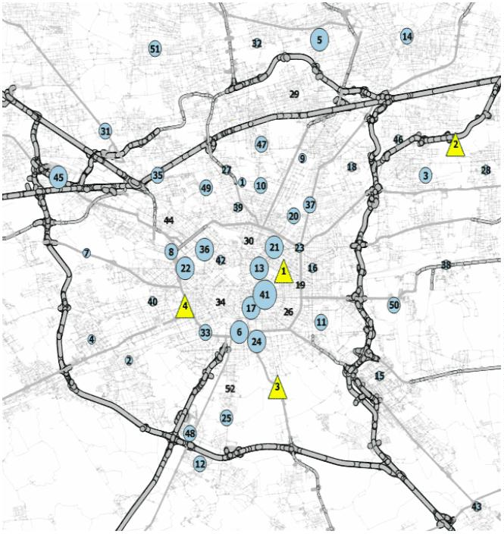
X.XX, Y.YY: Bootstrap Enhanced Scenario Optimization
6 Article submitted to Operations Research
3. The 2-echelon test case
Our proposed test case comes from an LSRT company that manages multiple retail stores in a
large city in northern Italy. Among these, 52 stores provided aggregate sales time series data
spanning at least 45 months prior to the forecast period, which is set at a three-month horizon, as
detailed in the following. Each store maintains a small inventory, replenished by deliveries from
one of four diﬀerent distribution centers (DCs) in the area. The products are categorized into three
lines: fresh, dry, and household. In this context, the focus has been exclusively on the logistics of
dry and household goods, including product categories ranging from personal care items to basic
electronics, from household goods to holiday decorations. For this product line, DCs are required
to maintain an aggregate inventory suﬃcient to cover a demand for a period of two weeks.
The supply chain consists of a large distribution center (DC) in the northern suburbs, a smaller
DC in the south, and two small satellite facilities closer to the city center. While the satellites have
limited storage capacity, they oﬀer lower-cost and more timely service to the majority of the city’s
stores. Figure 1:a shows the (anonymized) geolocation of the DCs and stores and 1:b the GIS model
of the locations (see also Maniezzo and Zhou 2023), where the DCs are the orange triangles and
the stores are the azure blobs whose size is proportional to the corresponding request.
(a) gmap view (b) GIS view
Figure 1 Stores and distribution centers locations.
Each store must be allocated to a distribution center (DC), ensuring that the total requests made
to a DC do not exceed its storage capacity. Both capacities and requests are quantiﬁed in terms of

X.XX, Y.YY: Bootstrap Enhanced Scenario Optimization
Article submitted to Operations Research 7
pallets, with no further granularity at this analytical level. The cost of servicing a store from a DC
is assessed based on the travel time required to transport goods between the two entities. Notably,
the three smaller DCs are fully owned by the company, whereas the fourth DC is situated in a leased
facility.
The ultimate goal of the analysis is to determine how much space to rent during the next peak
demand period, the Christmas season. To achieve this, we ﬁrst optimize the allocation of stores to
DCs, taking into account transportation and storage costs, and from the solution it is immediate to
derive the space required in each DC, therefore the space to rent in the largest one.
Another requirement characterizes the problem we are addressing: large stores located near small
DCs often lead to rapid saturation of the capacity of central DCs. This forces nearby stores to be
served by comparatively distant DCs. Therefore, it has been proposed to allow tentative split service
for certain selected stores to facilitate what-if analysis. The problem we address thus involves a
parametric number of possible assignments for each store, where which store should be allowed
multiple (double) assignments is an input parameter, not a decision variable.
The analysis was conducted during the summer of 2022 in preparation for the subsequent
Christmas season. At the time of the analysis, the anticipated demand requests were unknown
and required forecasting. The analysis underwent iterative reﬁnements throughout the summer,
culminating in the ﬁnal forecast produced in September. Consequently, the data presented in this
paper correspond to a three-month forecasting case.
The data for this test case were proposed by (Maniezzo and Zhou 2023), but that previous
work took a fundamentally diﬀerent approach, consisting of a Lagrangian matheuristic applied to
a deterministic model with diﬀerent objective and constraints to those considered here. This paper
therefore presents a genuinely novel approach that greatly expands the signiﬁcance of the test case.
The extended benchmark set is also entirely new.
All codes and data are available in an anonymized format from the project repository (public
upon acceptance). Speciﬁcally, the ﬁle containing the request time series can be downloaded from
the repository, where all series are complete up to the most recent actual values. However, it should
be noted that the last three values were unknown at the time the ﬁnal forecast was generated.
According to the classiﬁcation proposed in (de Kok et al. 2018) our contribution is described by
the following typology string: 2,D,D,G|F,C|D,G|b,F,N|SC|E,O standing for: System speciﬁcation: 2
echelons, Divergent material structure, Discrete events, Global information; Resources speciﬁca-
tions: bounded storage, Constant delivery time; Market speciﬁcations: Discrete stochastic demand,

X.XX, Y.YY: Bootstrap Enhanced Scenario Optimization
8 Article submitted to Operations Research
Guaranteed service; Control type speciﬁcations: installation base stock policy, Flexible release
quantities, No other means to satisfy unexpected requirements; Performance speciﬁcations: meet-
ing service requirements and minimization of costs; Generic scientiﬁc aspects: Exact techniques,
Optimization.
4. The predictive module
Data-driven approaches to estimating the distribution of stochastic variables have gained increasing
attention as alternatives to classical parametric modeling, particularly in settings where assumptions
of stationarity or known distributional forms are invalid. Unlike traditional techniques that rely
on a priori speciﬁcation of distribution families (e.g., Gaussian or Poisson), data-driven methods
infer distributional characteristics directly from historical or observed data, making them especially
suited for real-world applications with complex, noisy, or limited information.
Among the most prominent techniques are resampling-based methods such as the Bootstrap
(Efron 1979), which generates empirical distributions by repeatedly sampling from the data with
replacement. The Maximum Entropy Bootstrap (MEB) (Vinod and Kourentzes 2006) extends this
idea by producing replicates that preserve dependence structures in time series data, making it
particularly valuable for short or non-stationary sequences.
Recent work has explored the integration of these empirical distribution estimates into stochastic
and robust optimization pipelines. Notable contributions include nonparametric scenario generation
(Bayraksan and Morton 2011), distributionally robust optimization using empirical Wasserstein
distances (Esfahani and Kuhn 2017).
In our proposal, we utilize the MEB methodology in conjunction with the ensemble learning
technique known as bagging (Bootstrap Aggregating). This combination enhances the accuracy
and robustness of predictive models through the generation of multiple bootstrapped datasets
from the original data. By training individual models on these datasets and aggregating their
predictions through averaging, we adhere to MEB’s principles while capturing the underlying
statistical variability. Maximizing entropy under empirical constraints allows the integration of
bagging with MEB to produce more robust models. In more details, each model trained on distinct
bootstrapped samples incorporates uncertainty characteristics from the original data, allowing for
a comprehensive representation of its variation.
The incorporation of MEB into the bagging framework not only bolsters the performance of
predictive models but also facilitates uncertainty quantiﬁcation in the predictions. Each model

X.XX, Y.YY: Bootstrap Enhanced Scenario Optimization
Article submitted to Operations Research 9
produces a set of predictions that can be used to construct conﬁdence intervals, thereby oﬀering
insights into the variability and reliability of the forecasted outcomes. The ability to assess the
spread of predictions from multiple bootstrapped datasets presents a more nuanced understand-
ing of potential prediction intervals, which is particularly valuable in the context of the present
paper, characterized by short, non-stationary, and possibly non linear time series surrounded by a
signiﬁcant amount of uncertainty.
Furthermore, this synergistic approach allows for dealing with noisy datasets and mitigating
overﬁtting, as bagging inherently provides a mechanism to increase the robustness of the predictive
model by leveraging the diversity across the bootstrapped samples. Since MEB generates boot-
strapped datasets based on the maximum entropy principle, the resulting models avoid being overly
sensitive to any one particular realization of the data.
Mathematically, if we denote the bootstrapped replicas of the dataset as ꢂ∗₁, ꢂ∗₂, . . . , ꢂ∗_{ꢃ}, where ꢃ represents the number of bootstrapped samples, the resulting predictive framework can be expressed as: ꢄˆ_{BAG} = ꢅ(ꢄˆ_{ꢆ}(ꢇ)), where ꢄˆ_{ꢆ}(ꢇ) is the prediction made by the ꢆ − ꢈℎ model trained on the bootstrapped sample ꢂ∗_{ꢆ} and ꢅ a generic centrality parameter. This averaging process eﬀectively reduces variance by smoothing out the predictions of the individual models, leading to enhanced stability and generalization capabilities in the ﬁnal aggregated model. The parameter ꢅ is often deﬁned as either a simple average or the median, which leads to the following bagging predictors:
∑
1 ^{ꢃ}
ꢄˆ_{BAG} = ꢄˆ_{ꢆ}(ꢇ) (1)
ꢃ
ꢆ=1
ꢄˆ_{BAG} = 
ꢄˆ_{ꢆ}(ꢇ) ꢀ_{ℎ+21}ꢁ
(2)
if ℎ is odd
ꢄˆ_{ꢀ (ꢇ)}[ ₂ ]+ꢄˆ_{ꢀ (ꢇ)}[ ₂ ₊¹]
ℎ ℎ
2 if ℎ is even
here, ꢄˆ_{ꢆ}(ꢇ) is sorted in ascending order whereas ℎ is the number of future values to be predicted.
4.1. Resampling techniques
In recent years, resampling techniques, especially the bootstrap method, have become valuable for
overcoming the limitations of conventional forecasting methods (Hasni et al. 2019). The bootstrap
method creates simulated time series through resampling from observed data. This approach is
useful for non-stationary, non-linear, intermittent, and asymmetric cyclical patterns, as well as low
signal-to-noise scenarios (Feliu 2024, Suman 2024, Kreiss and Lahiri 2012). Moreover, resampling

X.XX, Y.YY: Bootstrap Enhanced Scenario Optimization
10 Article submitted to Operations Research
methods help address the eﬀects of limited sample sizes (Davison and Hinkley 1997) and model
uncertainty (Sarris et al. 2020).
The utility of bootstrap methods in model selection has been extensively validated. Fenga and
Politis (Fenga and Politis 2011) introduced a bootstrap-based approach for autoregressive moving
average (ARMA) order selection, demonstrating its eﬀectiveness in enhancing model accuracy with
ﬁnite sample sizes. Their work (Fenga and Politis 2013) extended this to threshold autoregressive
models (SETAR), validating bootstrap techniques for optimal model speciﬁcations. Furthermore,
Fenga and Politis (Fenga and Politis 2017) explored the LASSO technique for sparse autoregression,
illustrating a bootstrap framework for model selection in high-dimensional contexts. These studies
collectively show how bootstrap methods can enhance order selection across statistical modeling
frameworks, underscoring their relevance in modern statistical analysis.
The standard bootstrap assumes independent and identically distributed (i.i.d.) data — an assump-
tion that fails for time series, where observations are dependent and ordered.
This failure is more pronounced when the series is short, making dependence patterns more
inﬂuential, the data exhibits autocorrelation, seasonality, or trend and when resampling destroys
the structure and underrepresents variability.
In these cases Maximum Entropy Bootstrap (MEB) guarantees the following advantages:
• Preservetion of Dependence Structure MEB maintains the temporal dependence (e.g., auto-
correlation, trend, seasonality) by using rank-based and interpolation techniques that reorder
and smooth the data. Unlike i.i.d. bootstrap, it doesn’t break time series structure.
• Better Handling of Short Time Series In short samples, structural properties (e.g., local trends)
are easily lost by standard resampling. MEB keeps these features by reconstructing plausible
time series paths that are consistent with observed data and uncertainty.
• No Need for Model Speciﬁcation Unlike block bootstrap or parametric resampling, MEB is
nonparametric and doesn’t require selecting block sizes or ﬁtting ARMA models — a key
beneﬁt for short samples where such models may be unstable or overﬁtted.
• Generation of Smooth Pseudo-Series MEB produces continuous, smoothed pseudo-series
through linear interpolation, making it well-suited for statistical inference tasks like forecasting,
conﬁdence intervals, and hypothesis testing.
• Maximum Entropy Principle It applies the maximum entropy principle, meaning the generated
bootstraps are the least biased (i.e., most non-committal) estimates consistent with the known
constraints (the observed data). This is especially valuable when little information is available
— like in short series.

X.XX, Y.YY: Bootstrap Enhanced Scenario Optimization
Article submitted to Operations Research 11
• Support of Stationary and Non-Stationary Series MEB is ﬂexible with both stationary and
non-stationary time series, whereas other bootstrap techniques often require stationarity or
explicit transformation to achieve it.
The MEB resampling scheme adopted here oﬀers a principled and ﬂexible approach to bootstrap-
ping time series data, leveraging the Maximum Entropy Principle (MEP) (Shannon 1948) to address
the inherent limitations of conventional bootstrap methods, thus addressing many limitations of
traditional block bootstrap methods. The essence of MEP is grounded in the idea that in the absence
of speciﬁc information, the most rational probability distribution to adopt is one that maximizes
entropy, reﬂecting the greatest uncertainty about the system (Jaynes 1957). This is mathematically
articulated through Shannon entropy, deﬁned as ꢉ(ꢊ) = −Í
_{ꢌ=1} ꢊ_{ꢌ} log(ꢊ_{ꢌ}), where ꢊ_{ꢌ} denotes the
ꢋ
probability associated with the i-th outcome within a discrete sample space of size ꢋ.
The pivotal advancement provided by MEB lies in its ability to formulate bootstrapped samples
that adhere to a spectrum of constraints dictated by the original dataset, such as predetermined
moments, probabilities, or other statistical characteristics (Berger 1985). Speciﬁcally, under typical
circumstances, these constraints can be speciﬁed in the form of normalized probabilities and empir-
ical expectations, expressed as Í
_{ꢌ=1} ꢊ_{ꢌ} = 1 to ensure that the probabilities form a valid distribution,
ꢋ
and Í
_{ꢌ=1} ꢊ_{ꢌ} ꢁ_{ꢌ} = ꢁ¯, where ꢁ_{ꢌ} represents measurements or statistics relevant to the analysis, with ꢁ¯
ꢋ
being the empirical mean of these measurements. The formulation of the Maximum Entropy prob-
lem consequently leads to a constrained optimization framework. The optimization problem can be succinctly encapsulated in the Lagrangian: ꢍ(ꢊ, ꢎ, ꢏ) = ꢉ(ꢊ) + ꢎ ꢂ1 − Í_{ꢌ=1} ꢊ_{ꢌ}ꢃ + ꢏ ꢂ ꢁ − Í_{ꢌ=1} ꢊ_{ꢌ} ꢁ_{ꢌ}ꢃ
, ¯
ꢋ ꢋ
where ꢎ and ꢏ are Lagrange multipliers that adjust the balance under the constraints of normalizing
the distribution and matching the empirical mean, respectively. The solution to this maximization
problem yields a probability distribution, which appears as ꢊ_{ꢌ} = ꢐ^{ꢁ ꢂꢃ}
Í
_{ꢁ ꢂ ꢅ} , where the parameter ꢏ ꢄ
_{ꢅ=1} ꢐ
is determined through the constraint equations, speciﬁcally via a numerical root-ﬁnding approach
that satisﬁes the moment condition Í
_{ꢌ=1} ꢊ_{ꢌ} ꢁ_{ꢌ} = ꢁ¯.
ꢋ
Sure — below is a LaTeX-formatted version, ready to paste into a paper. I preserved structure,
notation, and style consistency.
“‘latex The pivotal advancement provided by MEB lies in its ability to formulate bootstrapped
samples that adhere to a spectrum of constraints dictated by the original dataset, such as predeter-
mined moments, probabilities, or other statistical characteristics (Berger 1985). Speciﬁcally, under
typical circumstances, these constraints can be speciﬁed in the form of normalized probabilities
and empirical expectations, expressed as Í
_{ꢌ}^{ꢋ}₌₁ ꢊ_{ꢌ} = 1 to ensure that the probabilities form a valid



X.XX, Y.YY: Bootstrap Enhanced Scenario Optimization
12 Article submitted to Operations Research
distribution, and Í
_{ꢌ=1} ꢊ_{ꢌ} ꢁ_{ꢌ} = ꢁ¯, where ꢁ
_{ꢌ} represents measurements or statistics relevant to the anal- ꢋ
ysis, with ꢁ¯ being the empirical mean of these measurements. The formulation of the Maximum
Entropy problem consequently leads to a constrained optimization framework. The optimization
problem can be succinctly encapsulated in the Lagrangian:
ATTENTION: The following displayed equation, in
its current form, exceeds the column width that
will be used in the published edition of your
article. Please break or rewrite this equation
to fit, including the equation number, within a
column width of 240 pt / 84.67 mm / 3.33 in (the
width of this red box).
ꢍ(ꢊ, ꢎ, ꢏ) = ꢉ(ꢊ) + ꢎ  1 − |  | ∑  ꢋ  ꢌ=1 |  | ꢊ_{ꢌ}! + ꢏ |  | ∑  ꢋ  ¯  ꢁ −  ꢌ=1 |  | ꢊ_{ꢌ} ꢁ_{ꢌ}! |  | ,
where ꢎ and ꢏ are Lagrange multipliers that adjust the balance under the constraints of normalizing
the distribution and matching the empirical mean, respectively. The solution to this maximization
problem yields a probability distribution, which appears as
 | ꢊ_{ꢌ} = |  | ꢐ^{ꢏ ꢁ}  Í  ꢃ  ꢋ ꢏ ꢁ_{ꢅ}  _{ꢑ=1} ꢐ |  | ,
where the parameter ꢏ is determined through the constraint equations, speciﬁcally via a numerical
root-ﬁnding approach that satisﬁes the moment condition Í
_{ꢌ=1} ꢊ_{ꢌ} ꢁ_{ꢌ} = ꢁ¯.
ꢋ
Building on this classical formulation, we deﬁne an Objective-Augmented Maximum Entropy
Bootstrap (OA-MEB) scheme that incorporates additional optimization-oriented structure directly
into the resampling distribution. To do so, we introduce an auxiliary objective-related component
ꢒ_{ꢌ}, representing scenario-wise quantities that are relevant to downstream decision or cost functions
in stochastic programming (e.g., expected cost contributions, constraint violations, or risk-sensitive
statistics). The OA-MEB extends the entropy maximization problem by embedding a tunable scalar
parameter ꢓ ≥ 0 that controls the inﬂuence of this additional term while preserving the probabilistic and moment-matching constraints. The resulting augmented Lagrangian is given by:

X.XX, Y.YY: Bootstrap Enhanced Scenario Optimization
Article submitted to Operations Research 13
ATTENTION: The following displayed equation, in
its current form, exceeds the column width that
will be used in the published edition of your
article. Please break or rewrite this equation
to fit, including the equation number, within a
column width of 240 pt / 84.67 mm / 3.33 in (the
width of this red box).
ꢍ_{OA}(ꢊ, ꢎ, ꢏ, ꢓ) = ꢉ(ꢊ) + ꢎ  1 −  ∑  ꢋ  ꢌ=1 |  | ꢊ_{ꢌ}! + ꢏ |  | ¯  ꢁ − |  | ∑  ꢋ  ꢌ=1 |  | ꢊ_{ꢌ} ꢁ_{ꢌ}! + ꢓ ꢊ_{ꢌ}ꢒ_{ꢌ}!  ∑  ꢋ  ꢌ=1 |  | ,
where the additional inner product term Í
_{ꢌ}^{ꢋ}₌₁ ꢊ_{ꢌ}ꢒ_{ꢌ} promotes bootstrap resamples that remain statistically coherent while incorporating optimization-driven scenario emphasis. Solving the ﬁrst-
order optimality conditions yields a modiﬁed exponential-tilting solution:
exp (ꢏ ꢁ
_{ꢌ} + ꢓꢒ_{ꢌ})
Í_{ꢑ=1} exp ꢂ _{ꢑ} ꢃ
ꢊ^{OA}
ꢌ = ,
ꢋ
ꢏ ꢁ_{ꢑ} + ꢓꢒ
showing that classical MEB is recovered as the special case ꢓ = 0. Calibration of ꢓ governs the
trade-oﬀ between purely information-theoretic sampling and decision-aligned resampling, and may
be performed via cross-validation, bilevel optimization, or risk-preference calibration strategies
consistent with the downstream stochastic programming model.
This formulation transforms the problem into one that allows for ﬂexible adaptation to various
types of data and constraints imposed by the empirical observations. Once this extended maximum
entropy distribution is established, resampling via bootstrapping can commence by selecting ꢔ
samples according to the derived ꢊ_{ꢌ}. This produces synthetic datasets that not only reﬂect the vari-
ability and uncertainty characteristic of the original data but also adhere to the speciﬁc constraints
imposed, which may include higher moments or even domain-speciﬁc statistics.
This resampling process can be iterated to generate a comprehensive set of bootstrapped samples,
enabling a multitude of statistical analyses, including conﬁdence interval estimation, hypothesis
testing, and model validation (Efron and Tibshirani 1993).
5. The prescriptive module
The results of the predictive module become a structural component of the prescriptive module,
whose goal is to optimize the allocation of stores to DCs thus to permit the quantiﬁcation of space to
rent in a third-party DC. The results of the optimization are used to evaluate the modeled scenario,
where scenarios are deﬁned for speciﬁc what-if analyses. For example, the objective of the what-if

X.XX, Y.YY: Bootstrap Enhanced Scenario Optimization
14 Article submitted to Operations Research
analyses could be to examine the eﬀect of freezing some allocations while leaving the rest free, or
possibly accepting some multiple, in our test case double, allocations for some selected stores.
The core optimization problem is a split allocation problem. This variant of the basic allocation
problem has already received attention in the optimization literature, mainly in the context of
survivable communication network design (Ernst and Krishnamoorthy 1998, Mokhtar et al. 2019),
and more generally as the splittable capacitated multiple allocation hub location problems (Marín
2005). It ﬁnds applications in ﬁber optic access networks (Youngjin et al. 2011), split delivery
routing (Dror and Trudeau 1989), and even in school timetabling (Beyrouthy et al. 2007). The
problem we are interested in is related to one that is presented in (Zhu et al. 2021), but it is modelled
in a very diﬀerent way.
The mathematical model we use is a direct extension of the standard model for allocation
problems. As our proposed framework is valid beyond the speciﬁc case study described in the
paper, we will refer to the application elements (stores and data centers) using standard allocation
terminology in what follows. To emphasize the generality of the analysis, we will use the term
’clients’ for stores and ’servers’ for data centers. In our context, assignment constraints can accept
a parametric number of assignments, enabling requests to be serviced across multiple servers. The
notation used in the model is as follows:
ꢋ number of clients (stores)
J index set of clients, ꢕ = {1, . . . , ꢋ}
ꢔ number of servers (DCs)
I index set of servers, ꢖ = {1, . . . , ꢔ}
ꢗ_{ꢌꢑ} global cost for allocating client ꢑ ∈ ꢕ to server ꢌ ∈ ꢖ
ꢘ_{ꢌ} storage capacity of server ꢌ ∈ ꢖ
ꢙ_{ꢌ} unit storage cost of server ꢌ ∈ ꢖ
ꢚꢐꢛ_{ꢑ} total request of client ꢑ.
ꢆ_{ꢑ} maximum number of servers (DCs) client ꢑ can be assigned to
ꢇ_{ꢌꢑ} binary decision variable equal to 1 iﬀ client ꢑ is allocated to server ꢌ, ꢌ ∈ ꢖ and ꢑ ∈ ꢕ
ꢛ_{ꢌꢑ} integer decision variable representing the amount (number of pallets) of request of client ꢑ
provided from server ꢌ
In the ﬁnal test case, the amount requested by each client was always set to equal the corresponding
predicted value. However, in some scenarios, some clients’ requests could be split between two servers, meaning the requested ꢛ₍ꢌꢑ) amounts could vary.

X.XX, Y.YY: Bootstrap Enhanced Scenario Optimization
Article submitted to Operations Research 15
The mathematical model used for this problem was as in the following formulation FD.
(ꢜꢂ) ꢝ (ꢗ_{ꢌꢑ}ꢇ_{ꢌꢑ} + ꢙ
_{ꢜꢂ} = min ∑_{ꢌ∈ꢖ} ∑
_{ꢌ}ꢛ_{ꢌꢑ}) (3)
subject to ∑ _{ꢑ∈ꢕ}
ꢛ_{ꢌꢑ} = ꢚꢐꢛ_{ꢑ} ꢑ ∈ ꢕ (4)
∑
ꢌ∈ꢖ
ꢌ ꢌ ∈ ꢖ (5) ꢛ_{ꢌꢑ} ≤ ꢘ
∑_{ꢑ∈ꢕ}
ꢇ_{ꢌꢑ} = ꢆ_{ꢑ} ꢑ ∈ ꢕ (6)
ꢌ∈ꢖ
ꢛ_{ꢌꢑ} ≤ ꢚꢐꢛ
_{ꢑ}ꢇ_{ꢌꢑ} ꢌ ∈ ꢖ, ꢑ ∈ ꢕ (7) ꢇ_{ꢌꢑ} ∈ {0,1} ꢌ ∈ ꢖ, ꢑ ∈ ꢕ (8) ꢛ_{ꢌꢑ} ∈ Z+0 ꢌ ∈ ꢖ, ꢑ ∈ ꢕ (9)
The constraints in equation 6 are formulated as equalities due to the need to impose speciﬁc
splits in ’what if’ scenarios. However, if this is not of particular interest, these constraints could
be replaced by less-than-or-equal-to inequalities combined with inequalities that ensure allocations
are made to at least one server.
Note that when ꢆ_{ꢑ} = 1 for all clients, i.e., when each client ꢑ ∈ ꢕ can be served by only one server, constraints 7 and 4 force the entire quantity requested by client ꢑ, ꢚꢐꢛ_{ꢑ}, to be supplied by a single server. The constraints 7 thus become equations, the constraints 4 become redundant, and the constraints 5 can be expressed by replacing Í ꢛ_{ꢌꢑ} with Í
ꢚꢐꢛ_{ꢑ}ꢇ_{ꢌꢑ}. Problem P reduces to
ꢑ∈ꢕ ꢑ∈ꢕ
the standard GAP and can be solved by any of the methods described in Maniezzo et al. (2021).
However, we are interested in the general case that allows for multiple assignments. Since the
cost is derived from these assignments, the problem can be considered a ﬁxed-cost split-assignment
allocation problem. Furthermore, as future client requests can only be forecast, it is more convenient
to formulate the problem as a stochastic optimization problem, where the future requests are random
variables ꢅ_{ꢑ}, ꢑ ∈ ꢕ, whose distributions are derived from the forecast results. The resulting stochastic problem is formulated as follows.

X.XX, Y.YY: Bootstrap Enhanced Scenario Optimization
16 Article submitted to Operations Research
(ꢜꢉ) ꢝ (ꢗ_{ꢌꢑ}ꢇ_{ꢌꢑ} + ꢙ
_{ꢜꢉ} = min ∑_{ꢌ∈ꢖ} ∑
_{ꢌ}ꢛ_{ꢌꢑ}) (10)
subject to ∑ _{ꢑ∈ꢕ}
ꢛ_{ꢌꢑ} = ꢞ(ꢅ
_{ꢑ}) ꢑ ∈ ꢕ (11)
∑
ꢌ∈ꢖ
ꢌ ꢌ ∈ ꢖ (12) ꢛ_{ꢌꢑ} ≤ ꢘ
∑
ꢑ∈ꢕ
ꢇ_{ꢌꢑ} = ꢆ_{ꢑ} ꢑ ∈ ꢕ (13)
ꢌ∈ꢖ
ꢌꢑ ꢌ ∈ ꢖ, ꢑ ∈ ꢕ (14) ꢛ_{ꢌꢑ} ≤ ꢞ(ꢅ_{ꢑ})ꢇ
ꢇ_{ꢌꢑ} ∈ {0,1} ꢌ ∈ ꢖ, ꢑ ∈ ꢕ (15)
ꢛ_{ꢌꢑ} ∈ Z+0 ꢌ ∈ ꢖ, ꢑ ∈ ꢕ (16)
where the values ꢞ(ꢅ_{ꢑ}) in the constraints 11 and 14 refer to any same realization of the random variable ꢅ_{ꢑ}.
Diﬀerent methods can be used to deal with this case (Shapiro et al. 2009). We transformed the
formulation (FS) into its deterministic equivalent (Dantzig 1955) using the forecasts computed on
the bootstrap sets. This transformed the original stochastic problem into a deterministic optimization
one. We generated multiple scenarios each containing a realization of the stochastic variable ꢅ,
which is deﬁned as a forecast of one series from the bootstrap set in use. For each scenario ꢟ, we
thus created a version of the constraint with ꢆ_{ꢌ}^{ꢟ} as the right-hand side. The ﬁnal solution must satisfy
these constraints across all scenarios.
The objective function now incorporates the quantities to be delivered to each client in diﬀerent
scenarios. Therefore, we consider the expected cost as a weighted average across these scenarios
and include it in the objective function.
The resulting formulation is as follows. The random variables ꢅ_{ꢑ} are sampled in a ﬁnite number
of scenarios. Let ꢅ^{ꢟ}_{ꢑ} denote the realization of ꢅ_{ꢑ} in scenario ꢟ, ꢟ ∈ ꢉ, and let ꢊ
_{ꢟ} = ¹
be the
|ꢉ|
probability associated with scenario ꢟ ∈ ꢉ. The variables ꢠ_{ꢑꢟ} are slack variables for the customer service constraints.


X.XX, Y.YY: Bootstrap Enhanced Scenario Optimization
Article submitted to Operations Research 17
ATTENTION: The following displayed equation, in
its current form, exceeds the column width that
will be used in the published edition of your
article. Please break or rewrite this equation
to fit, including the equation number, within a
column width of 240 pt / 84.67 mm / 3.33 in (the
width of this red box).
ꢟ∈ꢉ ꢑ∈ꢕ ∑ _{ꢑꢟ}!!
(ꢂꢡ) ꢝ (ꢗ_{ꢌꢑ}ꢇ_{ꢌꢑ} + ꢙ _{ꢌꢑ}) + ꢢꢠ
_{ꢂꢡ} = min∑ ꢊ_{ꢟ} ∑
_{ꢌ}ꢛ^{ꢟ} (17)
s.t.∑ ꢌ∈ꢖ
ꢛ^{ꢟ} _{ꢑꢟ} = ꢅ^{ꢟ}_{ꢑ} ꢑ ∈ ꢕ, ꢟ ∈ ꢉ (18)
_{ꢌꢑ} + ꢠ
∑
ꢌ∈ꢖ
ꢛ^{ꢟ}
_{ꢌꢑ} ≤ ꢘ
ꢌ ꢌ ∈ ꢖ, ꢟ ∈ ꢉ (19)
∑
ꢑ∈ꢕ
ꢇ_{ꢌꢑ} = ꢆ_{ꢑ} ꢑ ∈ ꢕ (20)
ꢌ∈ꢖ
ꢛ^{ꢟ} _{ꢑ}ꢇ_{ꢌꢑ} ꢌ ∈ ꢖ, ꢑ ∈ ꢕ, ꢟ ∈ ꢉ (21)
_{ꢌꢑ} ≤ ꢅ
ꢟ
ꢇ_{ꢌꢑ} ∈ {0,1} ꢌ ∈ ꢖ, ꢑ ∈ ꢕ (22)
ꢛ_{ꢌ}^{ꢟ}_{ꢑ} ∈ Z+0 ꢌ ∈ ꢖ, ꢑ ∈ ꢕ, ꢟ ∈ ꢉ (23)
ꢠ_{ꢑꢟ} ∈ Z+0 ꢑ ∈ ꢕ, ꢟ ∈ ꢉ (24)
In this formulation, since each variable ꢅ^{ꢟ}_{ꢑ} derives from a speciﬁc realization of the corresponding
random variable ꢅ_{ꢑ}, the amounts to be delivered to each store ꢑ ∈ ꢕ are scenario-speciﬁc. However,
it is required to determine a unique allocation that allows to serve all stores in any proposed scenario.
This last requirement may be infeasible, so the slack variables ꢠ_{ꢑꢟ} are needed in the formulation.
They are lexicographically penalized in the objective function by appropriately high costs, in order
to implement the primary concern of achieving feasibility.
Optimizing formulation (DE) makes it possible to determine the quantities that each server must
be able to supply to each client, i.e. the total quantity that each server must handle. In terms of
our logistical application, since each DC must maintain suﬃcient inventory to meet the anticipated
demand during the designated period, the optimization of the client (retailer) allocation translates
directly into a quantiﬁcation of the DC inventory and therefore of its required minimum size. Thus,
solving the allocation problem also solves the dimensioning question that motivated this research.

X.XX, Y.YY: Bootstrap Enhanced Scenario Optimization
18 Article submitted to Operations Research
6. Computational results
This section reports on the results of validating the predictive and prescriptive modules in accor-
dance with the speciﬁcations previously described.
6.1. Predictive module tests
The objective of the predictive module is to forecast demand for each store, asking for a forecast
three months ahead. The available data consists of a time series for each of the 52 stores. Each
series contains 45 values corresponding to four years of monthly data on relevant requests for each
store. The values for the last three months are missing, as these are yet to be forecast.
The core approach set out in this paper is the bootstrap method, which is described in Section
4. The results obtained using this method were validated against those obtained using several
alternative forecasting algorithms: SARIMAX, Holt-Winters, MLP, RNN (LSTM), Random Forest
and Gradient Boosting (XGBoost). The relevant hyperparameters were determined by grid search
for algorithms with integer-valued parameters, such as SARIMAX, and by Hammersley sampling
(Hammersley 1960) for real-valued parameters.
All series were pre-processed using a ’log-diﬀ’ transform to approach stationarity, and a max–min
scaler was applied to the artiﬁcial intelligence-derived methods. Python version 3.11 was used for
all implementations and the codes were run on a Windows PC workstation equipped with four Intel
Core i7-4790 CPUs running at 3.60 GHz and with 32 GB of RAM.
The focus of this part of the research is on the bootstrap method. To this end, we tested the
approach with the following settings:
• bootstrap sets containing 75, 125 and 175 series;
• bootstrap sets generated by simple autoregressive AR(p) with p=5 model (the default in
python’s statsmodels), where parameters are estimated using Yule-Walker equations (Brock-
well and Davis 1991), and by ARIMA, where autoarima is run on each of the seed series and
the optimized orders are then applied to each boosted series;
• the forecasting of all the boosted series generated as above to obtain the boosted forecasts
was tested with AR(ꢊ), Random Forest or ARIMA. In the case of ARIMA, autoarima was
only repeated on the ﬁrst series of each bootstrap set. In the case of AR, the parameter ꢊ
was set for each series after a loop on diﬀerent ꢊ values, keeping the one that maximized the
corresponding AIC value.

X.XX, Y.YY: Bootstrap Enhanced Scenario Optimization
Article submitted to Operations Research 19
We also attempted to generate bootstrap sets with and without backcasting, as well as with simple
extraction and repetitions among the residuals of the seed series, and compared these with their
scrambling. We did not report the results of these tests because backcasting worsened the results,
while scrambling the residuals showed no diﬀerence compared to extraction with repetitions.
Therefore, in line with the literature, we decided to use the latter approach.
The forecasts were compared using three cost functions: mean absolute error (MAE), mean
squared error (MSE) and bias. The results are reported by ranking the corresponding forecasts for
each series according to the quality of the considered function to emphasize how the algorithms
perform relative to each other. Then, the rank of each function is averaged over all series. Appendix
A reports the absolute values of the error measures, rather than the rank-based values, for all
boostset sizes.
Table 1 presents the results of comparing the forecasts obtained using standard algorithms with
those obtained using boosting. The boosted series were computed using an AR(5) model based on
Yule-Walker equations. The forecasts of these series were obtained using a simple autoregressive
model. The boosted sets consisted of 75, 125, and 175 series, which are labelled ꢣꢤ_ꢥꢞ_75,
ꢣꢤ_ꢥꢞ_125, and ꢣꢤ_ꢥꢞ_175, respectively.
The columns show the average ranking of each cost function (MAE, MSE or bias) for each
boostset size, while on the rows we report:
• ꢁ ꢗꢦꢟꢈ_ꢦꢧꢒ: boost forecast obtained as the average of the corresponding ranks;
• ꢁ ꢗꢦꢟꢈ_50: boost forecast obtained as the median of the corresponding ranks;
• ꢄꢦꢚ: non-boost forecast obtained by an AR model;
• ꢄꢦꢚꢌꢔꢦ: non-boost forecast obtained by an ARIMA model;
• ꢄℎꢨ: non-boost forecast obtained by a Holt and Winters model;
• ꢄꢔꢩꢊ: non-boost forecast obtained by a multilayer perceptron model;
• ꢄꢟꢧꢔ: non-boost forecast obtained by a SVM model;
• ꢄꢩꢟꢈꢔ: non-boost forecast obtained by a LSTM model;
• ꢄꢚ ꢁ : non-boost forecast obtained by a random forest model;
• ꢄꢇꢒꢆ: non-boost forecast obtained by a XGboost model;
The table shows that boosting is consistently the most reliable method for minimizing forecast
errors, even when forecasts are obtained from a model as simple as AR[p], while ARIMA produces
the least bias.


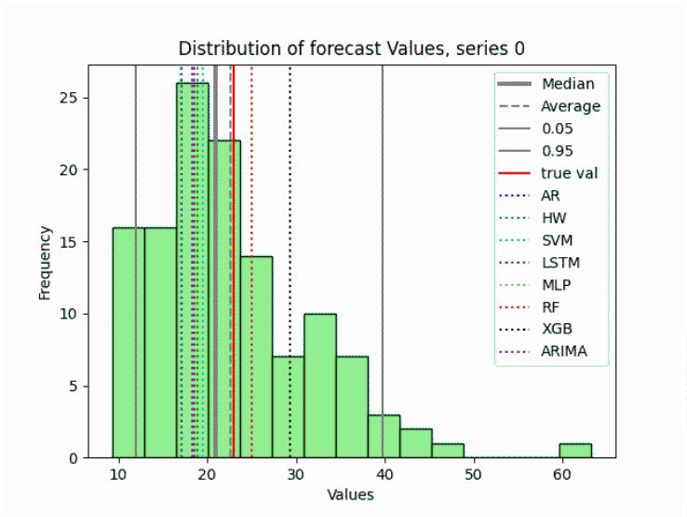
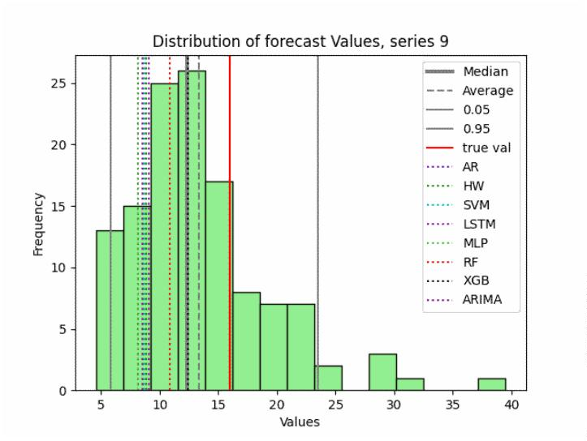
X.XX, Y.YY: Bootstrap Enhanced Scenario Optimization
20 Article submitted to Operations Research
YW_AR_75 YW_AR_125 YW_AR_175 MAE MSE bias MAE MSE bias MAE MSE bias
fcast_avg 2.67 2.67 0.08 2.58 2.58 0.05 3.83 3.83 0.04
fcast_50 3.04 3.04 0.06 3.19 3.19 0.04 2.50 2.50 0.03
yhw 5.42 5.42 0.08 6.06 6.06 0.04 5.88 5.88 0.03
yarima 5.73 5.73 0.05 6.04 6.04 0.03 6.08 6.08 0.02
ysvm 5.88 5.88 0.08 5.50 5.50 0.05 5.50 5.50 0.03
ylstm 6.02 6.02 0.06 5.52 5.52 0.04 6.27 6.27 0.02
yar 6.06 6.06 0.04 6.54 6.54 0.02 6.79 6.79 0.02
ymlp 6.38 6.38 0.05 5.98 5.98 0.03 6.17 6.17 0.02
yrf 6.46 6.46 0.11 6.31 6.31 0.06 5.48 5.48 0.04 yxgb 7.33 7.33 0.12 7.29 7.29 0.07 6.50 6.50 0.05
Table 1 Average rankings for diﬀerent boostset size.
Figure 2 shows two examples of forecast distributions obtained for two diﬀerent series. The green
bars correspond to the distribution of the results obtained by the AR[p] model over the diﬀerently
recolored alternatives of a series. The distribution is superimposed with lines representing the
results of other forecasting algorithms applied to the original series.
(a) 75 bootset (b) 125 boostset
Figure 2 Distribution of bootstrap forecasts.
The relative merits of the diﬀerent forecasting approaches are better highlighted by critical
diﬀerence diagrams based on the non-parametric Friedman test followed by a post-hoc Nemenyi
test. These diagrams allow for a visual comparison of performance ranks and indicate whether
the diﬀerences between classiﬁers are statistically signiﬁcant (D06). In our case, the graphs were
generated using the SciKit version (Scikit 2024) and plot the average rank across all series for each
algorithm along the x-axis. Horizontal bars connect those that could not be considered statistically
diﬀerent.

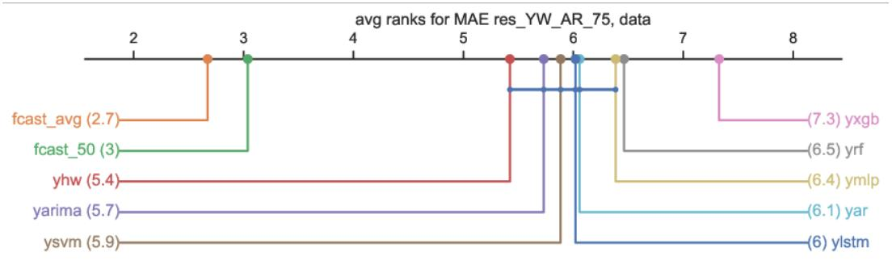
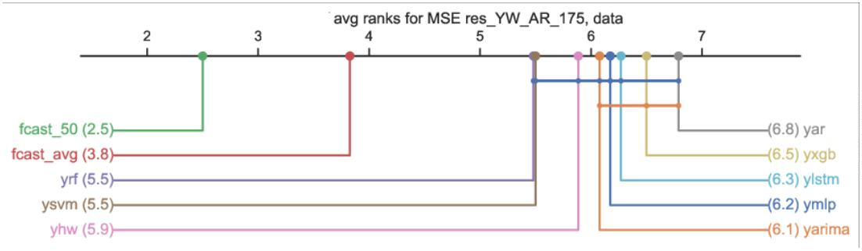
X.XX, Y.YY: Bootstrap Enhanced Scenario Optimization
Article submitted to Operations Research 21
Figures 3 and 4 show a comparison of the ranks on MAE for the 75 series boostset and on MSE for
the 175 series boostset. In both cases, as with all those tested, the accuracy of the boost forecasts is
signiﬁcantly higher than that obtained with alternative models. The tables in the Appendix conﬁrm
that the comparison yields consistent results across all boostset sizes and cost functions, except for
bias. The bias rankings are in fact unrelated to those obtained with the other cost functions. This
is because the bias is very small in all cases, less than 1% of the average of the empirical values,
which ensures that all the forecasting models are free of systematic errors on our data and makes
the diﬀerence in the rankings insigniﬁcant.
Figure 3 Average ranks for MAE on instance res_YW_AR_75
Figure 4 Average ranks for MSE on instance res_YW_AR_175
Our relatively short time series require a forecasting approach that can handle both limited data
and non-stationarity. Although sophisticated machine learning models such as recurrent neural
networks (RNNs) and gradient boosting machines (GBMs) have become more popular in recent
years, they can perform less well when there is limited data available, particularly when the data has
non-stationary properties. This can lead to overﬁtting. The autoregressive (AR) model combined
with maximum entropy bootstrap oﬀers a powerful and promising alternative. This technique
performed excellently in the context of this study, consistently outperforming more complex machine
learning models. It oﬀers an approach based on robust statistical principles that mitigates the
risk of overﬁtting inherent in many AI approaches. Moreover, the AR model combined with the
bootstrap methodology provides reliable forecasts ideally suited to integration into the subsequent
optimization module.

X.XX, Y.YY: Bootstrap Enhanced Scenario Optimization
22 Article submitted to Operations Research
In our case, the choice of an autoregressive (AR) model not only oﬀers superior accuracy,
but also several crucial advantages over more complex machine learning approaches. Firstly, the
AR model’s inherent simplicity makes it easy to implement and interpret. Unlike many machine
learning algorithms, which operate as ’black boxes’, the parameters of the AR model have clear
statistical interpretations that provide insight into the underlying dynamics of the time series data.
Secondly, the well-established theoretical framework of the AR model and the readily available
diagnostic tools allow for robust validation and assessment of model performance.
6.2. Prescriptive module tests
The results reported in section 6.1 provided the basis for instantiating the optimization on the results
obtained by the bootstrap forecasts. The prescriptive module was ﬁrst run in a deterministic setting,
to deﬁne a benchmark solution, then extended to the stochastic setting described in section 5.
When the problem is modelled using the (FD) formulation and the average predictions obtained
by boosting are used as deterministic data, it can be easily solved by any state-of-the-art MILP
solver. This demonstrates the feasibility of dealing with a signiﬁcant deterministic equivalent of the
stochastic formulation (FS). The optimal deterministic value of ꢝ_{ꢜꢪ} = 15553 is used as a benchmark
in the following tests.
We moved on to the (DE) formulation generating a value for each of the stochastic variables ꢅ_{ꢑ}
in correspondence to each bootstrap forecast. Given these input data, we ran experiments to assess
the impact of the variation of the remaining sets of parameters of the formulation, i.e., cardinality
of the boostsets, number of splittable clients, and assumptions on inventory costs.
All reported tests were run on the same machine as in subsection 6.1, a Windows PC workstation
equipped with four Intel Core i7-4790 CPUs running at 3.60 GHz and 32 GB of RAM, but in this
case the implementation language was C++ to allow ﬁner control over the MILP solver used, which
was CPLEX v. 22.11.
Increasing boostset size The size of the boostset helps to stabilize the results during forecasting,
but it also has a deep impact on the optimization. In fact, the number of variables and constraints
in the DE formulation do not depend on the size of the boostset, larger boostsets are more likely
to contain unusual values or combinations thereof. This makes the constraints in equation (18)
progressively harder to satisfy, which increases the cost and may render the instance infeasible.
To ascertain this, we conducted experiments using 75, 125 and 175 series boostsets, with a time
limit of 600 seconds on the optimization process. Figure 5 shows a boxplot diagram depicting the

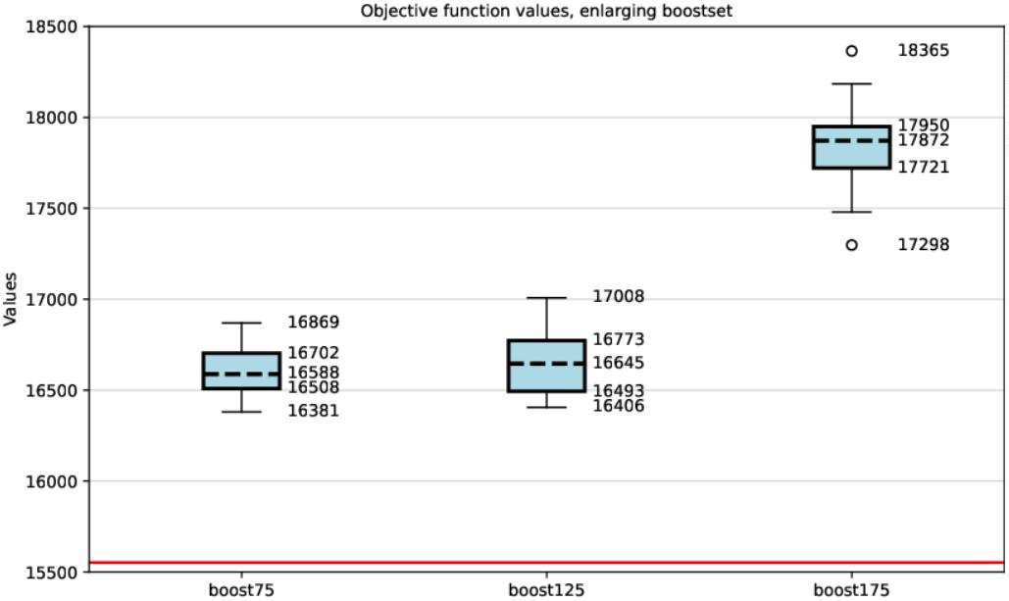
X.XX, Y.YY: Bootstrap Enhanced Scenario Optimization
Article submitted to Operations Research 23
distribution of the optimized cost over a number of tests equal to 1/5 of the number of series in the
boostset, i.e., 15, 25, 35, respectively.
Figure 5 Allocation cost for increasing boostset size
Figure 5 has a red horizontal line at the cost value for the deterministic case. Therefore, the
increase in cost can be considered a quantiﬁcation of the value of information about storage requests.
We observe that the cost remains relatively stable for the 75 and 125 series sets, but increases
signiﬁcantly for the 175 boostset. This is due to the increased diﬃculty of the larger boostset
instances, which meant that some could only be solved heuristically within the time limit. While
all instances were feasible, seven out of 35 still had a gap between the lower and upper bounds after
600 seconds of CPU time.
Finally, we note that, as expected, taking the optimal solution obtained with the coeﬃcients
imposed by the 75 series and evaluating it with the coeﬃcients of the 125 series results in a more
costly solution than that computed with the 125 series coeﬃcients. More interestingly, however,
this solution is not feasible with the 175 series coeﬃcients.
Increasing number of splittable clients A deﬁning feature of the problem we face is the
possibility of accepting split service for some clients. This is unusual for allocation problems and
results from the requirement to perform speciﬁc what-if analyses on the results. The number of
clients allowed to split, and which ones they are, is given in input. In the actual case, the service to
a client, if splittable, could be split between at most two servers, and the quantities delivered had to
be integers, as speciﬁed in all formulations.

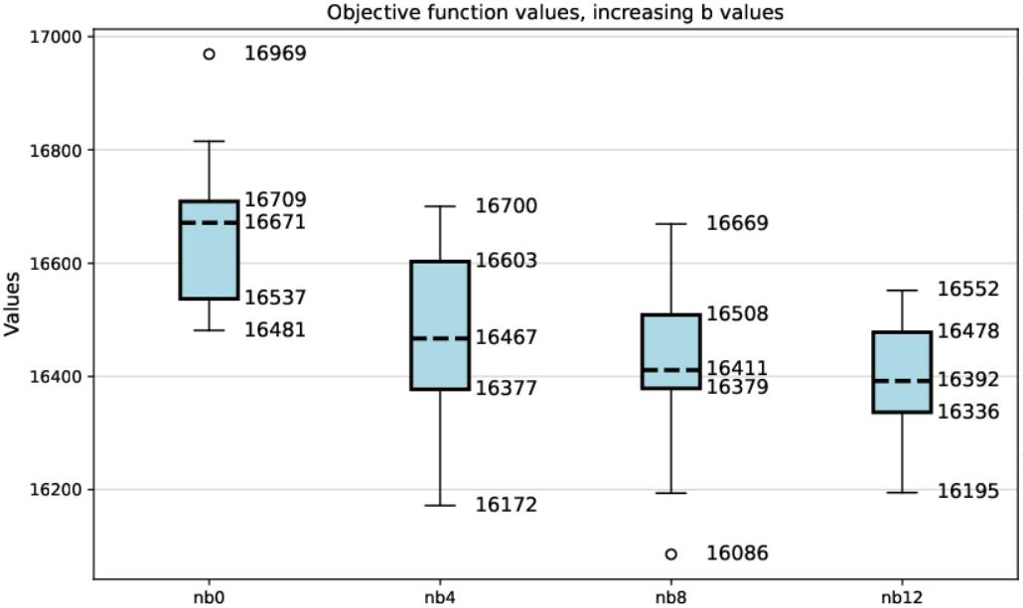
X.XX, Y.YY: Bootstrap Enhanced Scenario Optimization
24 Article submitted to Operations Research
The clients to be split are chosen from the most requesting clients. We ran a series of tests based
on 75 series boostsets, allowing the 0, 4, 8, and 12 most requesting clients to be split. Figure 6
shows the corresponding boxplots.
Figure 6 Allocation cost for increasing number of splittable clients
Allowing a service to be split for a client is a partial relaxation of the corresponding assignment
constraint, so the expected optimal cost is lower. This can indeed be seen in ﬁgure 6, where the
more clients that are permitted to split, the lower all distribution moments become. However, the
marginal decrease becomes smaller as the number of clients who can split increases, since splitting
a small client may result in only a small contribution, if any.
Impact of diﬀerent inventory cost assumptions A further set of tests was conducted to
determine the impact of inventory costs ꢙ_{ꢌ}, ꢌ ∈ ꢖ on the search process. Recall that in the original
case study, one of the objectives was to determine how much space should be rented in the only
DC not owned by the company, where storage space needs to be leased. The case study reported in
Maniezzo and Zhou (2023) did not include storage costs. Here, we consider storage costs that are
inversely proportional to the average distance of the DC from the stores. We consider three settings,
one with no storage costs, one where only the most distant DC incurs costs, and one where all DCs
need to lease space. Costs are proportional to the quantities stored and are therefore inﬂuenced by
the allocation policy.
All the tests were performed using the 75-series BoostSet. The focus of the analysis is not on the
increase in optimal costs, since an increase in the costs of the decision variables clearly leads to
an increase in the total costs. Rather, the focus is on the variation in the complexity of the search,
as reﬂected in the CPU time required to reach the ﬁnal result, and on the optimality or feasibility


X.XX, Y.YY: Bootstrap Enhanced Scenario Optimization
Article submitted to Operations Research 25
ꢋ ꢔ ꢋ_{ꢆꢫꢫꢟꢈ} ꢋ_{ꢛ} ꢋ_{ꢌꢋ ꢁ} GAP GAP t.CPU
lin ﬁn
52 4 75 0 0 0.01 0.00 333.95
52 4 75 1 1 0.18 0.17 600
52 4 75 1 0 0.15 0.14 1200
52 4 75 1 0 0.14 0.13 3600
52 4 75 2 0 0.04 0.04 600
52 4 75 2 0 0.01 0.03 1200
52 4 75 2 0 0.01 0.03 3600
52 4 75 3 0 0.01 0.00 211.03 52 4 75 4 0 0.01 0.00 13.00
Table 2 Gap and CPU time for increasing number of leased servers.
of the solutions. To evaluate the eﬀectiveness of increasingly lengthy searches, we present results
after 600, 1200, and 3600 seconds of CPU time.
The results are summarized in the table 2. All results are based on 15 repetitions, and the columns
show:
• ꢋ: number of clients (stores);
• ꢔ: number of servers (DCs);
• ꢋ_{ꢆꢫꢫꢟꢈ}: number of series in the boostset;
• ꢋ_{ꢛ}: number of servers incurring leasing costs;
• ꢋ_{ꢌꢋ ꢁ} : number of infeasible solutions at the end of the search;
• GAP lin: average gap between the linear bound and the best solution at the end of the search;
• GAP ﬁn: average gap between the best lower bound and the best solution at the end of the
search;
• t.CPU: average CPU time (in sec) of the search process.
Table 2 illustrates an interesting feature of the ﬁtness landscape of this split-cost allocation
problem: the complexity of the search is not monotonic with respect to the number of leased servers.
In fact, CPLEX was able to solve all instances to optimality for 0, 3 and 4 leased servers. However,
for 1 or 2 leased servers, it was never able to prove the optimality of the best solution found within
the time limit of 3600 seconds. Furthermore, instances with one leased server are more challenging
than those with two, as demonstrated by the gap between the lower and upper bounds, both between
the linear relaxation bound and the best solution found and between the best lower bound at the end
of the search and the best solution. This feature is discussed further in subsection B.

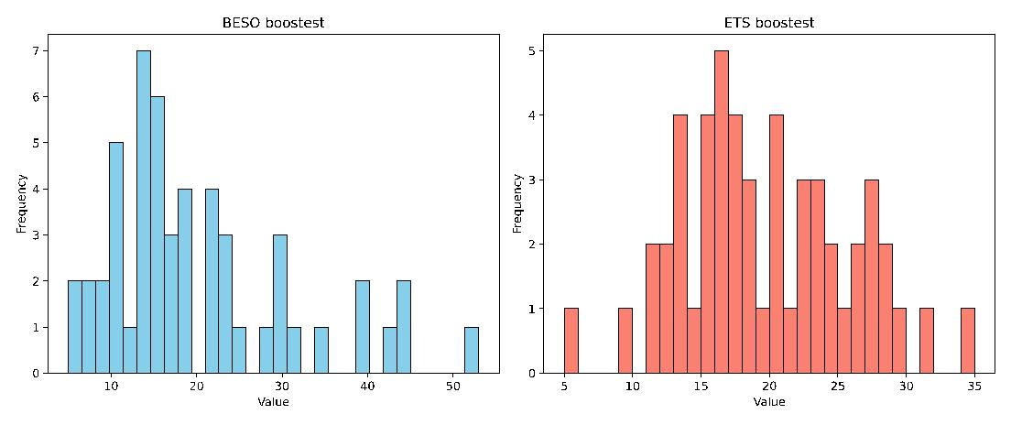
X.XX, Y.YY: Bootstrap Enhanced Scenario Optimization
26 Article submitted to Operations Research
As a ﬁnal note, we point out that the objective function was structured to lexicographically ﬁrst
strive for feasibility and then optimize within the feasible domain. In fact, all instances have always
resulted in feasible solutions. Reducing the cost coeﬃcient of the request slack variables allows us
to explore the trade-oﬀ between solution cost and the probability of reaching an infeasible solution.
However, we did not explore this further.
Test case solution To further evaluate the beneﬁts of the proposed approach, we compared the
eﬀectiveness of the robust, BESO-optimized solution with that obtained using a parametric method
which assumed a Gaussian distribution of forecasts from the request datasets. This comparison was
conducted using scenarios derived from a Gaussian distribution based on the conﬁdence intervals
of the forecasts provided by an Holt-Winters ETS model (Hyndman et al. 2008).
Figure 7 shows the distributions of the forecasts of the 75 boostset obtained by BESO and by
ETS. Note that the BESO distribution, given its MEB foundation, spans a wider range of values
than the ETS distribution.
Figure 7 Comparison of distributions on 75 bootstrapped series
The wider distribution has an impact on the proposed allocation. We had empirical proof of this
when we tested the BESO and ETS solutions on the validation data obtained by the end of the year
— i.e. when we ﬁnally received the data for which we were asked to provide a forecast.
Table 3 presents a comparison of solutions in the ﬁrst two columns when no rental cost was added
for the use of leased ﬂoor space and in the last two columns when the rental cost was included in the
objective function. As expected, given that the constraints were less restrictive, the ETS solution
is less expensive in both cases. However, in both cases, the solution was infeasible as it did not
provide all the goods requested by one of the retailers. This result was obtained in a single instance;
therefore, it may not have happened. However, it is signiﬁcant that, even in the ﬁrst instance in
which we tested our model, its robustness proved important in dealing with a limit case.



X.XX, Y.YY: Bootstrap Enhanced Scenario Optimization
Article submitted to Operations Research 27
No rental cost With rental cost
BESO ETS BESO ETS
Assign. Cost 17781 15423 5446720 4378380
Optimality gap% 0 0 16.07 0.69
Infeasibilities 0 1 0 1
t.Cpu 33 29 3600 3600
Table 3 Solution cost with and without rental cost
No rental cost With rental cost
BESO ETS BESO ETS
DC 0 67 / 120 119 / 120 82 / 120 116 / 120
DC 1 571 / 1000 430 / 1000 532 / 1000 428 / 1000
DC 2 257 / 300 301 / 300 257 / 300 303 / 300
DC 3 128 / 180 173 / 180 152 / 180 176 / 180
Table 4 DC usage with and without rental cost
Table 4 details the proposed usage of the DCs in the diﬀerent cases. It appears that DC 2, the
biggest owned one, is the overloaded one in both cases, even though by small amounts.
Finally, we note that Table 3 shows that including the rental cost makes otherwise identical
instances much harder to solve. In fact, the time limit of 3600 CPU seconds was too short to reach
optimality, and a duality gap was left in the proposed solutions, a substantial one in the case of the
BESO instance.
7. Conclusions and future directions
This paper introduced Bootstrap Enhanced Scenario Optimization (BESO), a general framework for
prescriptive analytics under uncertainty, demonstrated through a two-echelon logistics case study.
The method integrates a statistically principled forecasting engine with scenario-based optimization,
using bootstrapped autoregressive time series to model future retailer requests and guide the
allocation of stores to distribution centers (DCs). By capturing the empirical dynamics embedded
in historical data, BESO supports the derivation of inventory requirements, DC capacity decisions,
and allocation strategies that reﬂect both cost structures and forecast uncertainty.
A key contribution of BESO lies in oﬀering a credible alternative to prevailing Distributionally
Robust Optimization (DRO) methodologies. Classical DRO approaches rely on ambiguity sets
deﬁned through moment bounds, Wasserstein balls, or ꢀ-divergences, which—while theoretically

X.XX, Y.YY: Bootstrap Enhanced Scenario Optimization
28 Article submitted to Operations Research
elegant—often impose distributional geometry that does not match real empirical patterns, espe-
cially when the data exhibit nonstationarity, heavy tails, or structural breaks. In contrast, BESO
avoids the explicit construction of ambiguity sets by directly generating empirical scenario dis-
tributions through the Maximum Entropy Bootstrap (MEB). Moreover, the framework allows for
a lightweight objective-aware extension of MEB, in which elements derived from downstream
optimization costs can be incorporated into the entropy-maximization step, thereby biasing the
resampling distribution toward patterns that are more related to decision quality. This produces
scenario sets that are simultaneously statistically coherent, temporally realistic, and operationally
aligned, thus oﬀering a data-centric and computationally transparent alternative to conventional
DRO formulations.
Through both real transportation logistics data and controlled artiﬁcial instances, we showed
how BESO yields interpretable and robust prescriptions. The artiﬁcial benchmarks further revealed
how instance complexity evolves with volatility, seasonality, or spatial conﬁguration, illustrating
the framework’s adaptability to diverse uncertainty environments. These ﬁndings highlight that
integrating forecasting and optimization within a uniﬁed empirical pipeline is not merely conve-
nient—it can materially improve solution stability and operational performance relative to classical
scenario-generation or DRO-based approaches.
Several promising research directions emerge. Future work could explore incorporating MEB
into preprocessing pipelines, such as Box–Cox transformations, to enhance predictive accuracy.
Ensemble strategies—including weighted or Bayesian model averaging—may strengthen robust-
ness in environments with shifting dynamics. On the methodological level, deeper investigation
into bootstrap-driven ambiguity representations could position BESO as a fully data-implicit alter-
native to DRO, retaining robustness while avoiding restrictive geometric assumptions. Finally, the
closure properties of the MEB framework open the door to hybrid schemes that integrate exter-
nal knowledge or Bayesian priors, while further reﬁning the incorporation of optimization-aware
signals within the resampling process.
Overall, BESO expands the methodological toolkit for decision-making under uncertainty by
providing a data-driven alternative to classical DRO, one that captures empirical temporal structure,
enables mild but meaningful decision-awareness, and remains computationally accessible in real
operational settings.

X.XX, Y.YY: Bootstrap Enhanced Scenario Optimization
Article submitted to Operations Research 29
Appendix A: Bootstrap sets error costs
This section reports the absolute values of the various cost functions, which were calculated using
the forecast errors obtained by averaging the corresponding errors for each of the 52 test case series
described in the paper.
model bias MAPE ME MAE MPE RMSE
fcast_50 -0.27 0.09 -1.02 1.63 -0.05 2.12
fcast_avg 0.02 0.07 0.07 1.25 0.01 1.68
yar 0.36 0.34 1.36 5.86 0.07 9.75
yhw 0.63 0.34 2.41 5.99 0.13 10.59
ysvm 0.69 0.36 2.66 6.20 0.14 10.99
ylstm 0.56 0.35 2.13 6.01 0.11 10.41
ymlp 0.47 0.36 1.79 6.26 0.09 10.60
yrf 1.50 0.44 5.73 7.79 0.31 13.54
yxgb 2.28 0.58 8.74 10.12 0.49 17.05
yarima 0.44 0.34 1.67 5.80 0.09 9.77
Table 5 Error costs for the 75 series boostset.
model bias MAPE ME MAE MPE RMSE
fcast_50 -0.56 0.09 -1.08 1.59 -0.06 2.25
fcast_avg 0.02 0.07 0.05 1.18 0.01 1.65
yar -0.59 0.25 -1.13 4.36 -0.07 6.31
yhw -0.13 0.24 -0.26 4.33 -0.02 6.39
ysvm -0.06 0.24 -0.11 4.18 -0.01 6.39
ylstm -0.30 0.24 -0.58 4.15 -0.04 6.34
ymlp -0.47 0.24 -0.90 4.22 -0.05 5.99
yrf 1.27 0.28 2.44 5.01 0.14 7.48
yxgb 2.52 0.38 4.85 6.52 0.28 9.46
yarima -0.40 0.25 -0.76 4.44 -0.05 6.83
Table 6 Error costs for the 125 series boostset.
The functions reported in the columns are: bias, Means Absolute Percentage Error (MAPE),
Mean Error (ME), Mean Absolute Error (MAE), Mean Percentage Error (MPE) and Root Mean
Square Error (RMSE). Table 5 gives the cost values for the case of a boost set composed of 75
series, table 6 for the 125 series and table 7 for the 175 series sets.
All tables show signiﬁcantly consistent results across all boost set sizes.
Appendix B: Extended deterministic benchmark set
All analyses reported in sections 6.1 and 6.2 refer to the case study at the heart of this paper, but
the interest of the method is not limited to this particular case study as it can be eﬀective on any
instance of this 2-echelon supply chain problem. To test the generality of the results, we generated

X.XX, Y.YY: Bootstrap Enhanced Scenario Optimization
30 Article submitted to Operations Research
model bias MAPE ME MAE MPE RMSE
fcast_50 -0.04 0.07 -0.07 1.22 0 1.51
fcast_avg 0.99 0.12 1.90 2.04 0.12 2.76
yar -0.22 0.35 -0.42 5.84 -0.03 7.64
yhw 0.25 0.34 0.48 5.75 0.02 7.90
ysvm 0.30 0.33 0.58 5.66 0.03 7.76
ylstm 0.10 0.34 0.20 5.76 0 7.74
ymlp -0.19 0.34 -0.36 5.69 -0.02 7.57
yrf 1.72 0.37 3.31 6.39 0.18 9.66
yxgb 3.01 0.46 5.78 7.96 0.33 11.83
yarima -0.04 0.34 -0.08 5.69 -0.01 7.63
Table 7 Error costs for the 175 series boostset.
a benchmark set with varying dimensions and coeﬃcients. The study was conducted only with
respect to the deterministic setting, and is therefore signiﬁcant for assessing the computational
complexity of the split-allocation problem as a deterministic combinatorial optimization problem.
We generated 5 instances for each conﬁguration of number of clients (ꢋ), number of servers
(ꢔ), and number of splittable clients. The travel costs were obtained by randomly selecting ꢔ
rows and ꢋ columns from a large distance matrix, whose values were computed as the actual road
distances between points located in the same area as the test case. Server inventory costs were
inversely proportional to the average travel cost from the server to the clients and client requests
were inversely proportional to the average travel cost from the client to the servers. Note that the
distance matrix is asymmetric, as it was computed within a city area. The number ꢋ_{ꢆ} of splittable
clients was progressively increased as the number ꢋ_{ꢛ} of servers with nonzero inventory costs.
Speciﬁcally, the range of the deﬁning parameters were:
• ꢋ: {50, 52, 100, 200, 300};
• ꢔ: {4, 5, 10, 25, 50};
• ꢋ_{ꢆ}: {0, 4, 5, 10, 25, 50}
• ꢋ_{ꢛ}: {0, 1, 2, 3, 4, 5}
Not all combinations of values were generated, the larger values were used only for instances with
higher number of clients. In particular, the values 4 and 52 were only used to generate instances with
the same dimensionality as the case study, in order to check the generality of the results obtained.
The ﬁrst instance of this set was kept to be the case study one.
The computational results in the case of no costly server, reported as averages over the 5 generated
instances, are summarized in table 8, whose columns show:
• ꢋ, ꢔ: number of clients and number of servers;

X.XX, Y.YY: Bootstrap Enhanced Scenario Optimization
Article submitted to Operations Research 31
• ꢋ_{ꢆ}: maximum number of splittable clients;
• ꢋꢗꢫꢩꢟ, ꢋꢚꢫꢨꢟ: number of columns and number of rows in formulation FD;
• ꢒꢦꢊꢩꢆ: average percentage gap between the linear relaxation lower bound and the cost of the
best solution found;
• ꢒꢦꢊ ꢁ ꢌꢋꢦꢩ: average percentage gap between the best lower bound at the end of the search
(smallest cost of an unexpanded node) and the cost of the best solution found;
• ꢋꢌꢋ ꢁ : number of instances for which no feasible solution was found;
• ꢋꢫꢊꢈ: number of instances solved to proven optimality;
• ꢈꢗꢊꢬ: average CPU time for solving the instance, time to optimality or 3600 if optimality could
not be proven;
The table shows two trends. One, with respect to instance size, shows an expected increase in
complexity. While instances the size of our test case are easily solved to optimality by modern
solvers, increasing the size, as deﬁned by the number of variables and the number of constraints,
quickly leads to instances that could not be solved to optimality within the 3600-second time limit.
The number of splittable clients has an important eﬀect on the complexity of the instance. Instances
of the same absolute size, but with more splittable clients, usually have a looser linear relaxation
(LP) bound and have more diﬃculty reaching optimality, as can be seen by the decreasing number
of instances out of the 5 from each group that could be solved to optimality.
Note that the optimality gap of the LP bound is usually small, except for the ꢋ=100 and ꢔ=50
instances, but the search still struggles to close this gap. Interestingly, the LP bound gets tighter as
ꢋ increases, but this does not make the search any easier. The least-cost solution when optimality
was not proven was usually found within the ﬁrst 600 seconds of CPU time. However, we note that
designing eﬃcient heuristics for this problem is beyond the scope of this research. We could have
tweaked the solver conﬁguration to favor heuristic search at the expense of eﬃciency in proving
optimality, or designed custom heuristics, but the focus here is on assessing the ﬁtness landscape
when road network costs are involved.
Table 9 reports results about tests varying the number of costly servers, the columns show:
• ꢋ, ꢔ: number of clients and number of servers;
• ꢋꢗꢫꢩꢟ, ꢋꢚꢫꢨꢟ: number of columns and number of rows in formulation FD;
• lb0, t0: linear relaxation bound and CPU time in the case of no costly servers;
• lb1, t1: linear relaxation bound and CPU time in the case of 1 costly server;
• lb2, t2: linear relaxation bound and CPU time in the case of 2 costly servers;

X.XX, Y.YY: Bootstrap Enhanced Scenario Optimization
32 Article submitted to Operations Research
ꢋ ꢔ ꢋ_{ꢆ} ꢋꢗꢫꢩꢟ ꢋꢚꢫꢨꢟ ꢒꢦꢊꢩꢆ ꢒꢦꢊ ꢁ ꢌꢋꢦꢩ ꢋꢌꢋ ꢁ ꢋꢫꢊꢈ ꢈꢗꢊꢬ
52 4 0 416 316 0.21 0.01 0 5 0
50 5 0 500 355 0.39 0.00 0 5 3
50 5 5 500 355 0.40 0.00 0 5 4
50 10 0 1000 610 1.32 0.00 0 5 383
50 10 5 1000 610 1.34 0.00 0 5 378
50 10 10 1000 610 1.35 0.13 0 4 1150
100 10 0 1000 1210 0.50 0.12 0 2 1920
100 10 5 1000 1210 0.54 0.05 0 3 1514
100 10 10 1000 1210 0.57 0.09 0 3 2063
100 50 0 10000 5250 5.23 3.06 0 0 3600
100 50 5 10000 5250 4.77 2.70 0 0 3600
100 50 10 10000 5250 4.55 2.42 0 0 3600
100 50 25 10000 5250 4.52 2.61 0 0 3600
200 10 0 4000 2410 0.17 0.05 0 2 2369
200 10 5 4000 2410 0.17 0.09 0 1 2893
200 10 10 4000 2410 0.18 1.01 0 0 3600
200 50 0 20000 10450 1.66 1.26 0 0 3600
200 50 10 20000 10450 1.68 1.29 0 0 3600
200 50 25 20000 10450 1.71 1.37 0 0 3600
300 10 0 6000 3610 0.09 0.03 0 3 1798
300 10 5 6000 3610 0.09 0.07 0 0 3600
300 10 10 6000 3610 1.02 0.47 0 0 3600
300 50 0 30000 15650 0.94 0.73 0 0 3600
300 50 10 30000 15650 0.93 0.76 0 0 3600 300 50 25 30000 15650 0.96 0.84 0 0 3600
Table 8 Extended benchmark set, deterministic case, no costly server
• lb3, t3: linear relaxation bound and CPU time in the case of 3 costly servers;
• lb4, t4: linear relaxation bound and CPU time in the case of 4 costly servers;
• lb5, t5: linear relaxation bound and CPU time in the case of 5 costly servers;
The table reports results on two sets of instances. The top 4 rows contain aggregate results on a
set of instances, 5 for each conﬁguration, where inventory costs are directly proportional to average
travel distances, while the bottom 4 rows have inventory costs inversely proportional to average
travel distances.
The complexity of solving instances increases non-monotonically with the number of costly
servers, for both increasing and decreasing inventory costs. While the 0-cost instances are com-
paratively easy to solve, the CPU time required to prove optimality increases with the addition of
the ﬁrst costly servers and then decreases as more servers are paid to store inventory. However,


X.XX, Y.YY: Bootstrap Enhanced Scenario Optimization
Article submitted to Operations Research 33
n m ncols nrows lb0 t0 lb1 t1 lb2 t2 lb3 t3 lb4 t4 lb5 t5
52 4 416 316 0.86 0.2 0.17 0.81 0.08 0.22 0.01 0.02 0.00 0.02 - -
50 5 500 355 1.33 0.06 2.77 0.06 1.46 0.13 0.11 14.31 0.06 7 0.05 0.93
100 5 1000 705 0.41 0.24 0.09 6.39 0.06 3.2 0.01 0.06 0.02 4.8 0.02 2.71
200 5 2000 1405 0.14 1.43 0.01 1.79 0.01 0.25 0.01 0.17 0.01 0.11 0.01 7.84
52 4 416 316 0.86 0.36 0.24 0.22 0.22 0.14 0.26 0.09 0.05 1.9 - -
50 5 500 355 1.33 0.16 0.52 0.07 0.50 5.8 0.13 10.11 0.05 1.37 0.02 0.22
100 5 1000 705 0.41 0.33 0.19 8.58 0.04 6.14 0.02 0.41 0.02 0.58 0.02 3.78
200 5 2000 1405 0.14 1.55 0.07 39.07 0.04 9.44 0.01 0.12 0.02 4.48 0.01 6.66
Table 9 Extended benchmark set, deterministic case, increasing number of costly servers
this is not true of the gap between the linear relaxation bound and the cost of the optimal solution,
where the instances with no costly servers always have the largest gap. As expected, the CPU time
required to prove optimality increases with the dimension of the case, and the case with an inverse
correlation between storage cost and travel cost is more diﬃcult to solve than the case with a positive
correlation.
References
Aviv Y (2001) The eﬀect of collaborative forecasting on supply chain performance. Management Science 47(10):1326–
1343.
Bayraksan G, Morton DP (2011) A sequential sampling procedure for stochastic programming. Operations research
59(4):iii–1058.
Beale EML (2018) On minimizing a convex function subject to linear inequalities. Journal of the Royal Statistical
Society: Series B (Methodological) 17(2):173–184.
Ben-Tal A, Nemirovski A (1998) Robust convex optimization. Mathematics of Operations Research 23(4):769–805.
Berger J (1985) Statistical Decision Theory and Bayesian Analysis (Springer).
Bertsimas D, Kallus N (2019) From predictive to prescriptive analytics. Management Science 66(3):1025–1044, URL
http://dx.doi.org/10.1287/mnsc.2018.3253.
Bertsimas D, Sim M (2004) The price of robustness. Operations Research 52(1):35–53.
Beyrouthy C, Burke EK, Landa-Silva D, McCollum B, McMullan P, Parkes AJ (2007) The teaching space allocation
problem with splitting. Burke EK, Rudová H, eds., Practice and Theory of Automated Timetabling VI, 228–247
(Springer, Heidelberg).
Brockwell PJ, Davis R (1991) Time Series: Theory and Methods (Springer).
Clark A, Scarf H (1960) Optimal policies for a multi-echelon inventory problem. Management Science 6(4):475–490.
Dantzig G (1955) Linear programming under uncertainty. Management Science 1(3-4):197–206.
Davison AC, Hinkley DV (1997) Bootstrap Methods and Their Application (Cambridge University Press), ISBN
9780521573133.

X.XX, Y.YY: Bootstrap Enhanced Scenario Optimization
34 Article submitted to Operations Research
de Kok T, Grob C, Laumanns M, Minner S, Rambau J, Schade K (2018) A typology and literature review on stochastic
multi-echelon inventory models. European Journal of Operational Research 269(3):955–983.
Delage E, Ye Y (2010) Distributionally robust optimization under moment uncertainty with application to data-driven
problems. Operations Research 58(3):595–612.
Donti P, Amos B, Kolter JZ (2017) Task-based end-to-end model learning in stochastic optimization. Guyon I, Luxburg
UV, Bengio S, Wallach H, Fergus R, Vishwanathan S, Garnett R, eds., Advances in Neural Information Processing
Systems, volume 30 (Curran Associates, Inc.).
Dror M, Trudeau P (1989) Savings by split delivery routing. Transportation Science 23(2):141–145.
Efron B (1979) Bootstrap methods: Another look at the jackknife. The Annals of Statistics 7(1):1–26.
Efron B, Tibshirani RJ (1993) An Introduction to the Bootstrap (Chapman and Hall/CRC).
Elmachtoub AN, Grigas P (2022) Smart “predict, then optimize”. Management Science 68(1):9–26, ISSN 0025-1909,
URL https://doi.org/10.1287/mnsc.2020.3922.
Eppen G, Schrage L (1981) Centralized ordering policies in a multi-warehouse system with lead times and random
demand. Schwarz L, ed., Multi-Level Production/Inventory Control Systems, 51–69 (North Holland).
Ernst A, Krishnamoorthy M (1998) Exact and heuristic algorithms for the uncapacitated multiple allocation p-hub
median problem. European Journal of Operational Research 104(1):100–112.
Escorcia-Caballero J, Amaya-Mier R, Soto-Ferrari M, Chams-Anturi O (2020) Multi-echelon inventory management
policies: A case study for a two-echelon supply chain. proc. International Conference on Industrial Engineering
and Operations Management, 165–175.
Esfahani PM, Kuhn D (2017) Data-driven distributionally robust optimization using the wasserstein metric: Perfor-
mance guarantees and tractable reformulations. URL https://arxiv.org/abs/1505.05116.
Fairbrother J, Turner A, Wallace SW (2018) Scenario generation for single-period portfolio selection problems with tail
risk measures: Coping with high dimensions and integer variables. INFORMS Journal on Computing 30(3):472–
491.
Feliu JM (2024) Enhancing demand forecasting: an analysis of factors impacting sales and implementation of improved
methodologies for accurate prediction. B.S. thesis, Universitat Politècnica de Catalunya.
Fenga L, Politis D (2011) Bootstrap-based arma order selection. Journal of Statistical Computation and Simulation .
Fenga L, Politis DN (2013) Bootstrap order selection for setar models. Journal of Statistical Computationand Simulation
83(8):1749–1762.
Fenga L, Politis DN (2017) Lasso order selection for sparse autoregression: a bootstrap approach. Journal of Statistical
Computation and Simulation 87(2):319–334.
Hammersley J (1960) Monte carlo methods for solving multivariable problems. Annals of the New York Academy of
Sciences 86(3):844–874.

X.XX, Y.YY: Bootstrap Enhanced Scenario Optimization
Article submitted to Operations Research 35
Hasni M, Aguir M, Babai MZ, Jemai Z (2019) Spare parts demand forecasting: a review on bootstrapping methods.
International Journal of Production Research 57(15-16):4791–4804.
Hyndman R, Koehler A, Ord J, Snyder R (2008) Forecasting with Exponential Smoothing: The State Space Approach
(Switzerland: Springer), ISBN 9783540719168.
Jaynes E (1957) Information theory and statistical mechanics. Physical Review 106(4):620–630.
Keneley MJ, Van Der Zwaan B (2002) Demand forecasting and inventory control: A zero-inﬂated approach. European
Journal of Operational Research .
Kim D, Kim S (2010) A multi-echelon inventory model for supply chain management using the supply hub in industrial
park (ship) concept. International Journal of Production Economics 123(1):1–12.
Kreiss JP, Lahiri SN (2012) Bootstrap methods for time series. Handbook of statistics, volume 30, 3–26 (Elsevier).
Ma Z, Li H, Wang Y (2015) Combining forecasts in supply chain forecasting: A review. Omega .
Maniezzo V, Boschetti M, Stützle T (2021) Matheuristics, algorithms and implementations. EURO Advanced Tutorials
on Operational Research. Springer (New York: Springer International Publishing).
Maniezzo V, Zhou T (2023) Integrated forecast and optimization for retailer allocation in a two-echelon inventory
system. Bringas P, et al, eds., proc. of 18th Int. Conf. on Soft Computing Models in Industrial and Environmental
Applications (SOCO 2023), volume 749 of Lecture Notes in Networks and Systems, 279 – 289 (Springer).
Marín A (2005) Formulating and solving splittable capacitated multiple allocation hub location problems. Computers
& Oper. Research 32(12):3093–3109.
Mokhtar H, Krishnamoorthy M, Ernst AT (2019) The 2-allocation p-hub median problem and a modiﬁed benders
decomposition method for solving hub location problems. Computers & Operations Research 104:375–393.
Papier F (2016) Supply allocation under sequential advance demand information. Operations Research 64(2):341–361.
Römisch W (2018) Stochastic Programming, Scenario Generation In, 1–5 (John Wiley and Sons, Ltd), ISBN
9781118445112, URL http://dx.doi.org/https://doi.org/10.1002/9781118445112.stat08075.
Sarris D, Spiliotis E, Assimakopoulos V (2020) Exploiting resampling techniques for model selection in forecasting:
an empirical evaluation using out-of-sample tests. Operational Research 20(2):701–721.
Scikit (2024) posthocs critical diﬀerence diagram. Https://scikit-posthocs.readthedocs.io/en/latest/generated/
scikit_posthocs.critical_diﬀerence_diagram.html.
Shannon C (1948) A mathematical theory of communication. Bell System Technical Journal 27(3):379–423.
Shapiro A, Dentcheva D, Ruszczyński A (2009) Lectures on Stochastic Programming: Modeling and Theory (SIAM).
Shapiro A, Homem-de Mello T (1998) A simulation-based approach to two-stage stochastic programming with recourse.
Mathematical Programming 81:301–325.
Shenstone AG, Dekker R (2001) A literature review on approaches to the forecasting of intermittent demand. Jou. of
the Oper. Research Society .

X.XX, Y.YY: Bootstrap Enhanced Scenario Optimization
36 Article submitted to Operations Research
Suman D (2024) Deep Learning Methods for Demand Time Series Forecasting. Master’s thesis, Aalto Unniversity.
Syntetos AA, Boylan JE (2005) Demand forecasting and inventory control for intermittent demand using a weighted
moving average approach. International Journal of Production Economics .
Van Kampen T, Akkerman R, Donk D (2012) Sku classiﬁcation: A literature review and conceptual framework.
International Journal of Operations and Production Management 32(7):850–876.
Vinod HD, Kourentzes N (2006) Maximum entropy bootstrap for predictive inference. Journal of Forecasting 25(1):49–
63.
Wilder B, Dilkina B, Tambe M (2019) Melding the data-decisions pipeline: decision-focused learning for
combinatorial optimization. Proceedings of the Thirty-Third AAAI Conference on Artiﬁcial Intelligence,
AAAI’19/IAAI’19/EAAI’19 (AAAI Press), ISBN 978-1-57735-809-1.
Youngjin K, Youngho L, Junghee H (2011) A splitter location–allocation problem in designing ﬁber optic access
networks. European Journal of Operational Research 210(2):425–435, ISSN 0377-2217.
Zhu S, Hu X, Huang K, Yuan Y (2021) Optimization of product category allocation in multiple warehouses to minimize
splitting of online supermarket customer orders. Eur. Jou. of Oper. Research 290(2):556–571.

