
TOBB ETU
Economy & Technology University
BIL 495 / YAP 495
System Architecture Document (SAD)
Reference: IEEE 42010 / INCOSE SE Handbook 5th Ed.

Document Control Table
Document Title | Project Closure Report
Document ID | (To be assigned)
Prepared By (Author) | manifetch
Reviewed By
Approved By
Preparation Date | 19.11.25
Approval Date
Version / Revision | 1.0
Confidentiality Level | Internal / Restricted / Public
Reference Standards | IEEE 15288, IEEE 12207, INCOSE SE Handbook v5

Change Record (Revision History Table)
Revision | Date | Prepared By | Reviewed/Approved By | Description of Change
1.0 | 19.11.25 | manifetch | (Approver) | Initial Release
1.1 |  |  |  | Minor editorial updates
1.2 |  |  |  | Added stakeholder feedback section

1. Introduction
2. System Context
3. Architectural Views
3.1 Logical View
3.2 Process View
3.3 Physical View
3.4 Development View
4. Design Decisions
5. Compliance and Standards
6. Appendix
7. References

1. Introduction
This Software Architecture Document (SAD) describes the design and structure of the NICU Clinical Dashboard, a web-based system developed to monitor neonatal physiological signals, apply AI-assisted anomaly detection, and present real-time information to clinicians. The purpose of this document is to define how the system’s components interact, how data flows across the platform, and how the system meets its functional goals such as real-time monitoring, alerting, AI evaluation, patient management, and secure access control.
The platform is designed as a cloud-based system that can be deployed in both single-hospital and multi-hospital scenarios, allowing multiple NICUs from different healthcare institutions to securely access the system through a shared infrastructure.
The architecture follows a layered design and is built around a single central interaction model illustrated in the System Context Diagram. This diagram reflects the flow of information between major platform elements: IoMT devices, backend services, AI module, database layer, and the clinician-facing dashboard.

2. System Context

2.1 System Boundary
The NICU platform operates between multiple external and internal entities that exchange physiological data, clinical insights, and user interactions. The system boundary includes:
- IoMT sensors / simulated NICU devices — provide real-time streams of physiological signals (e.g., SpO₂, ECG, respiration).
- Backend API Layer — receives device data, handles authentication, applies business logic, communicates with AI module and database.
- AI Module — processes filtered datasets and generates anomaly predictions and risk scores.
- Frontend UI — displays real-time vitals, alerts, and patient information to clinicians.
- Database — stores patient information, time-series measurements, AI results, and audit logs.
- Hospital Organizations — represent individual healthcare institutions that host one or more NICUs and access the platform through hospital-scoped authentication and authorization mechanisms.

These elements define what is inside and outside the system’s operational environment.

2.2 External Actors

Actor | Role
Clinicians & Nurses | View real-time vitals, interpret alerts, make clinical decisions
Administrators | Manage user roles, access permissions, and configurations
Hospital IT Staff | Maintain secure network connectivity
Biomedical Engineers | Maintain device–platform communication
IoMT Devices / Simulators | Provide continuous data streams
Hospital Organization | Represents a healthcare institution that owns NICU units and defines data access boundaries

2.3 System Context Diagram
The overall relationship between these actors and system components is illustrated in Figure A.1 (Appendix).
This diagram is the primary architectural visual for this document.
Note: The same system context applies to both single-hospital and multi-hospital deployments. In multi-hospital scenarios, all interactions are scoped by hospital identifiers.

3. Architectural Views

3.1 Logical View
The logical architecture is composed of five key layers. These layers represent the system’s internal structure and how responsibilities are distributed across components.
Primary Logical Components
Layer | Components | Responsibilities
IoMT Integration Layer | MQTT Listener, HL7/FHIR Parser | Receives and validates physiological data, forwards device data to backend
Backend Layer | REST API, Auth & RBAC Service, Data Controller | Handles routing, data processing, authentication, authorization, alert logic, and interactions with AI/database
AI Module | Preprocessing Engine, Prediction Engine | Analyzes physiological inputs, detects anomalies, outputs risk levels
Frontend Dashboard | UI Components, Charts, Alerts, Reports | Provides real-time visualization and clinician interaction interfaces
Database Layer | Patient DB, Time-Series Storage, Logs | Stores patient profiles, historical data, alerts, audit trails

Logical Functional Grouping
- Visualization Module — Displays SpO₂, ECG, and respiration trends
- AI Decision Module — Performs anomaly prediction
- Alerting Module — Threshold evaluation and alarm generation
- User Access Module — Implements authentication + role-based access control
- Report Module — Generates PDF summaries
- Data Persistence Module — Manages long-term patient and signal storage

3.2 Process View
All incoming data and user requests are tagged with a hospital identifier, ensuring that data processing, AI analysis, and visualization are performed within the corresponding hospital scope. This view describes how data flows through the system during typical use:
- IoMT devices publish physiological measurements.
- Backend ingests data, validates structure, timestamps, and stores relevant values.
- Backend forwards selected data to the AI module for analysis.
- AI module preprocesses data and returns anomaly predictions.
- Backend applies threshold checks and produces alerts if necessary.
- Frontend UI receives updates on vitals, alerts, and predictions in real time.
- Clinician actions (patient selection, report requests, navigation) generate API calls.
- Backend retrieves necessary records from the database and returns them to the UI.
This behavior is reflected at a high level in the System Context Diagram, which captures the directional flow of interactions.

3.3 Physical View
The system deployment includes:
- Backend Server:
Hosts REST API, WebSocket endpoints, RBAC logic, alert engine, data handlers.
- AI Module Host:
Runs the preprocessing and model inference code; may operate as a standalone service or a colocated container.
- Database Server:
Stores patient records, time-series signal data, logs, and AI results.
- Client Devices (Clinicians):
Access the dashboard via a secure web interface on workstation, tablet, or mobile browser.
- Internal Network Environment:
Ensures protected communication between backend, AI module, and database.
- Cloud Infrastructure:
Hosts shared backend services, AI modules, and databases that are accessed by multiple hospitals through secure network connections.

3.4 Development View

3.4.1 Repository Structure
The codebase is organized into modular directories to support maintainability and separation of concerns:
backend/ — API logic, authentication, routing, data pipelines, alerting
frontend/ — UI components, routing, charts, visual elements
ai-module/ — preprocessing logic, inference code
configs/ — environment variables, deployment configs
docs/ — project documentation
tests/ — automated testing suites
This structure aligns development responsibilities across system layers.

4. Design Decisions

Layered Architecture: Separates device ingestion, backend orchestration, AI processing, UI rendering, and persistence.
Modular Services: AI is decoupled from the backend for flexibility and scalability.
Real-Time Data Path: WebSockets are used for instantaneous updates to clinicians.
Role-Based Access Control: Ensures secure, tiered system access.
Threshold-Based Alerts: Backend applies clear rules for alert generation.
Responsive Frontend: Dashboard is optimized for multiple screen sizes.
Secure Communication: All communication paths are protected and logged.
Extensible Design: New sensors, new AI models, or new dashboard features can be added without architectural change.

5. Compliance and Standards
The architecture adheres to:
- Secure communication practices
- Layered architectural structure
- Role-based authorization principles
- Responsiveness and accessibility requirements
- Stable data management and logging practices

6. Appendix

Figure A.1 — System Context Diagram:
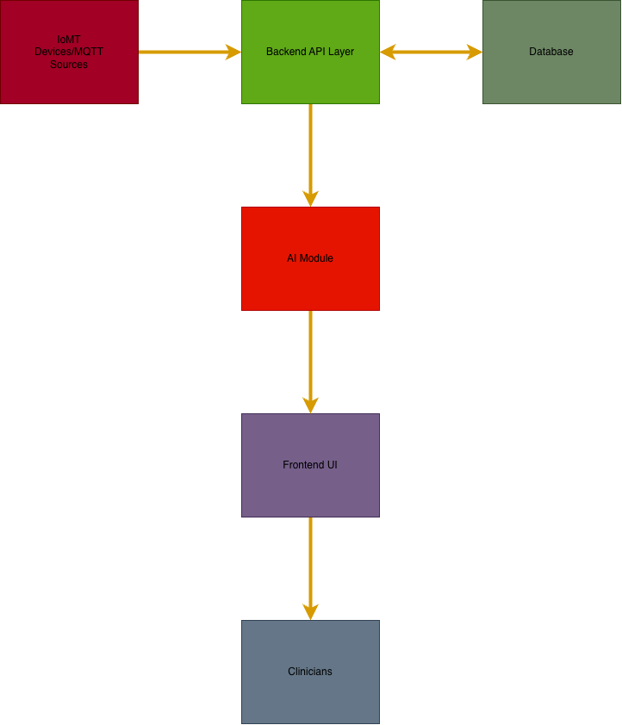

7. References

