
TOBB ETU
Economy & Technology University
BIL 495 / YAP 495

Software Design Description (SDD)
Reference: IEEE 1016-2009

Document Control Table
Document Title | Project Closure Report
Document ID | (To be assigned)
Prepared By (Author) | manifetch
Reviewed By
Approved By
Preparation Date | 17.11.2025
Approval Date
Version / Revision | 1.0
Confidentiality Level | Internal / Restricted / Public
Reference Standards | IEEE 15288, IEEE 12207, INCOSE SE Handbook v5

Change Record (Revision History Table)
Revision | Date | Prepared By | Reviewed/Approved By | Description of Change
1.0 | (Date) | (Author) | (Approver) | Initial Release
1.1 |  |  |  | Minor editorial updates
1.2 |  |  |  | Added stakeholder feedback section

1. Introduction
1.1 Purpose
1.2 Scope
1.3 References
2. System Overview
2.1 System Architecture
2.2 Design Rationale
3. Detailed Design
3.1 Component Descriptions
3.2 Interface Descriptions
3.3 Data Design
3.4 Algorithm Design
4. Traceability

1. Introduction

1.1 Purpose
This Software Design Description (SDD) document provides the design-level details of the NICU Clinical Dashboard system. It refines and implements the requirements defined in the Software Requirements Specification (SRS) by describing:
- The overall software architecture and major subsystems
- The internal structure and responsibilities of each component
- Interfaces between components and external systems
- Data models and storage design
- Core algorithms for data handling and AI-assisted diagnosis
- Traceability between design elements and SRS requirements
manifetch_IEEE_SRS.docx
The main audience of this document includes software architects, developers, testers, academic supervisors, and the industrial partner (Ertunç Özcan Import & Representation).

1.2 Scope
This SDD covers the software design of the NICU Clinical Dashboard prototype, including:
- Real-time acquisition and visualization of neonatal physiological signals (ECG, SpO₂, respiration rate)
- AI-based distress detection for respiratory and cardiac anomalies
- Web-based dashboard for clinicians, nurses, administrators, researchers
- Backend services, IoMT middleware, data storage, and security mechanisms
- Role-based access control and audit logging
It focuses on the prototype scope defined in the PMP and SRS: up to 5–10 concurrent users and simulated / open dataset–based signal sources, with future extension to real IoMT devices. In extended deployments, the design supports both single-hospital and multi-hospital usage through a centralized platform, where data access is scoped by hospital identifiers.

1.3 References
- Project Management Plan (PMP): A Unified Web-Based Platform for Real-Time NICU Signal Monitoring and AI-Assisted Diagnosis /manifetch_IEEE_PMP.docx
- Software Requirements Specification (SRS): NICU Clinical Dashboard /manifetch_IEEE_SRS.docx
- Project Proposal – Manifetch NICU Platform
Proposal_NICU.docx
- Universal Software-Driven Constraint Tracking Form
Universal_SW_Constraint_Trackin…
- IEEE 1016-2009 – Systems and Software Engineering – Software Design Descriptions
- ISO/IEC/IEEE 29148:2018 – Requirements Engineering
- ISO/IEC 25010:2011 – System and Software Quality Models

2. System Overview

2.1 System Architecture

The NICU Clinical Dashboard follows a modular, service-oriented, web-based architecture composed of the following layers:
- IoMT Data Source Layer
  - Real NICU monitoring devices (future work) and/or simulated data generators (BioSPPy, NeuroKit2, PhysioNet datasets).
  - Communication via MQTT, HTTP, or file-based batch import.
- IoMT Middleware & Data Ingestion Layer
  - MQTT broker and ingestion service to receive time-series signals.
  - Normalizes heterogeneous data formats into a unified internal schema.
  - Performs basic validation (CRC / checksum, timestamp validation).
Universal_SW_Constraint_Trackin…
- Backend API & Business Logic Layer
  - Implemented using Python (Flask) or Node.js.
manifetch_IEEE_SRS.docx
  - Exposes RESTful and WebSocket APIs for:
    - Signal streaming to frontend
    - Patient and user management
    - Triggering AI inference and returning predictions
  - Applies role-based authorization and access control.
- AI Module & Analytics Layer
  - Preprocessing, feature extraction, and model inference for respiratory and cardiac distress.
  - Uses Python + AI frameworks (TensorFlow / PyTorch, Scikit-learn).
- Data Storage Layer
  - Relational or NoSQL database (PostgreSQL or MongoDB).
  - Stores patient data, vital signals, AI results, alerts, user accounts, and logs.
- Frontend Dashboard Layer
  - React-based (JavaScript) SPA accessible from modern browsers.
  - Live charts, patient overview panels, detailed signal view, alerts, and report export.
manifetch_IEEE_SRS.docx
- Security & Infrastructure Layer
  - HTTPS/TLS 1.3, AES-256 encryption for data in transit and at rest.
  - JWT-based authentication, role-based authorization.
In multi-hospital scenarios, all backend services operate in a shared infrastructure while enforcing hospital-scoped data isolation.
A logical architecture diagram (to be included in the final document) will show these layers and their interactions:
IoMT → Middleware → Backend/API → AI → DB → Frontend.
The architecture is consistent with the system description and constraints defined in the SRS and PMP.

2.2 Design Rationale
Key design decisions and trade-offs include:
- Web-based architecture
  - Rationale: Enables access from any NICU workstation without installing client software, supports multi-user access and centralized updates.
Proposal_NICU.docx
- Separation of Concerns (IoMT, Backend, AI, UI)
  - Rationale: IoMT device integration, AI modeling, and UI evolution can progress semi-independently, reducing coupling and easing testing.
- Use of Open-Source Technologies
  - Rationale: Aligns with the 0-budget constraint and academic setting; allows reproducible research.
- REST + WebSocket Interfaces
  - REST for configuration, reports, CRUD operations; WebSocket for near real-time signal streaming with ≤1s latency.
- Containerization (Docker)
  - Rationale: Ensures portability across hospital test servers and academic environments.
manifetch_IEEE_SRS.docx
- AI Module as a Separate Service (logical separation)
  - Rationale: Allows the AI component to be updated or replaced (new models, retraining) without modifying the core backend API.
- Prototype Focus
  - Initial prototype operates on PhysioNet and synthetic data; integration with real hospital devices and HIS is deferred to later phases due to ethical and time constraints.

3. Detailed Design

3.1 Component Descriptions
Below are the main software components and their responsibilities.

3.1.1 IoMT Ingestion Service
- Responsibilities
  - Subscribe to MQTT topics / receive HTTP streams from NICU devices or simulators.
  - Validate incoming messages (CRC/checksum, schema, timestamps).
Universal_SW_Constraint_Trackin…
  - Convert device-specific formats to a unified internal representation.
  - Forward cleaned data to Backend Data Handler.
- Key Operations
  - onMessageReceived(rawPacket)
  - validatePacket(rawPacket)
  - normalizeToInternalFormat(rawPacket)
  - publishToBackendStream(normalizedData)

3.1.2 Backend API Gateway
- Responsibilities
  - Provide REST endpoints for user management, patients, reports, and configuration.
  - Provide WebSocket endpoints for real-time signal streaming and alerts.
  - Perform authentication (JWT) and role-based access control.
- Example REST Endpoints
  - POST /auth/login
  - GET /patients/{id}
  - GET /patients/{id}/signals (historical)
  - POST /patients/{id}/report
- Example WebSocket Channels
  - /ws/signals/{patientId}
  - /ws/alerts/{patientId}

3.1.3 Data Handler & Persistence Layer
- Responsibilities
  - Insert and query time-series vital signals (ECG, SpO₂, respiration).
  - Store AI predictions, alerts, and events.
  - Manage patient records and metadata.
  - Ensure data integrity and referential consistency.
- Key Operations
  - storeSignal(patientId, signalRecord)
  - querySignals(patientId, timeRange)
  - storeAlert(alertRecord)
  - createOrUpdatePatient(patientProfile)

3.1.4 AI Preprocessing & Inference Module
- Responsibilities
  - Preprocess raw signals (filtering, normalization, segmentation).
  - Extract features or feed raw windows into ML/DL models.
  - Generate risk scores and categorical labels (e.g., normal, moderate distress, high distress).
- Key Operations
  - preprocessSignal(rawSegment)
  - extractFeatures(preprocessedSegment)
  - runInference(featureVector)
  - returnDiagnosis(patientId, riskScore, label)
- Non-functional Constraints
  - Inference time ≤ 2–3 seconds per sample (SWC-04).
Universal_SW_Constraint_Trackin…

3.1.5 Dashboard Frontend (React)
- Responsibilities
  - Provide clinicians and nurses with a real-time overview of all monitored patients.
  - Visualize signals in graphs with ≤1s delay.
  - Display AI-driven alerts with color-coded severity and notification banners.
  - Offer patient-level detail pages, historical trends, and report export.
- Main UI Components
  - LoginPage
  - PatientListView
  - PatientDetailView (multi-chart view)
  - AlertPanel
  - ReportView

3.1.6 Authentication & Authorization Service
- Responsibilities
  - Authenticate users via username/password (later SSO possible).
  - Issue and validate JWT tokens.
  - Enforce role-based and hospital-scoped authorization using HospitalID/Tenant context.

3.1.7 Logging & Monitoring Component
- Responsibilities
  - Record system events, errors, and audit logs.
  - Support traceability for uptime metrics and security audits.

3.2 Interface Descriptions

3.2.1 IoMT Device / Simulator → IoMT Ingestion Service
- Protocol: MQTT or HTTP
Data Format (example JSON payload):
{
"deviceId": "nicudev-01",
"patientId": "P123",
"timestamp": "2025-03-10T10:15:30Z",
"signals": {
"ecg": [...],
"spo2": 96,
"respirationRate": 40
},
"checksum": "ABCD1234"
}

- Constraints:
  - Minimum 10 concurrent device streams (SWC-05).
Universal_SW_Constraint_Trackin…

3.2.2 IoMT Ingestion Service → Backend Data Handler
- Protocol: Internal message queue or HTTP/REST
- Responsibility: Deliver validated, normalized signal records in small batches or single events.

3.2.3 Frontend Dashboard → Backend API
- Authentication:
  - POST /auth/login with credentials → JWT token
- Data Access:
  - GET /patients → list of patients
  - GET /patients/{id}/signals?from=…&to=… → historical signals
  - GET /patients/{id}/alerts → alert history
- Security Constraints:
  - All endpoints served over HTTPS/TLS 1.3, AES-256 for data at rest.

3.2.4 Backend → AI Module
- Protocol: Internal REST or gRPC (prototype: REST).
Request Example:
{
"patientId": "P123",
"windowStart": "2025-03-10T10:15:00Z",
"windowEnd": "2025-03-10T10:15:30Z",
"signals": {
"ecg": [...],
"spo2": [...],
"respiration": [...]}
}

Response Example:
{
"patientId": "P123",
"riskScore": 0.82,
"label": "high_distress",
"explanation": {
"features": { "hrv": 0.12, "spo2Trend": -3.0 }
},
"inferenceTimeMs": 950}

3.3 Data Design
Following schema supports the functional requirements for monitoring, alerts, reporting, and security described in the SRS.

3.3.1 Logical Data Model (Main Entities)
Patient
patient_id (PK)
hospital_id
name (or pseudonymized ID in production)
date_of_birth
gestational_age
admission_date
notes
VitalSignalRecord
signal_id (PK)
patient_id (FK → Patient)
timestamp
signal_type (ECG, SPO2, RESP)
raw_values (array or blob)
sampling_rate
quality_flag
AIResult
ai_result_id (PK)
patient_id (FK)
timestamp
risk_score
risk_label
model_version
Alert
alert_id (PK)
patient_id (FK)
timestamp
severity (low, medium, high)
type (threshold, AI-based)
message
acknowledged_by (FK → User)
User
user_id (PK)
username
password_hash
role (doctor, nurse, admin, researcher)
status (active, disabled)
AuditLog
log_id (PK)
user_id (FK)
action
timestamp
details

3.3.2 Data Integrity and Constraints
- Foreign keys ensure patient–signal and patient–alert relationships.
- Unique constraints on username.
- Check constraints on severity levels and valid roles.
- CRC/checksum validation before persistence to prevent corrupted signals (SWC-06).

3.4 Algorithm Design

3.4.1 Real-Time Signal Ingestion & Validation Algorithm
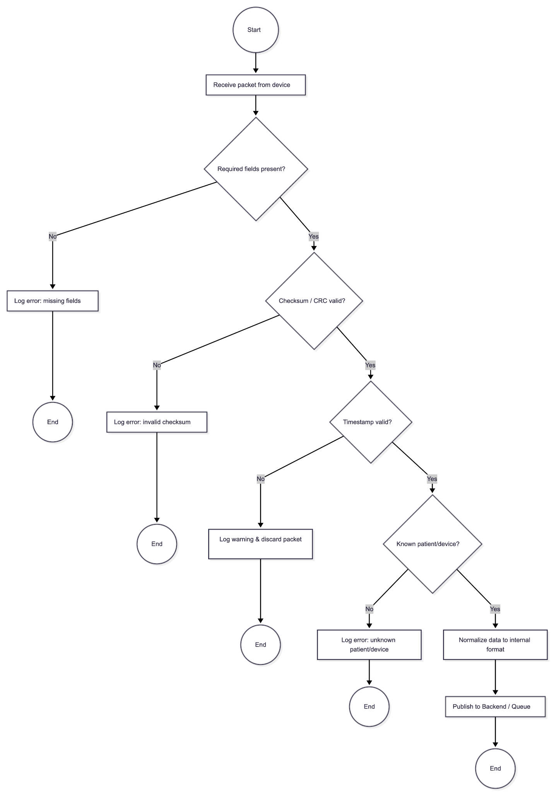

3.4.2 Signal Preprocessing & Windowing Algorithm
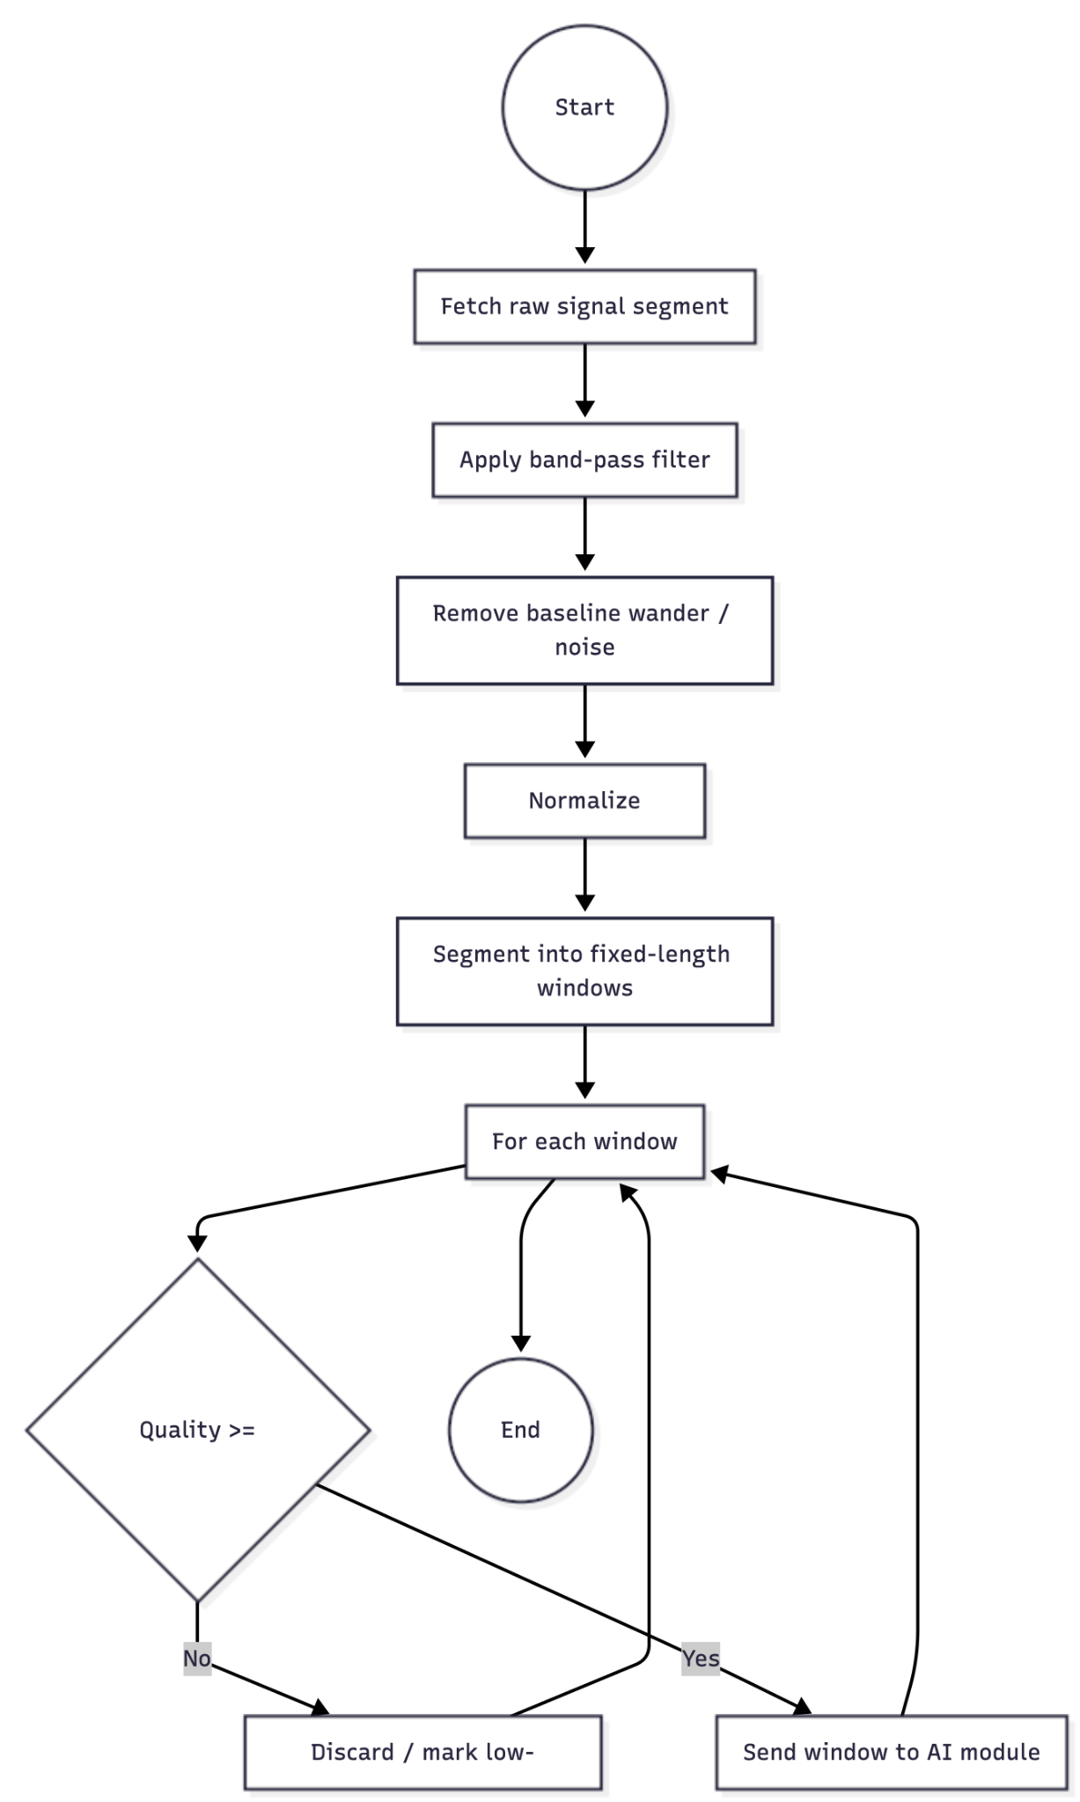

3.4.3 AI Inference & Alert Generation Algorithm
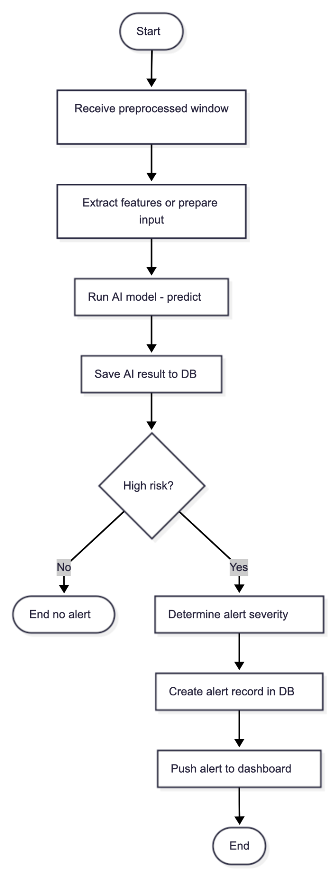

3.4.4 Real-Time Dashboard Update Algorithm
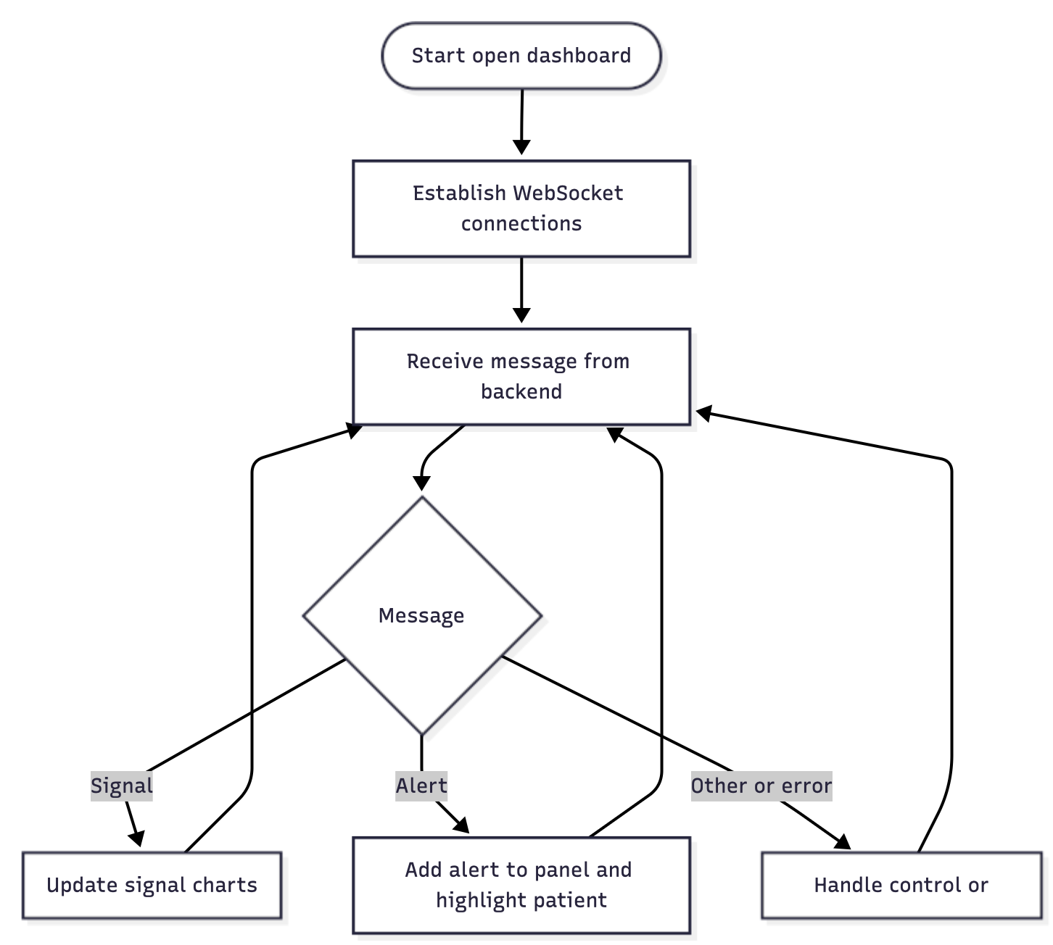

4. Traceability

SRS ID | Requirement Description | Design Element(s)
F-1 | Display live physiological signals (ECG, SpO₂, respiration). | IoMT Ingestion Service, Data Handler, WebSocket Streaming, PatientDetailView
F-2 | Visualize AI-based diagnostic results on patient panels. | AI Module, Backend API (/patients/{id}/ai-results), Alert Panel
F-3 | Role-based and hospital-scoped access control. | Authentication & Authorization Service, User & Role tables
F-5 | Generate alerts when thresholds exceeded. | Alerting Logic, Alert Entity, Frontend Alert Panel
F-6 | Export patient reports as PDF. | Backend Report Generator, ReportView
Q-001 | Uptime ≥ 95% (prototype). | Logging & Monitoring, containerized deployment, health checks
Q-002 | All data via HTTPS + AES-256. | Security & Infrastructure Layer, SSL configuration, DB encryption
C-001 | Latency ≤ 1s for visualization. | WebSocket streaming, optimized queries, limited payload sizes

5. Appendix
Flow charts for Algorithm Design section are already in 3.4

Flow diagram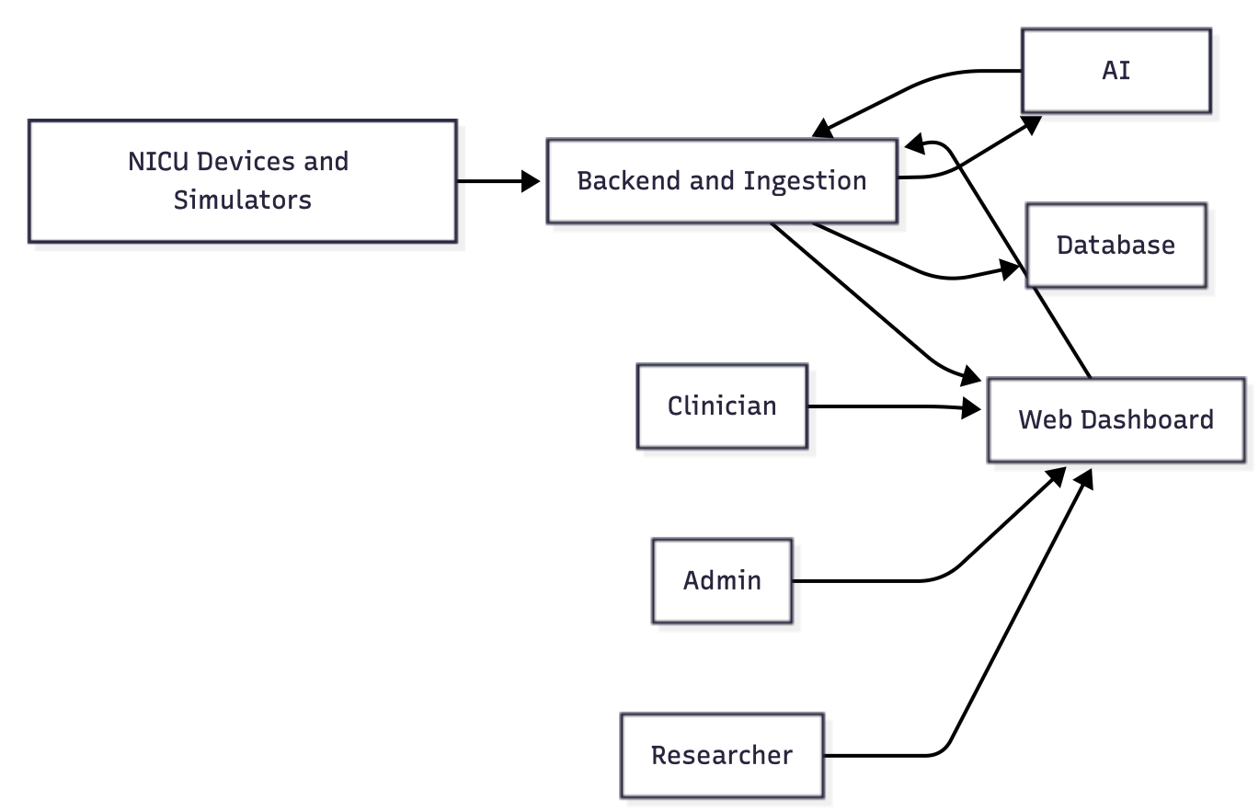

Component Diagram

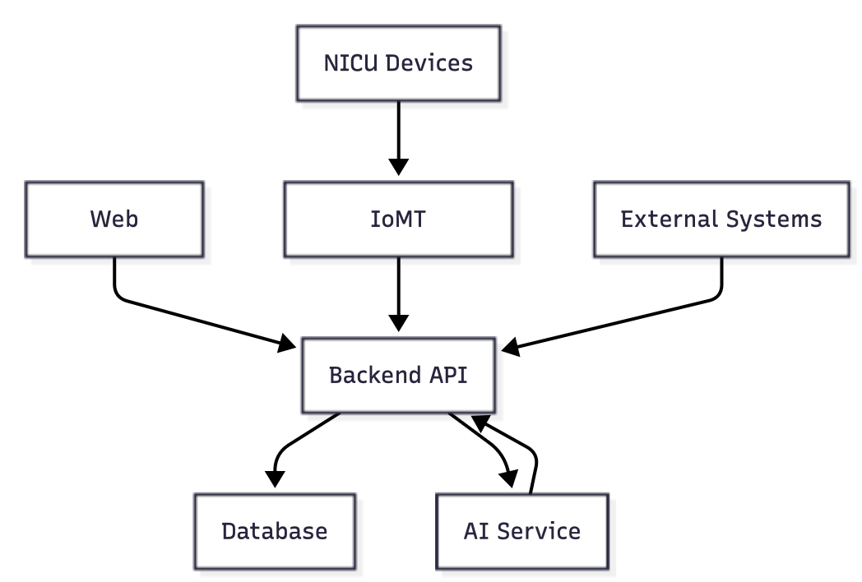

Class Diagram
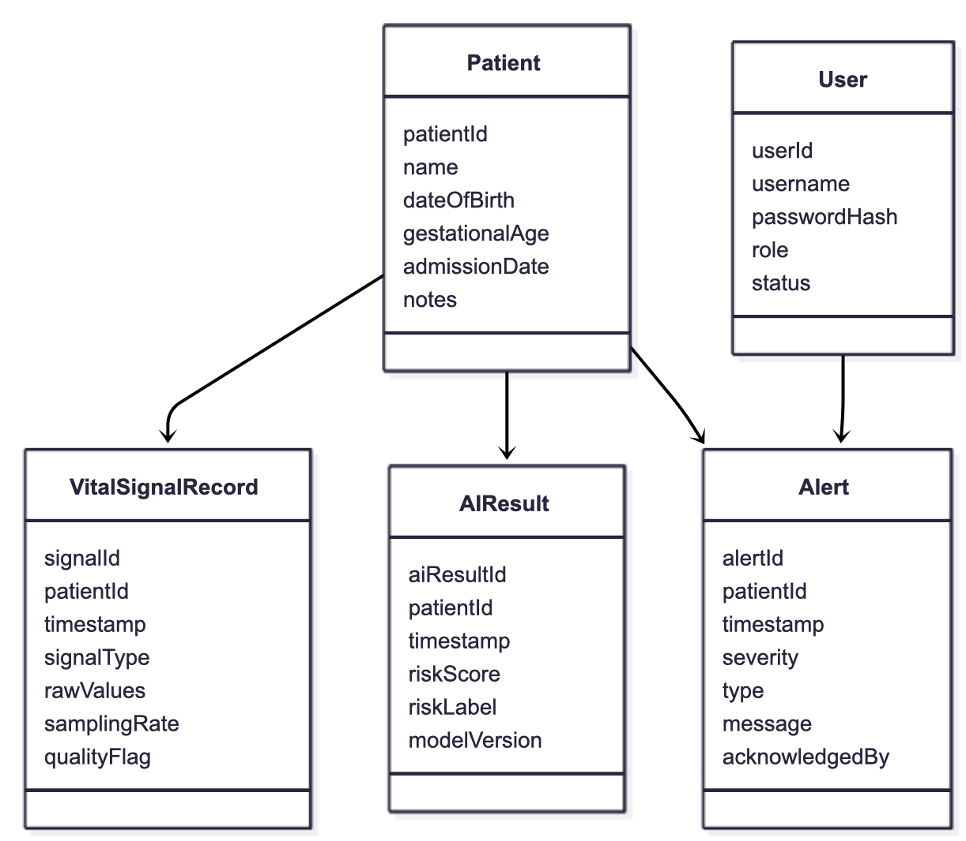

6. References

- Project Management Plan (PMP): A Unified Web-Based Platform for Real-Time NICU Signal Monitoring and AI-Assisted Diagnosis /manifetch_IEEE_PMP.docx
- Software Requirements Specification (SRS): NICU Clinical Dashboard /manifetch_IEEE_SRS.docx
- Project Proposal – Manifetch NICU Platform
Proposal_NICU.docx
- Universal Software-Driven Constraint Tracking Form
Universal_SW_Constraint_Trackin…
- IEEE 1016-2009 – Systems and Software Engineering – Software Design Descriptions
- ISO/IEC/IEEE 29148:2018 – Requirements Engineering
- ISO/IEC 25010:2011 – System and Software Quality Models
- PhysioNet datasets (PICS-DB, MIMIC-IV)
- ISO/IEC 25010, ISO/IEC/IEEE 29148
- IEC 62304 (medical software), GDPR/KVKK, HIPAA
- OWASP Top 10 (for web security)

