
TOBB ETU
Economy & Technology University
BIL 495 / YAP 495

Software Test Plan (STP)
Reference: IEEE 829-2008 / ISO/IEC/IEEE 29119-3

Document Control Table
Document Title | Project Closure Report
Document ID | (To be assigned)
Prepared By (Author) | manifetch
Reviewed By
Approved By
Preparation Date | 02.12.2025
Approval Date
Version / Revision | 1.0
Confidentiality Level | Internal / Restricted / Public
Reference Standards | IEEE 15288, IEEE 12207, INCOSE SE Handbook v5

Change Record (Revision History Table)
Revision | Date | Prepared By | Reviewed/Approved By | Description of Change
1.0 | (Date) | (Author) | (Approver) | Initial Release
1.1 |  |  |  | Minor editorial updates
1.2 |  |  |  | Added stakeholder feedback section

1. Introduction
1.1 Purpose
1.2 References
2. Test Items
3. Features to be Tested / Not Tested
4. Test Approach
5. Pass/Fail Criteria
6. Test Deliverables
7. Schedule and Responsibilities
8. Risks and Contingencies
9. Appendix
10. References

1. Introduction

1.1 Purpose
The purpose of this Software Test Plan (STP) is to define the testing strategy, scope, resources, and schedule for the NICU Clinical Dashboard project. This document ensures that the system meets the functional and non-functional requirements defined in the SRS, specifically focusing on real-time signal monitoring accuracy, AI-assisted diagnosis reliability, and system performance.
It serves as a guideline for the development team (manifetch) to verify that the integrated modules (IoMT Ingestion, Backend, AI, Frontend) function correctly before the final prototype delivery.

1.2 References
- Project Management Plan (PMP): manifetch_IEEE_PMP.docx
- Software Requirements Specification (SRS): manifetch_IEEE_SRS.docx (v2.0)
- Software Design Description (SDD): IEEE_SDD_manifetch.docx
- Constraint Analysis: Proje_K_s_t_ve_Etkiler.docx
- Standard: IEEE 829-2008 Standard for Software and System Test Documentation.

2. Test Items
The following software artifacts and subsystems will be tested as defined in the SDD:
- Frontend Dashboard (React): User Interface for clinicians, including charts, alerts, and patient management.
- Backend API (Flask/Node.js): RESTful endpoints for management and WebSockets for real-time streaming.
- AI Inference Module (Python): The machine learning component responsible for predicting respiratory and cardiac distress.
- IoMT Ingestion Service: The middleware ensuring data normalization from simulators (BioSPPy/NeuroKit2).
- Database Layer (PostgreSQL/MongoDB): Verification of data persistence for patient records and audit logs.

3. Features to be Tested / Not Tested

3.1 Features to be Tested
Based on the SRS Functional Requirements:
- F-1 Real-Time Signal Monitoring: Visualization of ECG, SpO2, and respiration with latency checks.
- F-2 AI Diagnostic Visualization: Verification that risk scores and alerts appear correctly on the dashboard.
- F-3 Role-Based Access Control (RBAC): Login validation for Admin, Doctor, and Nurse roles.
- F-5 Alert System: Triggering of visual/audio alerts when thresholds are exceeded or AI detects high risk.
- Security (NFR-1): Validation of JWT token generation and HTTPS enforcement.
- Performance (NFR-2): System stability under a load of 10 concurrent simulated devices.

3.2 Features Not Tested
- Physical Medical Device Integration: As per the project constraints, integration with physical hardware (ventilators/monitors) is out of scope for this phase; simulators will be used instead.
- HIS (Hospital Information System) Integration: Integration with hospital legacy systems (HL7/FHIR) is planned for future work.
- Real Patient Data: Due to ethical constraints (KVKK/GDPR), no real patient data will be used; synthetic/anonymized datasets (PhysioNet) will be used

4. Test Approach
The testing strategy follows a layered approach, moving from individual components to full system behavior.

4.1 Unit Testing
- Scope: Individual functions and classes (e.g., Signal normalization algorithms, Token validation logic).
- Tools: Jest for React (Frontend), PyTest for Python (Backend/AI).
- Responsibility: Developers responsible for the respective module.

4.2 Integration Testing
- Scope: Interaction between modules.
  - Backend <-> Database: Verify CRUD operations.
  - Backend <-> AI Module: Verify that signal data sent receives a prediction response within 3 seconds.
  - IoMT <-> Backend: Verify MQTT/WebSocket stream continuity.
- Tools: Postman (API testing), Supertest.

4.3 System & Performance Testing
- Scope: End-to-end validation of the complete prototype.
- Method:
  - Load Testing: Simulate 10-50 concurrent users/devices to ensure latency stays ≤1s.
  - Reliability: Run the system for defined periods to check for memory leaks or crashes (Target: 99% uptime during test).
- Tools: JMeter or Locust.

4.4 User Acceptance Testing (UAT)
- Scope: Validation of UI/UX by team members acting as "Clinicians".
- Method: Scenario-based testing (e.g., "Login as Nurse, view Patient X, observe Alert Y").

5. Pass/Fail Criteria
A test case or the overall system verification is considered PASSED only if:
- Functional: 100% of high-priority functional requirements (F-1, F-2, F-5) are met.
- Performance: Real-time signal latency is consistently ≤1 second under nominal load.
- AI Performance: Inference time per sample is ≤3 seconds.
- Stability: No critical system crashes (Severity 1 bugs) remain open.
- Test Coverage: Unit test code coverage is ≥70% for core business logic.
FAIL: Any critical functionality (e.g., failure to display an alert) is broken or performance metrics exceed thresholds by >20%.

6. Test Deliverables
- Test Plan (This Document): The strategy document.
- Test Cases (TC): Detailed steps mapping to requirements (Traceability Matrix in SRS Section 4.5).
- Test Scripts/Code: Automated test files (e.g., *.test.js, test_*.py).
- Test Summary Report: A final report summarizing pass/fail rates, defect density, and remaining risks.
- Defect Reports: Logged issues in the project management tool (e.g., Jira/GitHub Issues).

7. Schedule and Responsibilities

The following dates are assigned starting from the next school term first week.

Phase | Task | Start Date | End Date | Responsibility
Unit Testing – Data Handling | Test data collection & preprocessing functions | Week 1 | Week 2 | Developers
Unit Testing – Backend | Test backend setup, API endpoints, database CRUD functions | Week 3 | Week 5 | Backend Developers
Unit Testing – AI Model | Test feature extraction, model loading, forward pass | Week 6 | Week 7 | AI Developer
Unit Testing – Dashboard | UI component tests, frontend logic tests | Week 8 | Week 9 | Frontend Developer
Integration Testing | Backend ↔ Database ↔ API integration; Backend ↔ AI ↔ Dashboard data flow | Week 6 | Week 9 | Backend Lead
System Test | Full system flow test (sensor → backend → AI model → dashboard), load & performance test | Week 10 | Week 12 | Test Lead
UAT / Fixes | UI validation, AI result checking, workflow testing, bug fixing | Week 10 | Week 12 | All Team

Roles:
- Test Lead: Neva Varol.
- Testers: execute test cases and log defects.
- Developers: Fix bugs and write unit tests.
ALL members of the team will take roles in all parts.

8. Risks and Contingencies

Risk | Impact | Mitigation Strategy
AI Model Inaccuracy | False alarms may reduce user trust. | Use validated PhysioNet datasets (PICS-DB) for training; clearly label predictions as "beta/supportive"¹⁷.
Simulator Latency | Network lag in simulation might mimic system lag. | Run simulators on the same local network as the server during initial performance tuning.
Data Privacy Leaks | Violation of simulated "patient" privacy. | Ensure all test data is strictly synthetic or anonymized public data; verify encryption¹⁸.
Incomplete Scope | Running out of time for all features. | Prioritize "Real-time Monitoring" and "Alerts" (MVP); drop "Report Export" if necessary¹⁹.

9. Appendix

9.1 Sequence Diagram
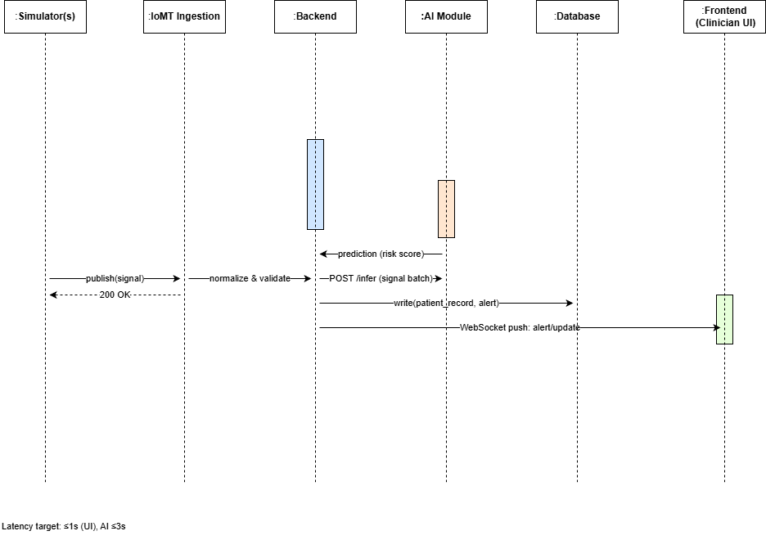Figure 1: NICU Dashboard System Flow Sequence Diagram
This diagram illustrates the message flow and execution sequence between the IoMT Simulator, Backend, AI Module, Database, and Frontend.

9.2 State Machine Diagram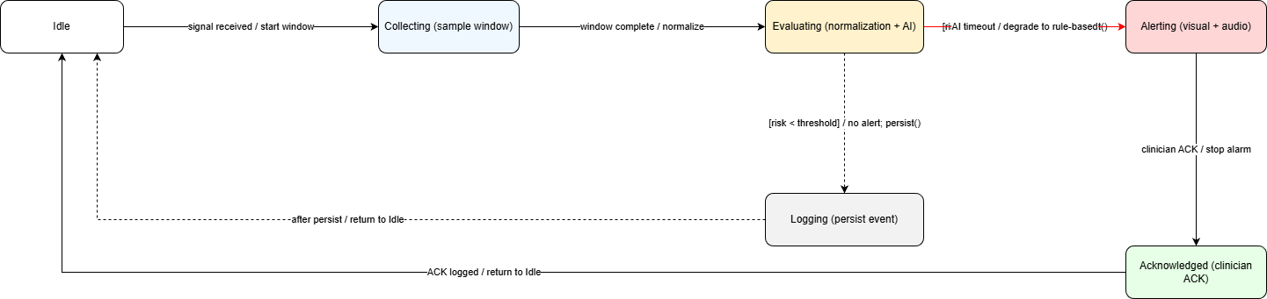
Figure 2: Alert System State Machine Diagram
This diagram depicts the state transitions of the critical alert system within the dashboard:
- States: Normal, Threshold Exceeded, Alert Triggered, Acknowledged.
- Transitions: Include guard conditions and triggering actions.
- The diagram allows test engineers to match expected alert behavior with actual system execution.

9.3 Deployment Diagram
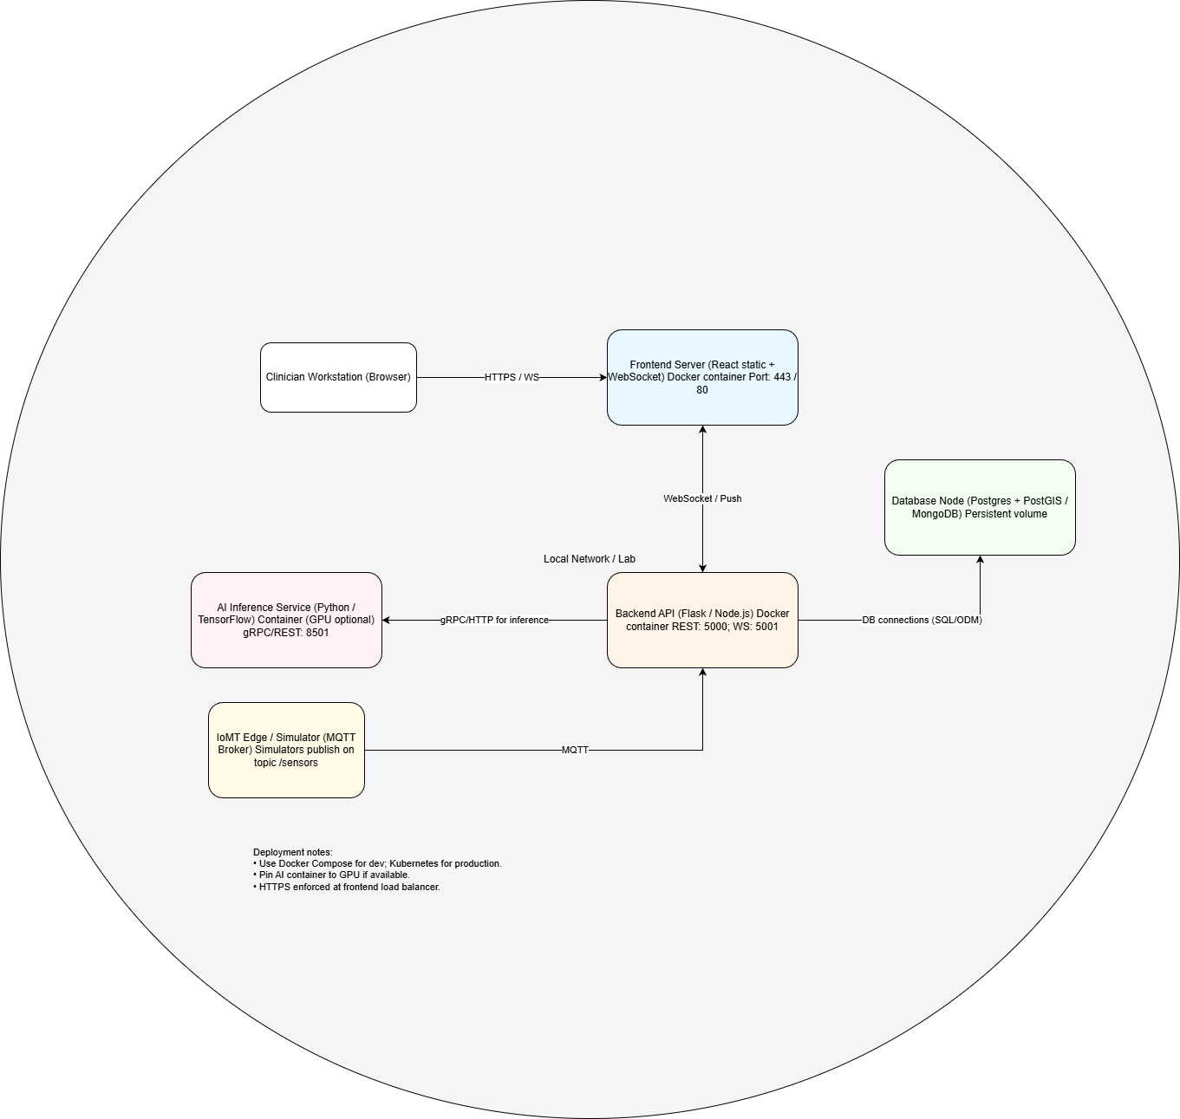
Figure 3: NICU Dashboard Deployment Diagram
This diagram shows the deployment of system components and their interconnections in the test environment:
- Nodes: IoMT Simulator, Backend Server, AI Module, Database, Frontend.
- Connections: REST API, WebSocket / MQTT data streams, and network layout.
- Additional Information: Docker containers, storage volumes, and network configuration.
The deployment diagram helps verify that the test environment is properly configured and that components are correctly interconnected.

10. References
- IEEE Standard for Software and System Test Documentation (IEEE 829-2008).
- manifetch_IEEE_SRS.docx (v2.0)
- IEEE_SDD_manifetch.doc

