Metadata-Driven Data Quality Framework
End-to-End Design — Flow Diagram, Metadata Model (ERD), and Rollout Plan

1. Objective
Build one Data Quality (DQ) framework that can check data across many datasets, on Google Cloud with Databricks as the primary platform, and Azure with Databricks as a secondary option when a client is on that stack. The framework should not need code changes every time a new dataset or a new check is added — new datasets and new checks are added by filling in configuration tables, not by editing the program.

2. End-to-End Flow
The diagram below shows how data moves through the platform and where the DQ engine sits in that flow.
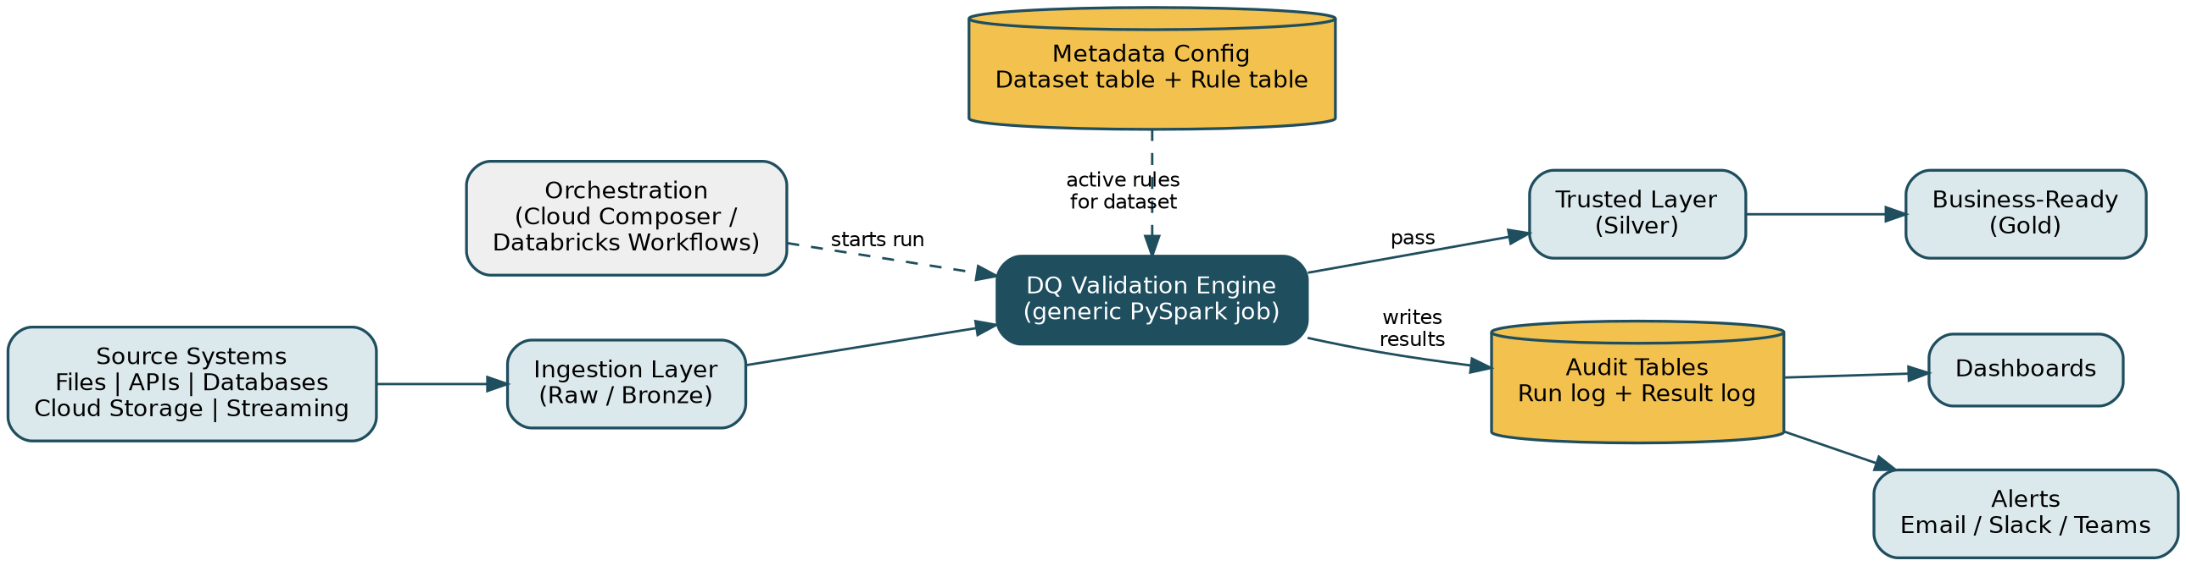
Figure 1 — End-to-end data flow with the DQ validation engine reading metadata and writing audit results
How to read it, stage by stage:
- Source systems — files, APIs, databases, cloud storage buckets, and streaming feeds land in the raw (bronze) layer through the ingestion layer, unchanged.
- An orchestration tool (Cloud Composer, or Databricks Workflows) kicks off a DQ run for a dataset on a schedule or right after ingestion finishes.
- The DQ validation engine — one generic PySpark job — reads the metadata config tables to find out which checks are active for that dataset, then runs them.
- Records that pass the required checks move on to the trusted (silver) layer, and later to the business-ready (gold) layer.
- Every run writes its results — pass/fail counts, failure percentage, and a sample of failed rows — to audit tables.
- Audit tables feed dashboards for ongoing monitoring, and trigger alerts (email, Slack, Teams) when a check fails or breaches its threshold.

3. Metadata Model (ERD)
Four tables are enough to drive the whole framework. This is a basic entity-relationship diagram showing how they connect.
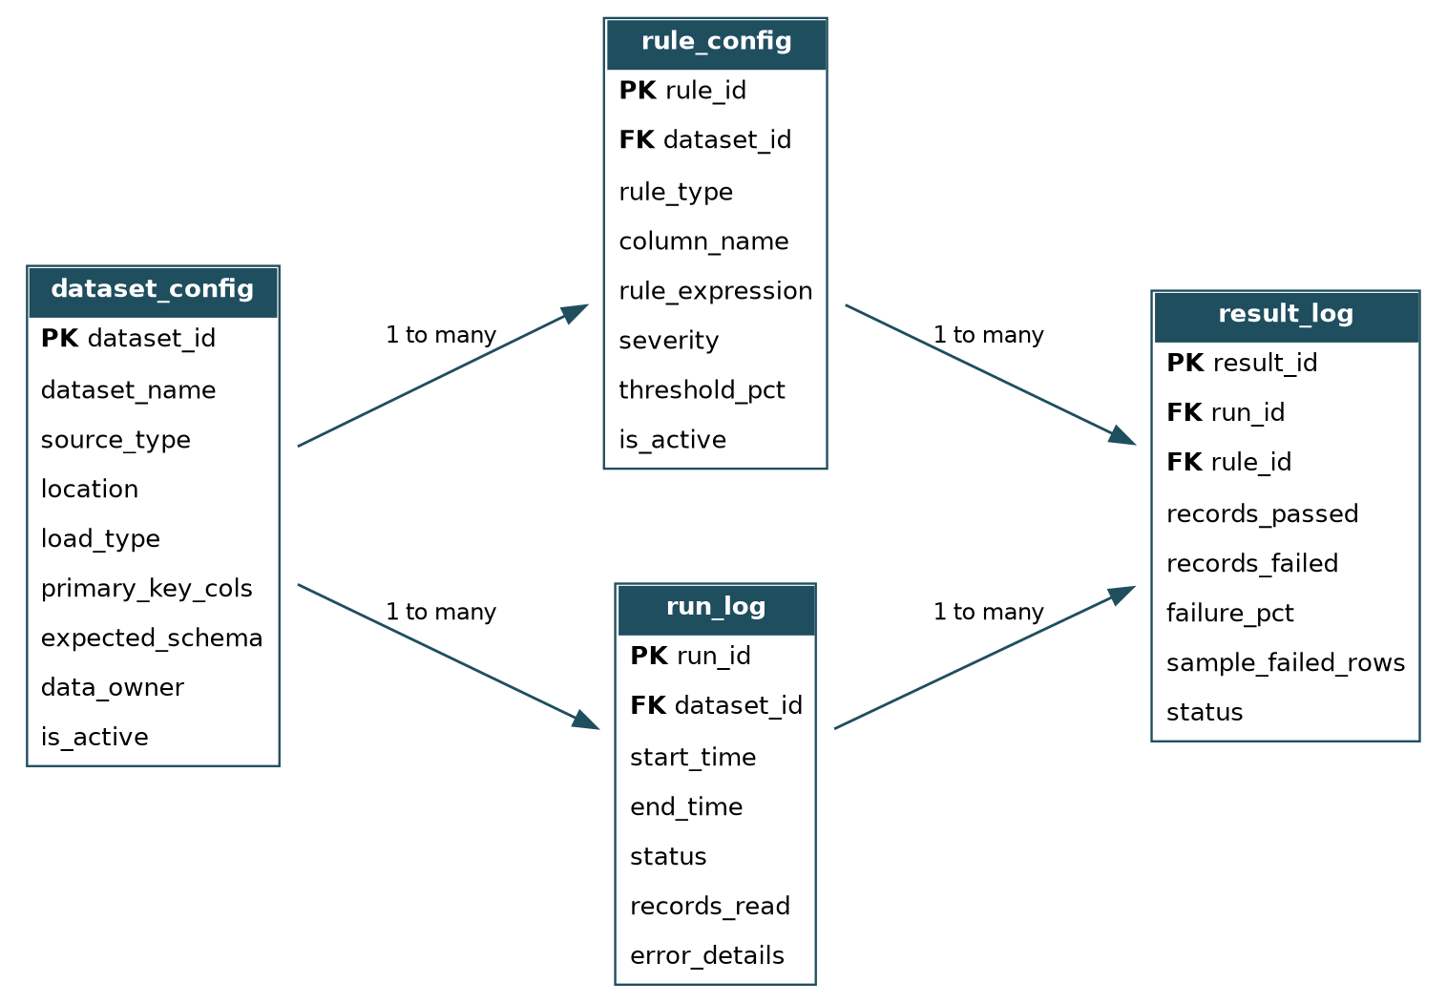
Figure 2 — Metadata / audit table relationships (basic ERD)

3.1 What each table is for
Table | Purpose | Key columns
dataset_config | One row per dataset to be checked — where it lives, what format, who owns it | dataset_id (PK), dataset_name, source_type, location, load_type, primary_key_cols, expected_schema, data_owner, is_active
rule_config | One row per check applied to a dataset/column | rule_id (PK), dataset_id (FK), rule_type, column_name, rule_expression, severity, threshold_pct, is_active
run_log | One row per execution of the engine against a dataset | run_id (PK), dataset_id (FK), start_time, end_time, status, records_read, error_details
result_log | One row per rule outcome within a run | result_id (PK), run_id (FK), rule_id (FK), records_passed, records_failed, failure_pct, sample_failed_rows, status

dataset_config and rule_config are the configuration side — this is what a data steward edits to onboard a new dataset or change a check. run_log and result_log are the audit side — this is what the engine writes automatically every time it runs, and what dashboards and alerts read from.

4. Rule Types Covered
Rule type | What it checks
Completeness | Required fields are not empty (e.g. order_id, customer_id must not be null)
Uniqueness | Primary keys are not duplicated
Validity | Values match a pattern, a range, or a list of allowed values (e.g. email format, country code list)
Accuracy / reconciliation | Totals or counts match the source system within an agreed tolerance
Referential integrity | Foreign keys exist in the related dataset (e.g. every customer_id on an order exists in the customer table)
Timeliness | Data has arrived within the expected time window (freshness)
Schema check | Column names, data types, and nullable settings match what is expected

5. How a New Check Gets Added — Without Touching the Engine
This is the part the assignment is really testing, so it is worth stating plainly:
- Every rule type — completeness, uniqueness, range check, referential integrity, and so on — is written as its own small PySpark function.
- Each function is mapped to a rule_type name (a plain text label) in the rule_config table.
- When the engine runs a dataset, it looks up which rule_type values are active for that dataset from rule_config, finds the matching function by that name, and runs it.
- To add a brand-new check, I write one new function and add one row to rule_config. I do not open or change the engine code that reads configuration and runs the checks.
- The same idea applies to new datasets (add a row to dataset_config) and new data sources (add one small read function per source type, e.g. BigQuery, GCS/Delta, JDBC) — the engine only ever asks “which function handles this?” and looks it up by name.

6. Execution Flow (Step by Step)
- Orchestration tool starts a run and passes in the dataset name and a run_id.
- Engine reads dataset_config for that dataset — where the data is, what format, what source type.
- Engine reads rule_config for that dataset — which checks are active, on which columns, at what severity and threshold.
- Engine loads the data into a Spark DataFrame using the read function that matches the dataset's source_type.
- Engine runs each active check, using the PySpark function that matches its rule_type.
- Engine calculates records passed, records failed, and failure percentage for each check, and stores a small sample of failed rows.
- Results are written to run_log and result_log.
- Based on severity and threshold, the run is marked Passed, Warning, or Failed. Critical failures can stop the pipeline before bad data reaches the trusted/business layers.
- Alerts go out through email, Slack, or Teams; dashboards refresh from the audit tables.

7. Cloud Mapping — GCP + Databricks (Primary), Azure + Databricks (Secondary)
Component | GCP (primary) | Azure (secondary)
Processing engine | Databricks on Google Cloud (PySpark) | Azure Databricks (PySpark)
Curated data storage | Delta tables on Google Cloud Storage (GCS) | Delta tables on Azure Data Lake Storage Gen2
Warehouse-native tables | BigQuery (read directly, no copy needed) | Synapse / Azure SQL, if applicable
Metadata & audit tables | Delta on GCS, or a BigQuery table for direct dashboard access | Delta on ADLS Gen2
Orchestration | Cloud Composer (Airflow) or Databricks Workflows | Azure Data Factory or Databricks Workflows
Alerting | Pub/Sub → Cloud Function → Slack / email | Event Hub → Logic App → Teams / email
Dashboards | Looker Studio / Databricks SQL | Power BI / Databricks SQL

Because reading a dataset and writing results are each handled by one small function per platform (one for GCS/Delta, one for BigQuery, one for ADLS/Delta), the same engine and the same metadata tables work on either cloud. Moving a client from GCP to Azure, or supporting both at once, is a matter of pointing dataset_config rows at the right source_type — not rewriting the framework.

8. Scalability and Extension
- The engine has no dataset-specific logic in it — everything it needs comes from dataset_config and rule_config.
- New datasets are onboarded by adding metadata rows, not by writing pipeline code.
- New rule types are added as one new function each, so existing checks are never touched or retested unnecessarily.
- PySpark runs the checks as distributed Spark jobs, so the same design scales from a few thousand rows to billions of rows.
- Large datasets are checked incrementally (only new/changed data since the last run, using a watermark column) instead of scanning the whole table every time.
- Checks can be turned on or off, or have their thresholds changed, by updating rule_config — no redeployment needed.

9. Reliability and Governance
- Every run gets a unique run_id, so any result can be traced back to exactly which run produced it.
- The engine is safe to re-run (idempotent) — re-running a failed run does not create duplicate audit rows.
- Access to the metadata tables and to failed-record samples is controlled, and sensitive columns in failed-row samples can be masked.
- Dashboards track rule pass rates, failure trends over time, how long runs take, and how fresh each dataset is.
- Testing includes unit tests for individual rule functions, integration tests for the end-to-end pipeline, and reconciliation tests comparing source and target record counts.

10. Example: Onboarding a Customer Dataset
To validate a new customer dataset, no engine code changes — only these configuration rows:
Table | Example row(s)
dataset_config | dataset_id = retail.customers, source_type = bigquery, location = retail_prod.customers, primary_key_cols = customer_id
rule_config | customer_id → completeness + uniqueness | email → validity (pattern) | country → validity (allowed list) | created_date → schema check (valid date)

The same engine then validates this dataset the next time it runs, alongside every other dataset already configured — hundreds of datasets can be added the same way, purely through configuration.

