Programming: Dart Software and Resources
This document provides you with instructions on how to install the Dart SDK and use Visual Studio Code. Follow the instructions carefully and completely. If you have any difficulties, ask in your practical session or use the Discord channel.

Dart
You need the Dart Software Development Kit (SDK) to run Dart code on your machines.

On University machines
- Open appsanywhere.port.ac.uk
- Search for “Git” and click “Launch”
- Next, search for “Flutter & Dart SDK” and click “Launch”
- Follow the instructions on Visual Studio Code.

On your personal computer
- Follow the instructions in this document to install a package manager for your computer.
- Next, get the Dart SDK, following the instructions on this web page.

Test your installation
Open PowerShell on Windows or Terminal in macOS. Test your installation and enter this:
Input (in the terminal, PowerShell, or Command Prompt)
dart --version
This should print the version of the Dart SDK that you have installed. At the time of writing this document, the current version is 3.11.1.

Visual Studio Code

University machines installation: AppsAnywhere
Visual Studio Code is available in AppsAnywhere. Follow the instructions below:
- Open AppsAnywhere in your browser and log in with your student credentials (same login as Moodle): appsanywhere.port.ac.uk
- Install the Dart SDK from AppsAnywhere first (see this section).
- Search for “Visual Studio Code” and click on “Launch”
- Follow the instructions in this section to learn how to use Visual Studio Code.

Local installation: On your own machines
- Install Visual Studio Code in either of the following ways:
  - Download and install Visual Studio Code from their website: code.visualstudio.com
  - Or install a package manager by following these instructions and then enter the following command, depending on your operating system:
PowerShell or Command Prompt (in Windows)
choco install vscode -y

Terminal (macOS)
brew install --cask visual-studio-code
- Once Dart is installed, follow the instructions in this section on using Visual Studio Code.

Using Visual Studio Code
- Open the extension panel (Ctrl+Shift+X or Cmd+Shift+X) from the left-hand sidebar and install the “Dart” extension.
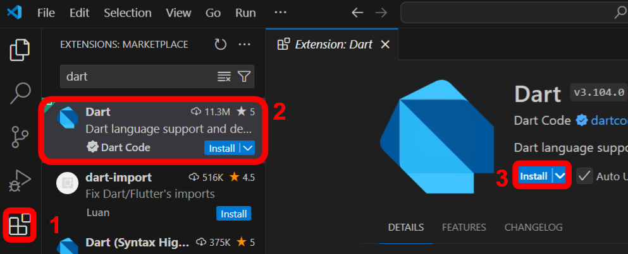
- Open the explorer panel (Ctrl+Shift+E or Cmd+Shift+E), click on Open Folder and open your programming folder. Remember, never open a single file in VS Code.
The folder must be saved in a location that is synced with a cloud. For instance:
  - O or N Drive on University machines
  - OneDrive on Windows computers
  - iCloud on macOS computers
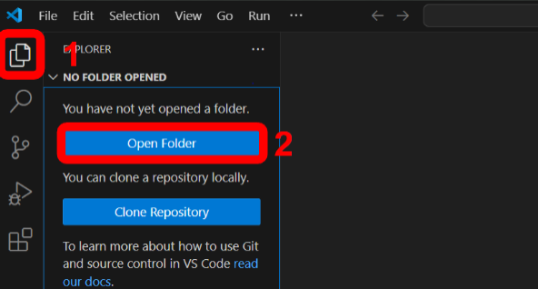

- Create a new file using the new file icon and call it pract15.dart:
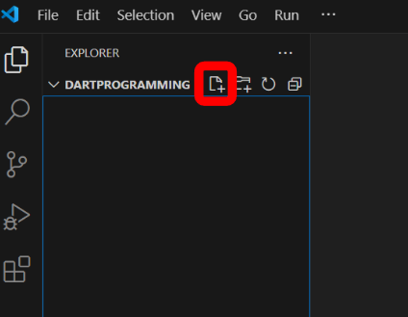
- Call this file pract15.dart and add the following code:
Editor
void main() {
print('Hello, World!');
}
- Next, open an integrated terminal window:
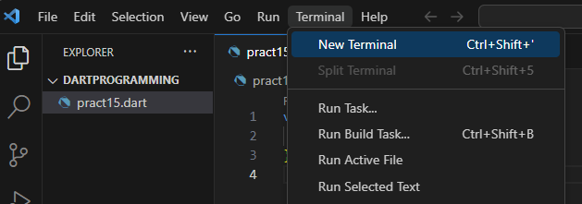
You could do the same thing by opening the command palette with Ctrl+Shift+P or Cmd+Shift+P and entering “Create New Terminal”.
- Finally, enter the following command in the terminal (replace pract15.dart with the name of your file).

Input (in the terminal, PowerShell, or Command Prompt)
dart pract15.dart
We are assuming that your file is directly in the Dart programming folder. If this is not the case, change the current directory with the cd command.

