Installing and Using Package Managers
We recommend using a package manager to install software that you need for your degree and future projects. This is an easy guide on how to install and use a package manager for your computer.

Note that AppsAnywhere (appsanywhere.port.ac.uk/) is the package manager on university machines. This guide is for your own personal computers only. You require admin access to the computer to install a package manager.

On Windows machines: Chocolatey
- Install Chocolatey by following the instructions on this page: https://chocolatey.org/install#install-step2
You need to run PowerShell as an Administrator and paste the command shown in the step of the page above.
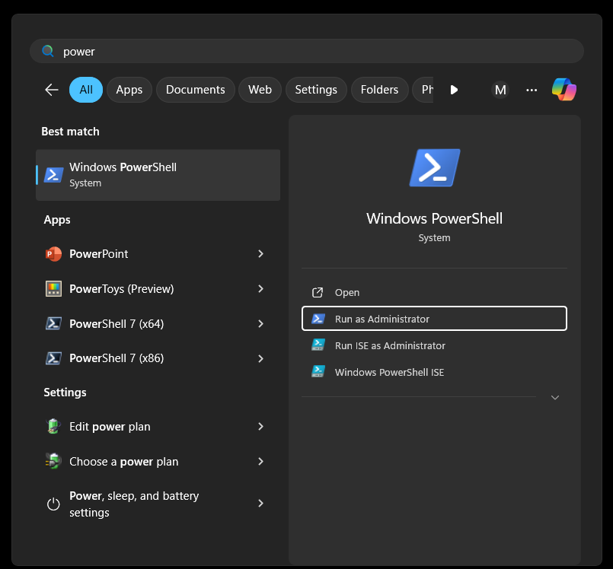
Make sure to read the output of this command in PowerShell. You may be asked to run further commands.
- Check that your installation was successful by entering the following in a new (non-admin) PowerShell and checking that the choco command is installed:

Input (in Command Prompt or PowerShell)
choco --version
- Open this page and look for the software or package that you would like to install: https://community.chocolatey.org/packages
- Copy the installation command using the clipboard icon 📋. For example, to install Thonny, we need to use the following command:
Input (in Command Prompt or PowerShell)
choco install thonny
- To install a package, open an admin PowerShell again. Then paste the command and press enter. Keep an eye on the installation, as you need to reply with y or a.

On macOS: Homebrew
- Open the Terminal app (use the Cmd + Enter shortcut and type in “Terminal”).
- Head to Homebrew’s website and copy the command on the page by clicking on the clipboard icon 📋: https://brew.sh/
- This command will download and install Homebrew on your Mac. It may take some time depending on your internet speed and system configuration.
If you encounter any errors, install Xcode’s Command Line Tools by running the following command in Terminal and retry.
Input (in Terminal)
xcode-select --install
- To verify that brew is installed and working as expected, run the following:
Input (in Command Prompt or PowerShell)
brew --version
- Open Homebrew’s home page again and use the Cmd + K shortcut to look for the software or package that you would like to install: https://brew.sh/
- Copy the installation command using the clipboard icon 📋. For example, to install the Python editor Thonny, you would use the following command:
Input (in Command Prompt or PowerShell)
brew install --cask thonny
- In a new Terminal window, paste the command and press enter.

