Southsea Cinema — Flutter Coursework
School of Computing
Field | Value
Module Title and Code | PROGRAMMING APPLICATIONS AND PROGRAMMING LANGUAGES - M30235 - FHEQ 5\nUSER EXPERIENCE DESIGN AND IMPLEMENTATION - M32605 - FHEQ 5
Module Coordinator | mani.ghahremani@port.ac.uk
Assessment Item number | Item 1
Assessment Title | Southsea Cinema — Flutter Coursework
Date Issued | 2026-27 delivery

Overview
Your task is to recreate a mobile-friendly version of the Southsea Cinema website using Flutter. You must begin by forking the southsea_cinema starter repository and then build your own version of the app step by step as you work through the weekly worksheets.
Reference website: Southsea Cinema
The starter app is deliberately minimal. It contains only a basic theme, an empty home page, a small drawer, and a default widget test. You are expected to add screens, widgets, data models, tests, persistence, and cloud services during the coursework.

Getting Started

Prerequisites
You need:
- A GitHub account
- A way to edit and run Flutter projects
- Git installed and connected to your GitHub account
You have three development options:
- GitHub Codespaces (browser-based, no local install required)
- University Windows computers
- Your own computer

Fork the Repository
Open this repository on GitHub and click Fork, as shown below:

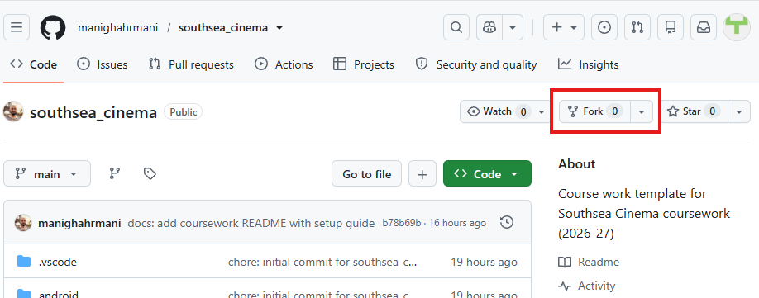
On the "Create a new fork" page, leave the default options as they are (do not change the repository name) and click Create fork:
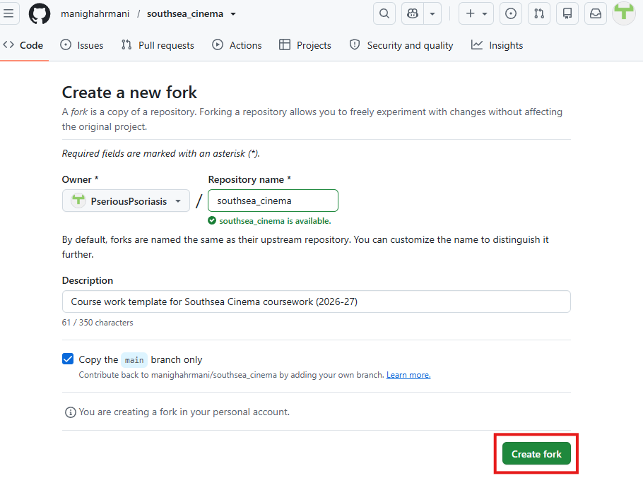
Your fork should be called southsea_cinema and should have a URL like this:
https://github.com/YOUR-USERNAME/southsea_cinema

Clone Your Forked Repository
On your forked repository page, click the green Code button and copy the HTTPS URL, as shown below:
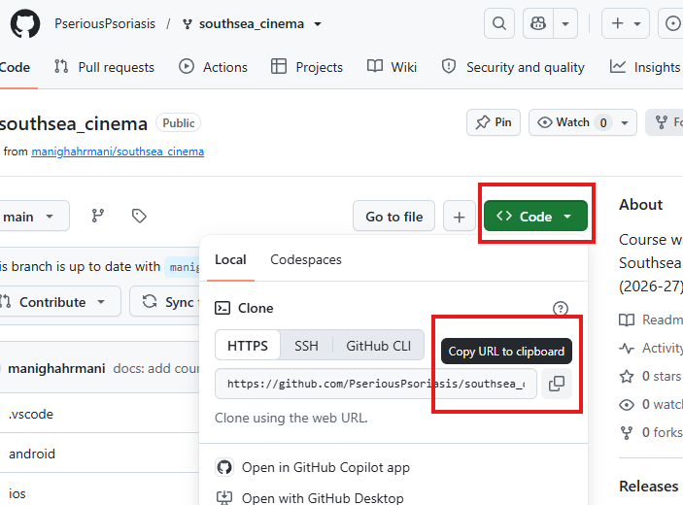
If you are using VS Code, open the Source Control panel and click Clone Repository, then paste the URL you copied:
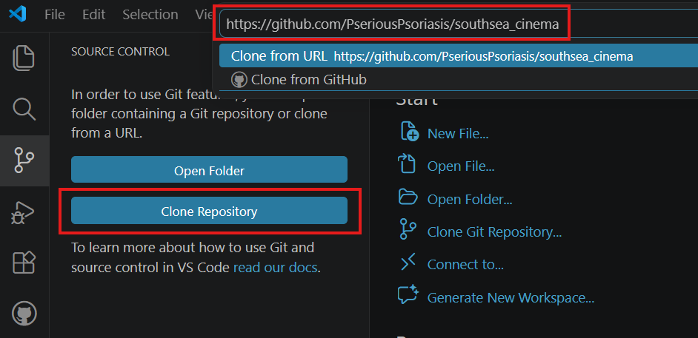
Alternatively, if you are using a terminal, run:
git clone https://github.com/YOUR-USERNAME/southsea_cinema.git
cd southsea_cinema

Install Dependencies
When you open the project, VS Code may show a popup asking if you want to fetch missing packages. If you see it, click Run pub get, as shown below:
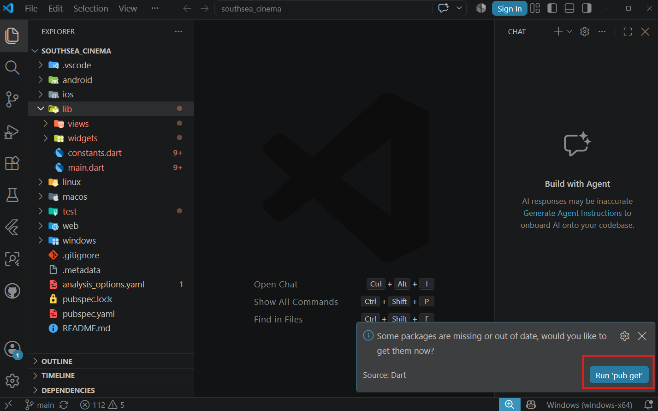
If you do not see this popup, open a terminal and run the command manually:
flutter pub get
This downloads the Flutter packages needed by the starter app.
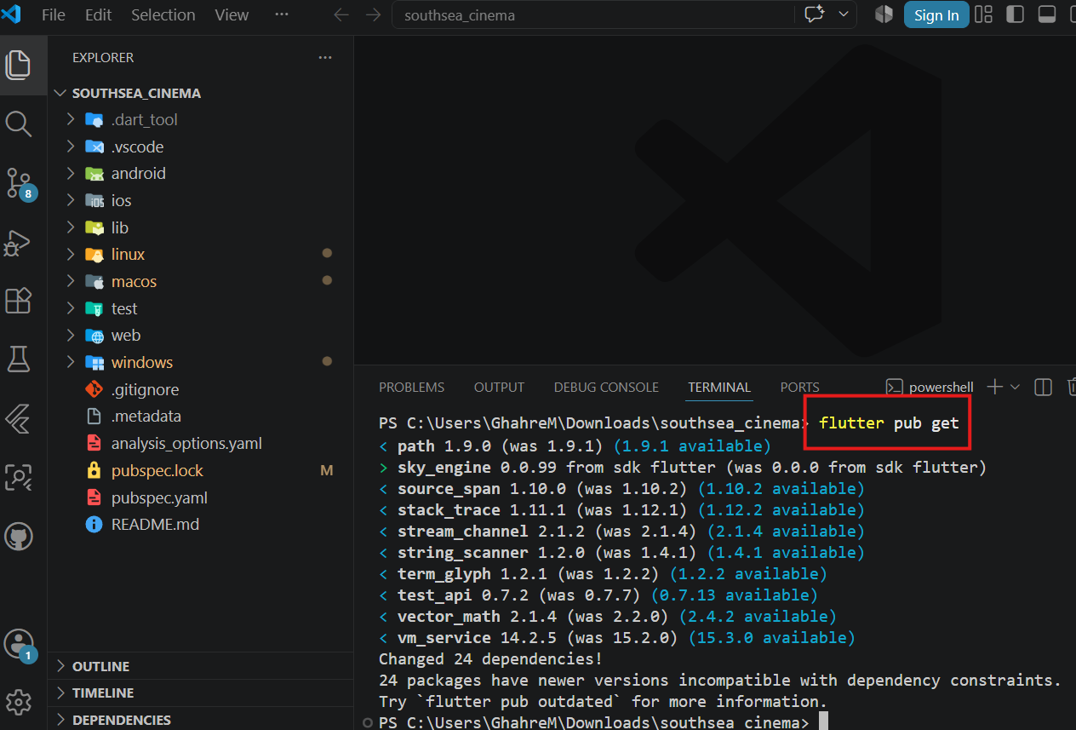

Run the Application
This coursework targets Flutter Web. Use Chrome or Edge.
flutter run -d chrome
flutter run -d edge
The app should open in your browser and show the Southsea Cinema starter home page, as shown below:
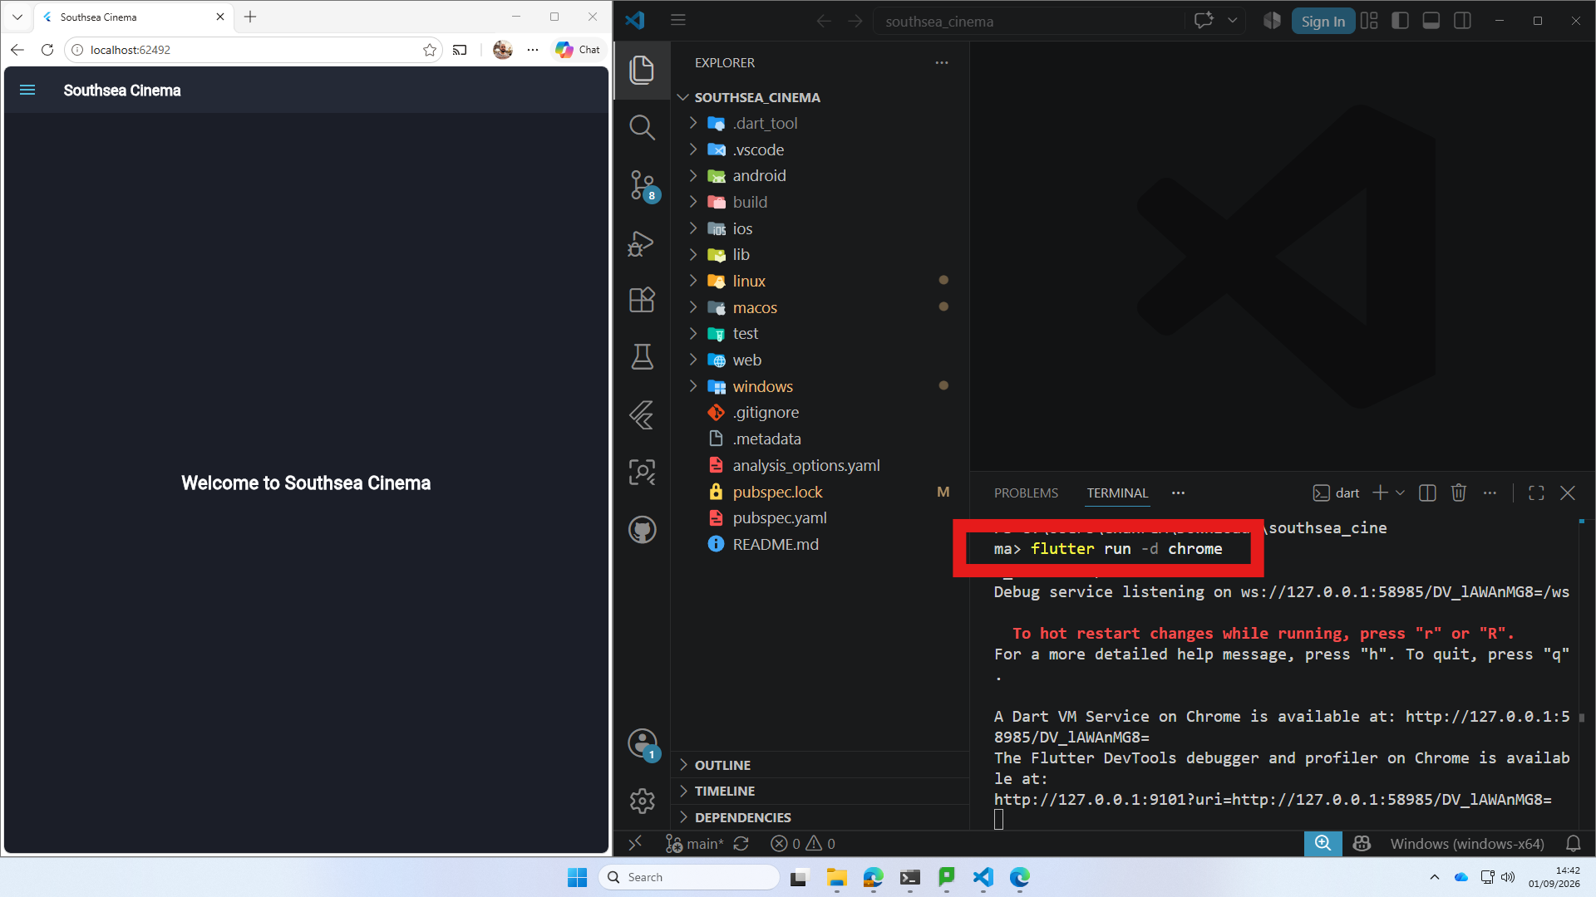

Use Mobile View
The coursework should be designed mobile-first.
1. Right-click the page and choose Inspect
2. Click the Toggle device toolbar button, highlighted below:
3. Choose a phone-sized device preset from the dropdown menu:
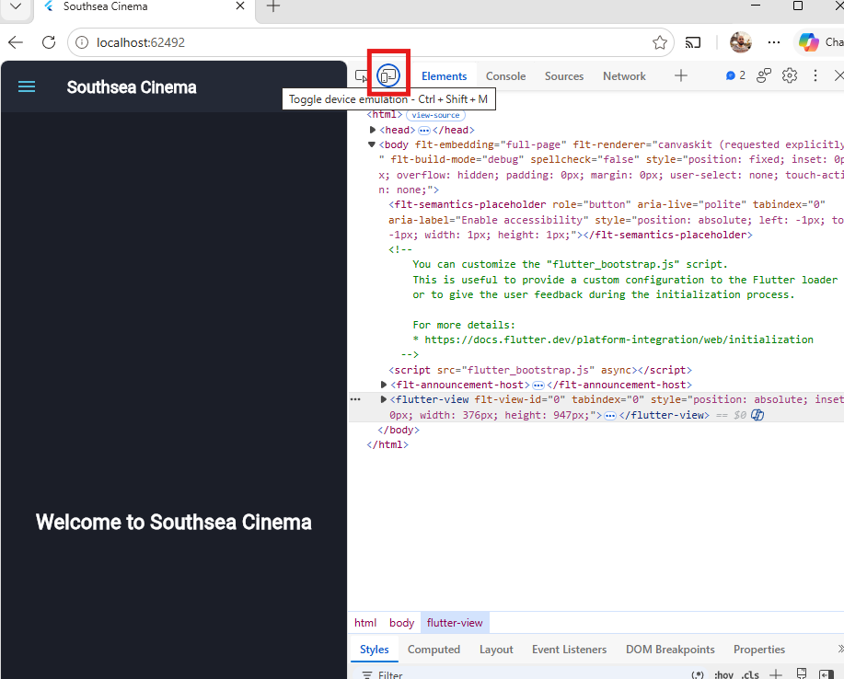
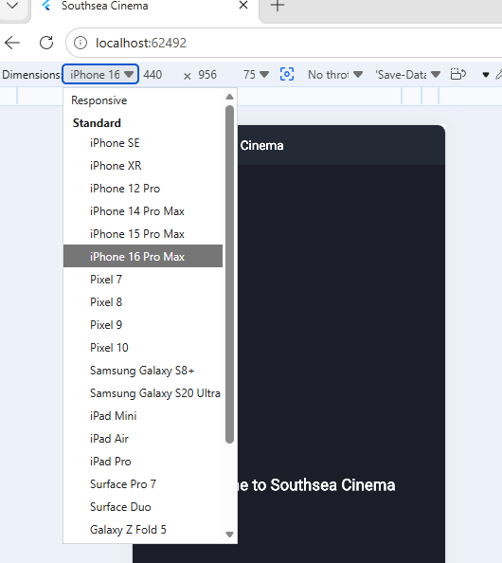

Assessment Structure
Item 1 is worth 50% of the overall module mark and is assessed entirely through 4 demo checkpoints of your Southsea Cinema coursework. There is no separate sign-off or coursework submission for Item 1: the demos are continuous assessment of the same coursework you build throughout the term.
The following demo windows are the times when students may complete the checkpoints:
Demo 1: 14/09/2026 to 18/09/2026
Demo 2: 05/10/2026 to 09/10/2026
Demo 3: 19/10/2026 to 23/10/2026 (opens) and 02/11/2026 to 06/11/2026 (closes)
Demo 4: 09/11/2026 to 13/11/2026
Each demo is marked out of 10 (10% of the module):
- Functionality (0-4): does the app implement the features expected by this point in the schedule?
- Quality (0-2): code quality on inspection.
- Understanding (0-4): your answers to questions about your own code and decisions.

Submission
You will submit the link to your public forked repository on Moodle when instructed. You are not submitting a zip file or a copy of the source code.

Demonstration
During each demo, you must be able to run your app and answer questions about your code. Before attending a demo, check that the app runs from a clean clone:
flutter pub get
flutter run -d chrome

Project Structure
The starter repository is intentionally small:
southsea_cinema/
├── lib/
│ ├── constants.dart
│ ├── main.dart
│ ├── views/
│ │ └── home_view.dart
│ └── widgets/
│ └── nav_drawer.dart
├── test/
│ └── widget_test.dart
├── pubspec.yaml
└── README.md

Help with Coursework

Support
If you need support, use the Discord support document and ask your question in the Flutter channel. Otherwise, attend your timetabled practical session and ask a member of staff for help.
For support links and course information, visit the Flutter Course homepage and the relevant worksheet pages.

