WPF Notes

//PresentationFramework.dll, v4.0.30319
public class Window : ContentControl, IWindowService
{

}
public class ContentControl : Control, IAddChild
{

}

public class Control : FrameworkElement
{

}
public class FrameworkElement : UIElement, IFrameworkInputElement, IInputElement, ISupportInitialize, IHaveResources, IQueryAmbient
{

}
public class UIElement : Visual, IAnimatable, IInputElement
{

}
// Summary:
// Provides rendering support in WPF, which includes hit testing, coordinate
// transformation, and bounding box calculations.
public abstract class Visual : DependencyObject, DUCE.IResource
{

}

//Represents an object that participates in the dependency property system.
public class DependencyObject : DispatcherObject
{

}
//Represents an object that is associated with a ystem.Windows.Threading.Dispatcher.
public abstract class DispatcherObject
{

}

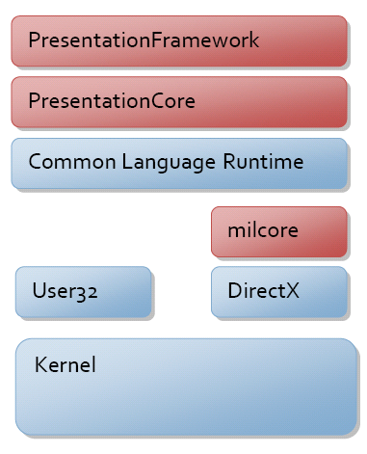
//PresentationFramework.dll, v4.0.30319

// Encapsulates a Windows Presentation Foundation (WPF) application.
public class Application : DispatcherObject, IHaveResources, IQueryAmbient
{

}

// Exceptions:
// System.InvalidOperationException:
// System.Windows.Application.Run() is called from a browser-hosted application
// (for example, an XAML browser application (XBAP)).
[SecurityCritical]
public int Run(Window window);

Run – method provides the message loop.

Application.Run(Window):
Starts a Windows Presentation Foundation (WPF) application and opens the specified window.

If you create your Application using markup, or markup and code-behind, you can automatically open a window during using either of the following techniques:
- Declaratively, by setting StartupUri.
- Programmatically, by handling Startup.
Application is a class that encapsulates WPF application-specific functionality, including the following:
- Application Lifetime: Activated, Current, Deactivated, DispatcherUnhandledException, Exit, Run, SessionEnding, Shutdown, ShutdownMode, Startup.
- Application-Scope Window, Property, and Resource Management: FindResource, GetContentStream, GetResourceStream, LoadComponent, MainWindow, Properties, Resources, StartupUri, Windows.
- Command-Line Parameter and Exit Code Processing: Application. Startup , Application. Exit , Application. Shutdown .
- Navigation: FragmentNavigation, LoadCompleted, Navigated, Navigating, NavigationProgress, NavigationStopped, NavigationFailed, SetCookie, GetCookie.
Application implements the singleton pattern to provide shared access to its window, property, and resource scope services. Consequently, only one instance of the Application class can be created per AppDomain.

WPF application should have:
- A class inherited from Application class
- A class inherited from Window class
When CLR converts the managed code to native code, it creates the WinMain function for WPF/WinForms application.
We can directly use application class and window class. But its always better to inherit them and customize as per needs of our application.

Button btn = new Button();

btn.HorizontalAlignment = HorizontalAlignment.Center;
btn.VerticalAlignment = VerticalAlignment.Center;
mainWindow.Content = btn;

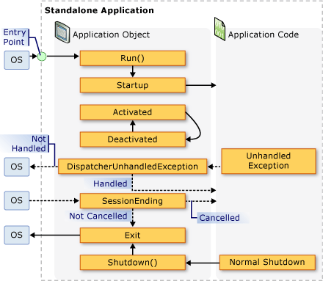

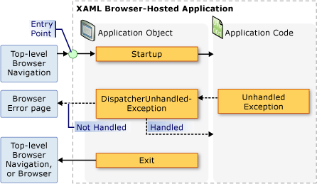

public MainWindow()
{
InitializeComponent();

Title = "My Simple Window";
Content = "Hi there.";
}

