**QUESTIONS**

1. Anand, the cofounder of JAT, claims that disease 6 (leaf curl) information was accessed at least 60 times every month on average since October 2017 due to this disease outbreak. Test this claim at a significance level of 0.05 using an appropriate hypothesis test.
2. Among the app users for disease information, at least 15% of them access disease information related to disease 6. Use an appropriate hypothesis test to check this claim at a = 0.05.
3. JAT believes that over the years, the average number of app users have increased significantly. Is there statistical evidence to support that the average number of users in year 2017-2018 is more than average number of users in year 2015-2016 at a=0.05? Support your answer with all necessary tests.
4. Farmers use apps to access information throughout the month. Using the data, check whether app usage is same or different across the four weeks of a month. Anand claims that app usage picked up after January 2016; so, test this hypothesis using data from January-2016 – May 2018.
5. Anand claims that number of users have increased over a period of two years. He wants to understand if app usage (number of times his app is accessed in a month by various users) has increased with the increased number of users. Prove this claim statistically. Also suggest a suitable statistical test to prove that the correlation between users and usage is non-zero.
6. A new version of the app was released in August 2016. Anand wants to understand which month in the given time frame after the launch of the new version, the mean usage pattern would start to show a statistically significant shift.
7. If a disease is likely to spread in particular weather condition (data given in the disease index sheet), then the access of that disease should be more in the months having suitable weather conditions. Help the analyst in coming up with a statistical test to support the claim for two districts for which the sample of weather and disease access data is provided in the data sheet. Identify the diseases for which you can support this claim. Test this claim both for temperature and relative humidity at 95% confidence.

t-critical value 1.72 with a =0.05

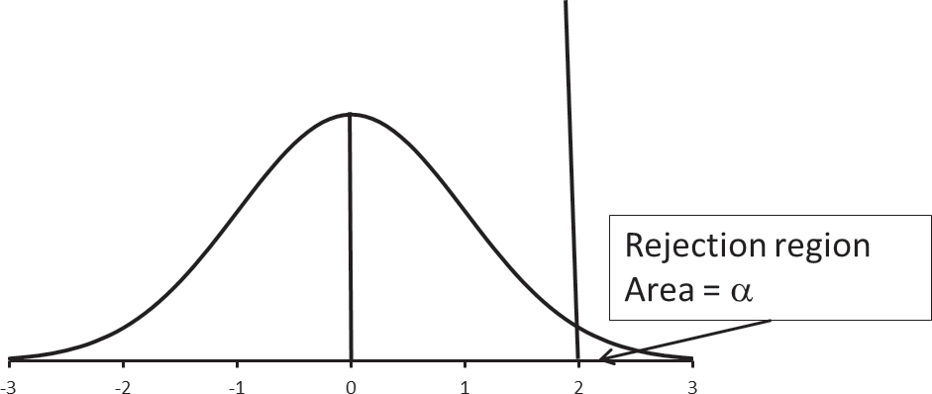

t-statistic value 1.82

Retain Null Hypothesis Reject Null hypothesis

