QualityAlloys

Manish Grewal

26/07/2020

## Executive Summary

### Executive summary description here

## Set working directory

setwd("C:/Users/manish.grewal/emdp/R/QualityAlloys")

## Load libraries

library(readxl)  
library(ggplot2)  
library(dplyr)

## Load the dataset

daily_visits <- read_excel("CU46-XLS-ENG.xls", sheet = "Daily Visits", skip = 4)  
  
# Read the main worksheets from xls workbook and   
  
weekly_visits <- read_excel("CU46-XLS-ENG.xls", sheet = "Weekly Visits", skip = 4)  
financials <- read_excel("CU46-XLS-ENG.xls", sheet = "Financials", skip = 4)  
lbs_sold <- read_excel("CU46-XLS-ENG.xls", sheet = "Lbs. Sold", skip = 4)  
  
# and remove non alphabet characters from column headers (names)  
  
names(weekly_visits) <- gsub("[^a-z]+", "", names(weekly_visits), ignore.case = TRUE)  
names(financials) <- gsub("[^a-z]+", "", names(financials), ignore.case = TRUE)  
names(lbs_sold) <- gsub("[^a-z]+", "", names(lbs_sold), ignore.case = TRUE)  
  
# merge needed columns into another data set (weekly_data)  
weekly_data <- data.frame(  
 Week = weekly_visits$Week,   
 UniqueVisits = weekly_visits$UniqueVisits,   
 Revenue = financials$Revenue,   
 Profit = financials$Profit,   
 LbsSold = financials$LbsSold)  
  
# convert Week to ordered factored   
weekly_data$Week <- factor(weekly_data$Week, levels = weekly_data$Week)

## 1. Column Charts

### Initialize the common plot data

p <- ggplot(weekly_data, aes(x = Week)) +  
 scale_x_discrete(breaks = weekly_visits$Week[seq(1, nrow(weekly_visits), 2)]) +  
 theme(axis.text.x = element_text(angle = 90, vjust = 0.5, hjust=1))

### a. unique visits over time

p + geom_bar(aes(y = UniqueVisits), stat = "identity", fill = "blue", color = "black")

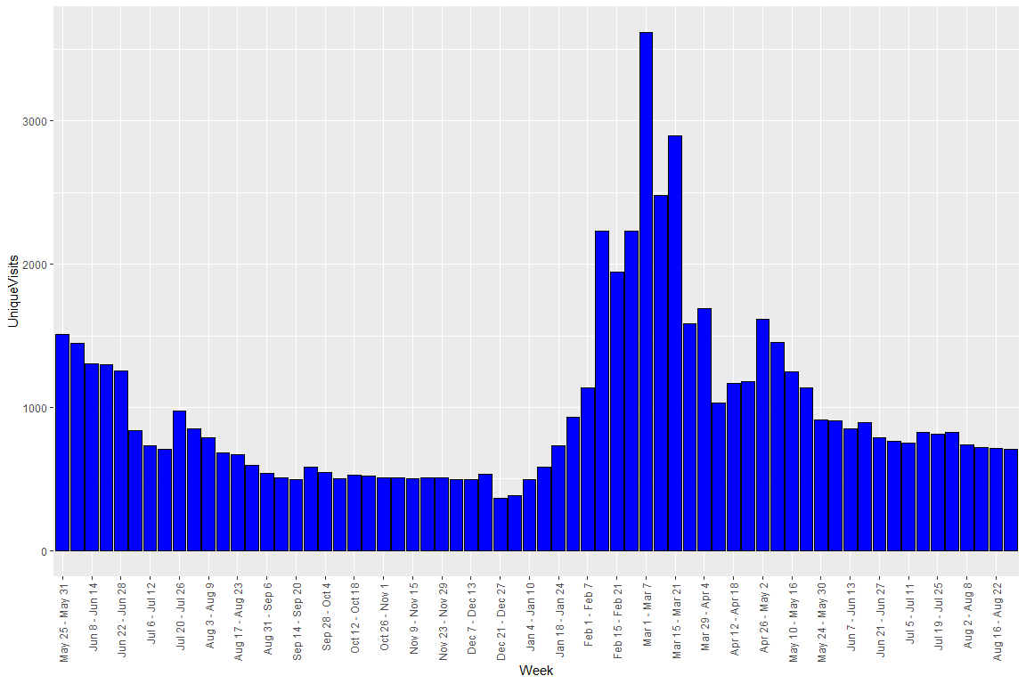

### b. revenue over time,

p + geom_bar(aes(y = Revenue), stat = "identity", fill = "blue", color = "black")

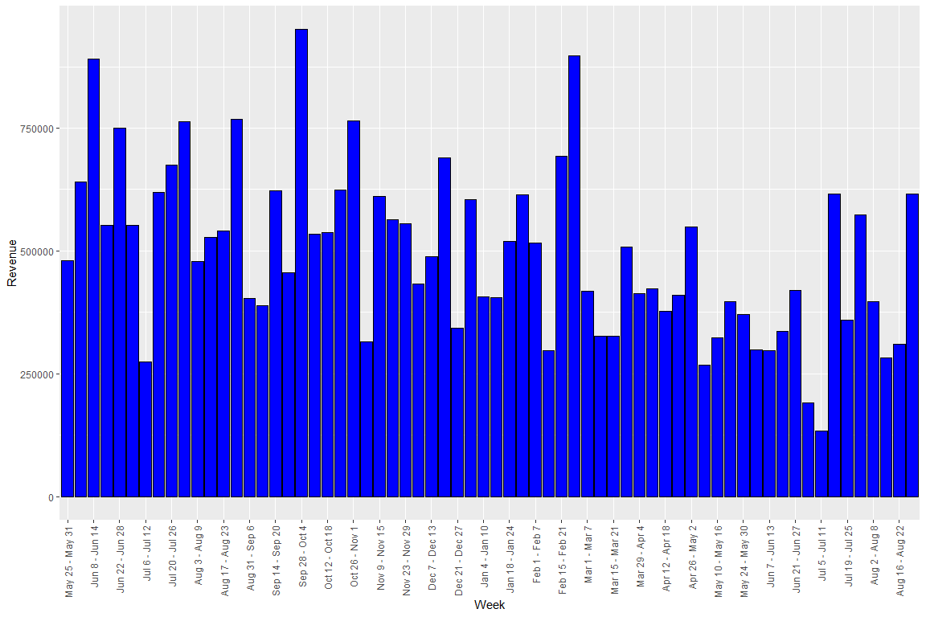

### c. profit over time

p + geom_bar(aes(y = Profit), stat = "identity", fill = "blue", color = "black")

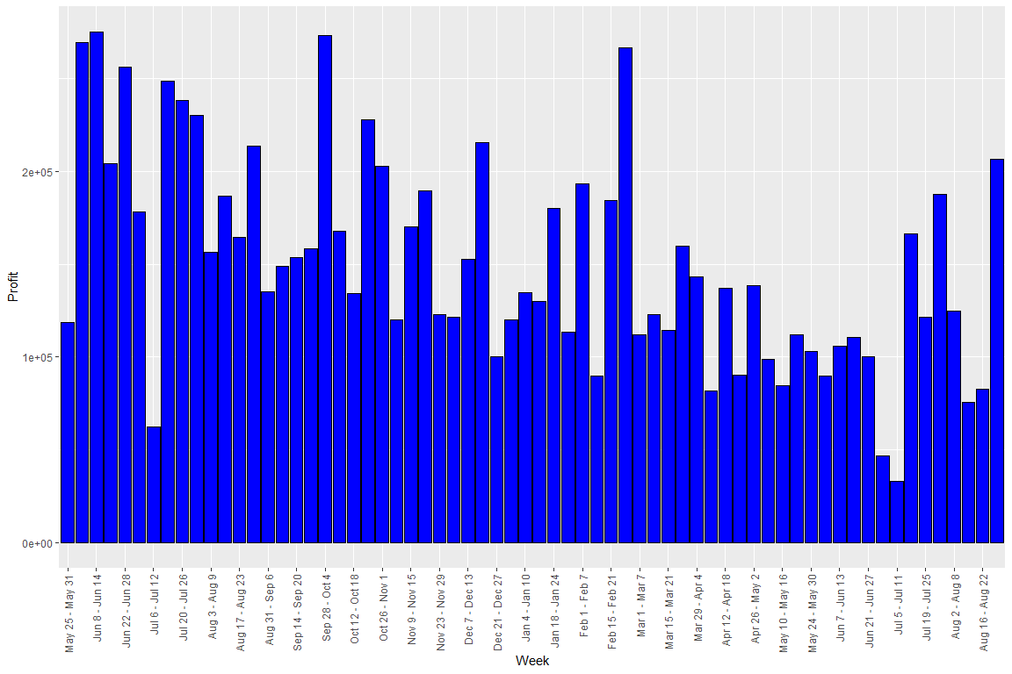

### d. pounds sold over time.

p + geom_bar(aes(y = LbsSold), stat = "identity", fill = "blue", color = "black")

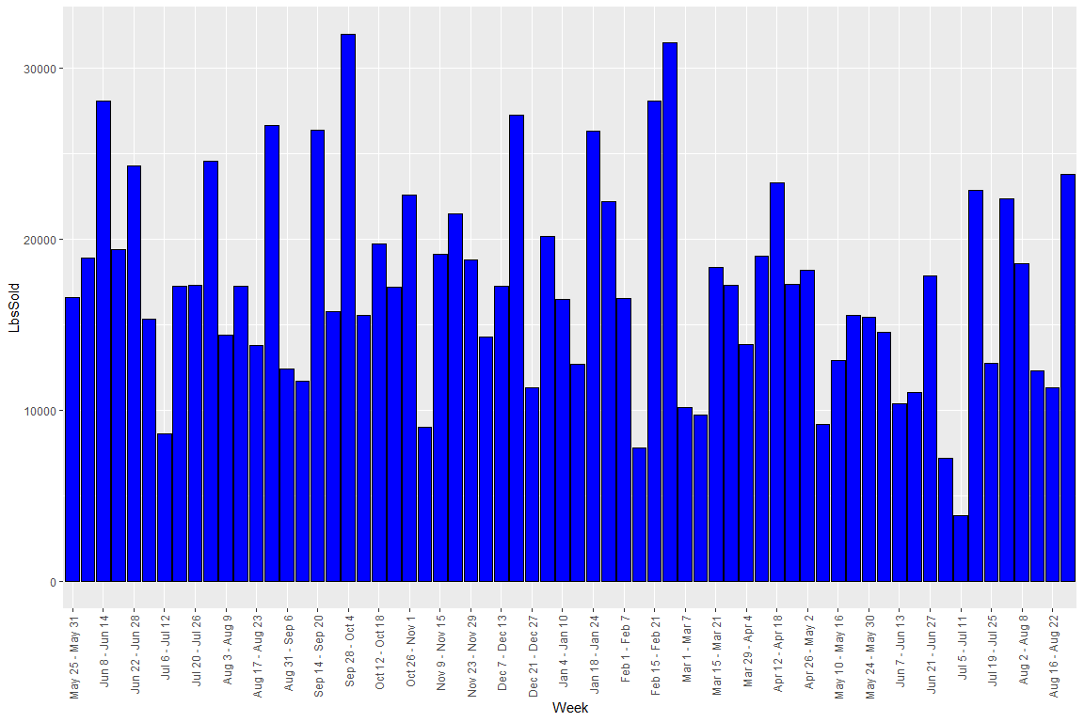

## 2.