QualityAlloys

Manish Grewal

26/07/2020

## Executive Summary

### Executive summary description here

## Load libraries

## Set working directory

## Load the dataset

## 1. Column Charts

### Initialize the common plot data

### a. unique visits over time

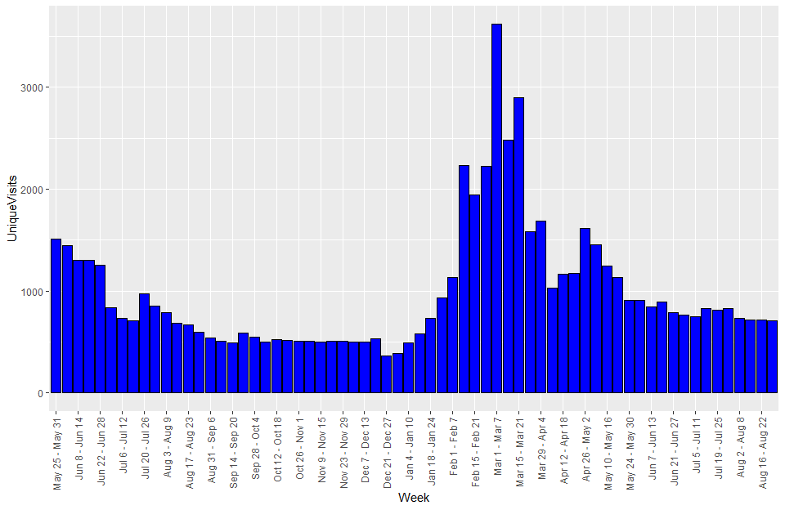

### b. revenue over time,

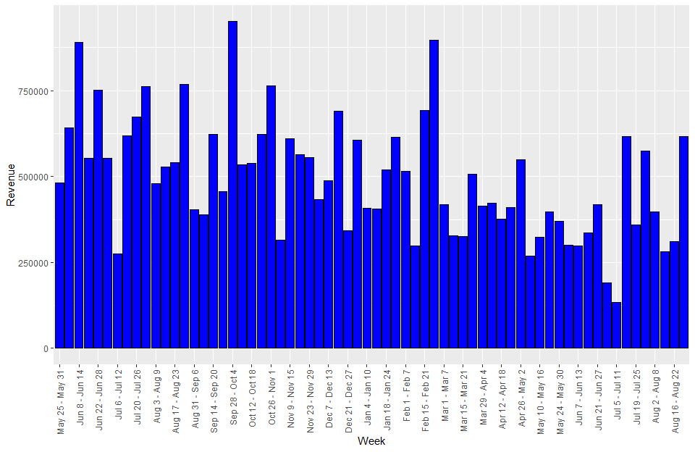

### c. profit over time

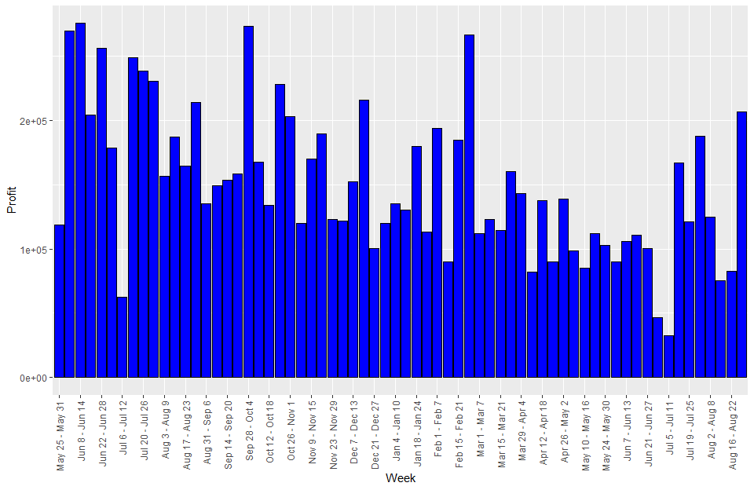

### d. pounds sold over time.

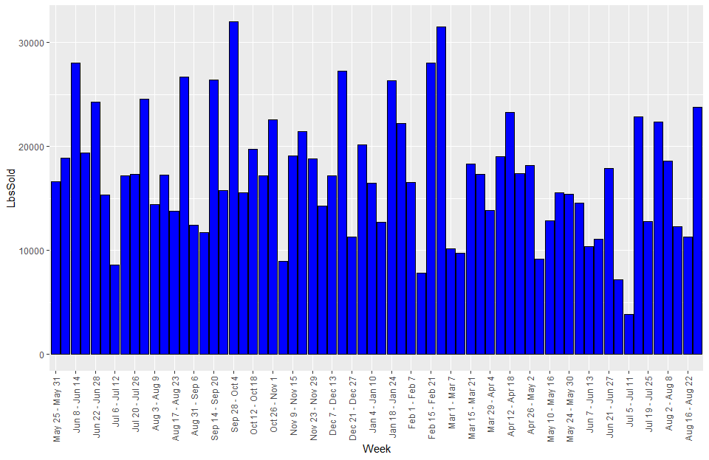

## 2. Summary by period

### a. Summary table of Initial Period

VISIT AND FINANCIAL SUMMARY MEASURES - INITIAL PERIOD

|  |  |  |  |  |  |
| --- | --- | --- | --- | --- | --- |
|  | Visits | UniqueVisits | Revenue | Profit | LbsSold |
| mean | 1055.2143 | 975.9286 | 608250.1 | 200233.41 | 18736.729 |
| median | 899.0000 | 845.5000 | 586169.7 | 208913.00 | 17269.696 |
| std. dev. | 355.0333 | 319.5972 | 155930.4 | 60691.55 | 5427.393 |
| minimum | 626.0000 | 594.0000 | 274567.6 | 62580.40 | 8633.059 |
| maximum | 1632.0000 | 1509.0000 | 890076.7 | 275218.10 | 28052.924 |

### b. Summary table of Pre-promotion Period

VISIT AND FINANCIAL SUMMARY MEASURES - PRE PROMOTION PERIOD

|  |  |  |  |  |  |
| --- | --- | --- | --- | --- | --- |
|  | Visits | UniqueVisits | Revenue | Profit | LbsSold |
| mean | 562.95238 | 516.80952 | 534313.5 | 159932.03 | 18440.774 |
| median | 558.00000 | 510.00000 | 534541.7 | 152476.40 | 17215.118 |
| std. dev. | 80.87118 | 70.93914 | 150502.8 | 42682.68 | 5965.630 |
| minimum | 383.00000 | 366.00000 | 315647.1 | 100388.40 | 8992.422 |
| maximum | 795.00000 | 734.00000 | 951216.2 | 273174.70 | 31968.976 |

### c. Summary table of Promotion Period

VISIT AND FINANCIAL SUMMARY MEASURES - PROMOTION PERIOD

|  |  |  |  |  |  |
| --- | --- | --- | --- | --- | --- |
|  | Visits | UniqueVisits | Revenue | Profit | LbsSold |
| mean | 1814.3529 | 1738.8235 | 456398.8 | 131929.90 | 17112.923 |
| median | 1663.0000 | 1585.0000 | 413937.1 | 114328.40 | 17299.115 |
| std. dev. | 758.1017 | 743.0253 | 161741.1 | 47776.85 | 6519.071 |
| minimum | 1000.0000 | 930.0000 | 268159.5 | 81841.40 | 7814.050 |
| maximum | 3726.0000 | 3617.0000 | 897163.7 | 266476.70 | 31496.257 |

### d. Summary table of Post-promotion Period

VISIT AND FINANCIAL SUMMARY MEASURES - POST PROMOTION PERIOD

|  |  |  |  |  |  |
| --- | --- | --- | --- | --- | --- |
|  | Visits | UniqueVisits | Revenue | Profit | LbsSold |
| mean | 856.57143 | 800.78571 | 371728.0 | 111045.82 | 14577.794 |
| median | 847.50000 | 800.00000 | 348397.1 | 104530.45 | 13646.895 |
| std. dev. | 70.88855 | 72.35615 | 145728.3 | 49065.27 | 5941.556 |
| minimum | 772.00000 | 709.00000 | 133966.9 | 32825.30 | 3825.748 |
| maximum | 963.00000 | 912.00000 | 615950.2 | 206441.20 | 23761.614 |

## 3. Column chart of the means over the four periods

### a. Mean Visits by Period

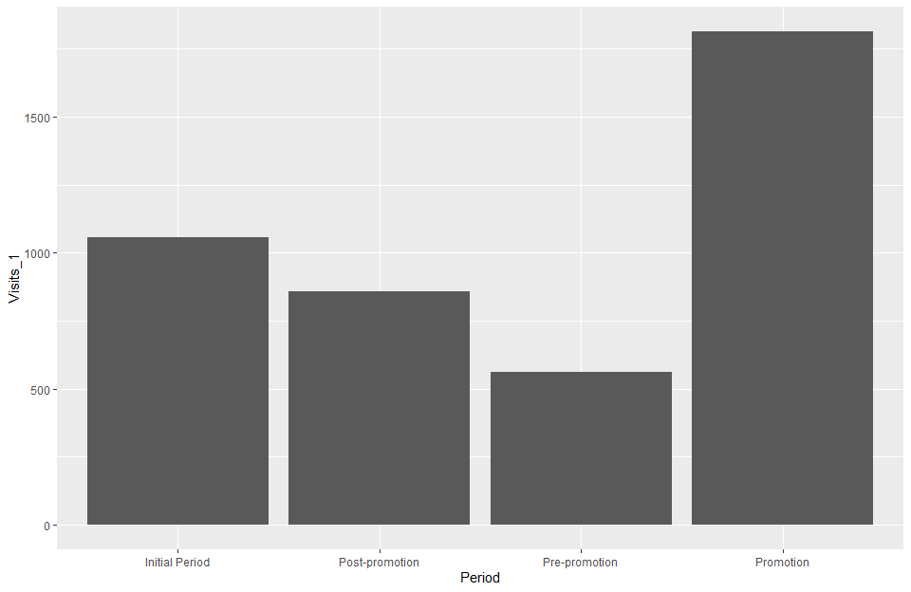

### b. Mean Unique Visits by Period

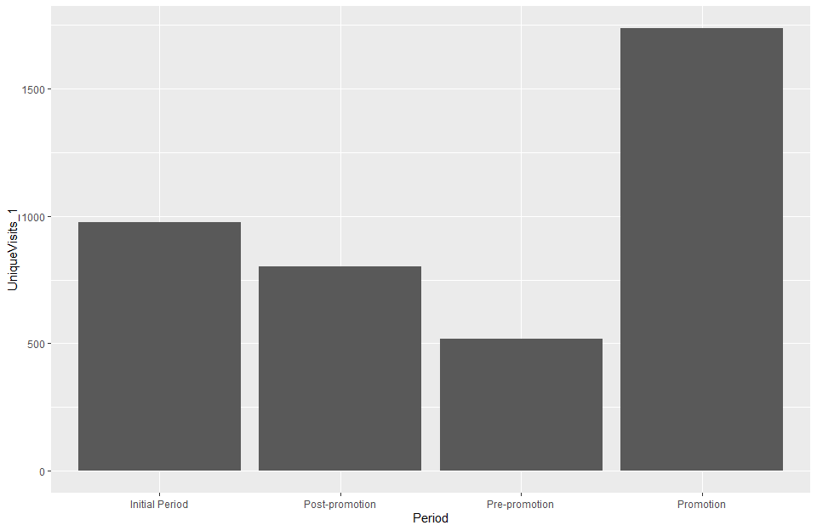

### c. Mean Revenue by Period

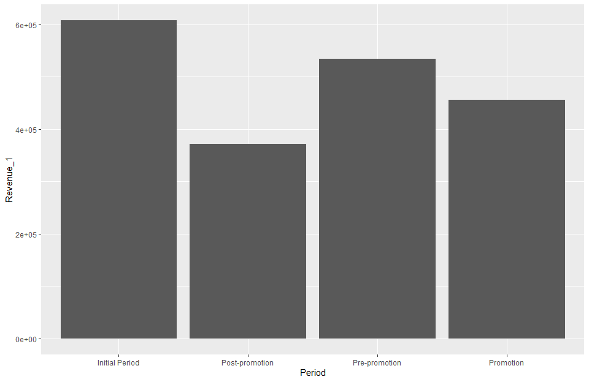

### d. Mean Profit by Period

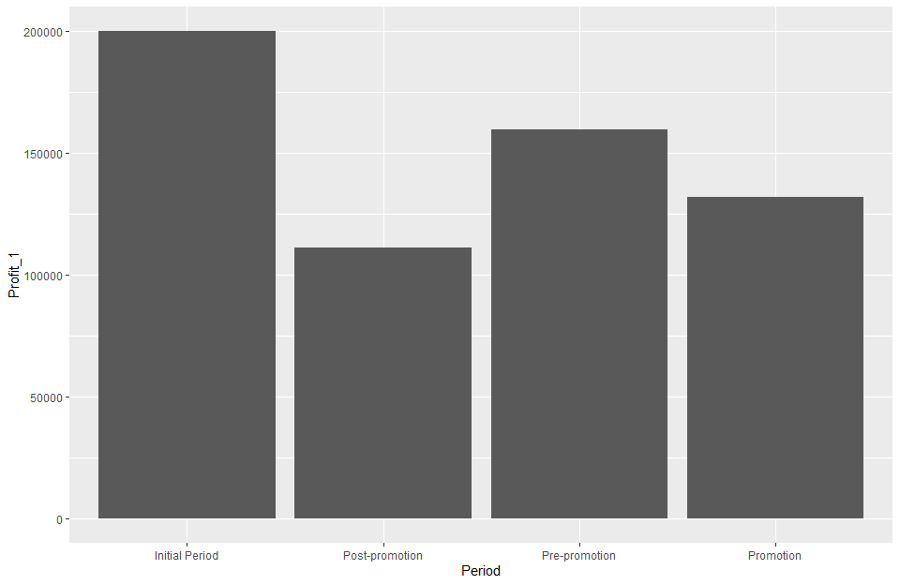

### e. Mean Lbs. Sold by Period

## Warning: Ignoring unknown parameters: stat

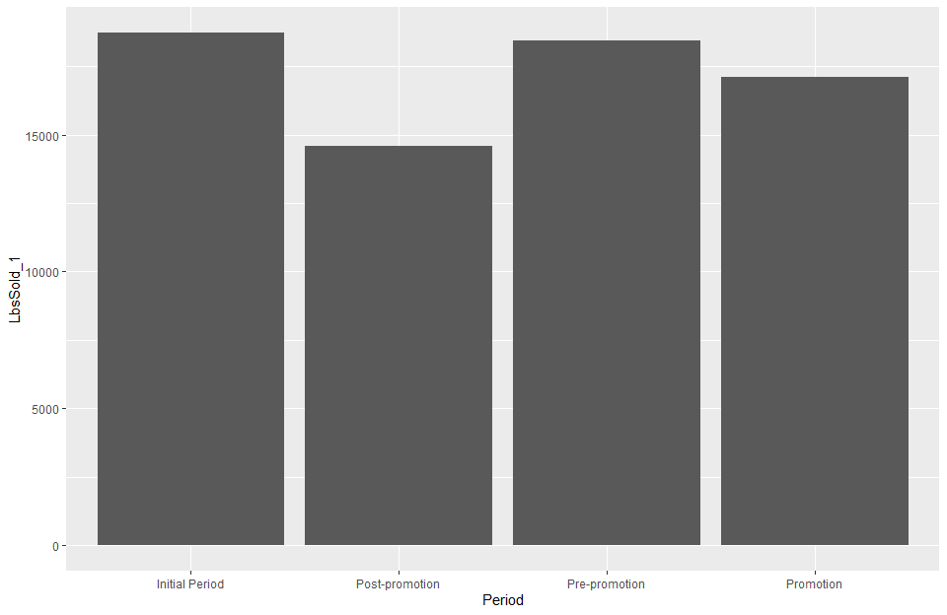

## 4. Summary of findings thus far

#### Average visits and average unique visits have shown a marked increase in promotion period. However, profit, revenue and lbs. sold show a steady declining trend over the four periods. This suggests that the website promotion did not have a positive effect on financials.

## 5. Revenue and Lbs. Sold

### a. Scatter plot Revenue and Lbs. Sold

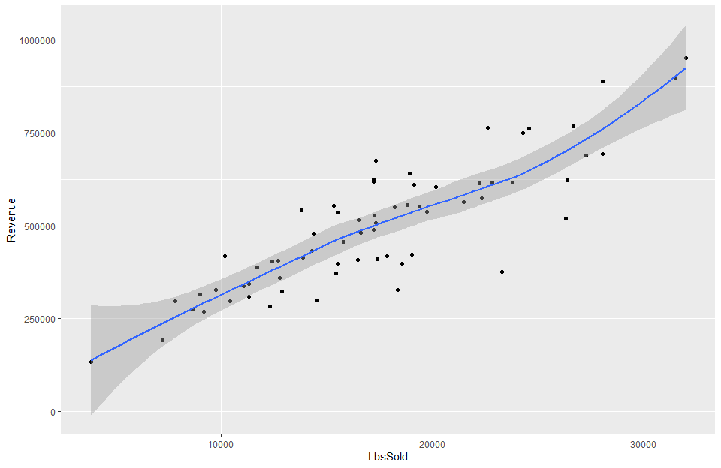

### b. Coefficient of Correlation

## [1] 0.8689297

## 6. Revenue and Visits

### a. Scatter plot Revenue and Visits

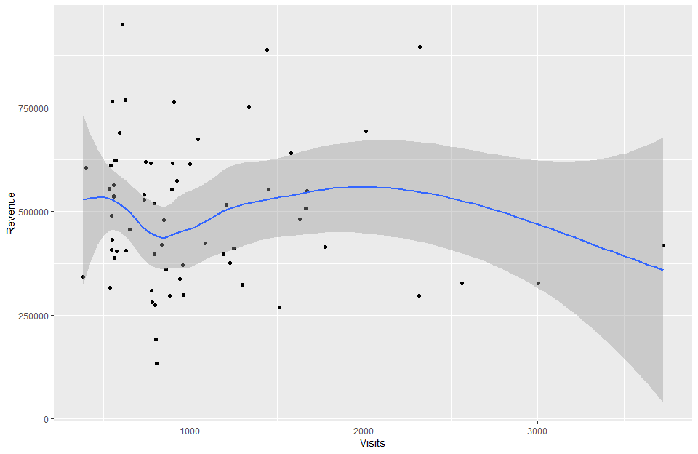

## 7. Summary of results

The scatterplot mirrors the earlier observations from Q4. Revenue does not increase or decrease with visits

## 8. Modeling data

### a. Summary of Lbs. Sold data per week from January 3, 2005, through the week of July 19, 2010.

## [1] "Mean: 18681.5551724138"

## [1] "Median: 17673"

## [1] "Std. Dev.: 6840.50793952086"

## [1] "Minimum: 3826"

## [1] "Maximum: 44740"

### b. Histogram of the pounds of material sold data.

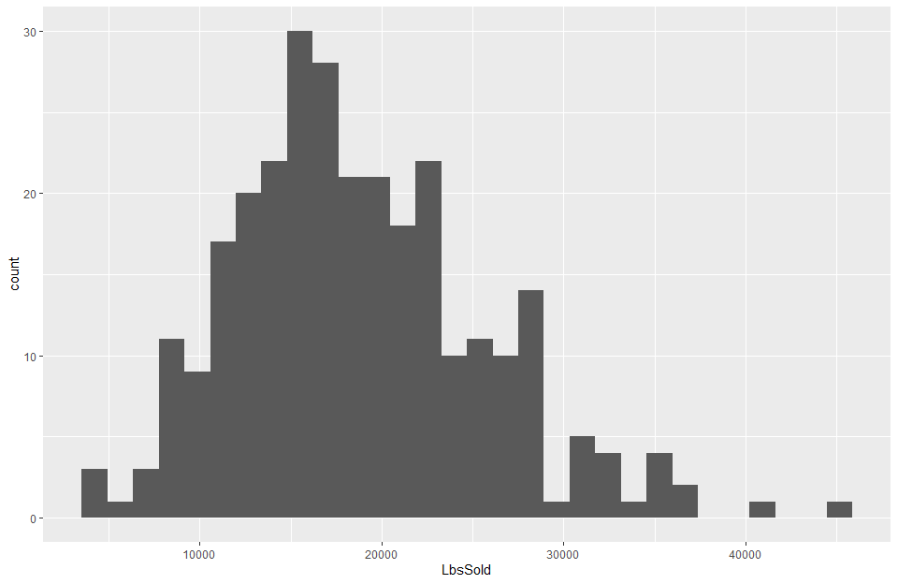

### c. Histogram appears bell shaped with few outliers on the right side. Also, mean is greater than median, so the data is right skewed.

### d. Empirical rule

|  |  |  |  |
| --- | --- | --- | --- |
| Interval | TheoreticalPctOfData | TheoreticalNoOfObs | ActualNoOfObs |
| mean ± 1 std. dev. | 68 | 197.2 | 201 |
| mean ± 2 std. dev. | 95 | 275.5 | 276 |
| mean ± 3 std. dev. 99% | 99 | 287.1 | 288 |

### e. Refine empirical rule

|  |  |  |  |
| --- | --- | --- | --- |
| Interval | TheoreticalPctOfData | TheoreticalNoOfObs | ActualNoOfObs |
| mean + 1 std. dev. | 34.101 | 99 | 84 |
| mean - 1 std. dev. | 34.065 | 99 | 117 |
| 1 std. dev. to 2 std. dev. | 13.669 | 40 | 35 |
| -1 std. dev. to -2 std. dev. | 13.631 | 40 | 40 |
| 2 std. dev. to 3 std. dev. | 2.139 | 6 | 9 |
| -2 std. dev. to -3 std. dev. | 2.131 | 6 | 3 |