QualityAlloys

Manish Grewal

26/07/2020

# PART 1 - EXECUTIVE SUMMARY

Your report should be submitted in two parts. The first part should be an executive summary, one to two pages in length. It should summarize results and provide recommendations to QA managers as to how they might best market their business with an aim towards improving sales.

effectiveness of QA’s promotional effort.

The goals of the company’s website were to (a) drive new sales, (b) make product and contact information available, and (c) give or add legitimacy to its brand.

extend its reach to many more customers in the United States, Europe, and Asia.

How many people visit the website? How do they come to the website? • Is the website generating interest, and does this interest yield actual sales? • Do traditional promotions drive web traffic, and in turn drive incremental sales? • How can visits to the website best be modeled? • Where and how should QA advertise?

ROI impact

Country level revenue / profit data needed for evealuting goal, internationalization priority

Adwords working

# PART 2 - DATA ANALYSIS

## 1. Column Charts

### a. unique visits over time

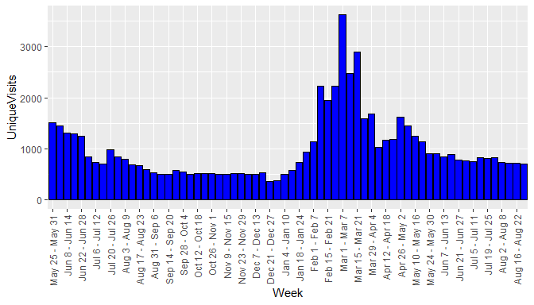

### b. revenue over time,

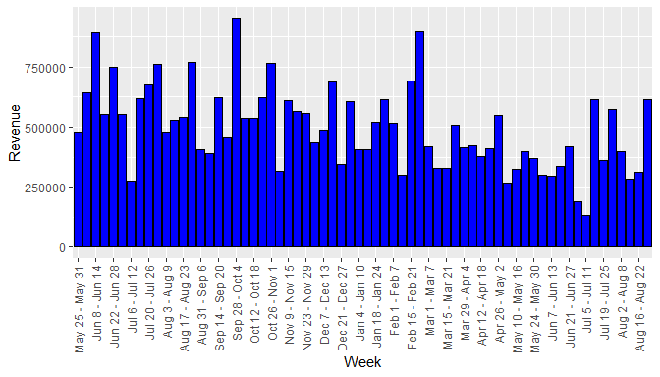

### c. profit over time

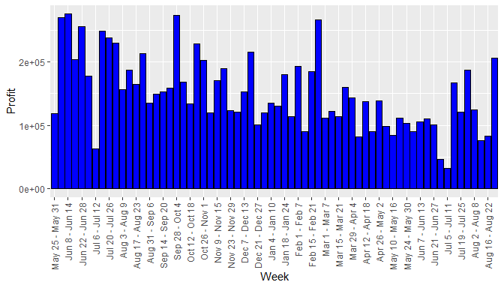

### d. pounds sold over time.

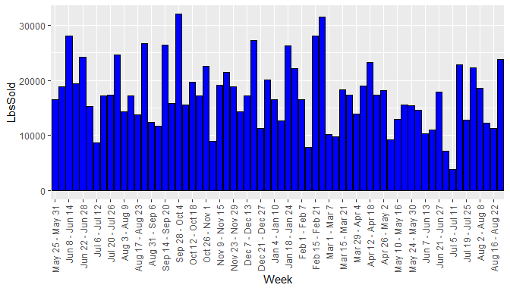

## 2. Summary by period

### a. Summary table of Initial Period

VISIT AND FINANCIAL SUMMARY MEASURES - INITIAL PERIOD

|  |  |  |  |  |  |
| --- | --- | --- | --- | --- | --- |
|  | Visits | UniqueVisits | Revenue | Profit | LbsSold |
| mean | 1055.2143 | 975.9286 | 608250.1 | 200233.41 | 18736.729 |
| median | 899.0000 | 845.5000 | 586169.7 | 208913.00 | 17269.696 |
| std. dev. | 355.0333 | 319.5972 | 155930.4 | 60691.55 | 5427.393 |
| minimum | 626.0000 | 594.0000 | 274567.6 | 62580.40 | 8633.059 |
| maximum | 1632.0000 | 1509.0000 | 890076.7 | 275218.10 | 28052.924 |

### b. Summary table of Pre-promotion Period

VISIT AND FINANCIAL SUMMARY MEASURES - PRE PROMOTION PERIOD

|  |  |  |  |  |  |
| --- | --- | --- | --- | --- | --- |
|  | Visits | UniqueVisits | Revenue | Profit | LbsSold |
| mean | 1814.3529 | 1738.8235 | 456398.8 | 131929.90 | 17112.923 |
| median | 1663.0000 | 1585.0000 | 413937.1 | 114328.40 | 17299.115 |
| std. dev. | 758.1017 | 743.0253 | 161741.1 | 47776.85 | 6519.071 |
| minimum | 1000.0000 | 930.0000 | 268159.5 | 81841.40 | 7814.050 |
| maximum | 3726.0000 | 3617.0000 | 897163.7 | 266476.70 | 31496.257 |

### c. Summary table of Promotion Period

VISIT AND FINANCIAL SUMMARY MEASURES - PROMOTION PERIOD

|  |  |  |  |  |  |
| --- | --- | --- | --- | --- | --- |
|  | Visits | UniqueVisits | Revenue | Profit | LbsSold |
| mean | 856.57143 | 800.78571 | 371728.0 | 111045.82 | 14577.794 |
| median | 847.50000 | 800.00000 | 348397.1 | 104530.45 | 13646.895 |
| std. dev. | 70.88855 | 72.35615 | 145728.3 | 49065.27 | 5941.556 |
| minimum | 772.00000 | 709.00000 | 133966.9 | 32825.30 | 3825.748 |
| maximum | 963.00000 | 912.00000 | 615950.2 | 206441.20 | 23761.614 |

### d. Summary table of Post-promotion Period

VISIT AND FINANCIAL SUMMARY MEASURES - POST PROMOTION PERIOD

|  |  |  |  |  |  |
| --- | --- | --- | --- | --- | --- |
|  | Visits | UniqueVisits | Revenue | Profit | LbsSold |
| mean | 562.95238 | 516.80952 | 534313.5 | 159932.03 | 18440.774 |
| median | 558.00000 | 510.00000 | 534541.7 | 152476.40 | 17215.118 |
| std. dev. | 80.87118 | 70.93914 | 150502.8 | 42682.68 | 5965.630 |
| minimum | 383.00000 | 366.00000 | 315647.1 | 100388.40 | 8992.422 |
| maximum | 795.00000 | 734.00000 | 951216.2 | 273174.70 | 31968.976 |

## 3. Column chart of the means over the four periods

### a. Mean Visits by Period

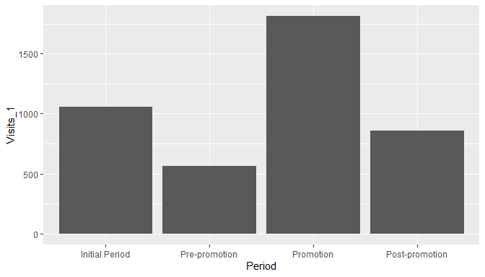

### b. Mean Unique Visits by Period

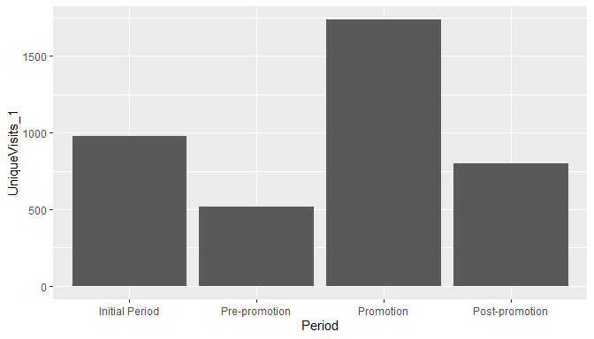

### c. Mean Revenue by Period

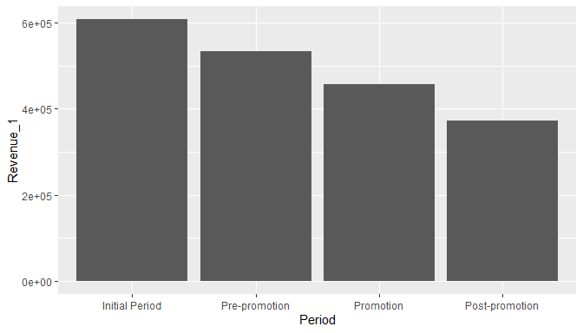

### d. Mean Profit by Period

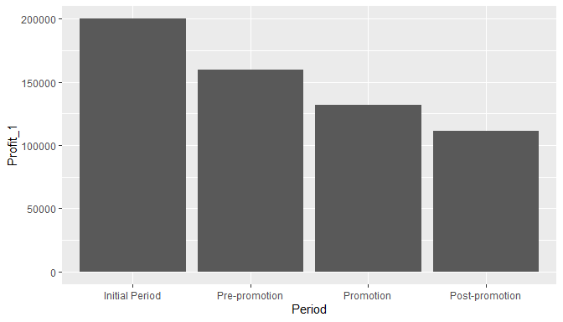

### e. Mean Lbs. Sold by Period

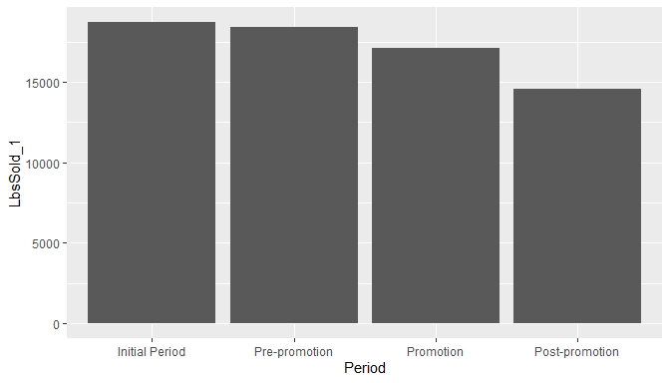

## 4. Summary of findings thus far

Average visits and average unique visits have shown a marked increase in promotion period. However, profit, revenue and lbs. sold show a steady declining trend over the four periods. This suggests that the website promotion did not have a positive effect on financials.

## 5. Revenue and Lbs. Sold

### a. Scatter plot Revenue and Lbs. Sold

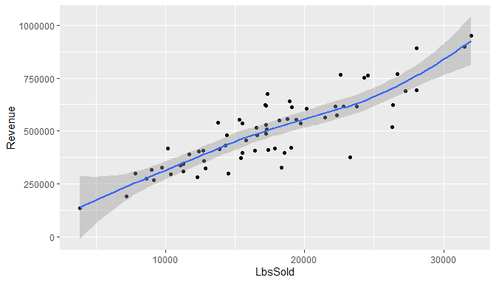

### b. Coefficient of Correlation

## [1] 0.8689297

## 6. Revenue and Visits

### a. Scatter plot Revenue and Visits

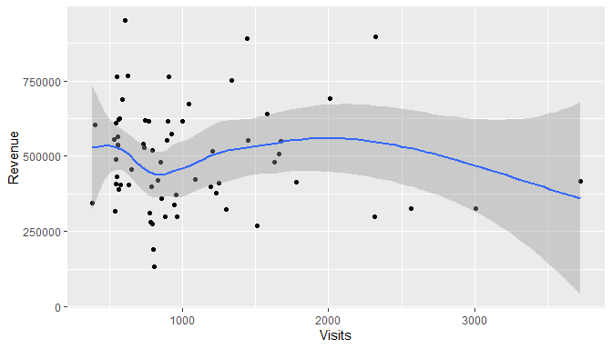

## 7. Summary of results

The scatterplot mirrors the earlier observations from Q4. Revenue does not increase or decrease with visits

## 8. Modeling data

### a. Summary of Lbs. Sold data per week from January 3, 2005, through the week of July 19, 2010.

## [1] "Mean: 18681.5551724138"

## [1] "Median: 17673"

## [1] "Std. Dev.: 6840.50793952086"

## [1] "Minimum: 3826"

## [1] "Maximum: 44740"

### b. Histogram of the pounds of material sold data.

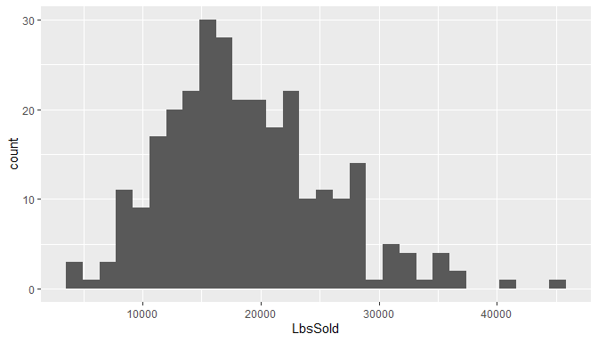

### c. Histogram description

Histogram appears bell shaped with a few outliers on the right side. Also, mean is greater than median, so the data is right skewed.

### d. Empirical rule

|  |  |  |  |
| --- | --- | --- | --- |
| Interval | TheoreticalPctOfData | TheoreticalNoOfObs | ActualNoOfObs |
| mean ± 1 std. dev. | 68 | 197.2 | 201 |
| mean ± 2 std. dev. | 95 | 275.5 | 276 |
| mean ± 3 std. dev. 99% | 99 | 287.1 | 288 |

### e. Refine empirical rule

|  |  |  |  |
| --- | --- | --- | --- |
| Interval | TheoreticalPctOfData | TheoreticalNoOfObs | ActualNoOfObs |
| mean + 1 std. dev. | 34.101 | 99 | 84 |
| mean - 1 std. dev. | 34.065 | 99 | 117 |
| 1 std. dev. to 2 std. dev. | 13.669 | 40 | 35 |
| -1 std. dev. to -2 std. dev. | 13.631 | 40 | 40 |
| 2 std. dev. to 3 std. dev. | 2.139 | 6 | 9 |
| -2 std. dev. to -3 std. dev. | 2.131 | 6 | 3 |

### f. pound of material sold bell shaped?

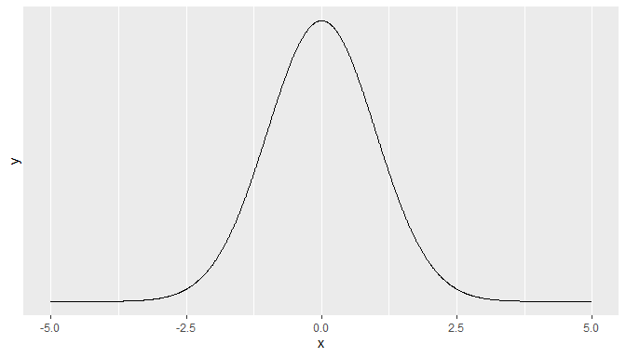

From the

### g. Skweness and Kurtosis

## [1] "Skewness using formula: 3*(mean-median)/sd = 0.442315913378401"

## [1] "Skewness using library = 0.629032218484559"

## [1] "Kurtosis = 3.53337138531912"

## 9. Comparison of the distribution of the pounds sold data with that of the daily visit data.

Daily visits seems more skewed

## 10. Demographics

## a. All Traffic Sources

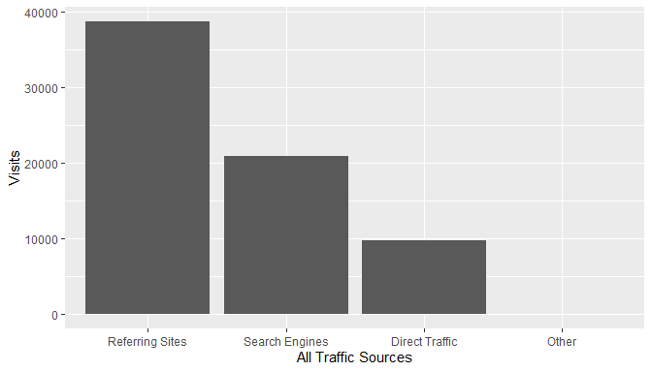

There is significant Direct Traffic, which could be a result of the website link socialized in the promotion. Traffic from search engines could be increased with the help of SEO (Search engine optimization).

## b. Top Ten Referring Sites

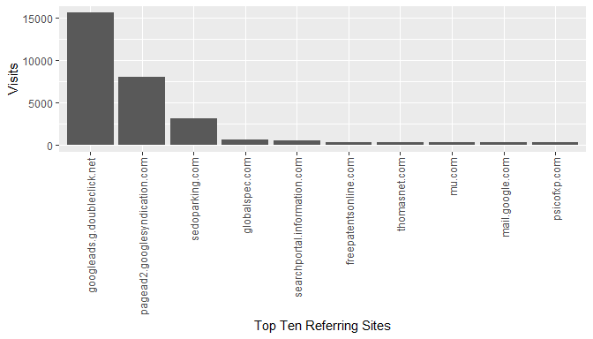

The paid listings on globalspec are generating more referrals than thomasnet, however, both of them together are not generating much referrals compared to google ads.

The traffic from sedoparking.com may need to be investigated more as it could indicate users mistyping the QA website address and landing on a parked domain with a similar name.

## c. Top Ten Search Engine Sources of Visits

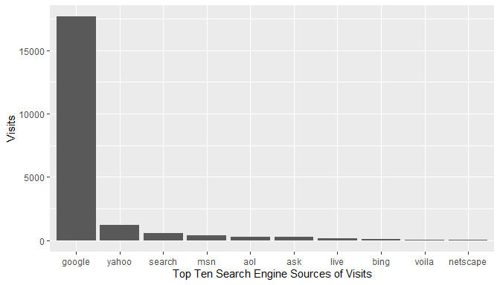

As expected, google is the top search engine source of visits. SEO should be targeted at google search engine.

## d. Top Ten Geographic Sources by Sub Continent Region

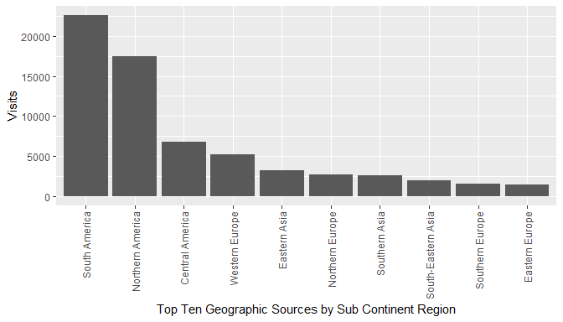

As the traffic is coming from various geographies, it may be a good idea to support multiple languages on the website (internationalization).

## e. Top Ten Browsers Used

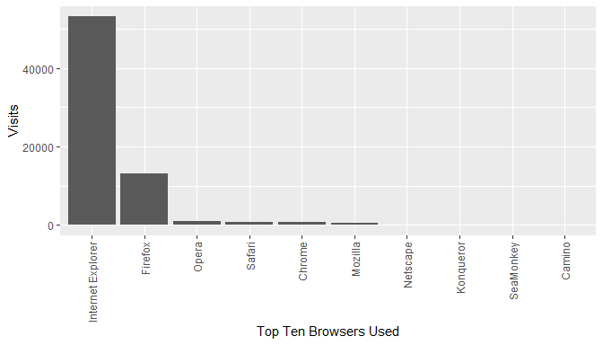

Website development / testing should focus on Internet Explorer and Firefox compatibility / support.

## f. Top Ten Operating Systems Used

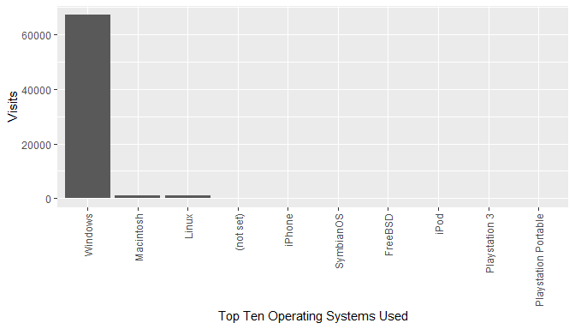

Website development / testing should focus on Windows platform, followed by Mac and Linux.