In near duplicates project student is asking to get near duplicates images also apart from text documents. So u can put all similar or related or duplicates images inside ‘images’ folder like below screen shots.

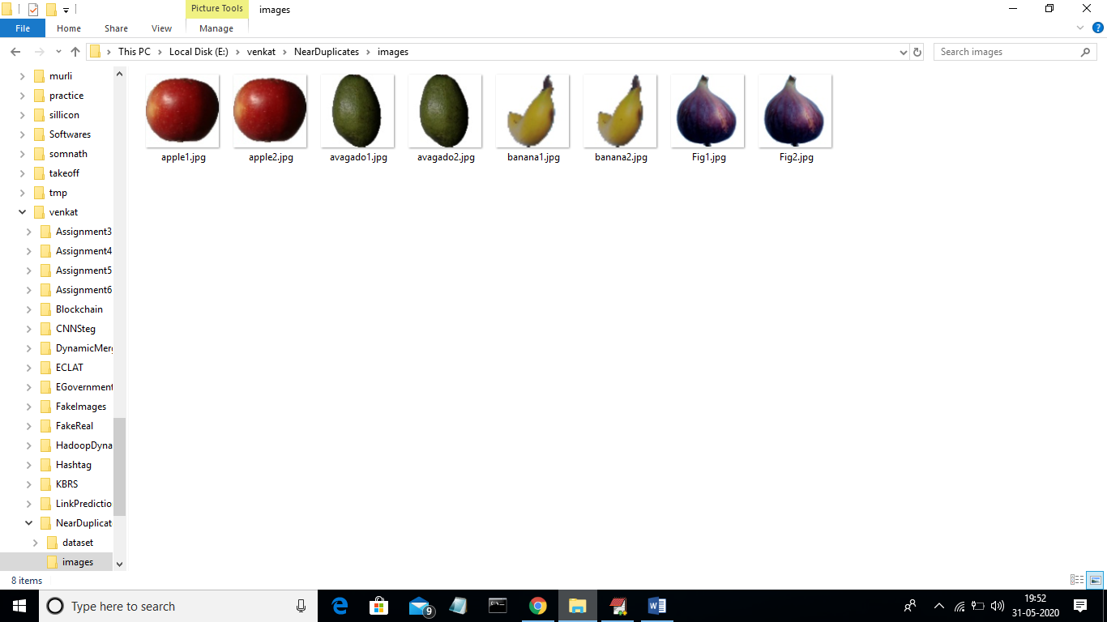

In above screen I put some related fruit images inside ‘images’ folder and you too can put your own images also. Now run code by double click on ‘run.bat’ to get below screen

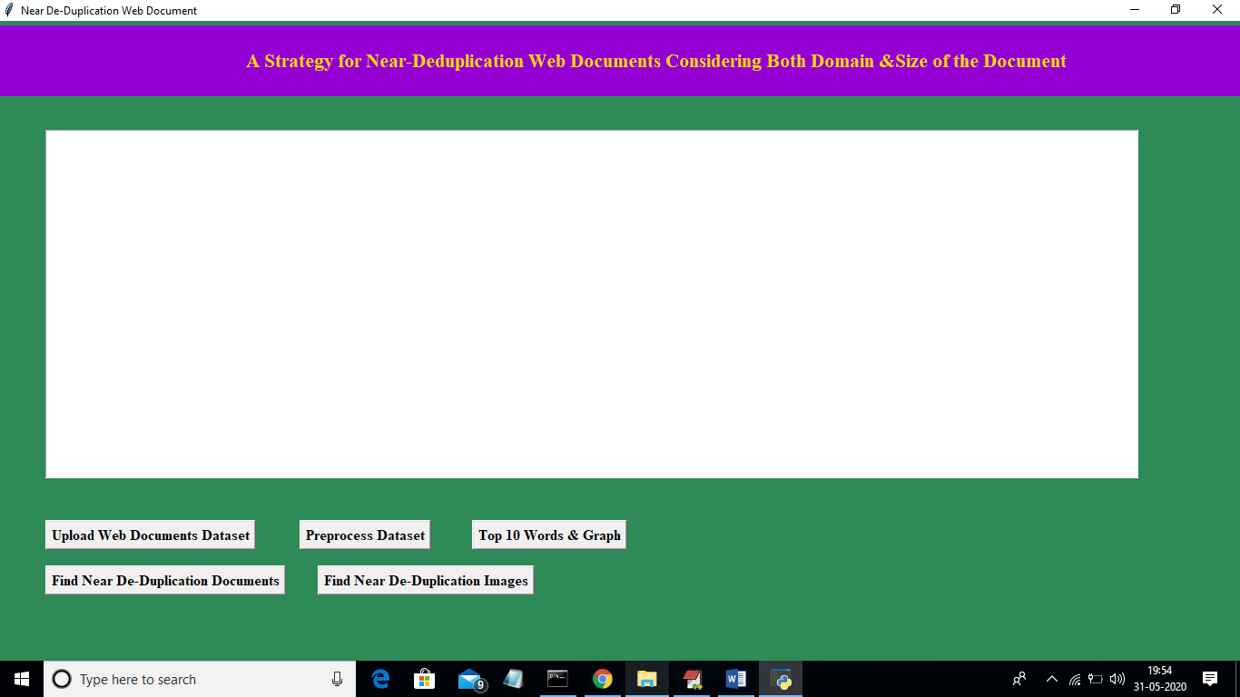

In above screen click on last button called ‘Find Near Duplicates Images’ button to allow application to find near duplicates and to get below screen

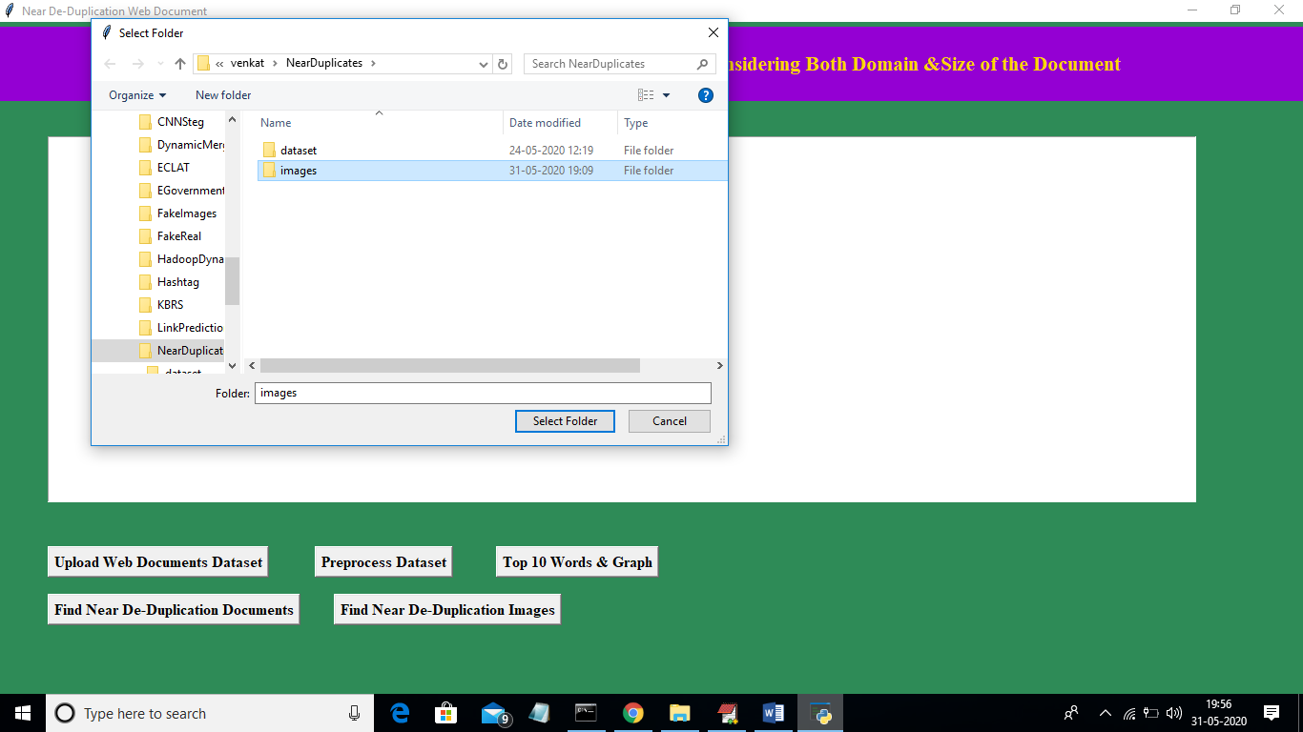

In above screen I am selecting and uploading ‘images’ folder and then click on ‘Select Folder’ button to get below output

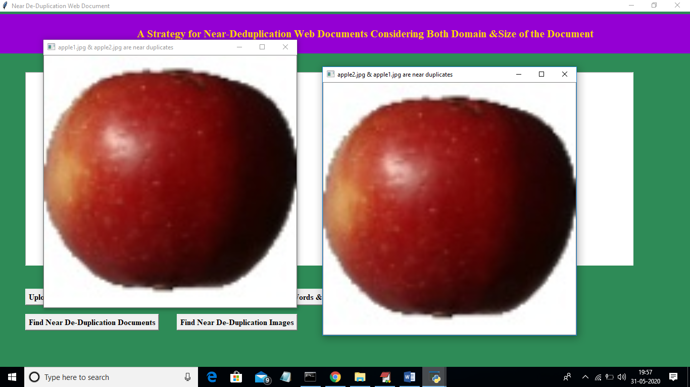in above screen application displaying what are the two images are near duplicates and we can see details in title bar of images. Now close those two images so application will find other 2 near images and continues till all images checking process are over. Now after closing above apple images will get below output

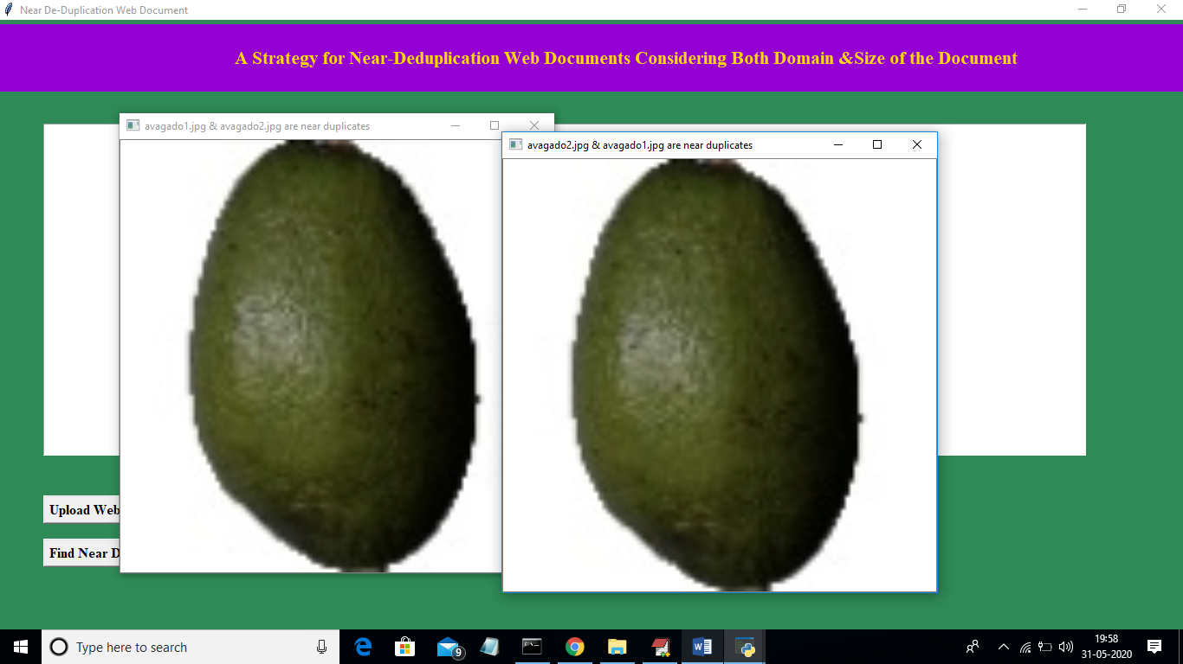

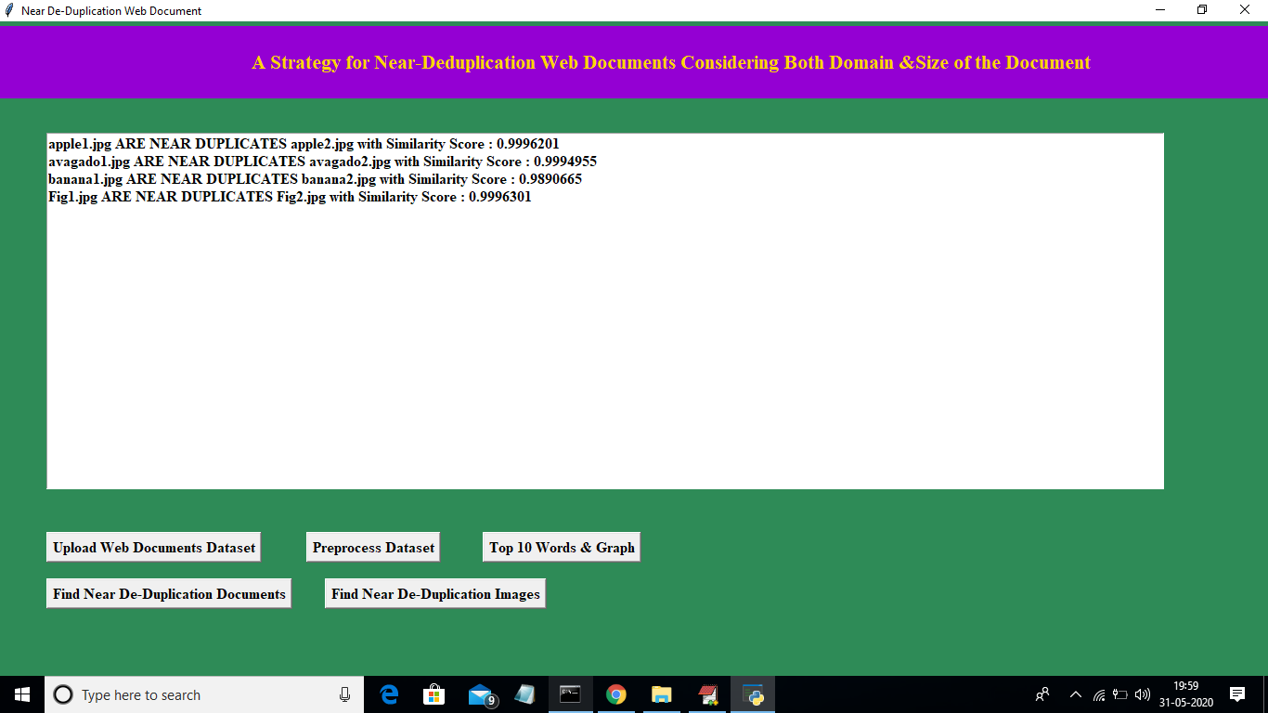

In above text area we can see what two images are near duplicates with similarity score