pH parameter
CNN Model
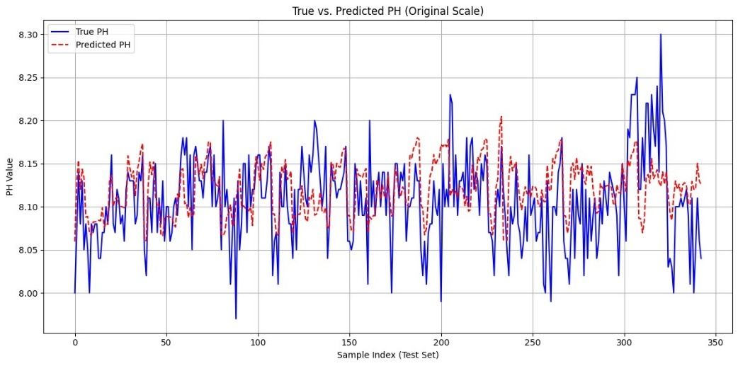
Fig 1: True vs Predicted PH
LSTM Model
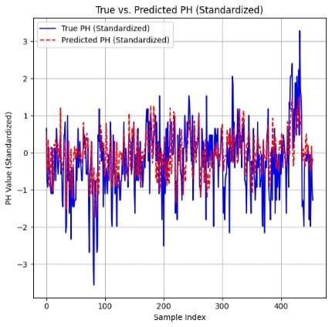
Fig 2: Ture vs predicted pH
GRU Model
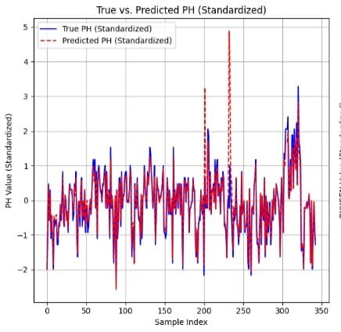
Fig 3: True vs Predicted pH
CNN +LSTM Model
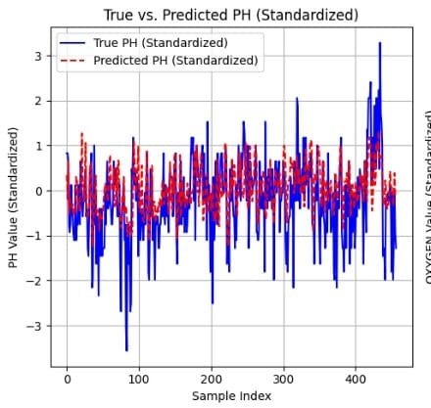
Fig 4: True vs Predicted pH
CNN+ Unet Model
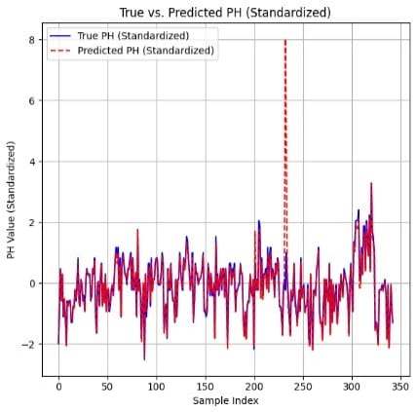
Fig 5: True vs Predicted pH
ANN Model
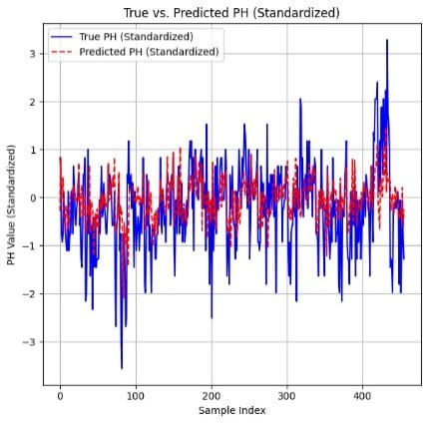
Fig 6: True vs predicted pH
GAM Model
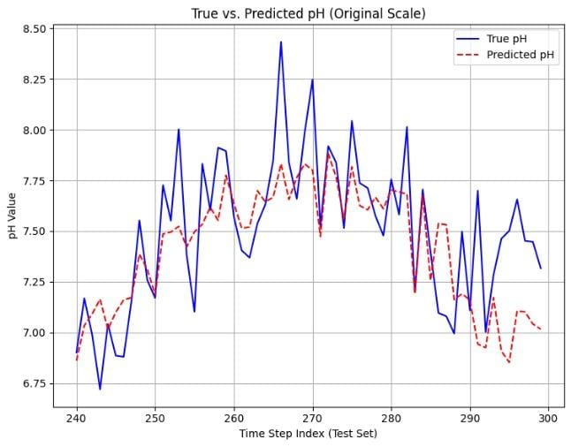
Fig 7: True vs Predicted pH
.
Dissolved Oxygen parameter
CNN Model
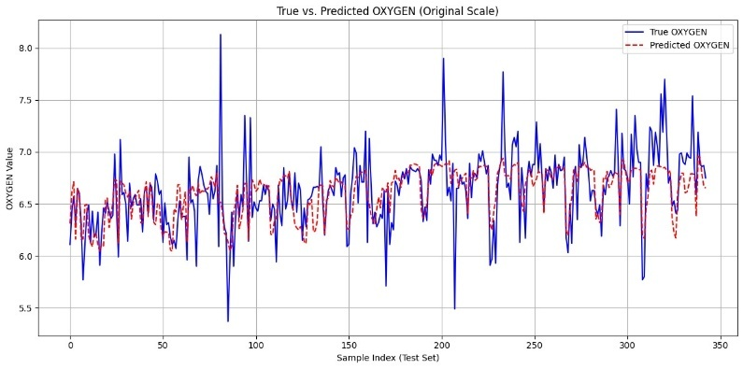
Fig 1: True vs Predicted Dissolved Oxygen

LSTM Model
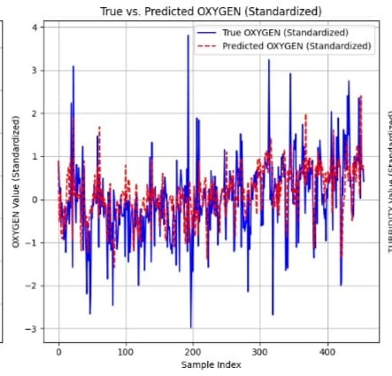
Fig 9: True vs Predicted Dissolved Oxygen
GRU Model
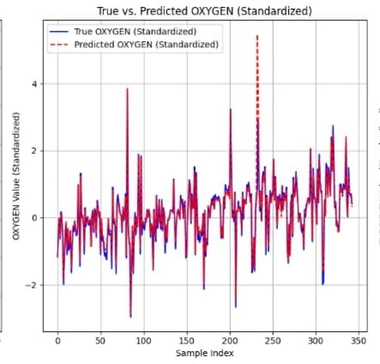
Fig 10: True vs Predicted Dissolved oxygen
CNN-LSTM Model
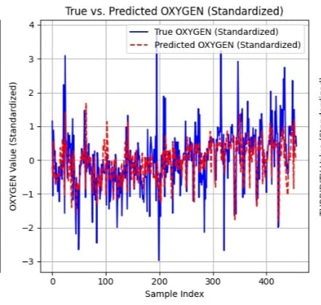
Fig 11: True vs predicted Dissolved oxygen
CNN-UNET Model
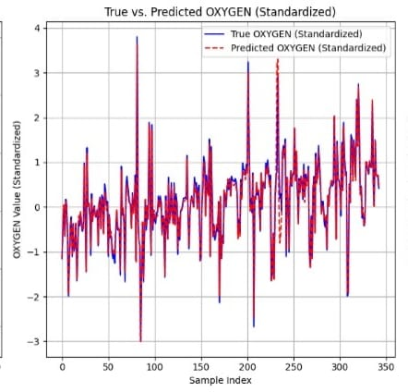
Fig 12: True vs predicted Dissolved oxygen
ANN Model
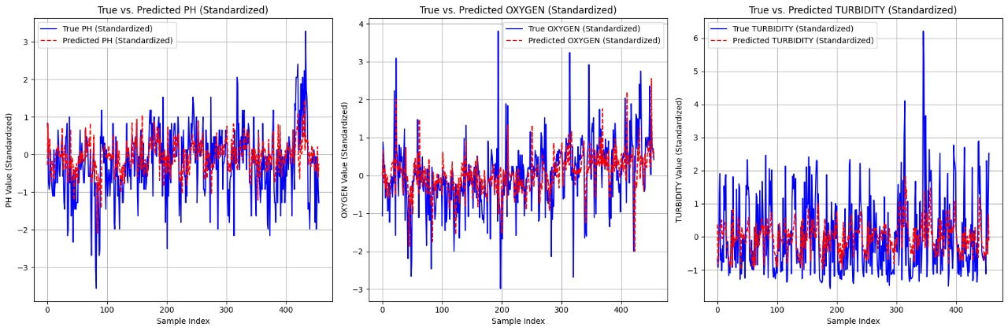
Fig 13: True vs predicted Dissolved oxygen
GAM Model
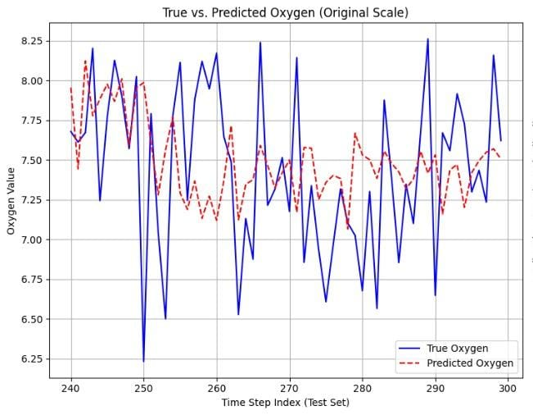
Fig 14: True vs predicted Dissolved oxygen
CNN Model
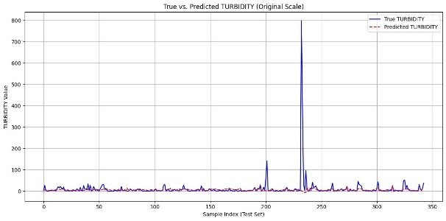
Fig 15: True vs predicted Turbidity
LSTM Model
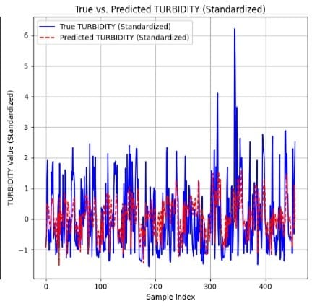
Fig 16: True vs predicted Turbidity
GRU Model
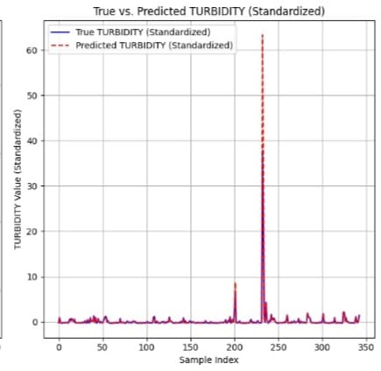
Fig 17: True vs predicted Turbidity
CNN-LSTM Model
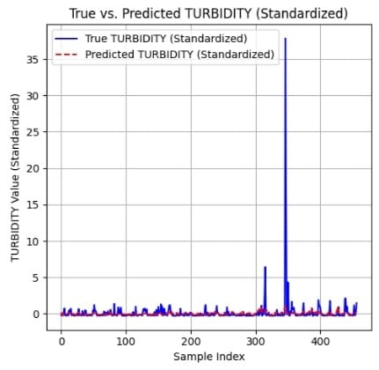
Fig 18: True vs predicted Turbidity
CNN-UNET Model
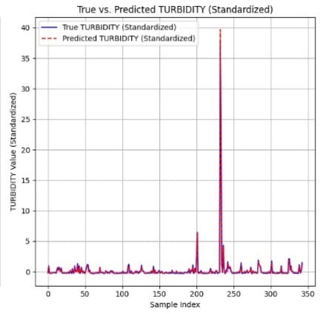
Fig 19: True vs predicted Turbidity
ANN Model
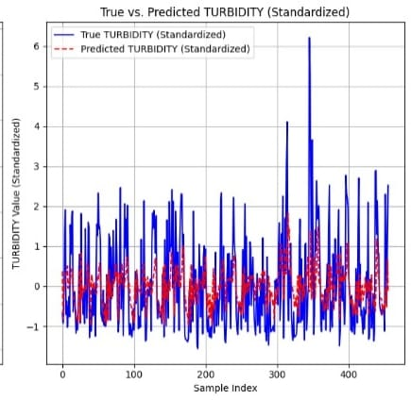
Fig 20: True vs predicted Turbidity
GAM Model
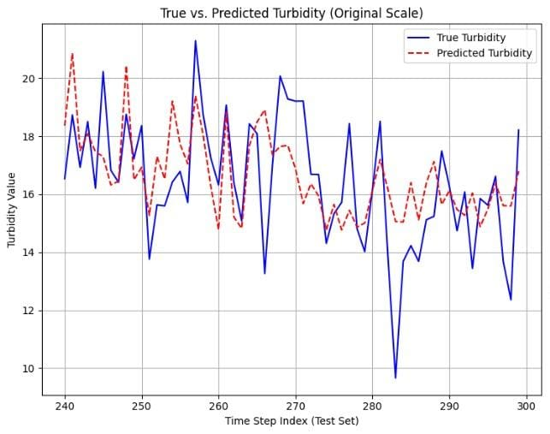
Fig 21: True vs predicted Turbidity
Salinity parameter
CNN Model
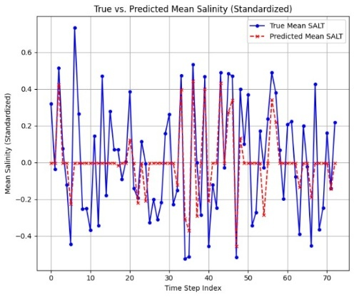
Fig 22: True vs predicted salinity
LSTM Model
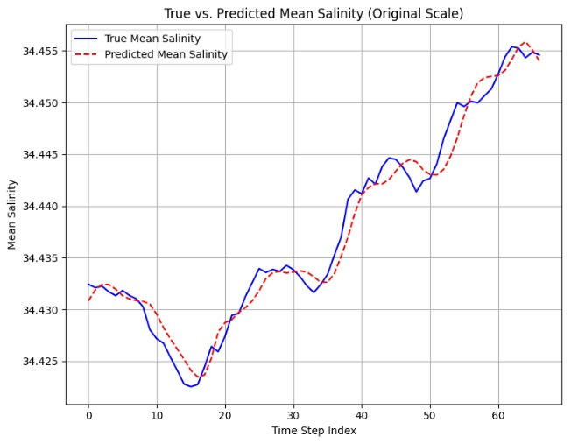
Fig 23: True vs predicted salinity
GRU Model
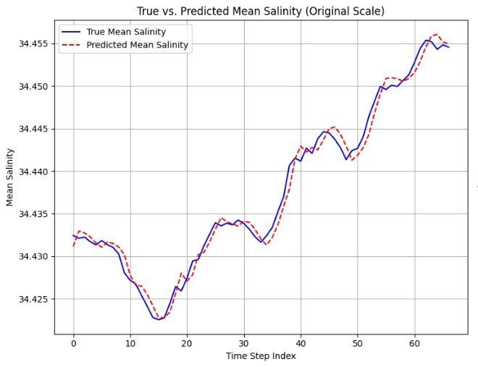
Fig 24: True vs predicted salinity
CNN-LSTM Model
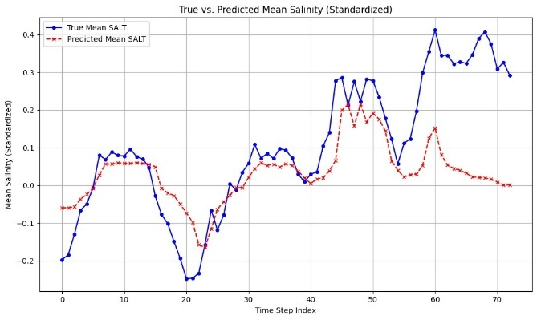
Fig 25: True vs predicted salinity
CNN-UNET Model
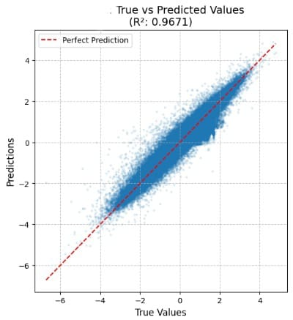
Fig 26: True vs predicted Salinity

ANN Model
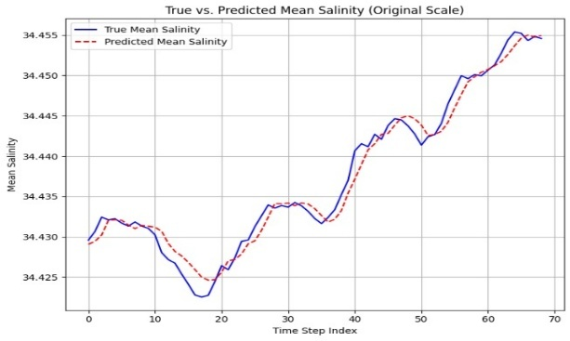
Fig 27: True vs predicted salinity
GAM Model
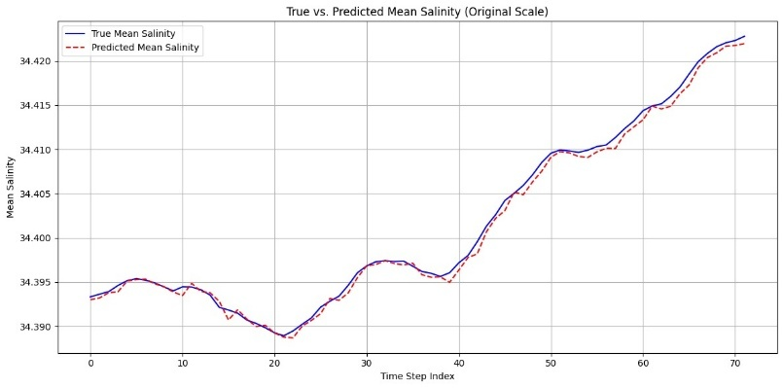
Fig 28: True vs predicted salinity

