Calculating Family Expenses using Service Now

Team Members:
- Manikandan S (Team Leader)
  - Mohamed Fayiz M
  - Mohamed Shalmansha S
  - Vishwa G
Department: Information Technology
Course: ServiceNow Administrator
Institution: A.V.C. College of Engineering
Mentor : Mr. N.P.K Ganesh Kumar A/S Prof., IT
Academic Year: 2025-2026

1. Abstract
The project aims to develop a comprehensive expense calculation system using ServiceNow. This system will enable users to track and manage family expenses efficiently. It will include features such as expense categorization, budget setting, real-time tracking, and reporting capabilities. Utilizing ServiceNow's robust platform, the project will ensure seamless integration, user-friendly interface, and scalability to accommodate varying family sizes and financial complexities. The end goal is to empower users with the tools they need to make informed financial decisions and promote financial well-being within the family unit.
2. Tasks Dones With Explanation
Step 1: Setting up ServiceNow Instance
- Sign up for a developer account on the ServiceNow Developer site “https://developer.servicenow.com”.
- Once logged in, navigate to the "Personal Developer Instance" section.
- Click on "Request Instance" to create a new ServiceNow instance.
- Fill out the required information and submit the request.
- You'll receive an email with the instance details once it's ready.
- Log in to your ServiceNow instance using the provided credentials.
- Now you will navigate to the ServiceNow.
Step 2: Creation of New Update Set.
- Go to All >> In the filter search for Local Update set > click on New.
- Enter the Details as:
Name : Family Expenses
- Then click on Submit and Make current.
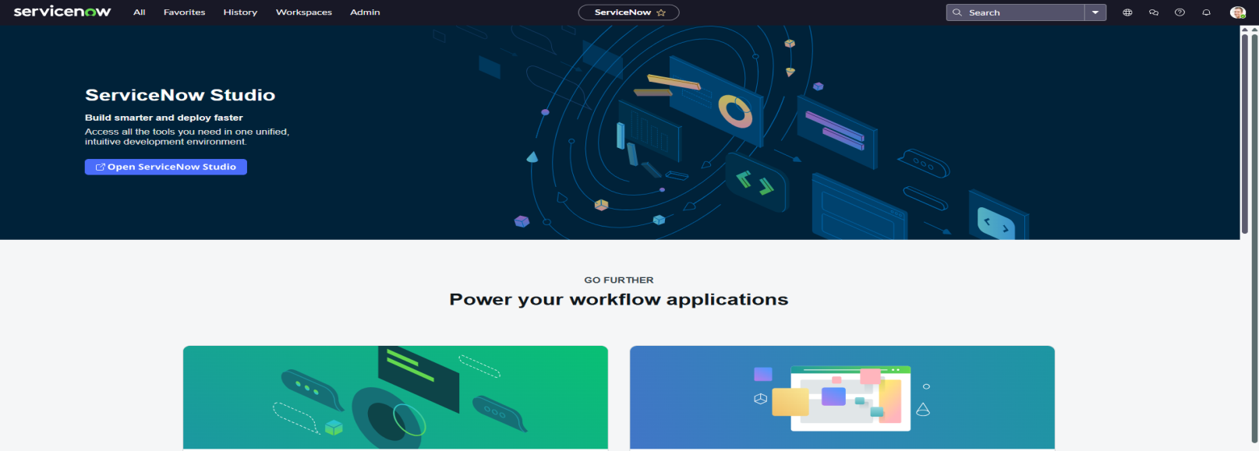
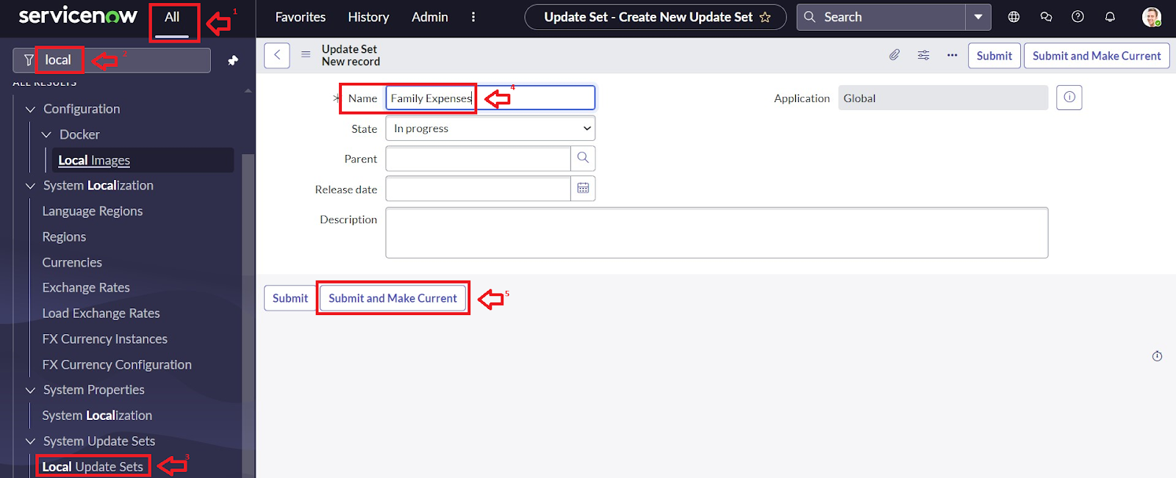
Step 3: Creation of Table
- Navigate to All > In the filter search for Tables > click on New.
- Enter the Details:
Label : Family Expenses
Name : Auto-Populated
New menu name : Family Expenditure.
3. click on Save..
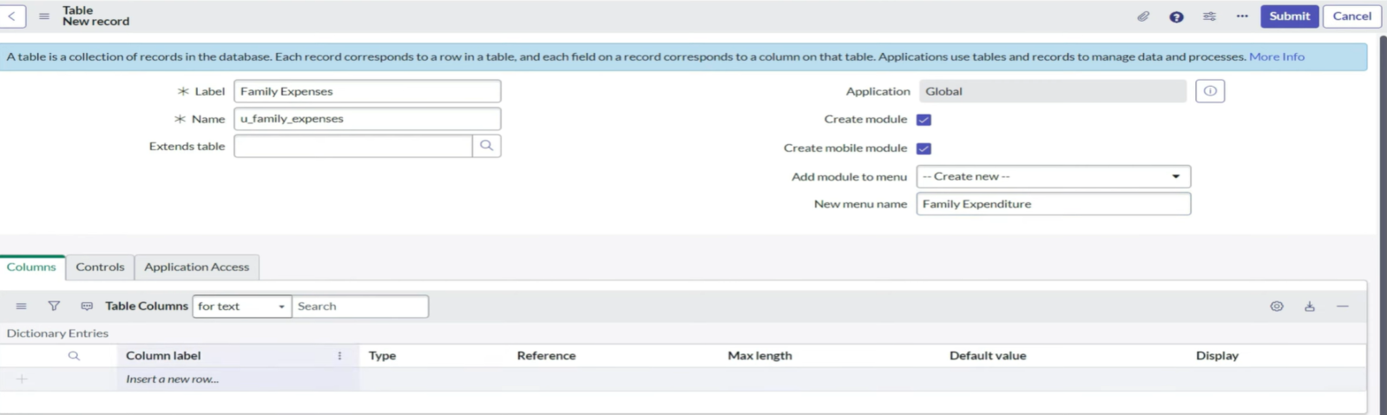

Step 4: Creations of columns
1) Near Columns Double click near insert a new row.
Give the details as:
1) Column label : Number
Type : String
2) Column label : Date
Type : Date
3) Column label : Amount
Type : Integer
4) Column label : Expense Details
Type : String
Max length : 800
2) click on Save.
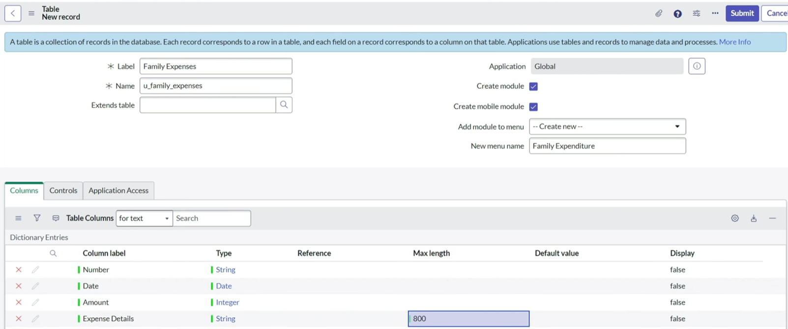
Step 5: Making Number Field an Auto-Number
- Double click on the Number Field/Column.
- Go down and double click on Advanced view
- In Default Value:
  - Use dynamic default : check the box
  - Dynamic default value : Get Next Padded Number
- Click on Update.

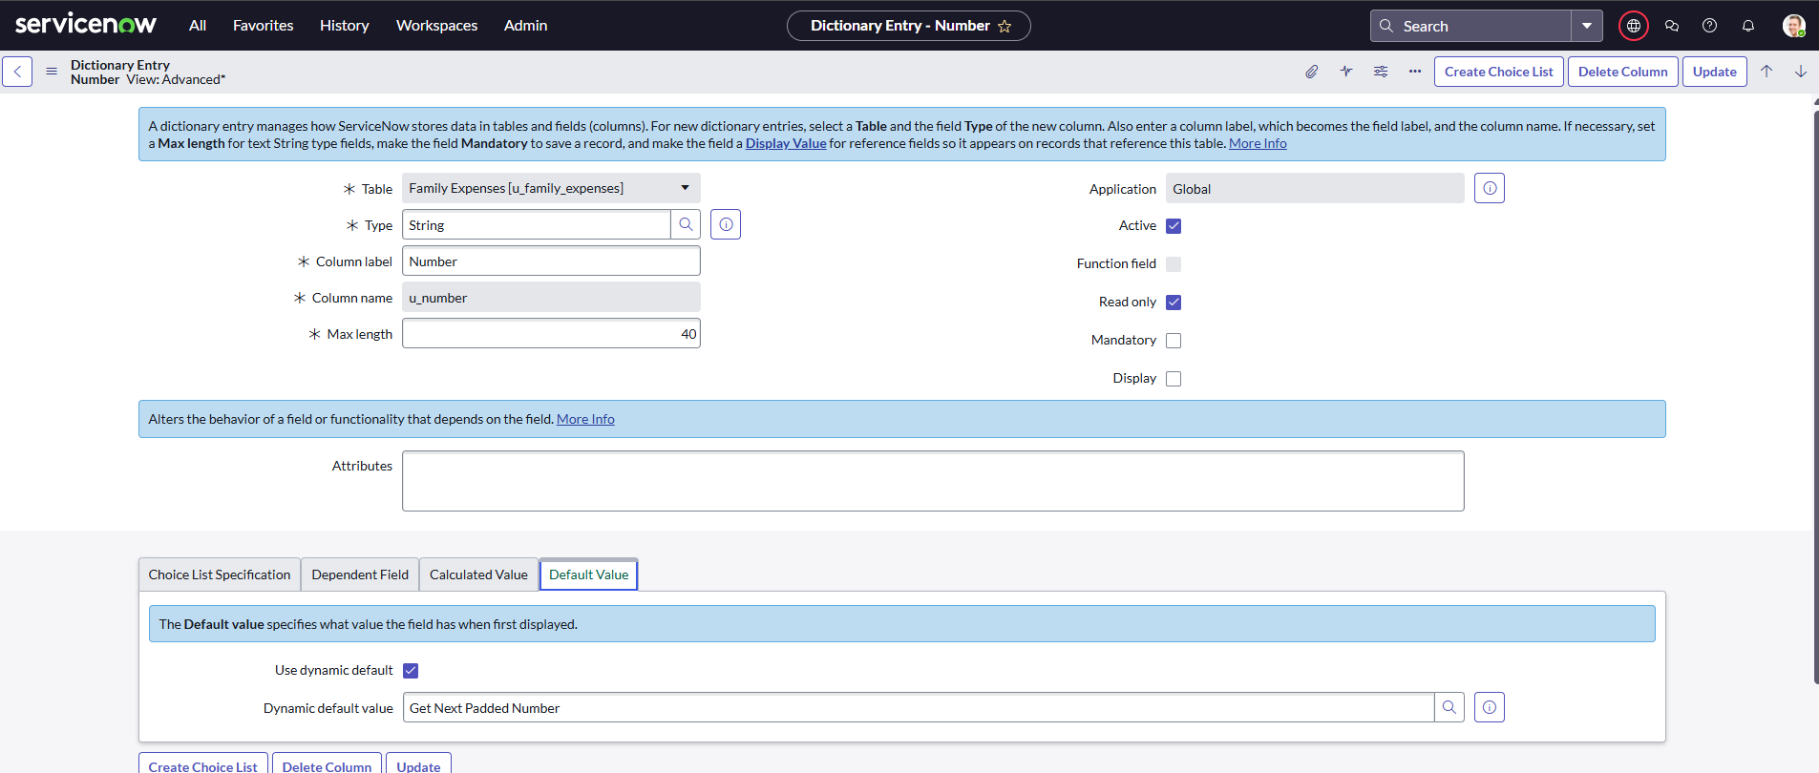
- Go to All >> select Number Maintenance
- Click on New.
Enter the below Details:
  - Table : Family Expenses
  - Prefix : MFE.
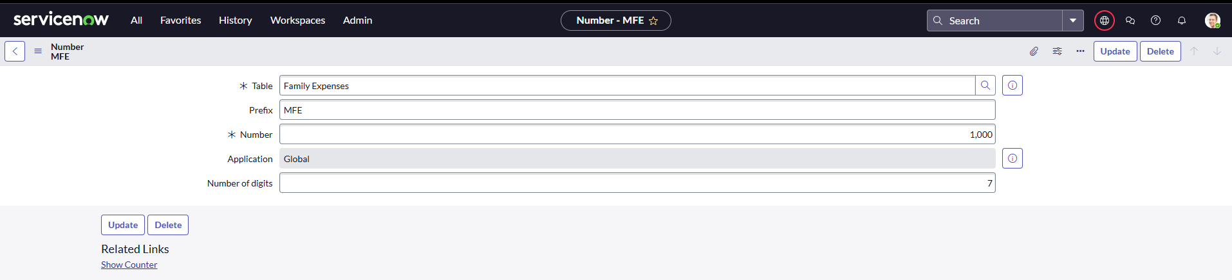
- Click Submit.
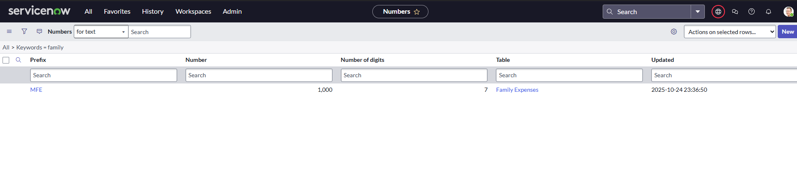
Step 5: Configure the Form
- Go to All >> In the filter search for Family Expenses >> Open Family Expenses
- Click on New
- Go to the Header and right click there>> click on Configure >> Select Form Design
- Customize or Drag Drop the form as per your requirement.
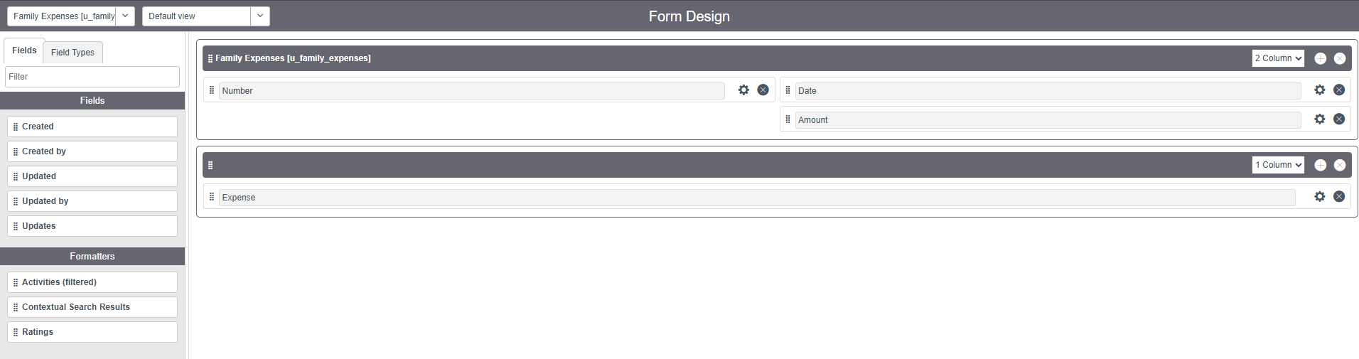
- Make Number Read-Only Field by clicking on the gear icon and checking Read-Only
- Make Date, Amount Mandatory Field by clicking on the gear icon and checking Mandatory
- Click on Save.
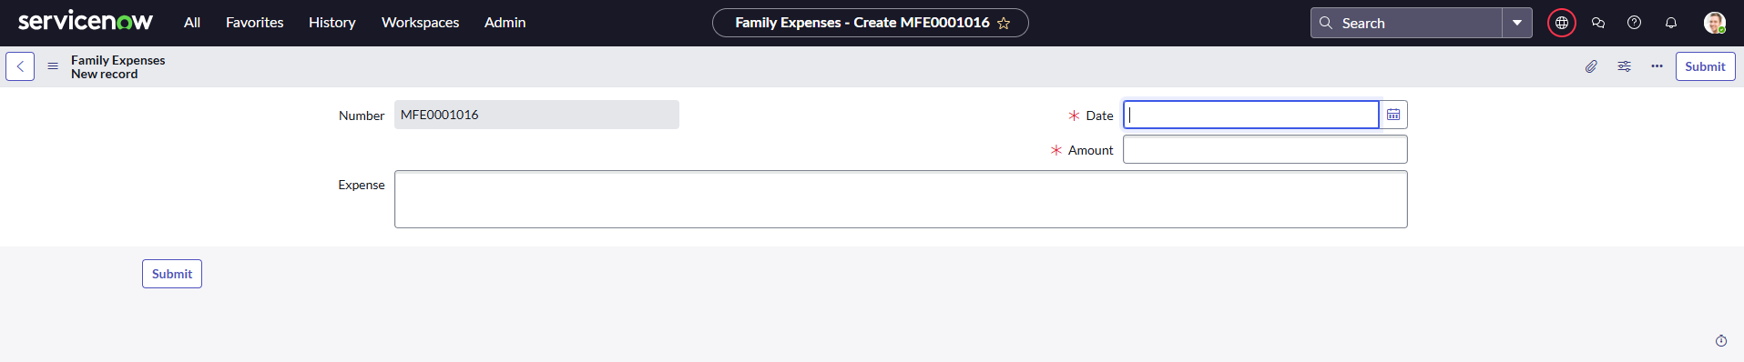
Step 6: Creation of Daily Expenses Table
- Go to All → Search Tables→ click on New .
- Enter the Details:
  - Label : Daily Expenses
  - Name : Auto-Populated
  - Add Module to menu : Family Expenditure
- click on Save..
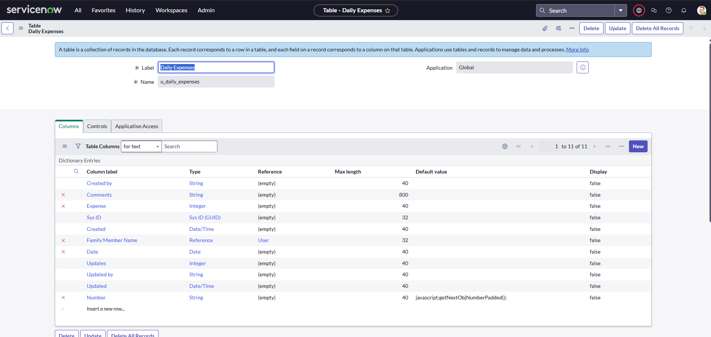
Step 7: Creation of Columns
Near Columns Double click near insert a new row.
Give the details as:
1) Column label : Number
Type : String
2) Column label : Date
Type : Date
3) Column label : Expense
Type : Integer
- Column label : Family Member Name
Type : Reference
Max length : 800
- Column label : Comments
Type : String
Max length : 800
- click on Save.
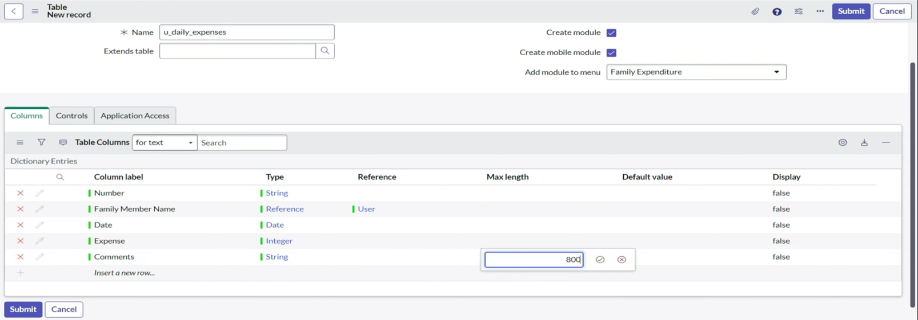
Step 8: Making Number Field an Auto-Number
- Double click on the Number Field/Column.
- Go down and double click on Advanced view
- In Default Value:
  - Use dynamic default : check the box
  - Dynamic default value : Get Next Padded Number
- Click on Update.
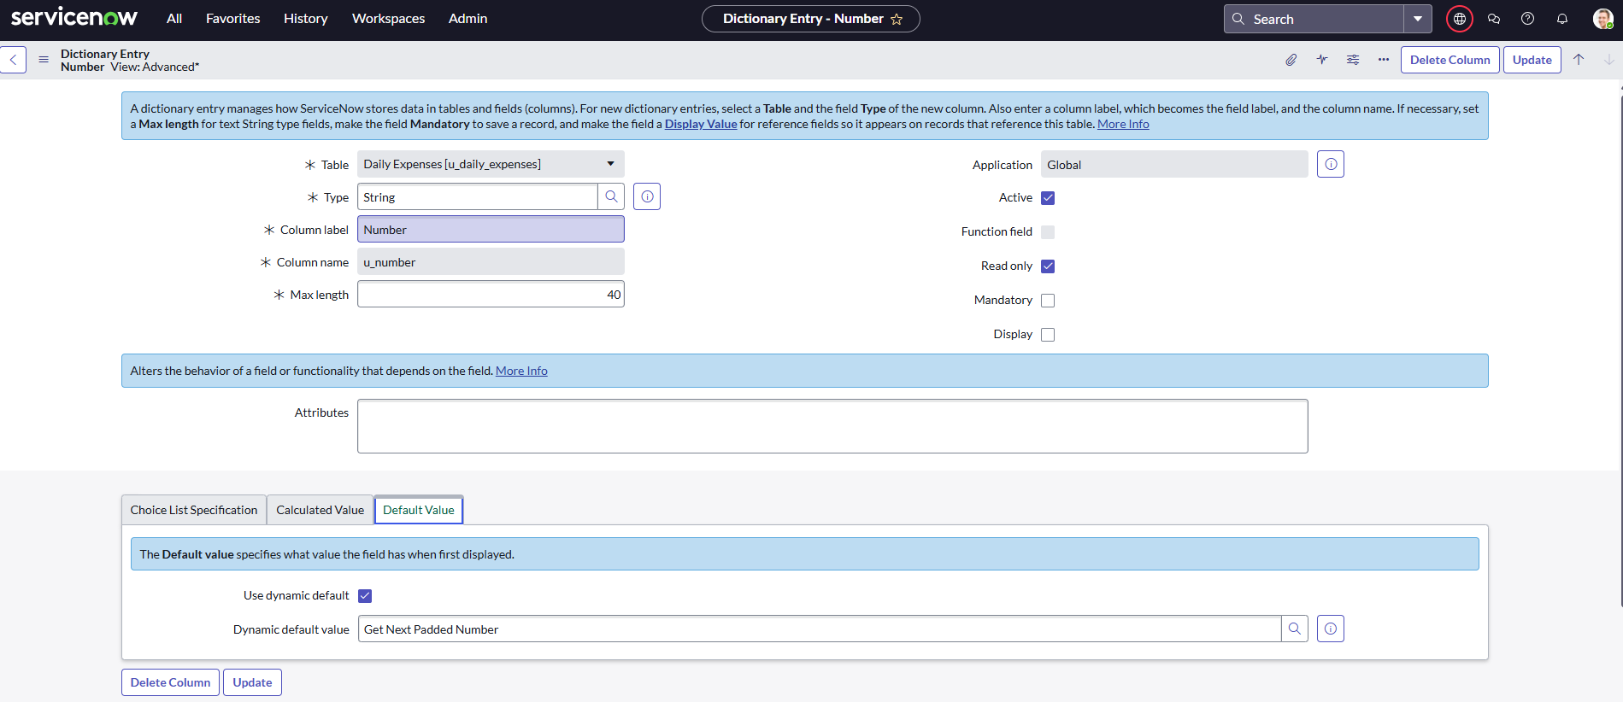
1. Go to All >> Search Number Maintenance >> select Number Maintenance.
2. Click on New.
3. Enter the below Details:
Table : Daily Expenses
Prefix : MFE
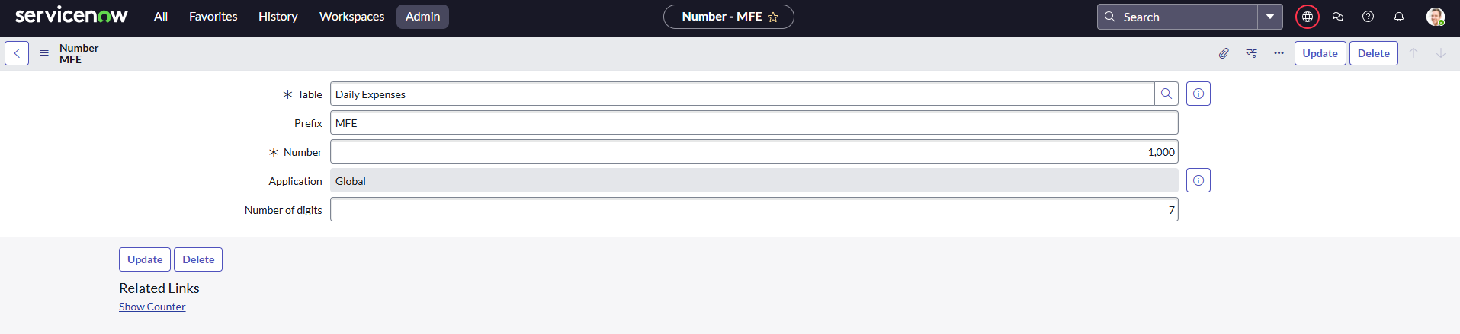

- Click on Submit.
Step 9: Configure the Form
- Go to All >> In the filter search for Daily Expenses >> Open Daily Expenses
- Click on New
- Go to the Header and right click there>> click on Configure >> Select Form Design
- Customize or Drag Drop the form as per your requirement.
- Make Number Read-Only Field by clicking on the gear icon and checking Read-Only
- Make Date, Family Member Name Mandatory Field by clicking on the gear icon and checking Mandatory
- Click on Save.
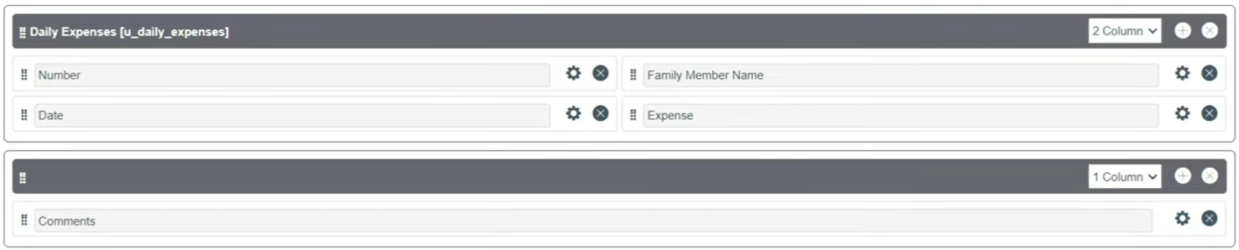

Step 10: Creation of Relationship between Family Expenses and Daily Expenses tables.
- Go to All >> In the filter search for Relationships >> Open Relationships
- Click on New.
- Enter the details:
  - Name : Daily Expenses
  - Applies to table : Select Family Expenses
  - Daily Expenses : Select Daily Expenses
- Click Save.

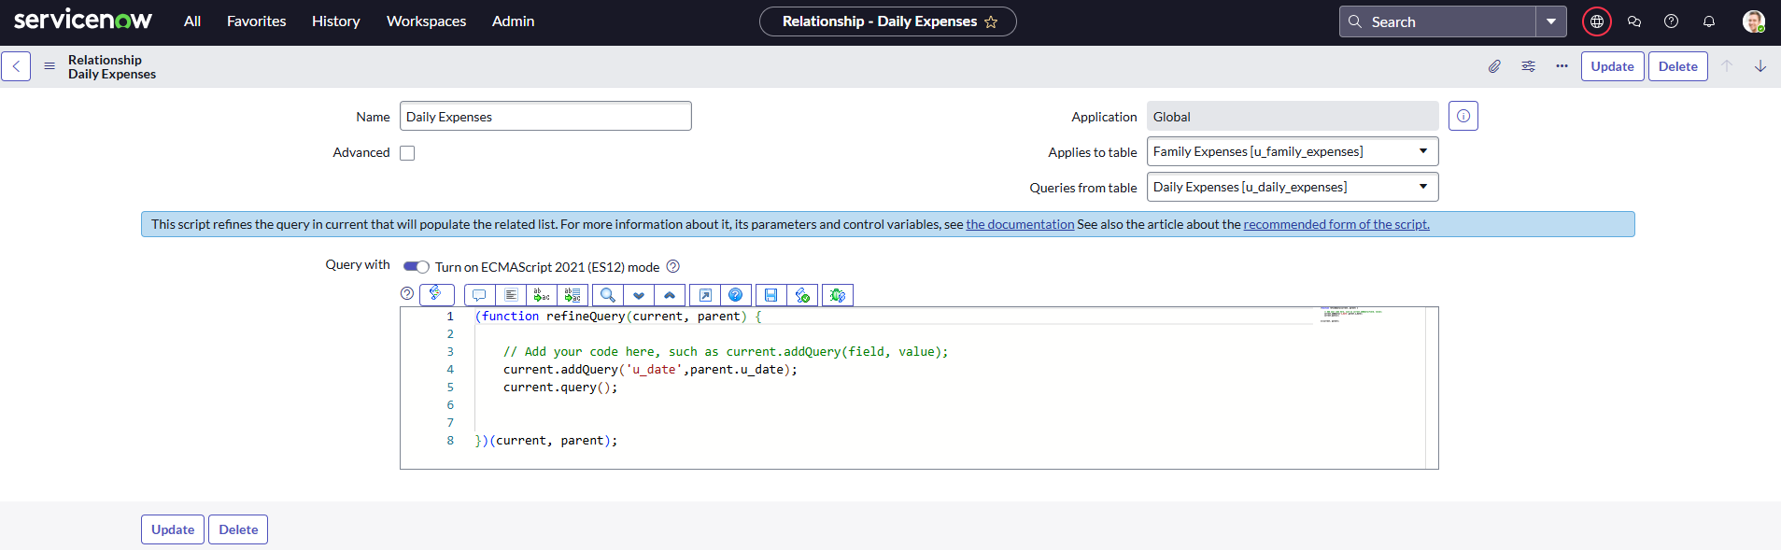
Step 11: Configuring Related List on Family Expenses.
- Go to All >> In the filter search for Family Expenses >> Open Family Expenses
- Click on New
- Go to the Header and right click there>> click on Configure >> Select Related Lists
- Add Daily Expenses to the Selected Area.
- Click on Save.
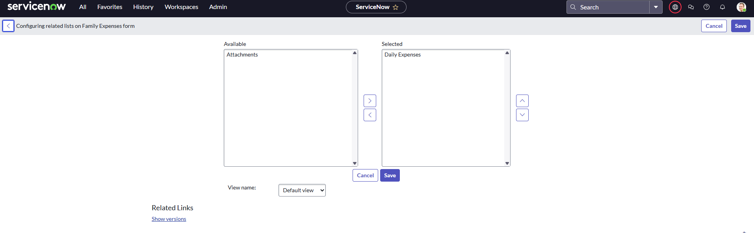
Step 11: Creation of Business Rules.
  - Go to All >> In the filter search for Business Rules.
  - Under System Definition Select Business Rules then click on New.
  - Enter the Details:
    - Name : Family Expenses BR
    - Table : Select Daily Expenses
  - Check Advanced
  - In when to run Check Insert and Update.
  - Go to the Header and right click there >> click on Save.
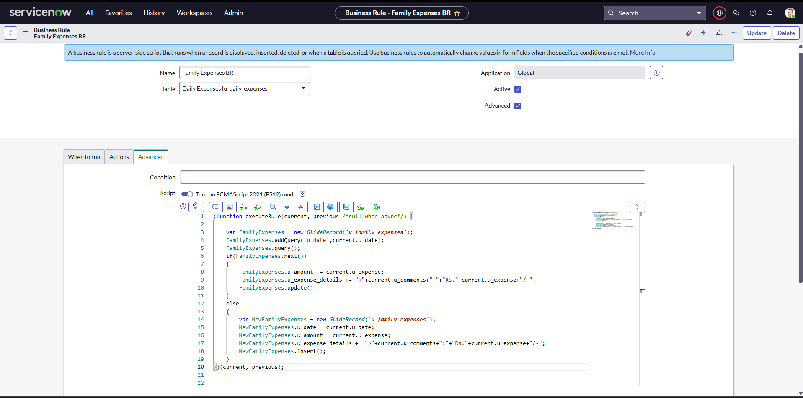
Step 11: Configure the Relationship
- Go to All >> In the filter search for Relationships >> Open Relationships.
- In that, open Daily Expenses Relationship.
- For Applies to table : Select Family Expenses.
- In Query with : write the Query.
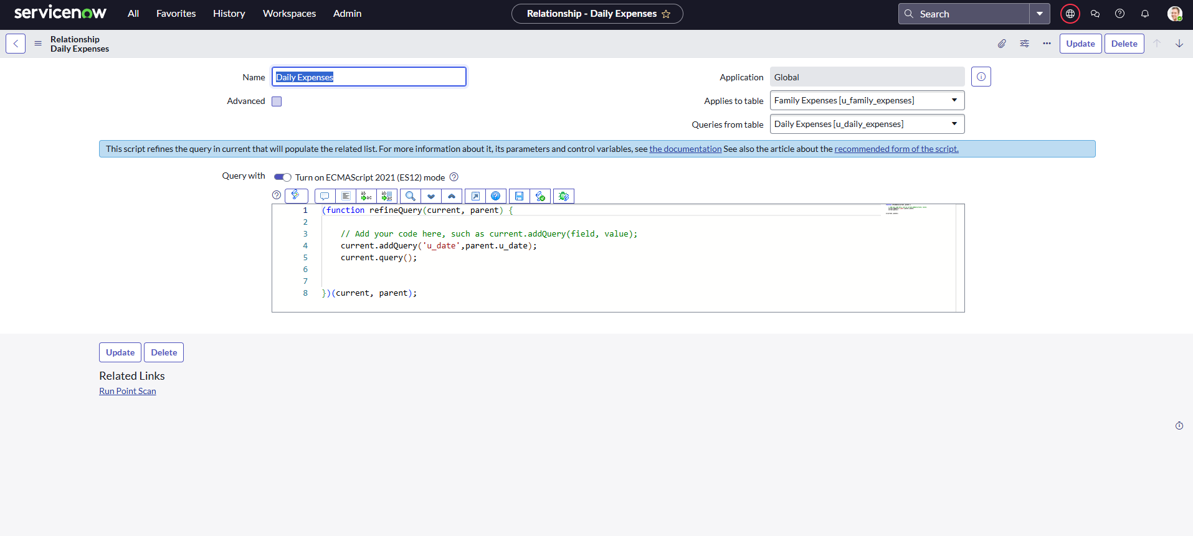
- Click on Update.

Result / Output
- Enter the details and then submit it.

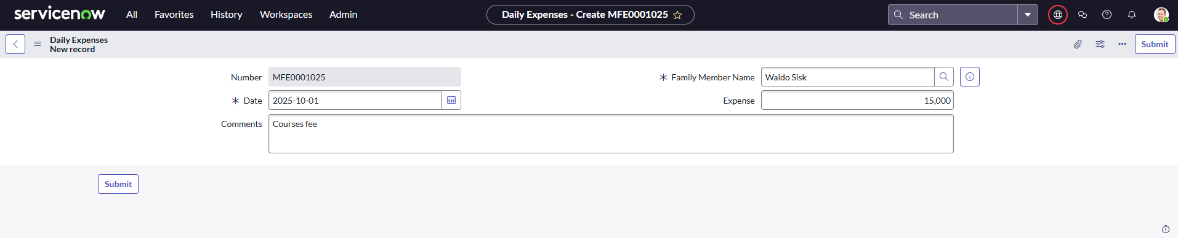
- Detail will be updated on Daily Expenses .
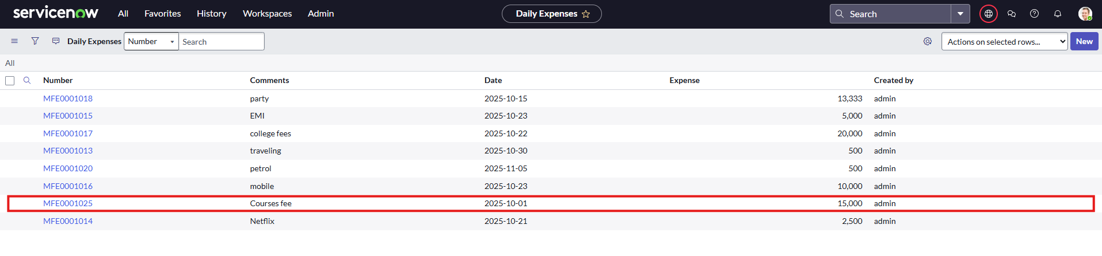
- Daily Expenses Details will be automatically updated on Family Expenses .

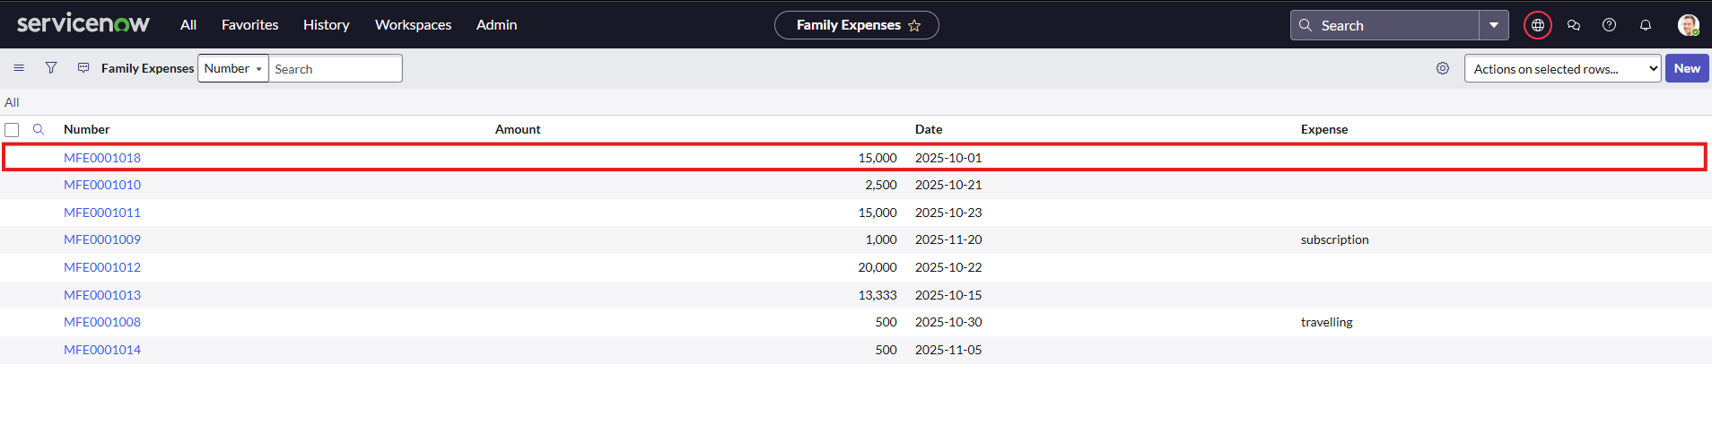
- Output will be successfully updated.
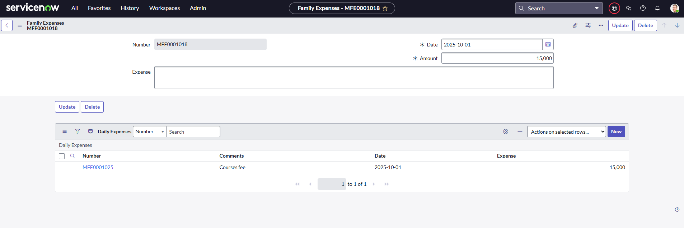

Conclusion
In conclusion, the “Calculating Family Expenses using ServiceNow” project effectively demonstrates how ServiceNow can be used to manage and track family expenses in an organized way. By creating custom tables, relationships, and business rules, the system allows users to record daily expenses and automatically update total family expenses. Features like auto-numbering, mandatory fields, and form customization make the application accurate and user-friendly. Overall, the project provides a simple and efficient solution for monitoring family budgets and supports better financial planning through automation on the ServiceNow platform.

