“Deal Lock”

A Project Report
submitted in partial fulfillment of the requirements for the award of the degree of

B.Tech. Computer Science with Specialization in
Cyber Security and Forensics
by:
Name | Roll No
Manik Garg | R134216076
Kritika Sharma | R134216072

Under the guidance of
Mr. U. Rajanikanth
Industry Fellow
Department of Systemics


DEPARTMENT OF SYSTEMICS
SCHOOL OF COMPUTER SCIENCE
UNIVERSITY OF PETROLEUM AND ENERGY STUDIES
BIDHOLI, VIA PREM NAGAR, DEHRADUN, UTTARAKHAND
2018-19

CANDIDATES DECLARATION

We hereby certify that the project work entitled “Deal Lock” in partial fulfilment of the requirements for the award of the Degree of “Bachelor of Technology in Computer Science and Engineering with Specialization in Cyber Security & Forensics” and submitted to the “Department of Systemics” at School of Computer Science, University of Petroleum and Energy Studies, Dehradun, is an authentic record of our work carried out during a period from January, 2019 to May, 2019 under the supervision of Mr. U. Rajanikanth, Industry Fellow.

The matter presented in this project has not been submitted by us for the award of any other degree of this or any other University.

Manik Garg
R134216076

Kritika Sharma
R134216072

This is to certify that the above statement made by the candidate is correct to the best of my knowledge.

(Date: April 30, 2019)

(Mr. U. Rajanikanth) Dr. Neelu Jyothi Ahuja
Project Guide Professor & Head
Department of Systemics
School of Computer Science
University of Petroleum and Energy Studies
Dehradun - 248001

ACKNOWLEDGEMENT

We wish to express our deep gratitude to our guide Mr. U. Rajanikanth, for all advice, encouragement and constant support he has given us throughout our project work. This work would not have been possible without his support and valuable suggestions.

We sincerely thank our Head of the Department, Dr. Neelu Jyothi Ahuja, for her great support in doing our project Smart Access Cryptographed Vault at SCS.

We are also grateful to Dr. Manish Prateek, Director SCS, UPES for giving us the necessary facilities to carry out our project work successfully.

We would like to thank all our friends for their help and constructive criticism during our project work. Finally, we have no words to express our sincere gratitude to our parents who have shown us this world and for every support they have given us.

ABSTRACT

The idea is to create a smart contract management system. This system will be using Block Chain as a primary base service to store and create contracts. This system will be irreversible and non-tamperable. Also, since we are using Block Chain, the system will work without the use of a third-party authenticator. We will be using Incremental Process Model to determine the Life Cycle of our project. We have chosen this model as it provides flexibility to us for adding further specifications in form of independent modules. One more reason because of which we have chosen this model is that it will help us in getting at least some workable modules before our next deadline.

Keywords: Block Chain, Security, Smart Contracts, CIA.
 |  | TABLE OF CONTENTS
Contents
1 | Introduction |  | 7
2 | Literature Review |  | 8
3 | Problem Statement |  | 9
4 | Objective |  | 9
5 | Methodology |  | 9
6 | System Requirements |  | 12
7 | Implementation |  | 12
 | 7.1 | Pseudocode . . . . . . . . . . . . . . . . . . . . . . . . . . . . . . . . . . . . | 12
 | 7.2 | Output Screen . . . . . . . . . . . . . . . . . . . . . . . . . . . . . . . . .. . | 13
 | 7.3 | Result Analysis . . . . . . . . . . . . . . . . . . . . . . . . . . . . . . . . . . | 13
8 | References |  | 14
A.1 APPENDIX I Source Code |  |  | 15

 |  | LIST OF DIAGRAMS
1 | PERT Chart |  | 9
2 | Level – 0 Data Flow Diagram |  | 10
3 | Use Case Diagram |  | 10
4 | Level 1 DFD |  | 11
5 | Class Diagram |  | 11

1 Introduction

Security is one of the most important aspect of current world scenario. Data being the most important and private part of our lives, needs to be protected and for that purpose we need to implement various security controls at all places which are involved in dealing with our data. Security controls refer to the mechanisms used to restrict the access to the data or assets so as to maintain confidentiality, integrity and availability thus maintaining the CIA Triad. Daily, people deal with various sensitive documents which need to be protected.

A smart contract system is nothing but an implementation of the Block Chain concept of hashed locks that authenticates with peer to peer modelling.

Block Chain is a modern and secure technology used to store data in the form of a Hyper Ledger Fabric. The data in block Chain are stored in form of variable size blocks. These blocks are then hashed so as to preserve the integrity of the data. A Block Chain uses the peer to peer model instead of the conventional Client Server Model. Basically, a Block Chain relies on a framework of Hyper Ledger fabric which is a dynamic block allocation algorithm. Some implementations of Block Chain include Crypto Currencies, Smart Prescriptions, etc.

Smart Contracts refer to deals done between some parties in the form of a digital concept. It uses two components: -

1. Digital Signature: - Digital Signature refers to certified signatory that verifies the current source and final integrity of the data and also sometimes helps in the encryption and authenticity of the data.
2. Peer to Peer Model: -This model aims at serving and verifying requests based upon concept of verified mediator among the interested parties.

Also, we will be using Java Swing Libraries to implement the GUI part and thus generate a user-friendly interface. For the implementation we will be using any open source Hyper Ledger Fabric.

- Literature Review

- Software Engineering by K.K. Aggarwal & Yogesh Singh Third Edition published by New Age International Publishers 2008 - We have used this resource to study about various life cycle Models and take the best suitable model for our project.

- Block Chain for Dummies by Manav Gupta IBM Limited Edition published by Wiley Publication – We have used this resource to study about the basic concepts of Block Chain and its usage using Hyper Ledger.

- Block Chain based Smart Contracts: A Systemic Mapping Study Conference: 3rd International Conference on Artificial Intelligence and Soft Computing. This paper introduced us to implementation of smart contracts using Block Chain.

- Problem Statement

We need to create a secure smart contracts management system which can be used to store digitally signed contracts.

- Objective
Our objective is to create a Blockchain based smart contracts management system. We have the following sub objectives: -
- Create a Hyper Ledger
- The data in the area should be secured
- We should not be able to modify the data in this area
- Implement Smart Contracts management

- Methodology

Since, we are using the Incremental SDLC Model thus our methodology will be including all the phases of that model.

System Feasibility: - We will be analyzing the feasibility of our product that whether it will be implementable or not. This phase has already been completed during the title analysis.

Software Plans & Requirements: - During this phase we analyzed all the requirements and planned the development cycle.
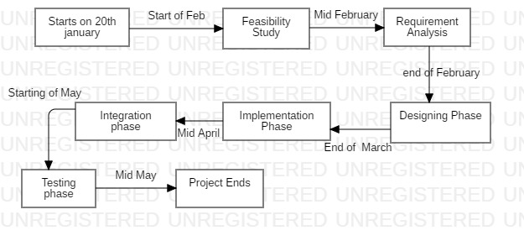
Figure 1 – PERT Chart

Product Design: - We will be developing Level 0 DFD & use case in this phase to know what modules are needed for this product.

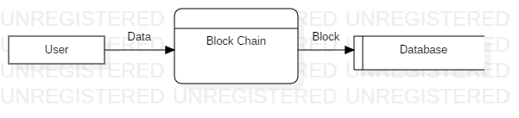
Figure 2 – Level 0 DFD

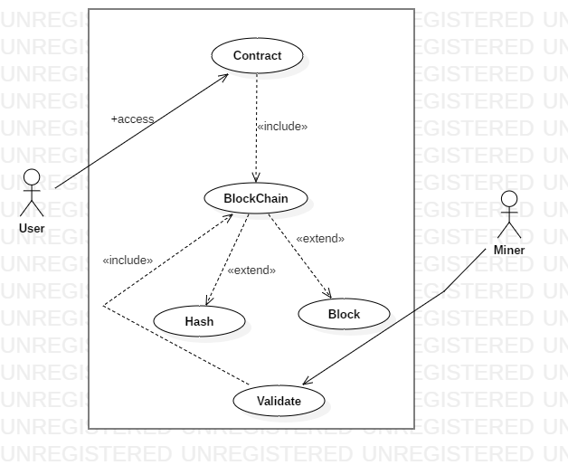
Figure 3 – Use Case Diagram
*This will mark the end of requirement verification

Detailed Design: - Here we will work on Level 1 DFD to show sub modules and implementable functions. We will be also working on developing the required Class diagram.
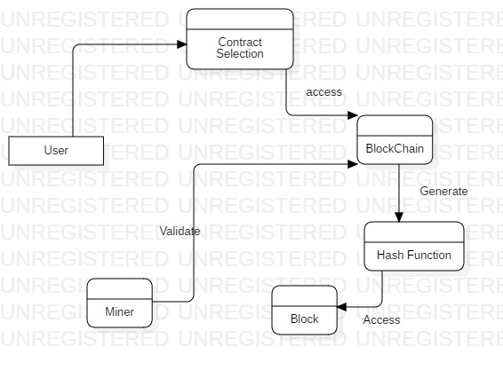
Figure 4 – Level 1 DFD
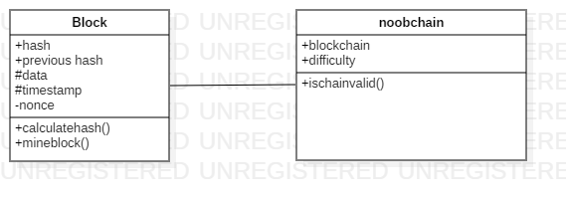
Figure 5 – Class Diagram
Code: - This will be our main phase which will be our implementation phase where we will code all the modules. Here we will also do the unit testing.

Integration: - This phase will aim at making the product out of the modules i.e. we will be merging the modules.

Implementation: - This will be our system testing phase. We will test all the merged modules. This will act as level one testing for our product.

Operations & Maintenance: - This is our last phase where will work towards achieving feedback and further improvements will be done accordingly.

6 System Requirements

Hardware:
- 8 GB Ram
- Intel Core i5 64 bit Processor
- Input and Output Devices
Software:
- Windows 10 1903 64 bit
- Visual Studio Code
- Star UML

- Implementation

The blockchain is created in java using a block class which defined the data members to be stored inside a block.

7.1 Pseudocode

The block class acts as a structure for the block chain. The code runs as follows: -
- A block is created with a transactional value and the data, hash of current block, hash of previous block and timestamp is stored in this block
- The calculate hash method uses the time stamp and previous hash to create a new hash using the SHA 256 algorithm
- The block is then mined by miners using a difficulty count of 5 to verify the block contents
- The chain validation is performed by verifying the hashes of each blocks with the succeeding and the preceding blocks
- The complete block is pushed to the database as to create a ledger where every row of the table maps to a block

7.2 Output Screen
Compiler Output:
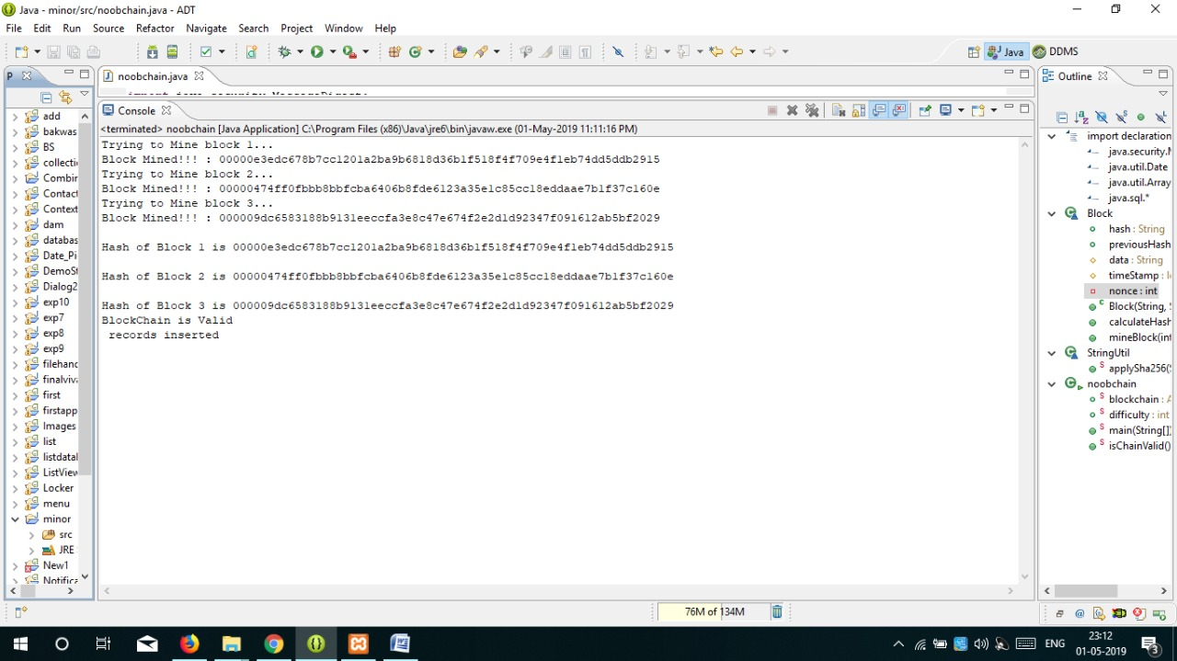
Database Output:
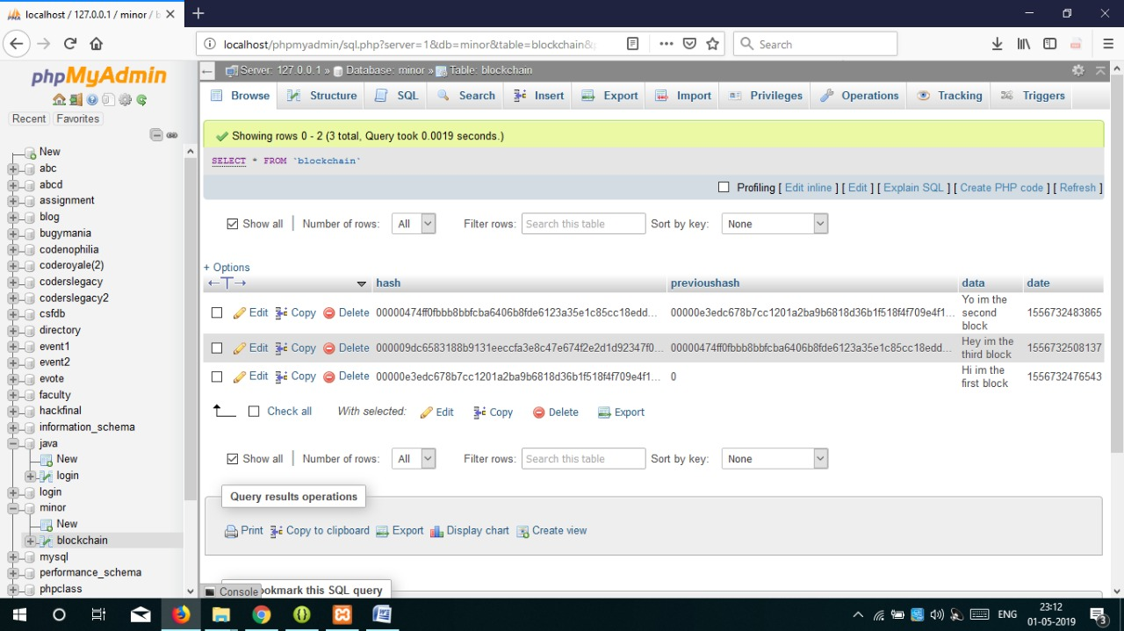

7.3 Result Analysis
We have finally succeeded in creating a secure block chain with the successful integration of SQL Database. This block chain satisfies all the needs and contains all the mentioned functionalities. The final unit and integration testing resulted in zero errors. Further new improvements will be added as part of the maintenance phase and future developments.
References

- Software Engineering by K.K. Aggarwal & Yogesh Singh Third Edition published by New Age International Publishers 2008 – (Accessed on - 5th February 2019) [1]

- Block Chain for Dummies by Manav Gupta IBM Limited Edition published by Wiley Publication – (Accessed on - 07th February 2019) [2]

- https://www.researchgate.net/publication/319603816_Blockchain_Based_Smart_Contracts_A_Systematic_Mapping_Study - (Accessed on - 10th February 2019) [3]
.

APPENDIX I Source Code
import java.security.MessageDigest;
import java.util.Date;
import java.util.ArrayList;
import java.sql.*;
class Block {
public String hash;
public String previousHash;
protected String data; //our data will be a simple message.
protected long timeStamp; //as number of milliseconds since 1/1/1970.
private int nonce;

//Block Constructor.
public Block(String data,String previousHash )
{
this.data = data;
this.previousHash = previousHash;
this.timeStamp = new Date().getTime();
this.hash = calculateHash();
}

public String calculateHash()
{
String calculatedhash = StringUtil.applySha256(previousHash+Long.toString(timeStamp) +Integer.toString(nonce) +data);
return calculatedhash;
}
public void mineBlock(int difficulty)
{
String target = new String(new char[difficulty]).replace('\0', '0'); //Create a string with difficulty * "0"
while(!hash.substring( 0, difficulty).equals(target))
{
nonce ++;
hash = calculateHash();
}
System.out.println("Block Mined!!! : " + hash);
}
}
class StringUtil
{
public static String applySha256(String input)
{
try {
MessageDigest digest = MessageDigest.getInstance("SHA-256");

byte[] hash = digest.digest(input.getBytes("UTF-8"));
StringBuffer hexString = new StringBuffer();
for (int i = 0; i < hash.length; i++)
{
String hex = Integer.toHexString(0xff & hash[i]);
if(hex.length() == 1) hexString.append('0');
hexString.append(hex);
}
return hexString.toString();
}
catch(Exception e)
{
throw new RuntimeException(e);
}
}
}

public class noobchain
{

public static ArrayList<Block> blockchain = new ArrayList<Block>();
public static int difficulty = 5;

public static void main(String[] args)
{
//add our blocks to the blockchain ArrayList:
blockchain.add(new Block("Hi im the first block", "0"));
System.out.println("Trying to Mine block 1... ");
blockchain.get(0).mineBlock(difficulty);

blockchain.add(new Block("Yo im the second block",blockchain.get(blockchain.size()-1).hash));
System.out.println("Trying to Mine block 2... ");
blockchain.get(1).mineBlock(difficulty);

blockchain.add(new Block("Hey im the third block",blockchain.get(blockchain.size()-1).hash));
System.out.println("Trying to Mine block 3... ");
blockchain.get(2).mineBlock(difficulty);

for(int i=0;i<3;i++)
{
System.out.println("\nHash of Block "+(i+1)+" is "+blockchain.get(i).hash);

}

if(isChainValid()==true)
{
System.out.println("BlockChain is Valid");
try{
Class.forName("com.mysql.jdbc.Driver");

Connection con=DriverManager.getConnection("jdbc:mysql://localhost:3306/minor","root","");
PreparedStatement stmt=con.prepareStatement("insert into blockchain values(?,?,?,?)");
for(int i=0;i< blockchain.size();i++)
{
stmt.setString(1,blockchain.get(i).hash);//1 specifies the first parameter in the query
stmt.setString(2,blockchain.get(i).previousHash);
stmt.setString(3,blockchain.get(i).data);
stmt.setLong(4,blockchain.get(i).timeStamp);
stmt.addBatch();
}
stmt.executeBatch();
System.out.println(" records inserted");

con.close();

}catch(Exception e)
{
System.out.println(e);
}
}
else
System.out.println("BlockChain is InValid");
}

public static Boolean isChainValid()
{
Block currentBlock;
Block previousBlock;

//loop through blockchain to check hashes:
for(int i=1; i < blockchain.size(); i++)
{
currentBlock = blockchain.get(i);
previousBlock = blockchain.get(i-1);
//compare registered hash and calculated hash:
if(!currentBlock.hash.equals(currentBlock.calculateHash()) )
{
System.out.println("Current Hashes not equal");
return false;
}
//compare previous hash and registered previous hash
if(!previousBlock.hash.equals(currentBlock.previousHash) )
{
System.out.println("Previous Hashes not equal");
return false;
}
}
return true;
}
}

