**User Manual**

**Running Unit Tests**

Table of Contents

Document History 3

Purpose 3

Intended Audience 3

Unit Testing 3

Unit Test Cases 3

Test Case for Recipient 4

Test Case for Offers 4

# Document History

|  |  |  |  |  |
| --- | --- | --- | --- | --- |
| **Version** | **Created, Date** | **Author** | **Approved, Date** | **Approved by** |
| 1.0 | 18-08-2018 | Manik Bhardwaj | 18-08-2018 | Manik Bhardwaj |
|  |  |  |  |  |
|  |  |  |  |  |

# Purpose

This quick manual will help you to run unit tests cases in Fuel PHP.

# Intended Audience

This user guide is for developers who want to run unit tests under voucherPool Management Tool.

# Unit Testing

FuelPHP uses PHPUnit for its Unit Testing needs. It must be installed for the tests to run.

You'll need to have [PHPUnit](http://www.phpunit.de/manual/current/en/index.html) installed locally if you want to run the tests that ship with FuelPHP, and if you want to use Oil to run your tests. If you don't already have PHPUnit installed, please refer to the PHPUnit installation documentation at: <https://phpunit.de/manual/current/en/installation.html>.

If you aren't interested in running unit tests with FuelPHP, then there is no need for you to install PHPUnit.

# Unit Test Cases

I have created app tests which goes into folder **fuel/app/tests.**  The rules which are followed for running and writing test cases are given in this url:

<https://fuelphp.com/docs/general/unit_testing.html>

https://github.com/manik348/voucherpool/blob/master/TESTING.md

Below here are all the unit test cases which I have created.

## Test Case for Recipient

This test is created under **app/tests/controller/recipient**. Covers three aspects of test:

1. Testing recipient list is displayed.
2. Testing creating new recipient
3. Testing deleting a recipient.

All the test cases are passed.

To run this test. Type in command prompt at project root

Php oil test –group=Controller

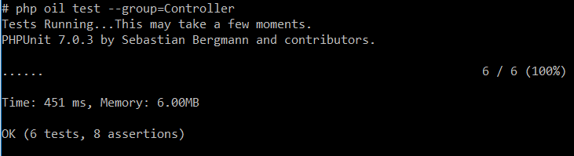

## Test Case for Offers

This test is created under **app/tests/controller/offers**. Covers three aspects of test:

1. Testing offers list is displayed.
2. Testing creating new offer
3. Testing deleting an offer.

All the test cases are passed.

To run this test. Type in command prompt at project root

Php oil test –group=Controller

