Mobile Usage Pattern and Privacy Implications

Progress Report#6

By Manik Saini, Parteek Singh and Ratnesh Patidar

**For: Michael Mitchell**

**Results this week:**

1. **All pair analysis of salary based on demographic location (zip codes):**
   * Based on the zip codes of the location of the surveyor, mean salary of the location was determined. A dataset was then formed to separate out the information of required zip codes, along with other variables for all-pair analysis.
   * Counts of the users, using encryption, android devices, iPhone devices and others were now counted using python script and another dataset was created with the number of counts.
   * No cross-correlation was found between various variables and increase in the salary of the users, as we had only single user from most of the locations. For few locations, we had very higher number of users which eventually led to a negative and insignificant correlation among variables.
2. **Salary and ethnicity:**
   * We divided the salary among 2 categories, based on US National Median income, which was found to be around $52000. Category is above and below the national median.
   * Around 68% of the surveyors fell under above national median range, out of which 45% were white Caucasians (majority group).
   * If we compare particular group wise, more number of whites are in above national median range, ~75% of all white Caucasians, but in case of minority group, 57% were above and 43% were below median.

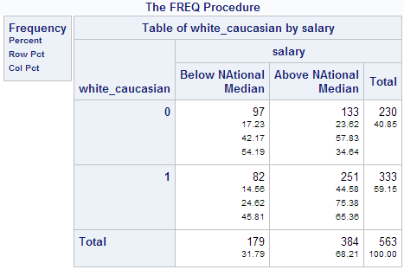

1. **Use of encryption and password vaults among people of various salary ranges**:
   * According to the frequency results for usage of password vaults or encryption for the files, more people fall under the above national median salary category. If we consider answers “always” and “sometimes” as 1, then among all the users, ~58% people use password vaults, out of which ~37% fall in above median salary range category. For encryption, among ~43% of users who encryption, the percentage of users in above median range salary category is 29%.
   * This concludes that, the users with salary ranges above median are more security concerned.

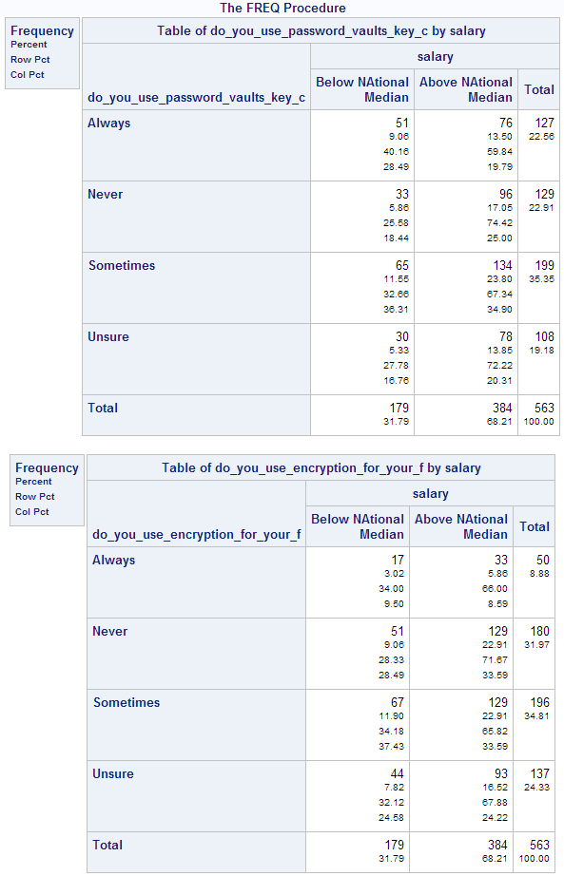

1. **(ethnicity plus usage of encryption) vs. Salary:**
   * In this section, we combined the ethnicity and usage of password vaults/encryption together. Variable “white_using_encryption” means that person is white Caucasian and uses password vaults and encryption.
   * Results shown that minorities, independent of their salary range, use encryption/password vaults almost equally (~25% and ~20% respectively). But among the majorities, ~25% more guys were found in above median salary range than in below median salary range which uses encryption/password vaults.
   * Concluding and strengthening our previous results that, above median salary range guys are more aware towards security.

