Here is the output of the program

1. Screenshot of excel file.

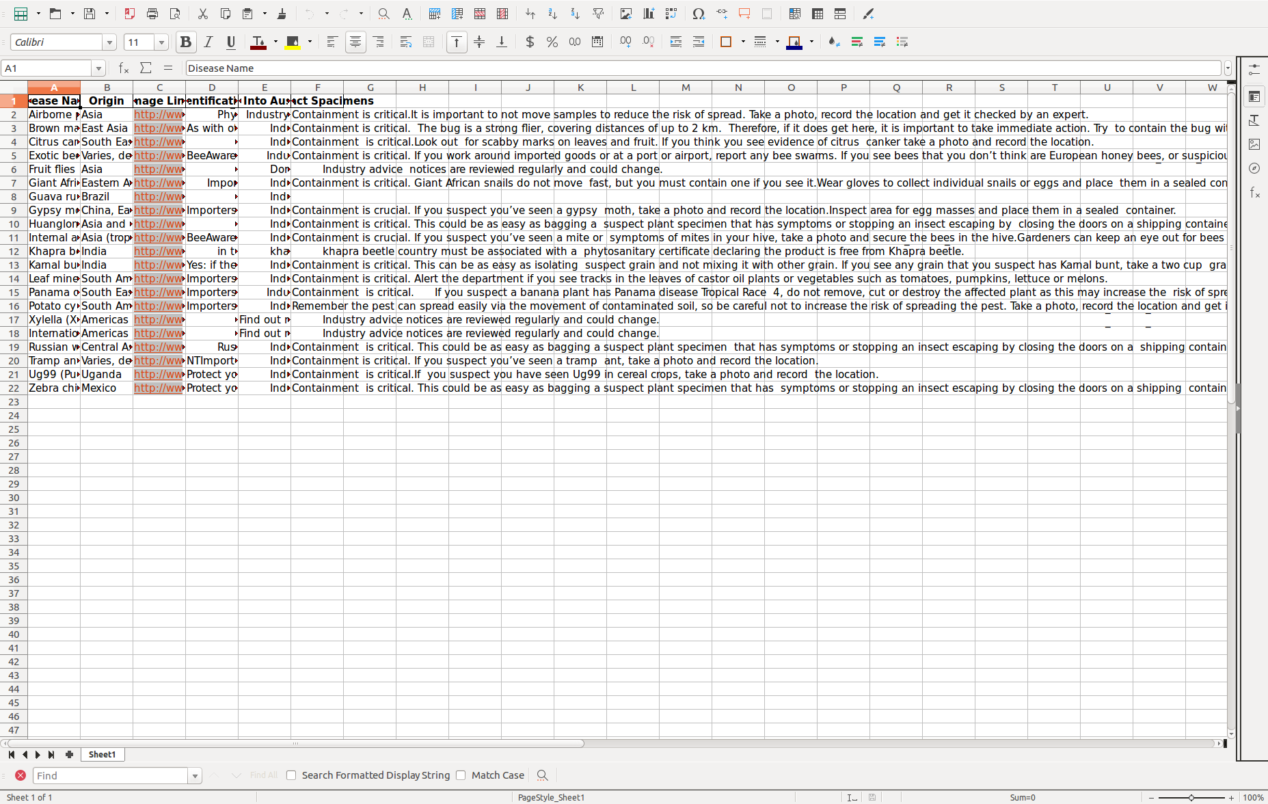

2. screenshot of downloaded images

