Brief Resume

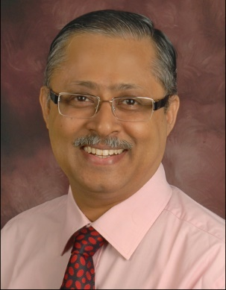

**Dr Shantanu Ganguly**

*MSc, MLibSc, MBA, PGDCA, PhD*

Chief Librarian

All India Institute of Medical Sciences (AIIMS)

Ansari Nagar, New Delhi - 110029

E-mail: [drshantanu.aiims@gmail.com](mailto:drshantanu.aiims@gmail.com) | [sganguly67@gmail.com](mailto:sganguly67@gmail.com) | head.aiimslibrary@gmail.com

Mobile: 9310496115| 9811330235 | 9910600235

LinkedIn: <https://www.linkedin.com/in/shantanu-ganguly-5421844/>

Experience and Expertise in Project Management, Knowledge Management, Research Mapping, Research Data Management

Capacity Development, and Digital Marketing

**Profile Summary**

* A result-oriented professional having exceptional intellectual capabilities with over 28 years of experience in Knowledge Management, Capability Management/Building Project Management, Reporting & Documentation, Change Management, Resource Management, and much more.
* Leadership in developing the Organization’s Knowledge Management (KM) Strategy in close collaboration with the peer group members, the Programme and Grant Managers including strategy for a roadmap for implementation.
* Prudently planning & developing the annual workplan for the KM Outcome Area in a collaborative manner and in support of the organization’s Logic Model.
* Developed a unique model of DAVE (Data Analytics and Visualization Experience).
* Expertise in Data and Research Storytelling.
* Expert in imparting training and support to Programme teams and partners for KM tools, Document Management, Workflow Process Management, Knowledge Transfer and Exchange (KTE) technologies or other learning material.
* Holds the distinction of conceptualizing and implementing the capability development program and working towards making the organization more effective and productive.
* Expertise in conducting profound Research and generating valuable content & managing the same to accomplish desired organizational goals.
* Supervising the analytical work & documentation as per the regulations and various regulatory authorities; preparing SOPs and relevant documents as well as undertook analytical method validation.
* An effective communicator with excellent relationship building & interpersonal skills.
* Recipient of National and International Accolades.
* Written several books and research papers.