**BODHISATVA GHOSH**

Six Sigma Black belt certified+ M.B.A (Mktg+HR)+B.E (Mech.)

With more than **21+ years professional Experience**

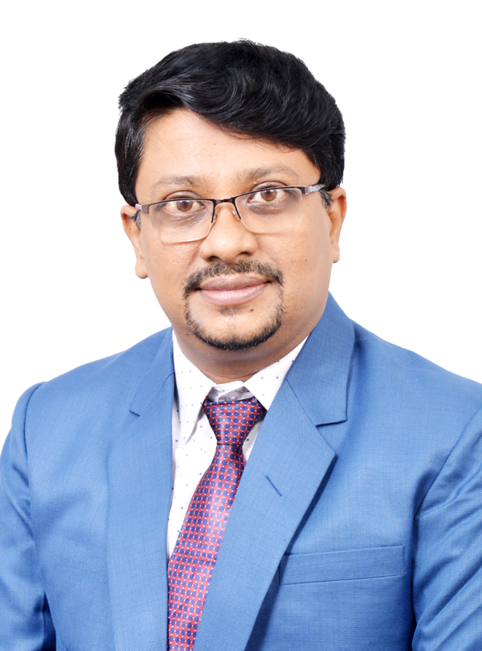

**Name- Bodhisatva Ghosh**

🕽:  **+91 8481 833 681**

**+91 7773 009 622**

🖂: [bodhisatvaghosh@gmail.com](mailto:bodhisatvaghosh@gmail.com)

**Int. Passport No.-** M3011987

**Nationality**: Indian

**Permanent Address**-

Flat-3C, Block-B, Mangaldeep Apartment, 523 R.N.Guha Road, Kolkata(W.B)-700074

**Mailing Address** –

Flat No.-242,”Daffodil”, Parthivi Pacific, Tatibandh. G.E Road, Raipur-492099

**SOCIAL**

**Skype**: bodhisatvag

**Whatsapp-**7773009622

**LinkedIn:** <https://www.linkedin.com/in/ghoshbodhisatva/>

**Facebook:** <https://www.facebook.com/bodhi.ghosh>

**LANGUAGE SKILLS-**

Fluent in English, Hindi and Bengali

**MEMBER OF ASSOCIATION**

Member of Bharat Soka Gakkai(BSG)-the Indian Affiliate of Soka Gakkai International(SGI)

**KEY IT SKILLS**

* MS Office (Excel, Word, Power Point) and Finacle-10 & Profile for Windows
* CRM/QMS/CCMS/WMS
* ERP for Realestate Developers
* WhatsApp, Instagram, Twitter and Facebook

Acknowledged, performance-driven professional offering **over 21+ years of multi-faceted experience** with proven competence in the **Training, Business Administration**, **Office Administration, Marketing Administration, Retail Branch Banking Operations, HR & Manpower Management, HR and Retail Store Management.**

**PROFESSIONAL EXPERIENCE**

* **Executive Assistant to The Chairman- Nov2015 – Till Date**

**Parthivi Group, Raipur, Chhattisgarh, India**

* Conducting Employee Training and development across the organizations.
* Imparting Marketing and Sales Training and coordinating in Advertisement Drafts, Brand Management and promotions of Projects.
* Expertise in delivering corporate presentations for business meetings and proposals, designing Presentations of various projects
* Project Planning, Construction Site Management, Coordination and Management
* Analysis of department Reports and evaluating productivity of Employee.
* Strategic Filtration of Flow of Management Communication to each level.
* With excellent Communication Skill actively handling client’s grievances,
* Strategic Communication with Corporate, Business Consultants and Institutional dignitaries.
* Strategizing and participating in Diversification of Business
* Exploring new Business Modules and evaluating Profitability
* Expertise in delivering corporate presentations for business meetings and proposals, designing Presentations of various projects.
* Expertise in documentation of various financial borrowings and Project Financing and managing Banking communication
* Expertise in Managing Infrastructural Project with TCS-iON-Digital Zone and coordinating the entire project Management.
* Expertise in public relations and Media communications
* Analysis of department Reports and evaluating productivity.
* Arranging and coordinating various Corporate and Business events heading a Business Vertical completely on behalf of the Company Directors.
* Coordinating, executing and processing all lease contracts & Property leasing..
* **Freelance Educational & Professional Trainer/Consultant** –

July 2013 – Oct 2015

Imparting corporate Induction, Soft skill Training, Sales Training and process training in various corporate and SME’s

* + **Manager - Administration** – Nov 2012 – Jun 2013,

Sky Mars Agro Industries Ltd, Kolkata , West Bengal India

* + **Branch Operations Service Head**- ING Vysya Bank Ltd., Kolkata, Jan 2012 – Sep 2012 & Jul 2007- Jul 2011
  + **Manager – Operations-** Axis Bank Ltd. Baharampur, India- Jul 2011 – Dec 2011
* **Customer Service Officer**- ICICI Bank Ltd., Mumbai, India- Oct 2004 – Jul 2007
* **Manager (Government & Institutional Sales of TATA Motors Commercial Vehicles)-**Bafna Motors (Mumbai) Pvt. Ltd., Thane, India- Nov 2002 – May 2004
* **Jr. Quality - Advisor -** Feb 2002 – Aug2002- Quality Systems and Allied Services, Raipur, India

**EDUCATION**

**KEY PROFESSIONAL SKILLS**

* Grievance Handling
* Sales Training
* Marketing Administration
* Sales Support
* Team Management
* Employee relations
* Total Quality Management
* ERP Process Coordination
* Liaison & Coordination
* Training & Development
* Project Report Drafting
* Travel Planning, Management
* Office Administration
* Social Media Advertising
* Employee relations
* Office Automation
* Project Management
* Training on Customer Service
* Financial Management
* Profitability Analysis
* Retail Store Management
* Cash Control & Management
* Banking Operations
* Manpower Planning

**HOBBIES**

Singing, Dancing, Pencil Sketching and Painting, Creativity & Cooking

**PERSONAL DETAILS**

**Date of Birth**: 14th September 1976

**Blood Group**: B+

**Gender:** Male

**Height**- 176 cm

**Marital Status**: Married

**Dependants**: 3

* **Post Graduation--M.B.A (Mktg. & Personnel Mgmt.)- from 1999 to 2001**

Nagpur University College-K.I.T.S, Ramtek, India- First Class

* **Graduation-Bachelor of Engineering(Mechanical)- from 1995 to 1999**

NMU Jalgaon, Gangamai College of Engg., Dhule, India- First Class

* **Diploma in Total Quality Management- 2007**-NCQM, Mumbai

**CERTIFICATION**

* **Certification in Six Sigma Black Belt- year 2016**

International Academy for Certification and Training, Delhi, India, -First Class

* **Certification in Six Sigma Green Belt- year 2012**-IACT-2016

**TRAININGS & PROJECTS UNDERTAKEN**

|  |  |
| --- | --- |
| * **Certification in Financial market Training, Equity,**   **Commodity and Currency Segment** at Financial Gurukul, Kolkata, India - 2014 | **60 Days** |
| * **Communication Skills** at ICICI Bank Ltd, Mumbai, India - 2006 | **2 Days** |
| * **Personal Effectiveness** at ICICI Bank Ltd, Mumbai, India - 2005 | **2 Days** |
| * **Personnel Management** at   The Associated Cement Companies Ltd (ACC), Durg - 2000 | **10 Days** |
| * **Marketing Management** at   Bhilai Steel Plant, Mumbai, India - 1999 | **15 Days** |
| * **Project on Rolling Mill and Coke Oven Plant** at   Bhilai Steel Plant, Mumbai, India - 1998 | **20 Days** |

**IMPORTANT PROJECTS ADMINISTERED**

* **REAL ESTATE PROJECT @ Parthivi Group-** Marketing Training, Planning, Coordinating, Project planning and prelaunch and post launching promotions & Invitations, Project launching , Project Financing Documentation & Purchase.
* **IT INFRASTRUCTURAL PROJECTS @ Parthivi Group-** Complete execution from Planning, project budgeting, Project Financial Planning, Purchase, Documentation, branding and furnishing. Executing various contracts and agreements. Final handover and Project commissioning.
* **MANAGING EVENTS @ Parthivi Group-** International Seminars, Travel Management of Delegates, Presentations, Negotiations with Event Management Agencies, Planning program schedules, hospitality & entertainment.
* **FIVE-S IMPLEMENTATION IN BANK BRANCH @ ICICI Bank-** Implementing, Executing and coordinating Five-S in Bank Branches. Achieving appreciation and driving in all branches.
* **BULK HCV, MCV, BUS SALES DEALS @Bafna Motors Pvt. Ltd.-** Participating in tendering process, Rewarded for Bulk Commercial vehicle Sales deals, coordinating the billing to final delivery in Government and Institutional Sales Dept..

**DECLARATION**

I hereby declare that above mentioned all information is correct to my knowledge and I bear the responsibility for the precision of above mentioned particulars

**BODHISATVA GHOSH**