EXP NO: 04  DATE: | INTERACTIVE CHARTS WITH PLOTLY
Aim:
To learn the basics of data visualization using Matplotlib by creating simple line, bar, and scatter charts from a sample dataset, and to understand how to add titles, axis labels, legends, and grids.
Procedure:
- Open Jupyter Notebook.
- Import the required libraries (pandas and plotly.express).
- Load the dataset using pd.read_csv().
- Display the first five rows using head().
- Create an interactive scatter plot using px.scatter().
- Add tooltips using the hover_data parameter.
- Create an interactive line chart using px.line().
- Add filters using the color parameter to categorize data.
- Display the charts using fig.show().
- Analyze the interactive visualizations and draw conclusions.

Program:
#import libraries and load dataset
import pandas as pd
import plotly.express as px
df = pd.read_csv("Teen_Mental_Health_Dataset.csv")
print(df.head)
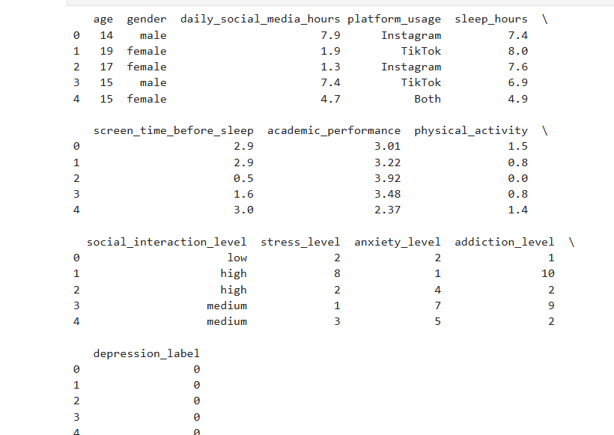
#interactive scatter plot
fig1 = px.scatter
( df,
x="daily_social_media_hours",
y="stress_level", color="gender", size="academic_performance",
hover_data=["age", "sleep_hours", "anxiety_level"],
title="Social Media Hours vs Stress Level" )

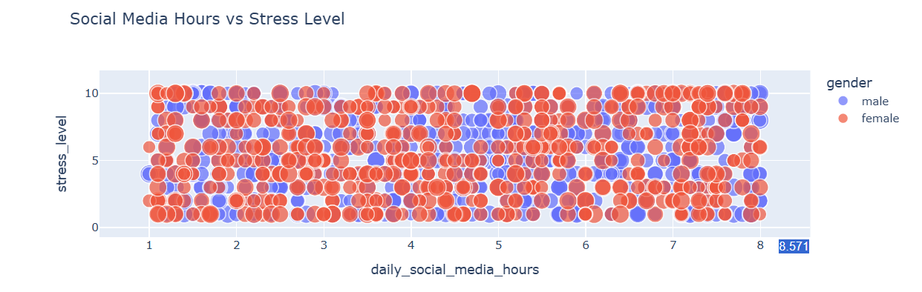
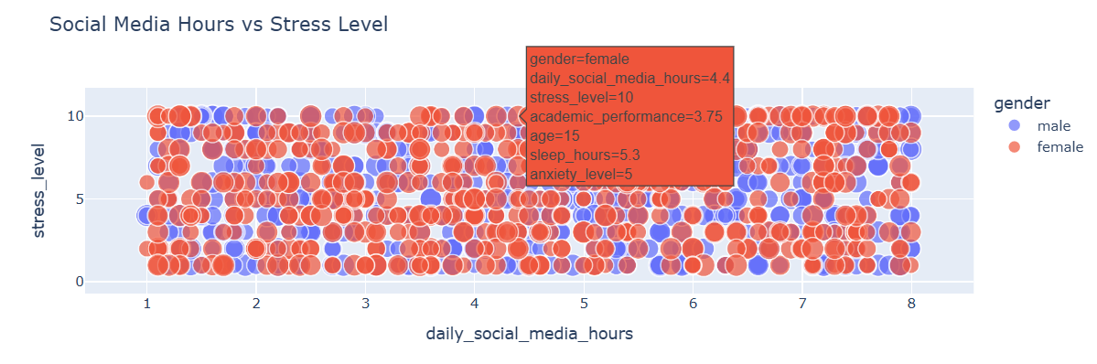

#interactive line chart
fig2 = px.line(
df.head(30),
x=df.head(30).index,
y="stress_level",
color="gender",
markers=True,
hover_data=["daily_social_media_hours", "sleep_hours"],
title="Stress Level of First 30 Students"
)
fig2.show()

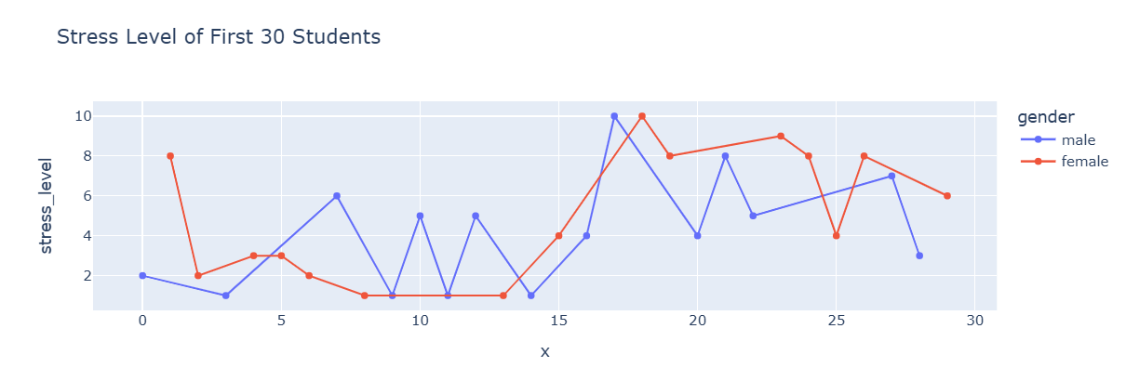
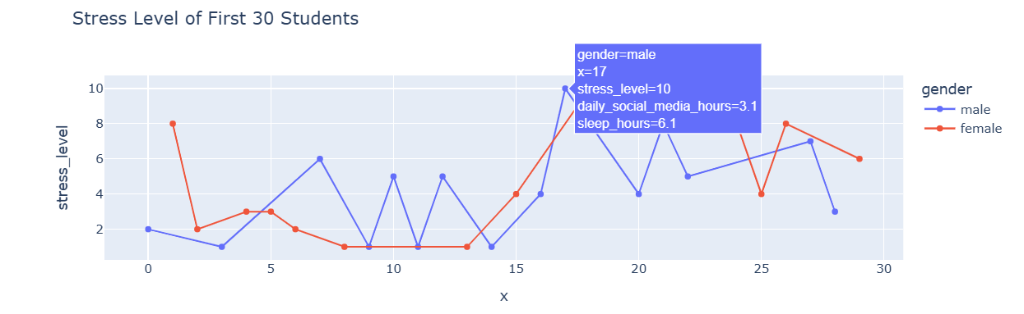
#interactive dashboard (scatter plot with filter)
fig3 = px.scatter(
df,
x="sleep_hours",
y="academic_performance",
color="depression_label",
size="stress_level",
hover_data=[
"age",
"gender",
"daily_social_media_hours",
"anxiety_level"
],
title="Academic Performance vs Sleep Hours"
)
fig3.show()

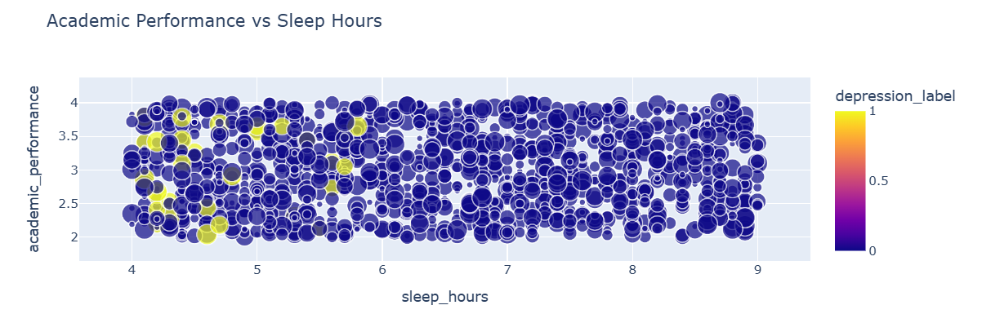

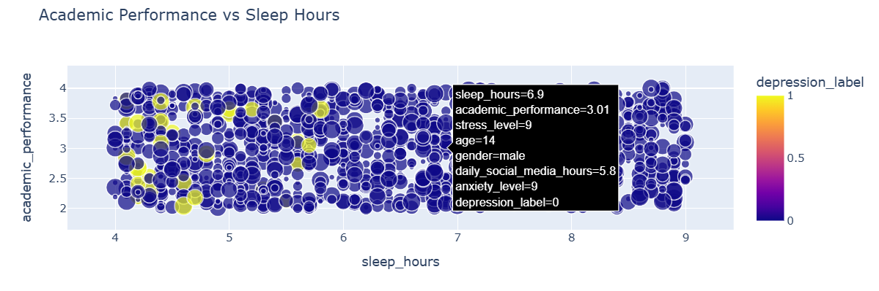
# Interactive Bar Chart
fig4 = px.bar(
df,
x="gender",
y="stress_level",
color="gender",
hover_data=["age", "sleep_hours", "anxiety_level"],
title="Average Stress Level by Gender"
)

fig4.show()
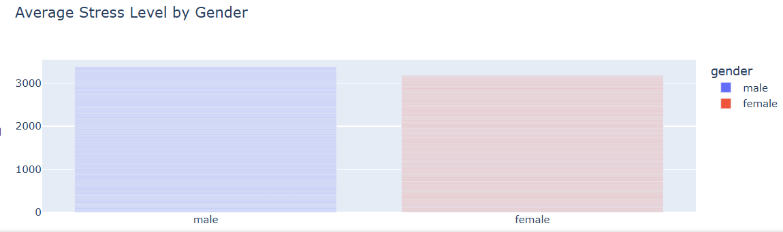

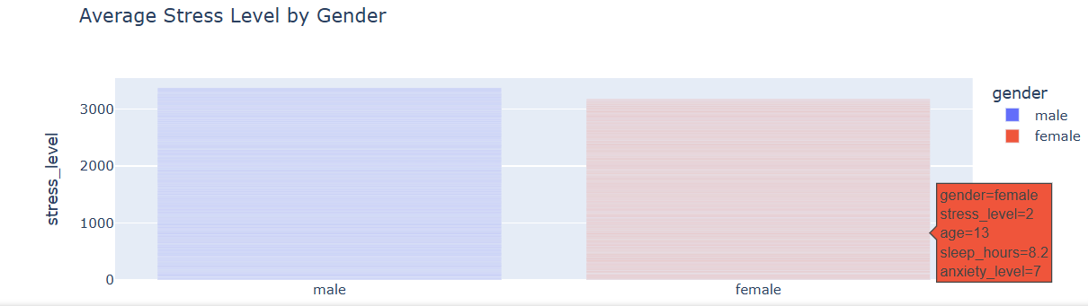

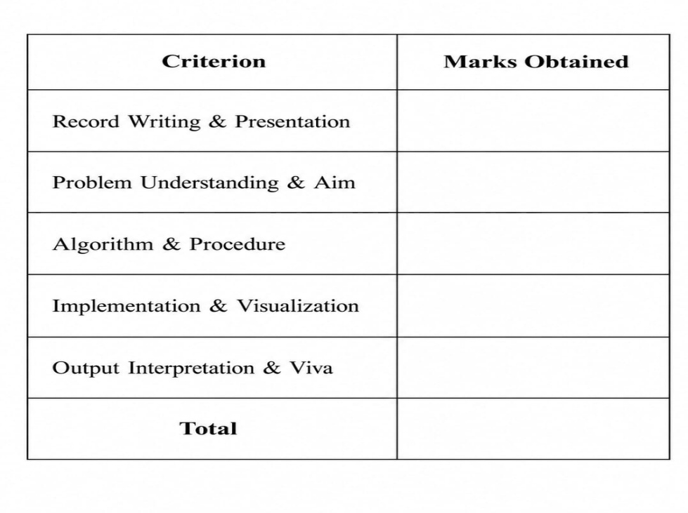

Result
The interactive scatter plot , line chart, and dashboard were
Successfully created using Plotly. Tooltips displayed detailed information
When hovering over data points, and color-based filtering made it easier to compare different categories in the dataset.

#scatter plot plt.figure(figsize=(7,5)) plt.scatter(df["SepalLengthCm"], df["PetalLengthCm"], color="red") plt.title("Sepal Length vs Petal Length") plt.xlabel("Sepal Length (cm)") plt.ylabel("Petal Length (cm)") plt.grid(True) plt.show()
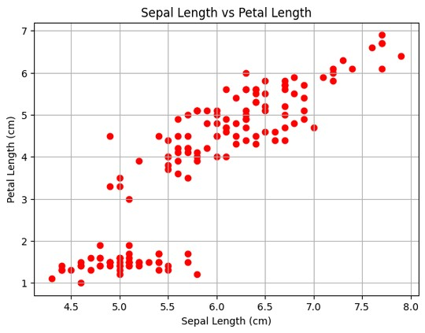
#bar plot
species_count = df["Species"].value_counts() plt.figure(figsize=(7,5)) plt.bar(species_count.index, species_count.values) plt.title("Number of Flowers in Each Species") plt.xlabel("Species") plt.ylabel("Count") plt.show()
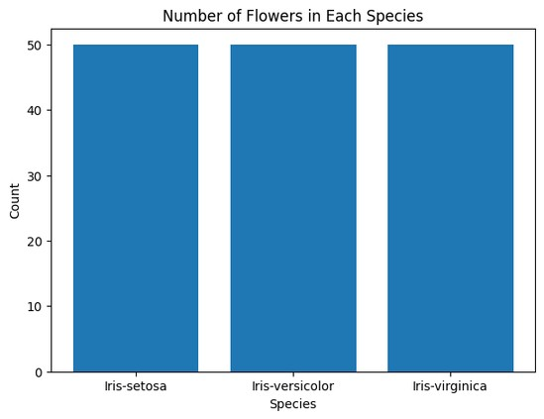
#pie chart
species_count = df["Species"].value_counts() plt.figure(figsize=(6,6)) plt.pie(species_count.values, labels=species_count.index, autopct="%1.1f%%", startangle=90) plt.title("Percentage of Flower Species") plt.show()
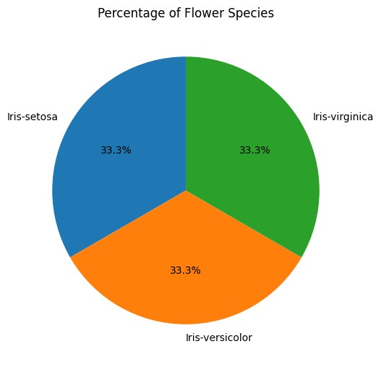
#histogram
plt.figure(figsize=(7,5)) plt.hist(df["SepalLengthCm"], bins=10, edgecolor="black") plt.title("Distribution of Sepal Length") plt.xlabel("Sepal Length (cm)") plt.ylabel("Frequency") plt.show()
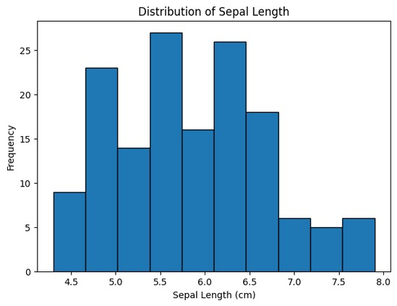
Result:
Simple line, bar, and scatter plots were successfully created using Matplotlib. The charts were properly labeled with titles, axis labels, legends, and grids, demonstrating the basic features of data visualization
EXP NO: 05 DATE: | TABLEAU WORKSHOP

Aim:
To connect Tableau to a real-world dataset containing multiple data types and variables, create different charts, and develop an interactive dashboard with filters and tooltips for data analysis.

Procedure:
• Open Tableau and connect the dataset
• Check the available fields and their data types.
• Create a Bar Chart using gender and stress_level.
• Create a Scatter Plot using daily_social_media_hours and stress_level.
• Create a Line Chart using age and stress_level.
• Create a Box Plot to study the distribution of stress levels.
• Add suitable titles, tooltips, and a Gender filter to the charts.
• Create a new Dashboard and combine all the charts.
• Arrange the charts neatly and apply the filter to the dashboard.
• Interact with the dashboard and observe the data using the charts and tooltips.

Progrram:
# Import Libraries import pandas as pd import seaborn as sns import matplotlib.pyplot as plt
# Read Dataset df = pd.read_csv("/content/sample_data/Iris.csv") df.head()
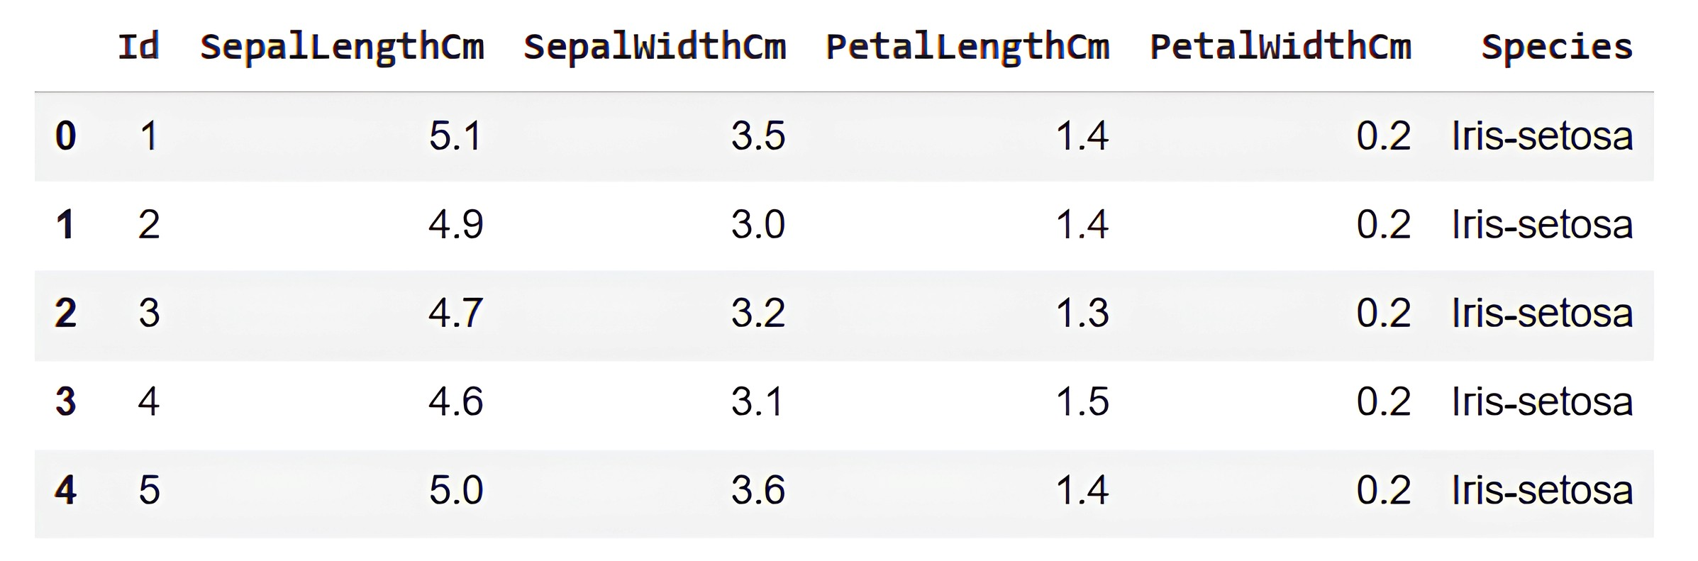
df.info()
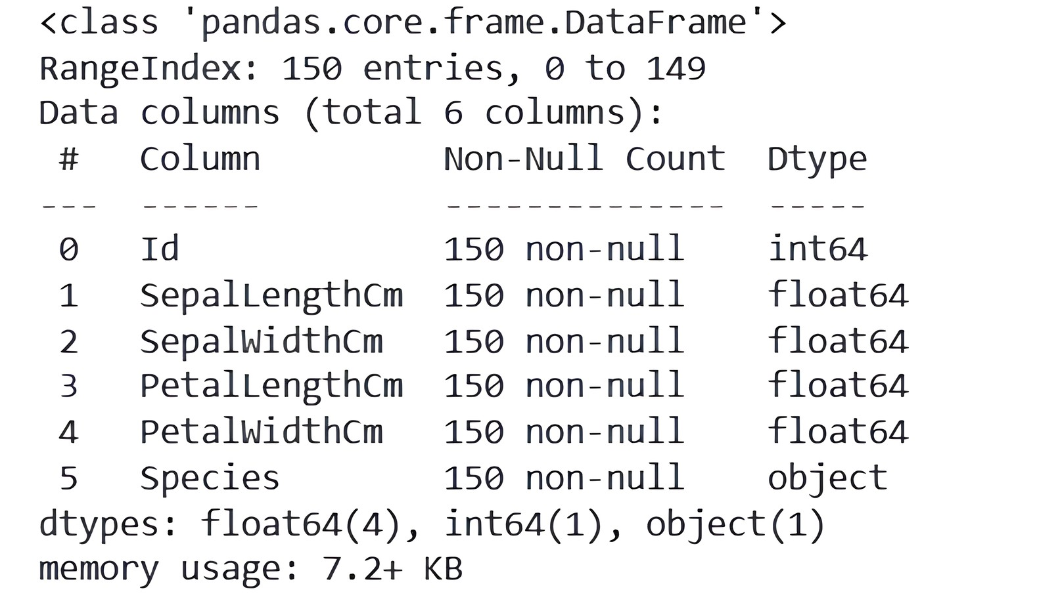
#Histogram with Density Estimation (KDE) plt.figure(figsize=(7,5)) sns.histplot(df["SepalLengthCm"], kde=True) plt.title("Distribution of Sepal Length") plt.xlabel("sepal_length") plt.ylabel("Count") plt.show()
# Box Plot 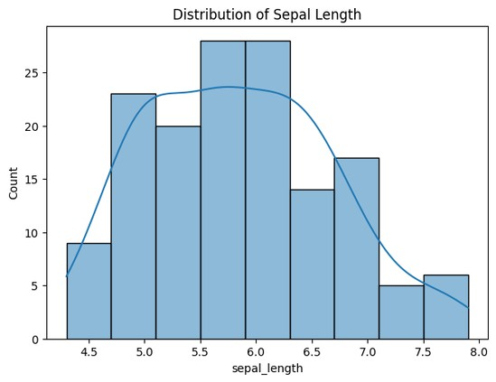plt.figure(figsize=(6,5)) sns.boxplot( y=df["SepalLengthCm"]
)
plt.title("Box Plot of Sepal Length") plt.show()
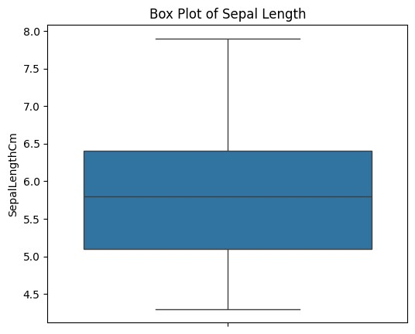
# Scatter Plot with Regression Line plt.figure(figsize=(7,5)) sns.regplot( data=df, x="SepalLengthCm", y="PetalLengthCm"
) plt.title("Sepal Length vs Petal Length") plt.show()
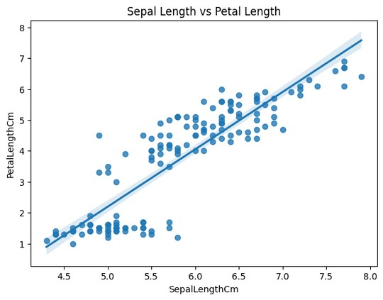
print(df["SepalLengthCm"].sort_values().tail())
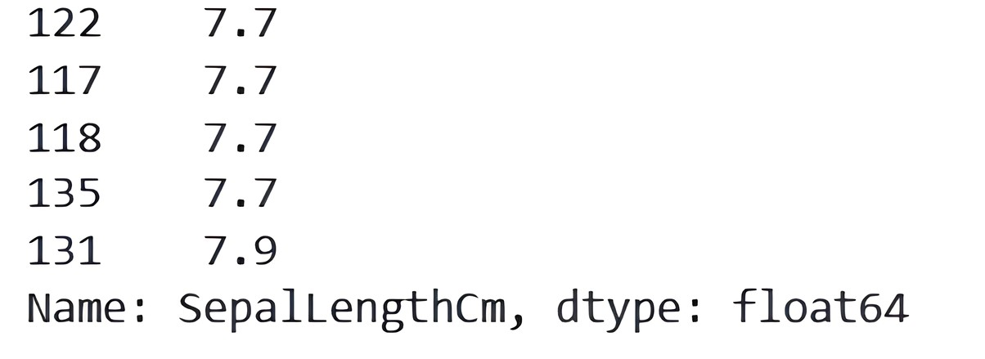
Result:
Histograms, boxplots, and scatter plots with regression lines were successfully generated using Seaborn. The plots clearly showed the distribution of data, detected outliers, and illustrated relationships between variables
EXP NO: 03 DATE: | DATA CLEANING IN PYTHON
Aim:
To perform data cleaning using the Pandas library by identifying and handling missing values and anomalous data, and to visualize the cleaned dataset
Procedure:
Open Google Colab.
Import the required libraries (pandas, numpy, matplotlib, and seaborn).
Load the Titanic dataset into a Pandas DataFrame.
Examine the dataset using functions like head(), info(), and describe().
Identify missing values using isnull().sum().
Handle missing values by:
Filling numerical values with the median or mean.
Filling categorical values with the mode.
Detect and remove or treat anomalous (outlier) data if required.
Plot the distribution of a feature before and after cleaning.
Compare the results to understand the impact of data cleaning.
Program:

SECTION A: HANDLING MISSING VALUES
# Import Libraries import pandas as pd import matplotlib.pyplot as plt
# Read Dataset
df = pd.read_csv("/content/sample_data/TitanicDataset.csv") df.head() df.info()
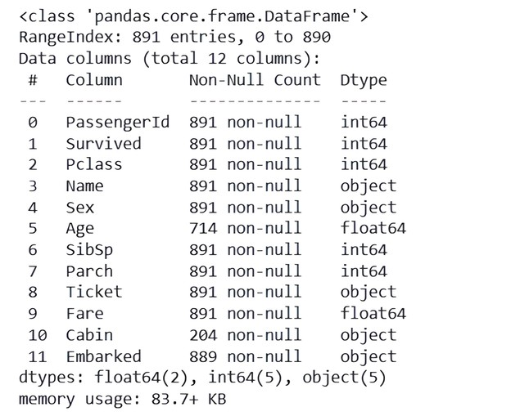
df.isnull().sum()
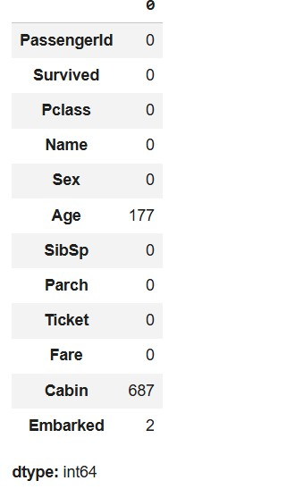
#Visualize Age Distribution (Before and After Cleaning) #Age Distribution Before Cleaning: # Histogram Before Cleaning plt.figure(figsize=(7,5)) plt.hist(df["Age"], bins=15, edgecolor="black") plt.title("Age Distribution Before Cleaning") plt.xlabel("Age") plt.ylabel("Frequency") plt.show()
# Histogram After Cleaning
# (Imputing missing values with the median age) df["Age"].fillna(df["Age"].median(), inplace=True) plt.figure(figsize=(7,5)) plt.hist(df["Age"], bins=15, edgecolor="black") plt.title("Age Distribution After Cleaning") plt.xlabel("Age") plt.ylabel("Frequency") plt.show()
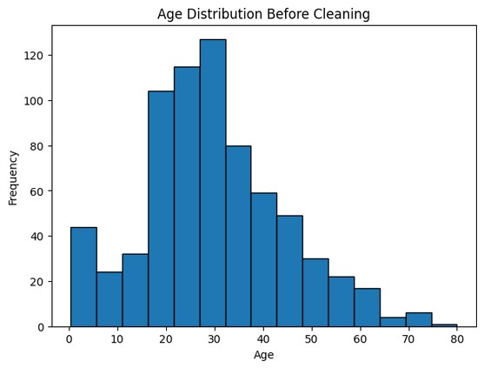
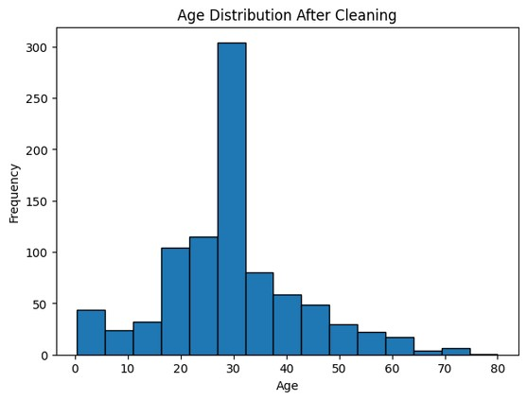

SECTION B: HANDLING ANOMALOUS (OUTLIER) VALUES
# Read Dataset
housing = pd.read_csv("/content/sample_data/california_housing.csv") housing.head() housing.info()
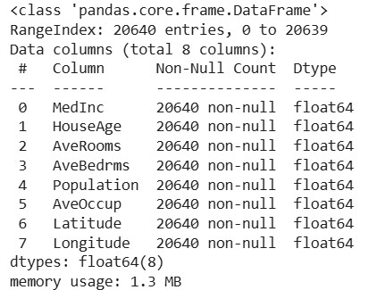
# Scatter Plot Before Cleaning plt.figure(figsize=(8,5)) plt.scatter(housing.index, housing["Population"]) plt.title("Population Before Cleaning") plt.xlabel("District Number") plt.ylabel("Population") plt.grid(True) plt.show()
# For this experiment, remove districts having population greater than 10,000. housing_clean = housing[housing["Population"] <= 10000]
# Scatter Plot After Cleaning plt.figure(figsize=(8,5)) plt.scatter(housing_clean.index, housing_clean["Population"]) plt.title("Population After Cleaning") plt.xlabel("District Number") plt.ylabel("Population") plt.grid(True) plt.show() print("Rows Before Cleaning", len(housing)) print("Rows After Cleaning", len(housing_clean))
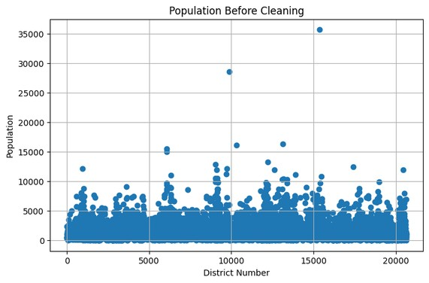
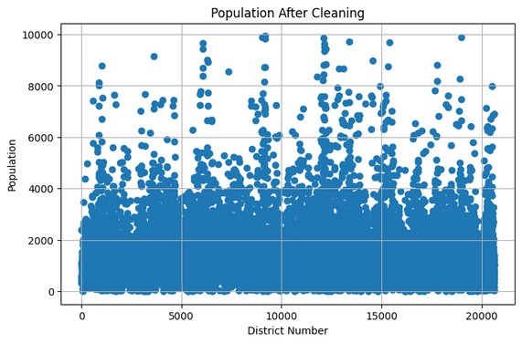
Rows Before Cleaning 20640 Rows After Cleaning 20617
Result:
Missing values and anomalous data were successfully identified and handled using Pandas. The cleaned dataset showed improved consistency, and the replotted visualizations clearly reflected the impact of the data-cleaning process.

