Module 5 - Spring Core and Maven

Exercise 4: Creating and Configuring a Maven Project

pom.xml

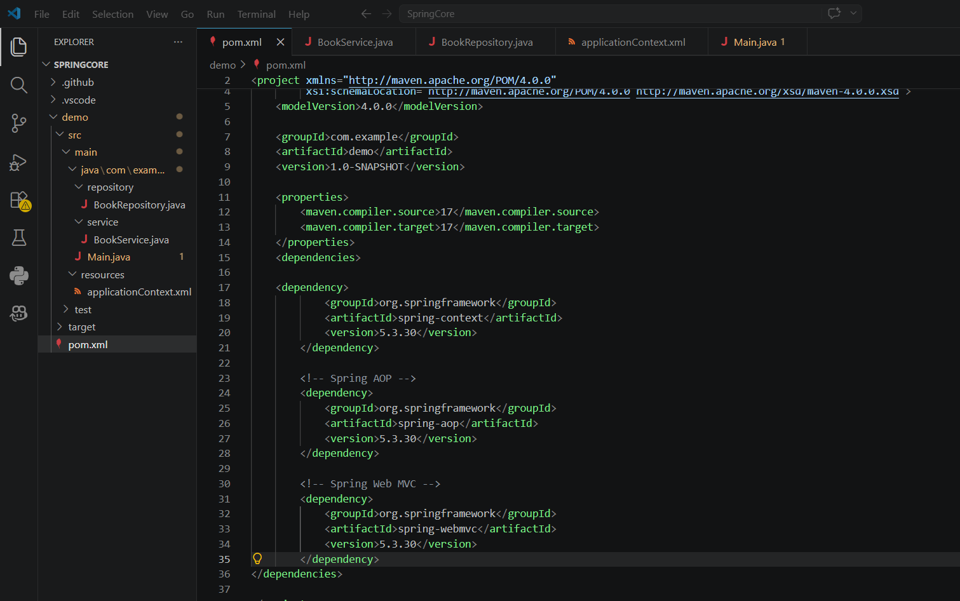

Output
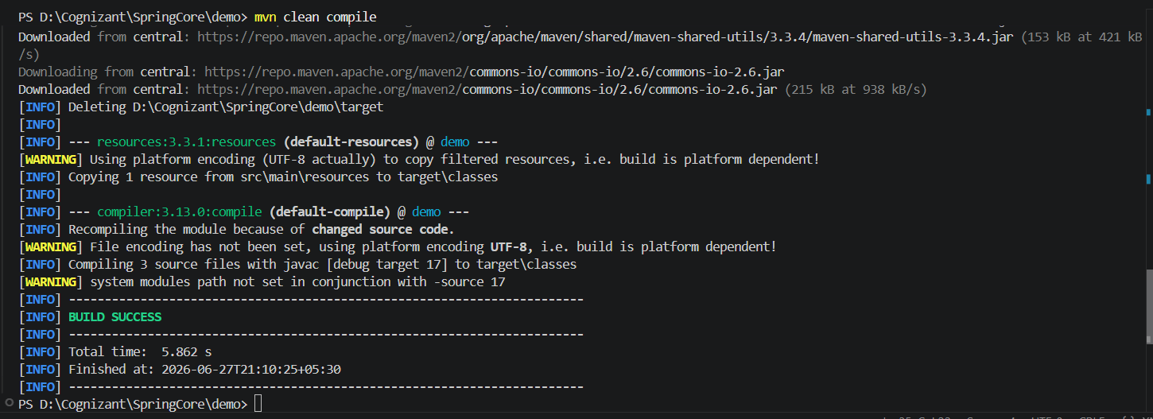
Explanation

- Maven
Maven is a build automation and dependency management tool for Java projects. It manages project dependencies, compiles the source code, runs tests, and packages the application.

- Spring Context
The Spring Context module provides the Spring IoC container, which manages application beans and dependency injection.

- Spring AOP
The Spring AOP module provides Aspect-Oriented Programming support, allowing cross-cutting concerns such as logging, security, and transaction management to be implemented separately from business logic.

- Spring Web MVC
The Spring Web MVC module is used for developing web applications following the Model-View-Controller architecture.

- Maven Compiler Plugin
The Maven Compiler Plugin specifies the Java version used to compile the project. In this exercise, both the source and target Java versions are set to 1.7.

