**Exercise 1: Implementing the Singleton Pattern**

package singleton;

public class Logger {

private static Logger instance;

private Logger() {

}

public static Logger getInstance() {

if (instance == null) {

instance = new Logger();

}

return instance;

}

public void log(String message) {

System.out.println("[LOG]: " + message);

}

}

package singleton;

public class LoggerTest {

public static void main(String[] args) {

Logger logger1 = Logger.getInstance();

Logger logger2 = Logger.getInstance();

logger1.log("Logger initialized");

logger2.log("Second log call");

if (logger1 == logger2) {

System.out.println("Same instance verified");

} else {

System.out.println("Different instances detected");

}

}

}

**Output :**

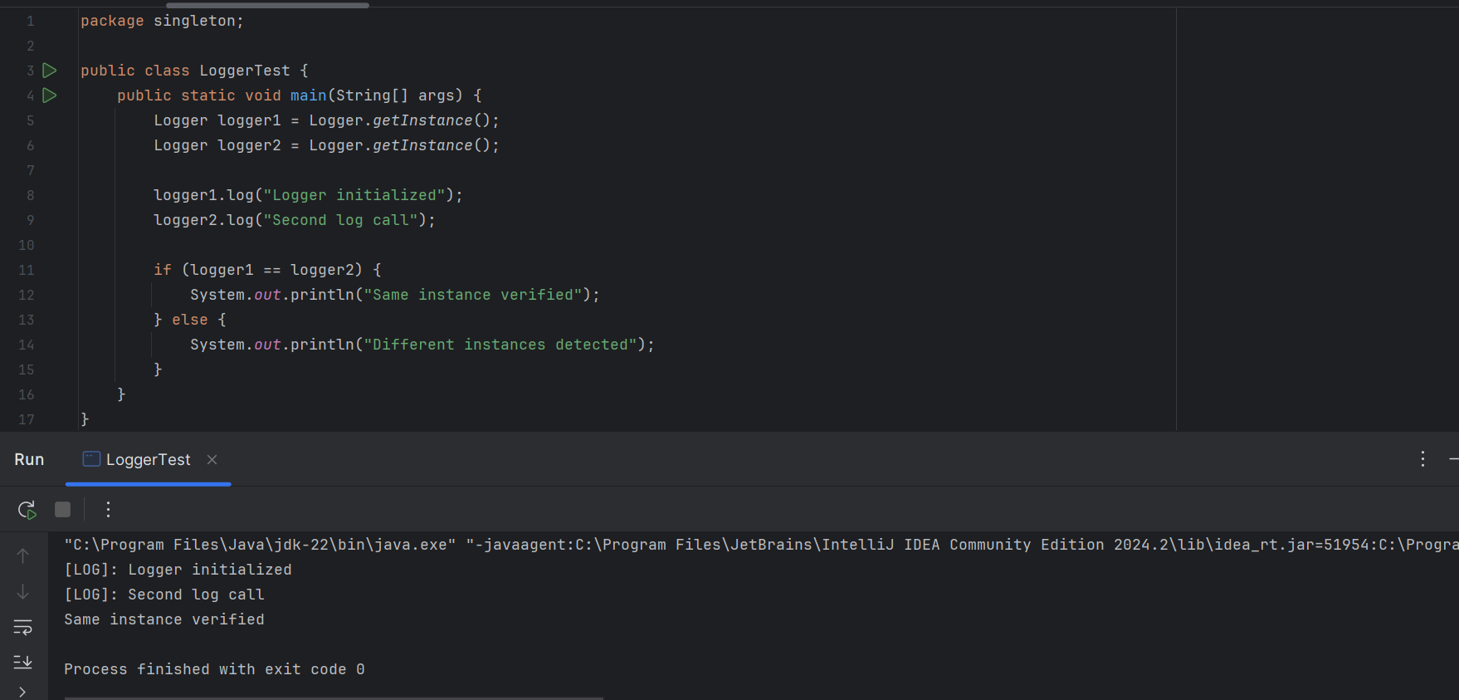

**Exercise 2: Implementing the Factory Method Pattern**

package factory;

public interface Document {

void open();

}

package factory;

public class WordDocument implements Document {

@Override

public void open() {

System.out.println("Word document opened");

}

}

package factory;

public class PdfDocument implements Document {

@Override

public void open() {

System.out.println("PDF document opened");

}

}

package factory;

public class ExcelDocument implements Document {

@Override

public void open() {

System.out.println("Excel document opened");

}

}

package factory;

public abstract class DocumentFactory {

public abstract Document createDocument();

}

package factory;

public class WordDocumentFactory extends DocumentFactory {

@Override

public Document createDocument() {

return new WordDocument();

}

}

package factory;

public class PdfDocumentFactory extends DocumentFactory {

@Override

public Document createDocument() {

return new PdfDocument();

}

}

package factory;

public class ExcelDocumentFactory extends DocumentFactory {

@Override

public Document createDocument() {

return new ExcelDocument();

}

}

package factory;

public class FactoryTest {

public static void main(String[] args) {

DocumentFactory wordFactory = new WordDocumentFactory();

Document wordDoc = wordFactory.createDocument();

wordDoc.open();

DocumentFactory pdfFactory = new PdfDocumentFactory();

Document pdfDoc = pdfFactory.createDocument();

pdfDoc.open();

DocumentFactory excelFactory = new ExcelDocumentFactory();

Document excelDoc = excelFactory.createDocument();

excelDoc.open();

}

}

**Output :**

