**SPRINGCORE_MAVEN**

**Exercise 1: Configuring a Basic Spring Application**

1. **Set Up a Spring Project:**

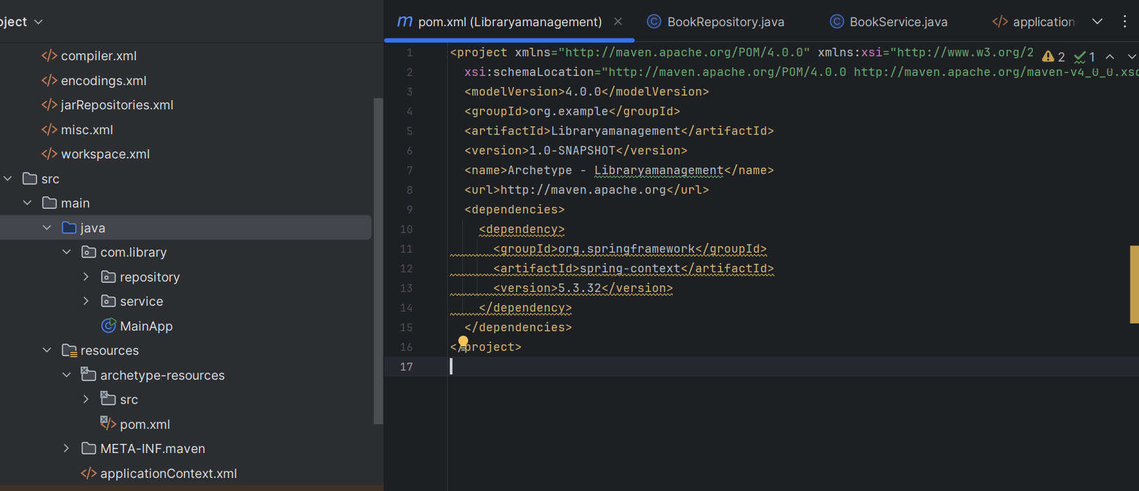

**Pom.xml**

<dependency>

<groupId>org.springframework</groupId>

<artifactId>spring-context</artifactId>

<version>5.3.32</version>

</dependency>

1. **Configure the Application Context:**

<?xml version="1.0" encoding="UTF-8"?>

<beans xmlns="http://www.springframework.org/schema/beans"

xmlns:xsi="http://www.w3.org/2001/XMLSchema-instance"

xsi:schemaLocation="

http://www.springframework.org/schema/beans

http://www.springframework.org/schema/beans/spring-beans.xsd">

<bean id="bookRepository" class="com.library.repository.BookRepository"/>

<bean id="bookService" class="com.library.service.BookService">

<property name="bookRepository" ref="bookRepository"/>

</bean>

</beans>

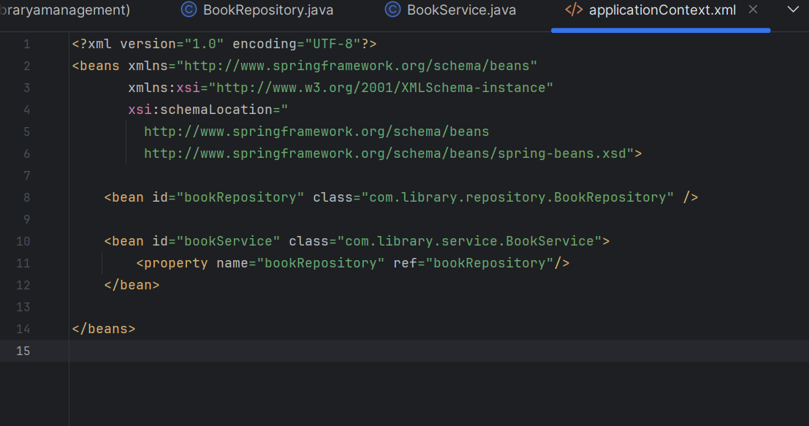

1. **Define Service and Repository Classes:**

**BookRepository.java**

package com.library.repository;

public class BookRepository {

public void saveBook(String title) {

System.out.println("Book saved: " + title);

}

}

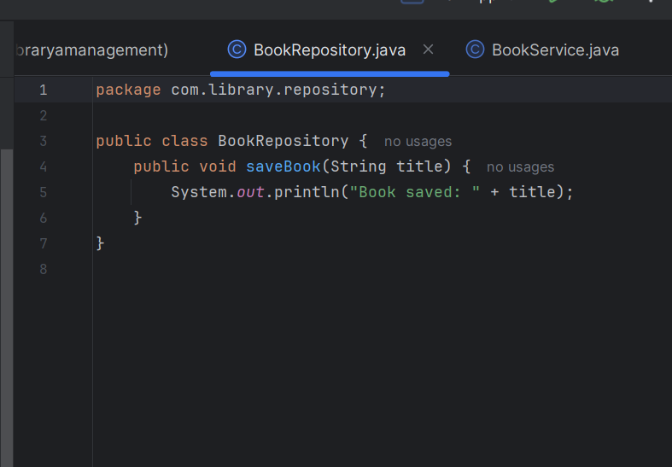

**BookService.java**

package com.library.service;

import com.library.repository.BookRepository;

public class BookService {

private BookRepository bookRepository;

public void setBookRepository(BookRepository bookRepository) {

this.bookRepository = bookRepository;

}

public void addBook(String title) {

System.out.println("Adding book: " + title);

bookRepository.saveBook(title);

}

}

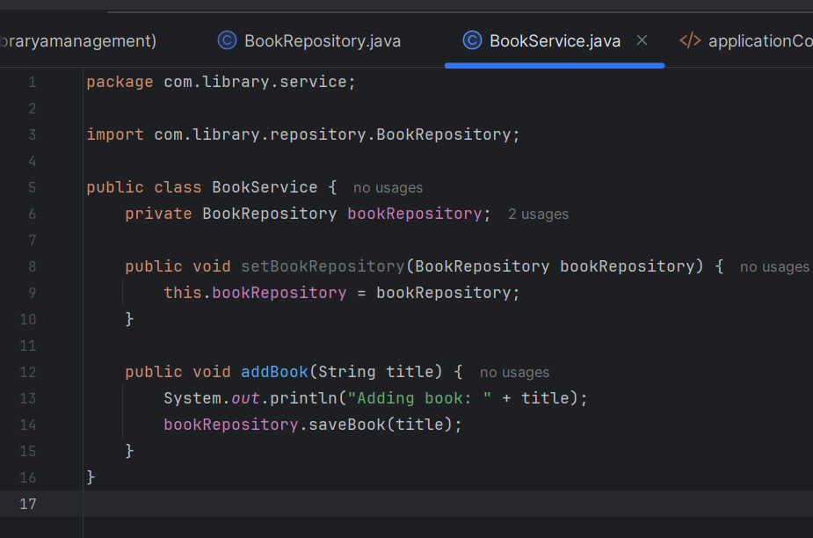

1. **Run the Application:**

**MainApp.java**

package com.library;

import com.library.service.BookService;

import org.springframework.context.ApplicationContext;

import org.springframework.context.support.ClassPathXmlApplicationContext;

public class MainApp {

public static void main(String[] args) {

ApplicationContext context = new ClassPathXmlApplicationContext("applicationContext.xml");

BookService bookService = (BookService) context.getBean("bookService");

bookService.addBook("The Great Gatsby");

((ClassPathXmlApplicationContext) context).close();

}

}

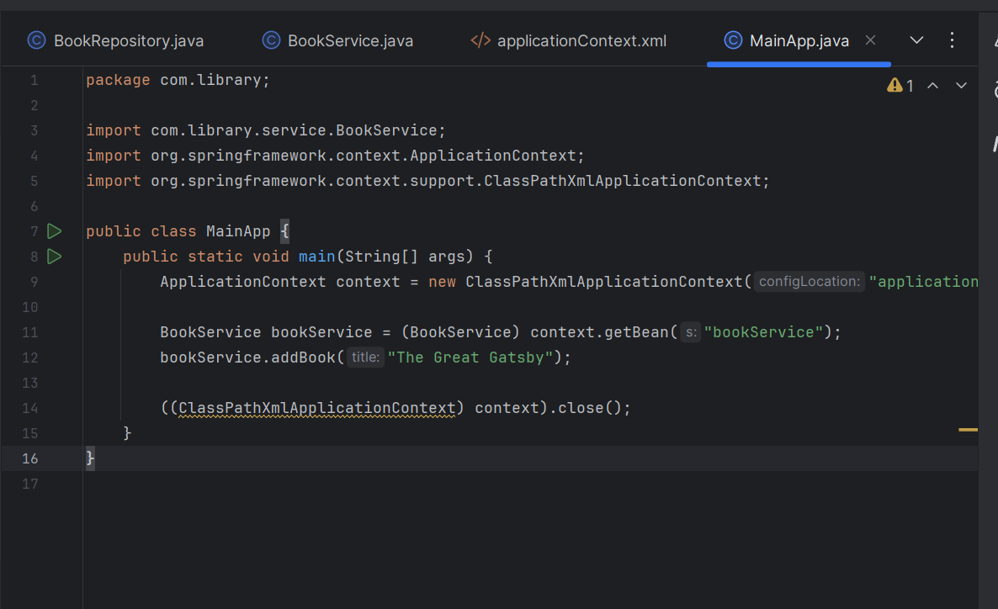

**Output :**

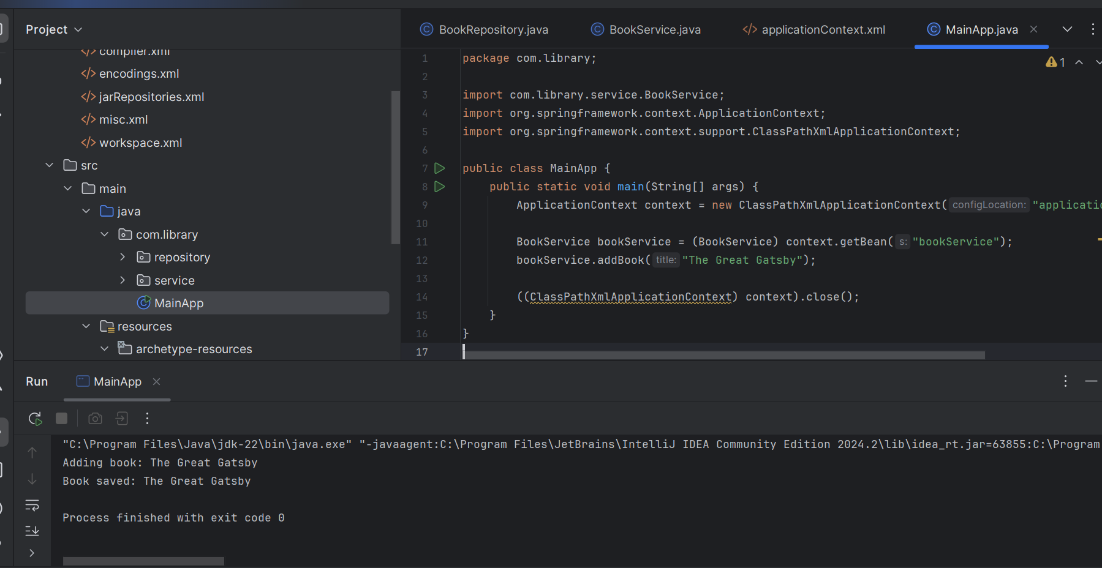

**Exercise 2: Implementing Dependency Injection**

1. **Modify the XML Configuration:**

<?xml version="1.0" encoding="UTF-8"?>

<beans xmlns="http://www.springframework.org/schema/beans"

xmlns:xsi="http://www.w3.org/2001/XMLSchema-instance"

xsi:schemaLocation="

http://www.springframework.org/schema/beans

http://www.springframework.org/schema/beans/spring-beans.xsd">

<!-- Define BookRepository bean -->

<bean id="bookRepository" class="com.library.repository.BookRepository" />

<!-- Define BookService bean and inject BookRepository -->

<bean id="bookService" class="com.library.service.BookService">

<property name="bookRepository" ref="bookRepository"/>

</bean>

</beans>

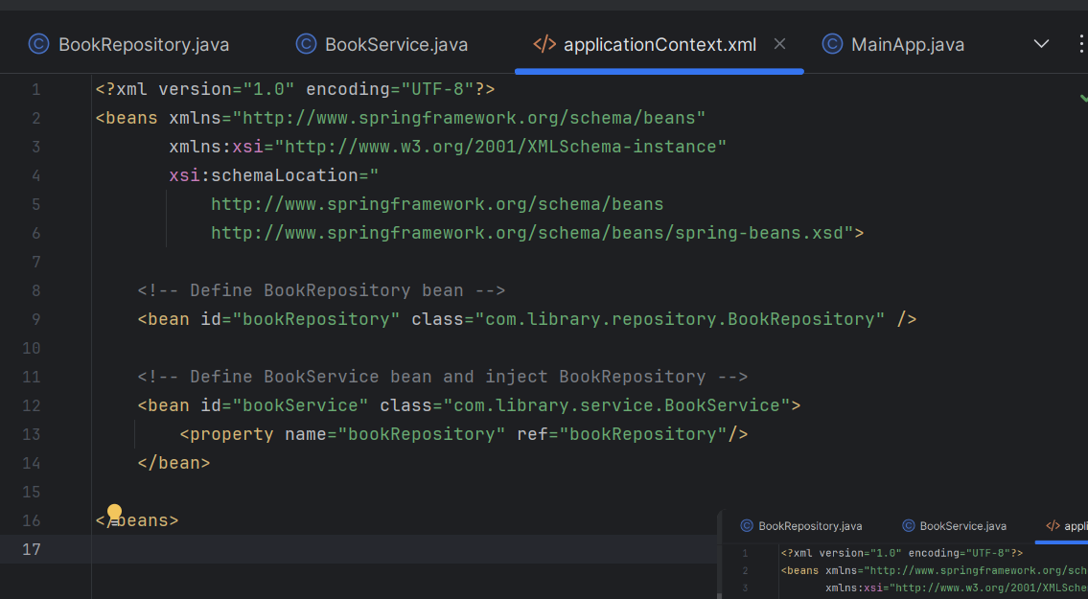

**2. Update the BookService Class:**

package com.library.service;

import com.library.repository.BookRepository;

public class BookService {

private BookRepository bookRepository;

// Setter required for DI

public void setBookRepository(BookRepository bookRepository) {

this.bookRepository = bookRepository;

}

public void addBook(String title) {

System.out.println("Adding book: " + title);

bookRepository.saveBook(title);

}

}

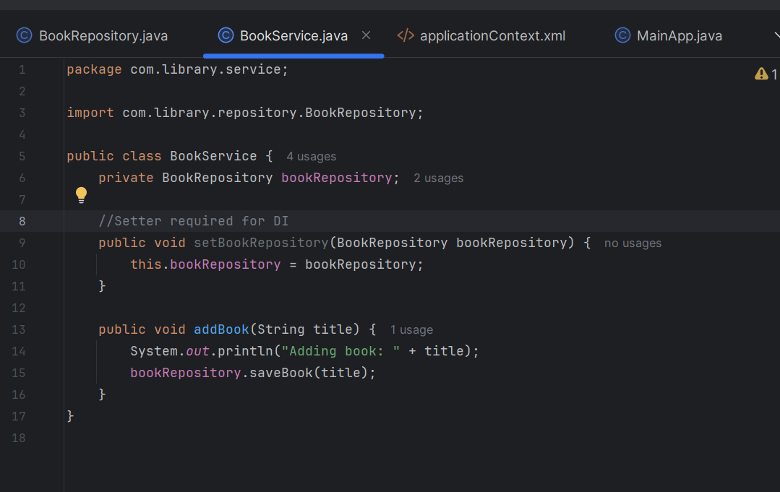

**3. Test the Configuration:**

package com.library;

import com.library.service.BookService;

import org.springframework.context.ApplicationContext;

import org.springframework.context.support.ClassPathXmlApplicationContext;

public class LibraryManagementApplication {

public static void main(String[] args) {

// Load Spring context from XML

ApplicationContext context = new ClassPathXmlApplicationContext("applicationContext.xml");

// Get bookService bean (DI applied)

BookService bookService = (BookService) context.getBean("bookService");

bookService.addBook("The Alchemist");

((ClassPathXmlApplicationContext) context).close(); // close context

}

}

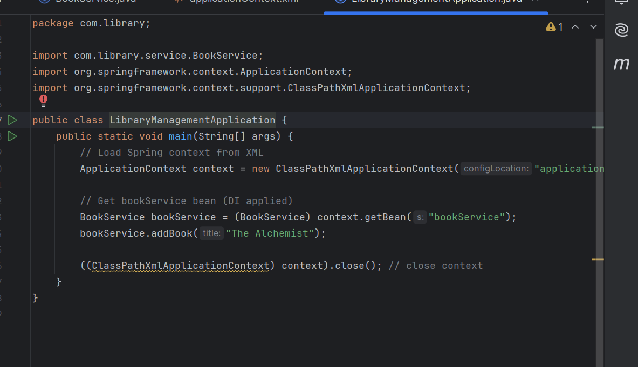

**Output :**

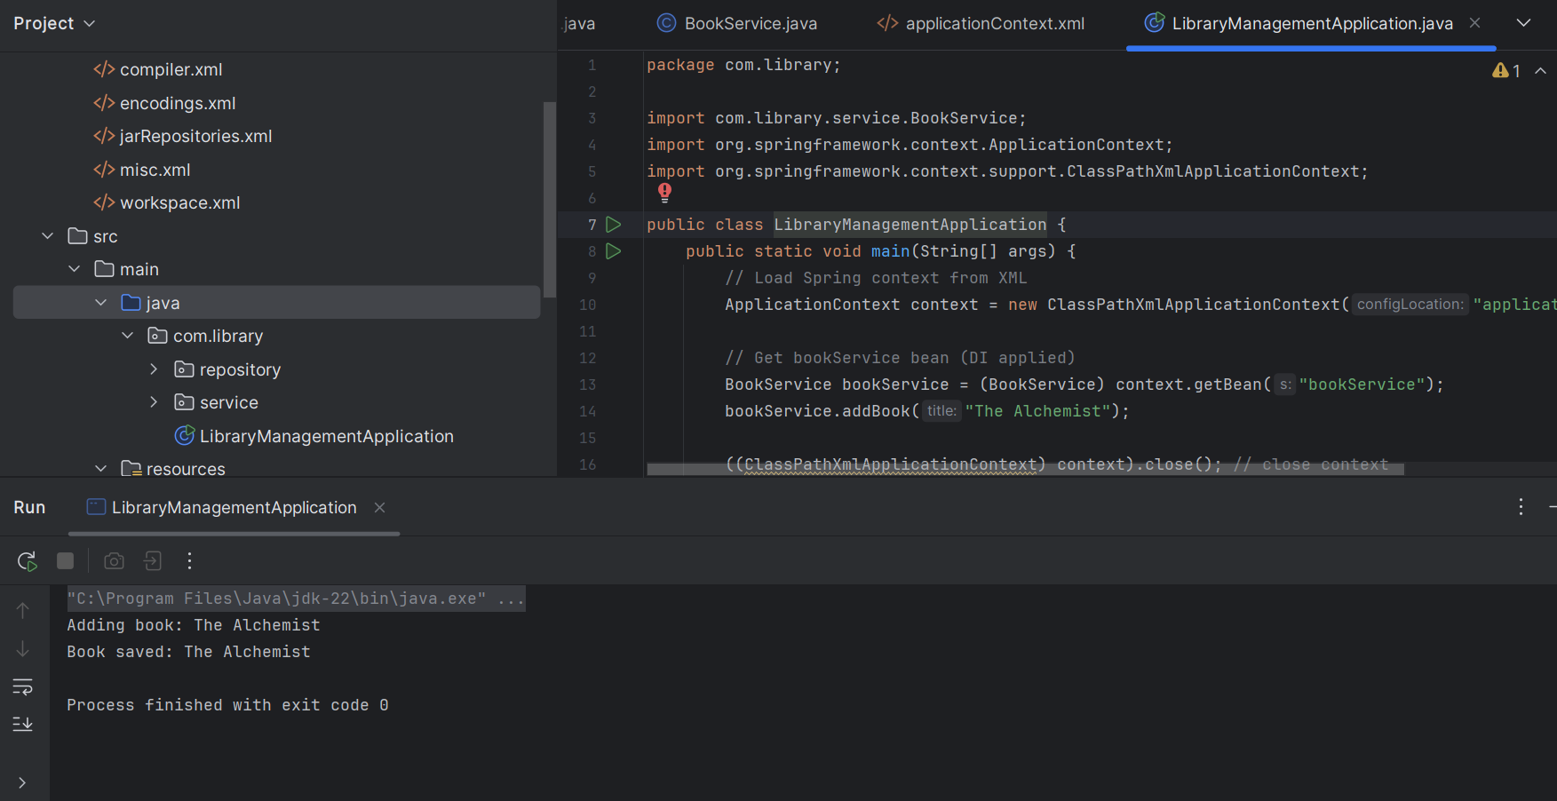

**Exercise 4: Creating and Configuring a Maven Project**

1. **Create a New Maven Project:**

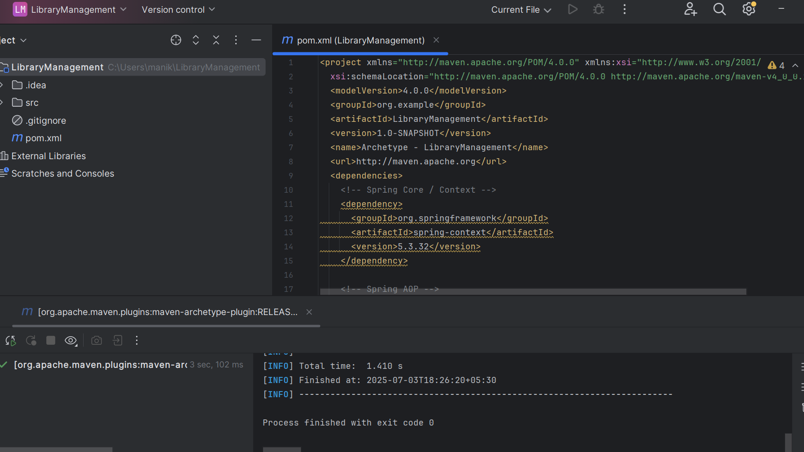

**2. Add Spring Dependencies in pom.xml:**

<dependencies>

<!-- Spring Core / Context -->

<dependency>

<groupId>org.springframework</groupId>

<artifactId>spring-context</artifactId>

<version>5.3.32</version>

</dependency>

<!-- Spring AOP -->

<dependency>

<groupId>org.springframework</groupId>

<artifactId>spring-aop</artifactId>

<version>5.3.32</version>

</dependency>

<!-- Spring Web MVC -->

<dependency>

<groupId>org.springframework</groupId>

<artifactId>spring-webmvc</artifactId>

<version>5.3.32</version>

</dependency>

</dependencies>

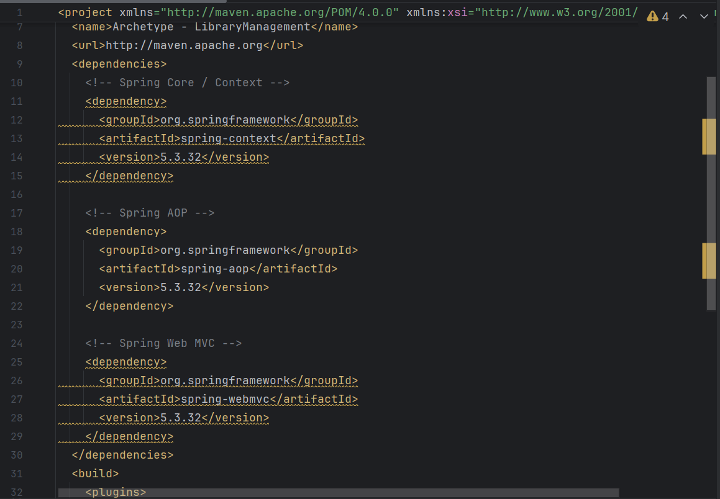

**3. Configure Maven Plugins:**

<build>

<plugins>

<!-- Maven Compiler Plugin -->

<plugin>

<groupId>org.apache.maven.plugins</groupId>

<artifactId>maven-compiler-plugin</artifactId>

<version>3.8.1</version>

<configuration>

<source>1.8</source>

<target>1.8</target>

</configuration>

</plugin>

</plugins>

</build>

