**Create a Spring Web Project using Maven**

EX- 1 :

package com.cognizant.spring_learn;  
  
import org.slf4j.Logger;  
import org.slf4j.LoggerFactory;  
import org.springframework.boot.SpringApplication;  
import org.springframework.boot.autoconfigure.SpringBootApplication;  
  
@SpringBootApplication  
public class SpringLearnApplication {  
 private static final Logger *LOGGER* = LoggerFactory.*getLogger*(SpringLearnApplication.class);  
  
 public static void main(String[] args) {  
 SpringApplication.*run*(SpringLearnApplication.class, args);  
 *LOGGER*.info("Main method has been executed successfully!!!");  
 }  
}

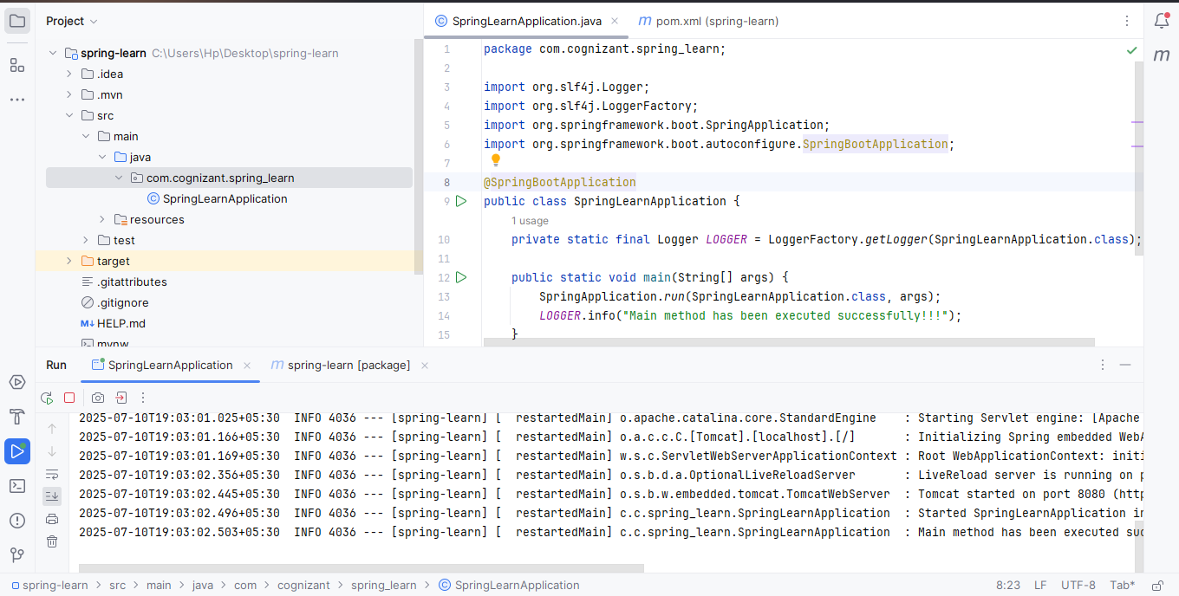

**Spring Core – Load Country from Spring Configuration XML**

EX-2:

package com.cognizant.spring_learn;  
  
import org.slf4j.Logger;  
import org.slf4j.LoggerFactory;  
import org.springframework.context.ApplicationContext;  
import org.springframework.context.support.ClassPathXmlApplicationContext;  
  
public class SpringLearnApplication {  
  
 private static final Logger *LOGGER* = LoggerFactory.*getLogger*(SpringLearnApplication.class);  
  
 public static void main(String[] args) {  
 *LOGGER*.info("START");  
  
 *displayCountry*();  
  
 *LOGGER*.info("END");  
 }  
  
 public static void displayCountry() {  
 ApplicationContext context = new ClassPathXmlApplicationContext("country.xml");  
 com.cognizant.springlearn.Country country = context.getBean("country", com.cognizant.springlearn.Country.class);  
 *LOGGER*.debug("Country : {}", country);  
 }  
}

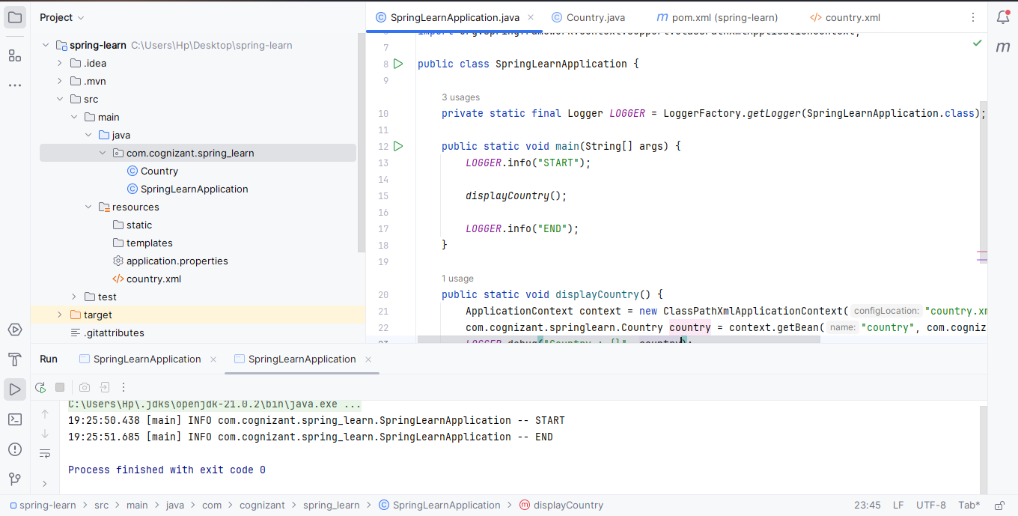

package com.cognizant.springlearn;  
  
import org.slf4j.Logger;  
import org.slf4j.LoggerFactory;  
  
public class Country {  
 private static final Logger *LOGGER* = LoggerFactory.*getLogger*(Country.class);  
  
 private String code;  
 private String name;  
  
 public Country() {  
 *LOGGER*.debug("Inside Country Constructor.");  
 }  
  
 public String getCode() {  
 *LOGGER*.debug("Inside getCode()");  
 return code;  
 }  
  
 public void setCode(String code) {  
 *LOGGER*.debug("Inside setCode()");  
 this.code = code;  
 }  
  
 public String getName() {  
 *LOGGER*.debug("Inside getName()");  
 return name;  
 }  
  
 public void setName(String name) {  
 *LOGGER*.debug("Inside setName()");  
 this.name = name;  
 }  
  
 @Override  
 public String toString() {  
 return "Country [code=" + code + ", name=" + name + "]";  
 }  
}

**Hello World RESTful Web Service**

EX-3:

package com.cognizant.spring_learn;  
  
import org.springframework.boot.SpringApplication;  
import org.springframework.boot.autoconfigure.SpringBootApplication;  
  
@SpringBootApplication  
public class SpringLearnApplication {  
 public static void main(String[] args) {  
 SpringApplication.*run*(SpringLearnApplication.class, args);  
 }  
}

package com.cognizant.springlearn;  
  
import org.slf4j.Logger;  
import org.slf4j.LoggerFactory;  
  
public class Country {  
 private static final Logger *LOGGER* = LoggerFactory.*getLogger*(Country.class);  
  
 private String code;  
 private String name;  
  
 public Country() {  
 *LOGGER*.debug("Inside Country Constructor.");  
 }  
  
 public String getCode() {  
 *LOGGER*.debug("Inside getCode()");  
 return code;  
 }  
  
 public void setCode(String code) {  
 *LOGGER*.debug("Inside setCode()");  
 this.code = code;  
 }  
  
 public String getName() {  
 *LOGGER*.debug("Inside getName()");  
 return name;  
 }  
  
 public void setName(String name) {  
 *LOGGER*.debug("Inside setName()");  
 this.name = name;  
 }  
  
 @Override  
 public String toString() {  
 return "Country [code=" + code + ", name=" + name + "]";  
 }  
}

package com.cognizant.spring_learn.controller;  
  
import org.slf4j.Logger;  
import org.slf4j.LoggerFactory;  
import org.springframework.web.bind.annotation.GetMapping;  
import org.springframework.web.bind.annotation.RestController;  
  
@RestController  
public class HelloController {  
  
 private static final Logger *LOGGER* = LoggerFactory.*getLogger*(HelloController.class);  
  
 @GetMapping("/hello")  
 public String sayHello() {  
 *LOGGER*.info("START - sayHello()");  
 String message = "Hello World Raja!!";  
 *LOGGER*.info("END - sayHello()");  
 return message;  
 }  
}

spring.application.name=spring-learn  
server.port=8083

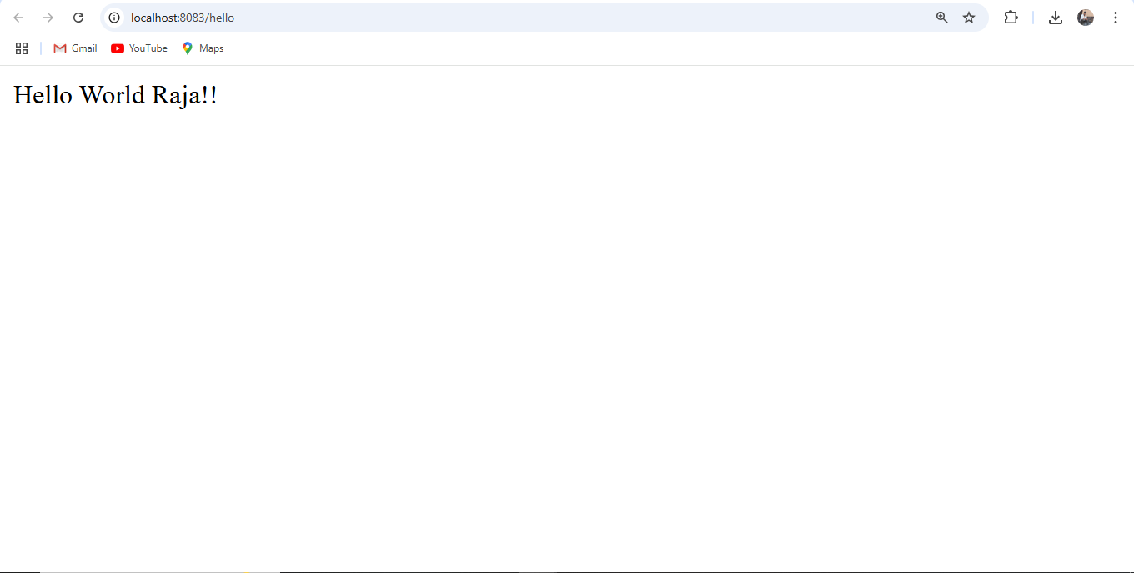

**REST - Country Web Service**

Ex-4 :

package com.cognizant.spring_learn;  
  
import com.cognizant.spring_learn.Country;  
import org.slf4j.Logger;  
import org.slf4j.LoggerFactory;  
import org.springframework.boot.SpringApplication;  
import org.springframework.boot.autoconfigure.SpringBootApplication;  
import org.springframework.context.ApplicationContext;  
import org.springframework.context.support.ClassPathXmlApplicationContext;  
  
@SpringBootApplication  
public class SpringLearnApplication {  
  
 private static final Logger *LOGGER* = LoggerFactory.*getLogger*(SpringLearnApplication.class);  
  
 public static void main(String[] args) {  
 *LOGGER*.info("START");  
  
 SpringApplication.*run*(SpringLearnApplication.class, args);  
  
 *// Uncomment if you want to test country loading directly from XML  
 // displayCountry();  
  
 LOGGER*.info("END");  
 }  
  
 public static void displayCountry() {  
 ApplicationContext context = new ClassPathXmlApplicationContext("country.xml");  
 Country country = context.getBean("country", Country.class);  
 *LOGGER*.debug("Country: {}", country.toString());  
 }  
}

*<?*xml version="1.0" encoding="UTF-8"*?>*<beans xmlns="http://www.springframework.org/schema/beans"  
 xmlns:xsi="http://www.w3.org/2001/XMLSchema-instance"  
 xsi:schemaLocation="http://www.springframework.org/schema/beans  
 https://www.springframework.org/schema/beans/spring-beans.xsd">  
  
 <bean id="country" class="com.cognizant.spring_learn.Country">  
 <property name="code" value="IN" />  
 <property name="name" value="India" />  
 </bean>  
</beans>

package com.cognizant.spring_learn.controller;  
  
import com.cognizant.spring_learn.Country;  
import org.slf4j.Logger;  
import org.slf4j.LoggerFactory;  
import org.springframework.context.ApplicationContext;  
import org.springframework.context.support.ClassPathXmlApplicationContext;  
import org.springframework.web.bind.annotation.RequestMapping;  
import org.springframework.web.bind.annotation.RestController;  
  
@RestController  
public class CountryController {  
  
 private static final Logger *LOGGER* = LoggerFactory.*getLogger*(CountryController.class);  
  
 @RequestMapping("/country")  
 public Country getCountryIndia() {  
 *LOGGER*.info("START - getCountryIndia()");  
 ApplicationContext context = new ClassPathXmlApplicationContext("country.xml");  
 Country country = context.getBean("country", Country.class);  
 *LOGGER*.info("END - getCountryIndia()");  
 return country;  
 }  
}

spring.application.name=spring-learn  
server.port=8083

**REST - Get country based on country code**

Ex - 5 :

*Countrycontroller.java*

package com.cognizant.springlearn.controller;

import com.cognizant.springlearn.model.Country;

import com.cognizant.springlearn.service.CountryService;

import org.springframework.beans.factory.annotation.Autowired;

import org.springframework.web.bind.annotation.*;

@RestController

public class CountryController {

@Autowired

private CountryService countryService;

@GetMapping("/countries/{code}")

public Country getCountry(@PathVariable String code) {

return countryService.getCountry(code);

}

}

*CountryService.java*

package com.cognizant.springlearn.service;

import com.cognizant.springlearn.model.Country;

import org.springframework.context.ApplicationContext;

import org.springframework.context.support.ClassPathXmlApplicationContext;

import org.springframework.stereotype.Service;

import java.util.List;

@Service

public class CountryService {

public Country getCountry(String code) {

ApplicationContext context = new ClassPathXmlApplicationContext("country.xml");

List<Country> countries = context.getBean("countryList", List.class);

return countries.stream()

.filter(c -> c.getCode().equalsIgnoreCase(code))

.findFirst()

.orElse(null);

}

}

country.xml

<?xml version="1.0" encoding="UTF-8"?>

<beans xmlns="http://www.springframework.org/schema/beans"

xmlns:xsi="http://www.w3.org/2001/XMLSchema-instance"

xsi:schemaLocation="http://www.springframework.org/schema/beans

https://www.springframework.org/schema/beans/spring-beans.xsd">

<bean id="countryList" class="java.util.ArrayList">

<constructor-arg>

<list>

<bean class="com.cognizant.springlearn.model.Country">

<property name="code" value="IN"/>

<property name="name" value="India"/>

</bean>

<bean class="com.cognizant.springlearn.model.Country">

<property name="code" value="US"/>

<property name="name" value="United States"/>

</bean>

</list>

</constructor-arg>

</bean>

</beans>

country.java

package com.cognizant.springlearn.model;

public class Country {

private String code;

private String name;

public Country() {

}

public Country(String code, String name) {

this.code = code;

this.name = name;

}

public String getCode() {

return code;

}

public void setCode(String code) {

this.code = code;

}

public String getName() {

return name;

}

public void setName(String name) {

this.name = name;

}

}

