**Week 5 Hands-on**

**Microservices with Spring Boot 3 and Spring Cloud**

**Ex. 1:** Creating Microservices for account and loan

**Account:**

package com.example.account_service;

import org.springframework.boot.SpringApplication;

import org.springframework.boot.autoconfigure.SpringBootApplication;

import jakarta.persistence.*;

import org.springframework.data.jpa.repository.JpaRepository;

import org.springframework.beans.factory.annotation.Autowired;

import org.springframework.web.bind.annotation.*;

import java.util.List;

*@SpringBootApplication*

public class AccountServiceApplication {

public static void main(String[] args) {

SpringApplication.*run*(AccountServiceApplication.class, args);

}

}

*@Entity*

class Account {

*@Id*

*@GeneratedValue*

private Long id;

private String name;

private double balance;

public Long getId() {

return id;

}

public void setId(Long id) {

this.id = id;

}

public String getName() {

return name;

}

public void setName(String name) {

this.name = name;

}

public double getBalance() {

return balance;

}

public void setBalance(double balance) {

this.balance = balance;

}

}

interface AccountRepository extends JpaRepository<Account, Long> {}

*@RestController*

*@RequestMapping*("/accounts")

class AccountController {

*@Autowired*

private AccountRepository repository;

*@GetMapping*

public List<Account> getAll() {

return repository.findAll();

}

*@PostMapping*

public Account save(*@RequestBody* Account account) {

return repository.save(account);

}

}

**Output:**

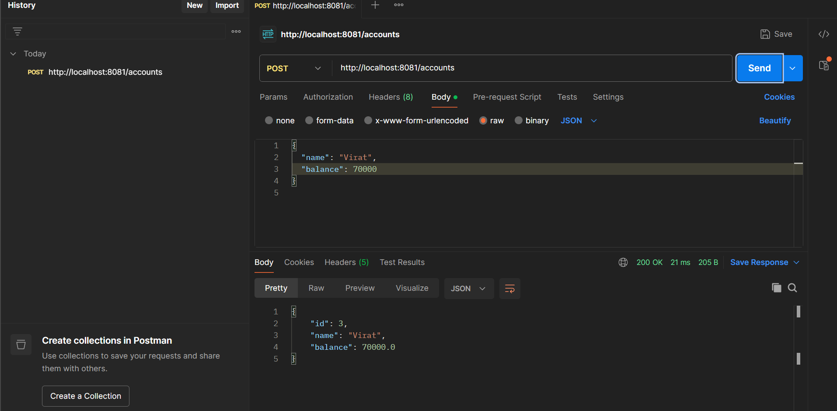

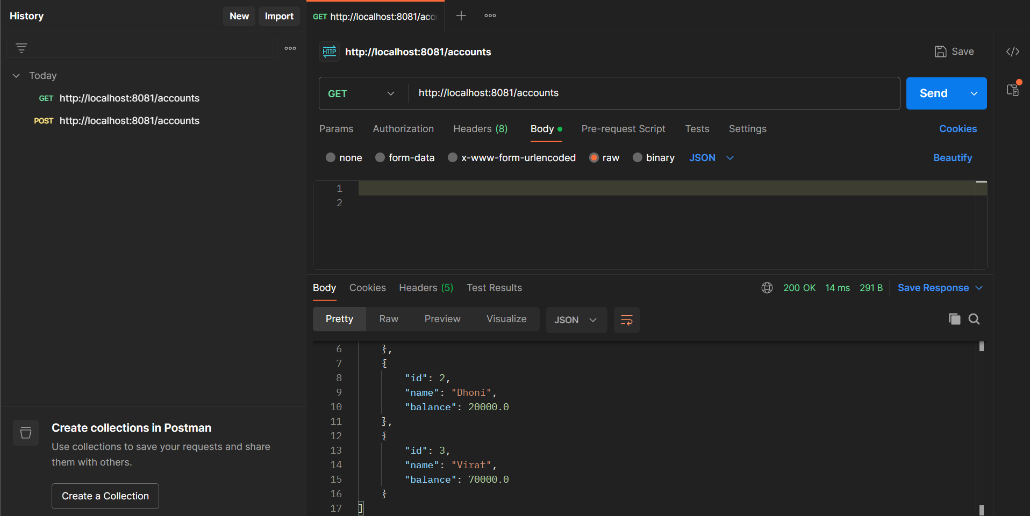

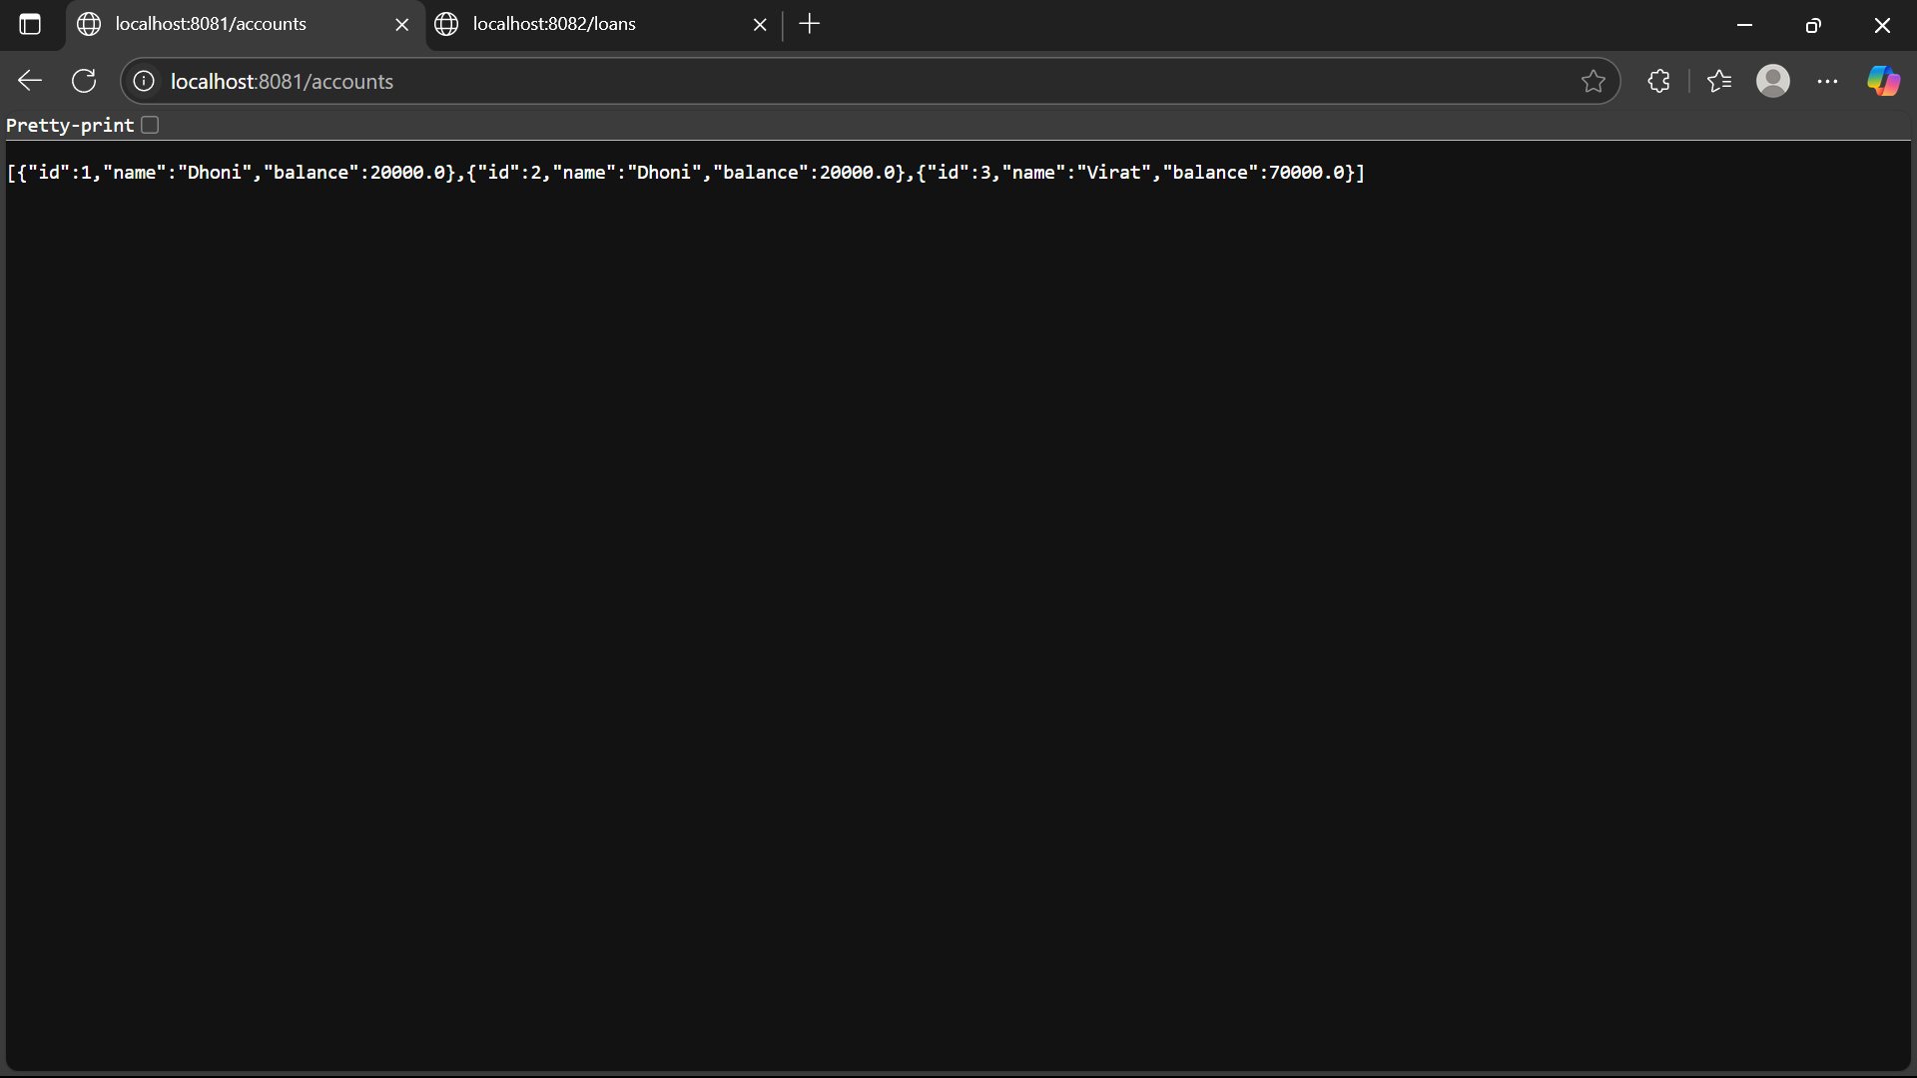

**Loan:**

package com.example.loan_service;

import org.springframework.boot.SpringApplication;

import org.springframework.boot.autoconfigure.SpringBootApplication;

import jakarta.persistence.*;

import org.springframework.data.jpa.repository.JpaRepository;

import org.springframework.beans.factory.annotation.Autowired;

import org.springframework.web.bind.annotation.*;

import java.util.List;

*@SpringBootApplication*

public class LoanServiceApplication {

public static void main(String[] args) {

SpringApplication.*run*(LoanServiceApplication.class, args);

}

}

*@Entity*

class Loan {

*@Id*

*@GeneratedValue*

private Long id;

private Long accountId;

private double amount;

private String status;

public Long getId() {

return id;

}

public void setId(Long id) {

this.id = id;

}

public Long getAccountId() {

return accountId;

}

public void setAccountId(Long accountId) {

this.accountId = accountId;

}

public double getAmount() {

return amount;

}

public void setAmount(double amount) {

this.amount = amount;

}

public String getStatus() {

return status;

}

public void setStatus(String status) {

this.status = status;

}

}

interface LoanRepository extends JpaRepository<Loan, Long> {}

*@RestController*

*@RequestMapping*("/loans")

class LoanController {

*@Autowired*

private LoanRepository repository;

*@GetMapping*

public List<Loan> getAll() {

return repository.findAll();

}

*@PostMapping*

public Loan save(*@RequestBody* Loan loan) {

return repository.save(loan);

}

}

**Output:**

