**Week-6 ReactJS**

**Exercise- 1 :**

**Create a new React Application with the name “myfirstreact”, Run the application to print “welcome to the first session of React” as heading of that page.**

1. **App.js**

**import React from 'react';**

**function App() {**

**return (**

**<div>**

**<h1>welcome to the first session of React</h1>**

**</div>**

**);**

**}**

**export default App;**

**Output :**

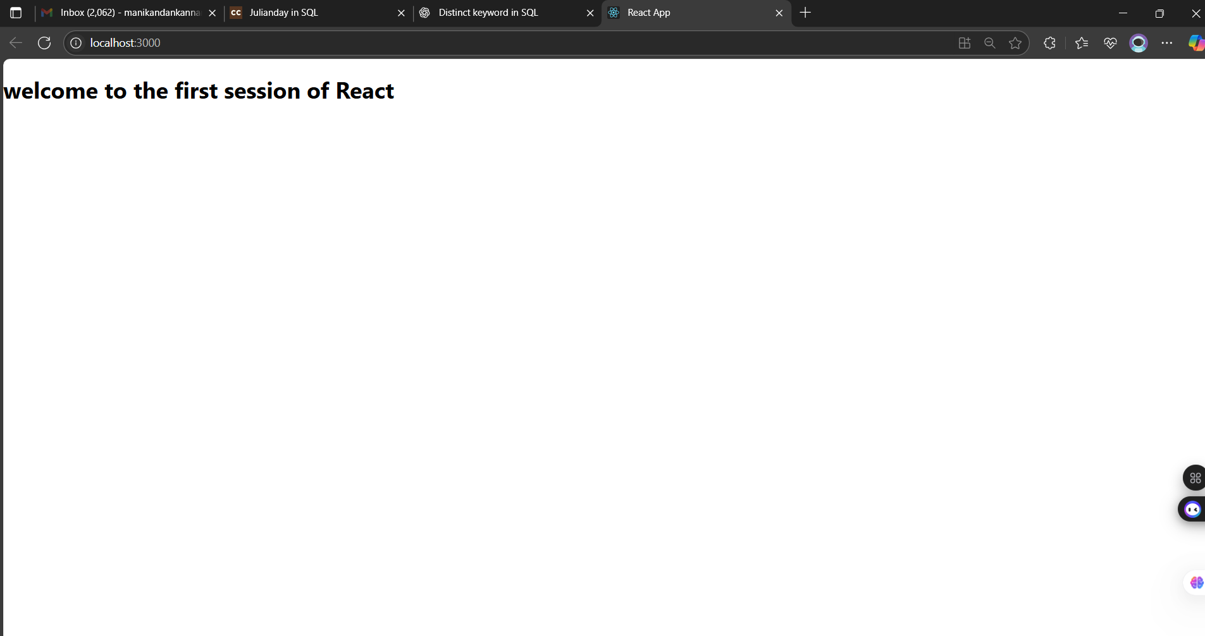

**Exercise 2 :**

**Create a react app for Student Management Portal named StudentApp and create a component named Home which will display the Message “Welcome to the Home page of Student Management Portal”. Create another component named About and display the Message “Welcome to the About page of the Student Management Portal”. Create a third component named Contact and display the Message “Welcome to the Contact page of the Student Management Portal”. Call all the three components.**

1. **Home.JS**

**import React, { Component } from 'react';**

**class Home extends Component {**

**render() {**

**return (**

**<div>**

**<h2>Welcome to the Home page of Student Management Portal</h2>**

**</div>**

**);**

**}**

**}**

**export default Home;**

1. **About.JS**

**import React, { Component } from 'react';**

**class About extends Component {**

**render() {**

**return (**

**<div>**

**<h2>Welcome to the About page of the Student Management Portal</h2>**

**</div>**

**);**

**}**

**}**

**export default About;**

1. **Contact.JS**

**import React, { Component } from 'react';**

**class Contact extends Component {**

**render() {**

**return (**

**<div>**

**<h2>Welcome to the Contact page of the Student Management Portal</h2>**

**</div>**

**);**

**}**

**}**

**export default Contact;**

**App.JS**

**import React from 'react';**

**import Home from './Components/Home';**

**import About from './Components/About';**

**import Contact from './Components/Contact';**

**function App() {**

**return (**

**<div>**

**<Home />**

**<About />**

**<Contact />**

**</div>**

**);**

**}**

**export default App;**

**Output :**

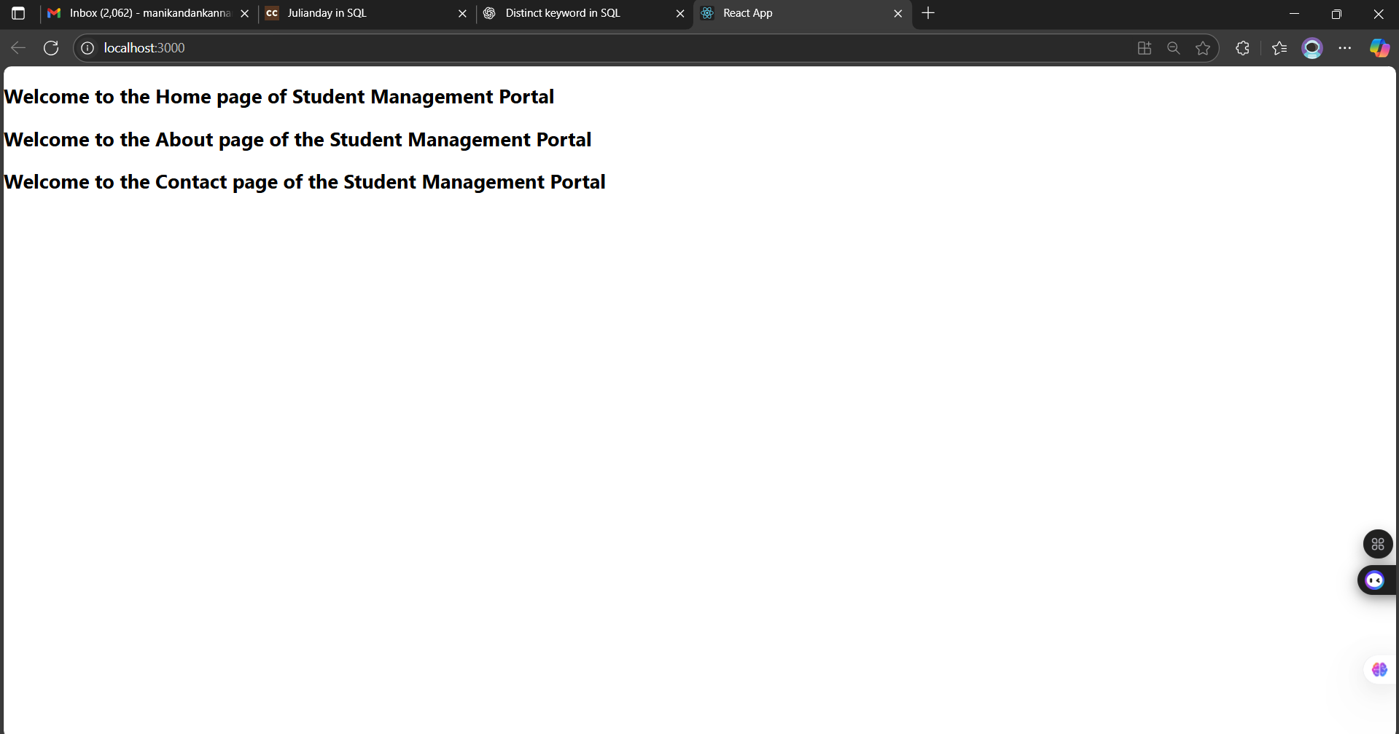

**Exercise 3 :**

**Create a react app for Student Management Portal named scorecalculatorapp and create a function component named “CalculateScore” which will accept Name, School, Total and goal in order to calculate the average score of a student and display the same.**

1. **CalculateScore.js**

**import React from 'react';**

**import '../Stylesheets/mystyle.css';**

**function CalculateScore(props) {**

**const average = props.Total / props.Goal;**

**return (**

**<div className="score-card">**

**<h2>Student Score Report</h2>**

**<p><strong>Name:</strong> {props.Name}</p>**

**<p><strong>School:</strong> {props.School}</p>**

**<p><strong>Total Marks:</strong> {props.Total}</p>**

**<p><strong>Goal:</strong> {props.Goal}</p>**

**<p><strong>Average:</strong> {average.toFixed(2)}</p>**

**</div>**

**);**

**}**

**export default CalculateScore;**

1. **Mystyle.css**

**.score-card {**

**border: 2px solid #444;**

**padding: 20px;**

**margin: 20px auto;**

**width: 60%;**

**background-color: #f9f9f9;**

**box-shadow: 2px 2px 10px rgba(0,0,0,0.2);**

**font-family: Arial, sans-serif;**

**}**

**.score-card h2 {**

**color: #333;**

**text-align: center;**

**}**

**.score-card p {**

**font-size: 16px;**

**margin: 8px 0;**

**}**

**App.js**

**import React from 'react';**

**import CalculateScore from './Components/CalculateScore';**

**function App() {**

**return (**

**<div className="App">**

**<CalculateScore Name="Manikandan" School="PSNA College" Total={450} Goal={5} />**

**</div>**

**);**

**}**

**export default App;**

**Output :**

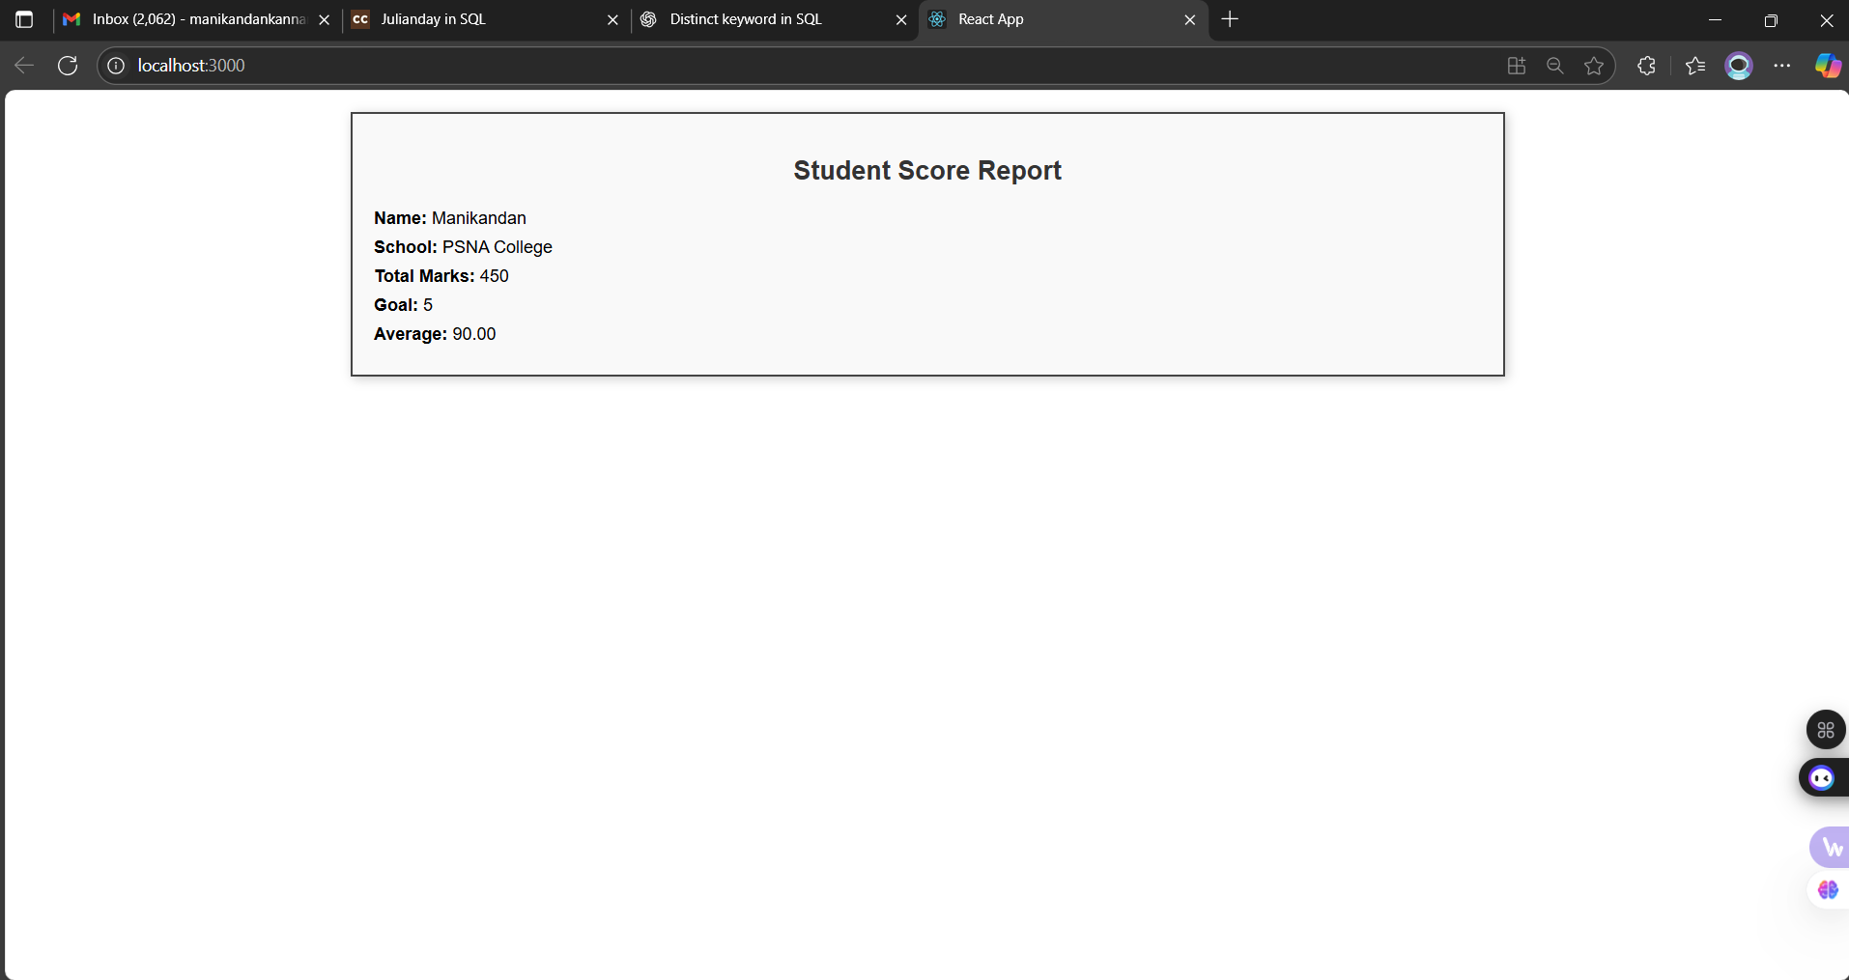

**Exercise 4 :**

**1. Create a new react application using *create-react-app* tool with the name as “blogapp”**

**2. Open the application using VS Code**

**3. Create a new file named as Post.js in src folder with following properties**

1. **Post.js**

**import React, { Component } from 'react';**

**class Post extends Component {**

**render() {**

**return (**

**<div style={{ border: '1px solid #ccc', padding: '10px', margin: '10px' }}>**

**<h3>{this.props.title}</h3>**

**<p>{this.props.body}</p>**

**</div>**

**);**

**}**

**}**

**export default Post;**

1. **Posts.js**

**import React, { Component } from 'react';**

**import Post from './Post';**

**class Posts extends Component {**

**constructor(props) {**

**super(props);**

**this.state = {**

**posts: [],**

**hasError: false**

**};**

**}**

**loadPosts() {**

**const customPosts = [**

**{**

**id: 1,**

**title: "React Lifecycle",**

**body: "This post explains componentDidMount and componentDidCatch."**

**},**

**{**

**id: 2,**

**title: "Using APIs",**

**body: "Learn how to fetch data in React using the Fetch API."**

**},**

**{**

**id: 3,**

**title: "Error Boundaries",**

**body: "componentDidCatch helps catch JavaScript errors in components."**

**},**

**{**

**id: 4,**

**title: "Class vs Function Components",**

**body: "Understand the differences between class and functional components in React."**

**},**

**{**

**id: 5,**

**title: "Styling in React",**

**body: "Explore various ways to apply styles to your React components."**

**}**

**];**

**this.setState({ posts: customPosts });**

**}**

**componentDidMount() {**

**this.loadPosts();**

**}**

**componentDidCatch(error, info) {**

**alert("Something went wrong while loading the posts.");**

**console.error("Error caught in component:", error, info);**

**}**

**render() {**

**if (this.state.hasError) {**

**return <p>Failed to load posts.</p>;**

**}**

**return (**

**<div>**

**<h2>Blog Posts</h2>**

**{this.state.posts.map(post => (**

**<Post key={post.id} title={post.title} body={post.body} />**

**))}**

**</div>**

**);**

**}**

**}**

**export default Posts;**

**App.js**

**import React from 'react';**

**import Posts from './Posts';**

**function App() {**

**return (**

**<div className="App">**

**<Posts />**

**</div>**

**);**

**}**

**export default App;**

**Output :**

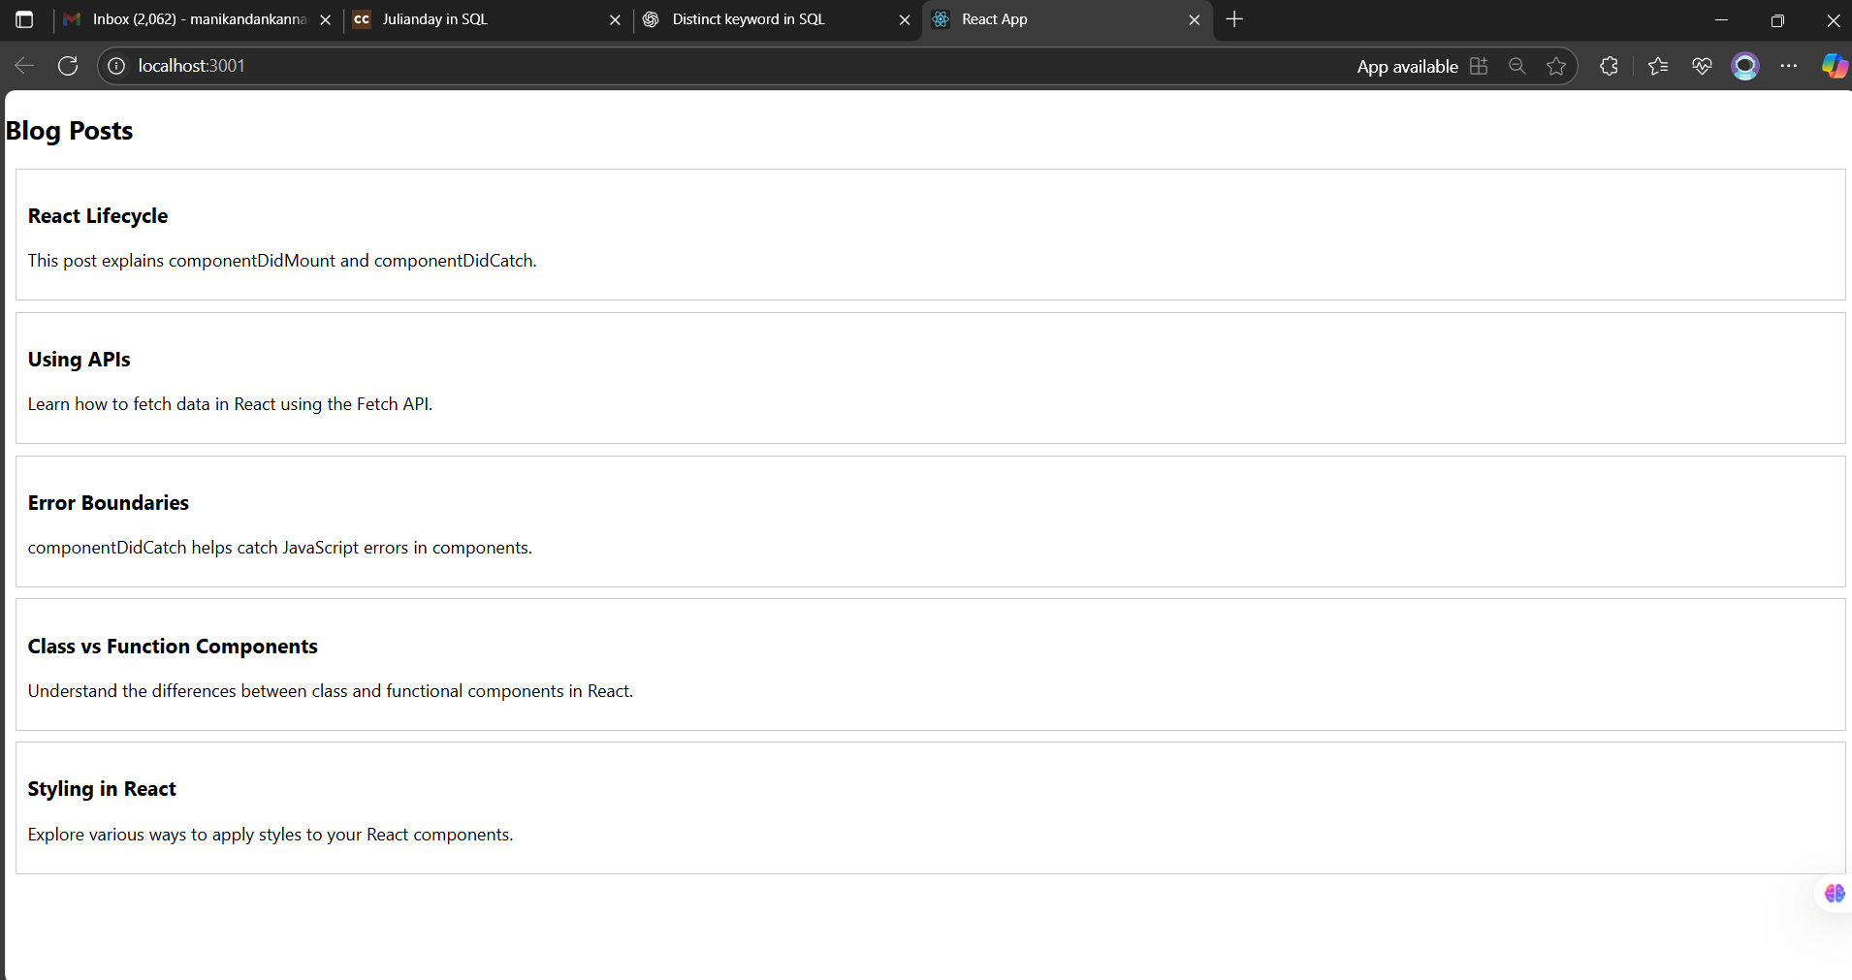

**Exercise 5 :**

**My Academy team at Cognizant want to create a dashboard containing the details of ongoing and completed cohorts. A react application is created which displays the detail of the cohorts using react component. You are assigned the task of styling these react components.**

1. **CohortDetails.js**

**import React from 'react';**

**import styles from '../CohortDetails.module.css';**

**function CohortDetails(props) {**

**const statusStyle = {**

**color: props.status === 'ongoing' ? 'green' : 'blue'**

**};**

**return (**

**<div className={styles.box}>**

**<h3 style={statusStyle}>{props.name}</h3>**

**<dl>**

**<dt>Trainer:</dt>**

**<dd>{props.trainer}</dd>**

**<dt>Status:</dt>**

**<dd>{props.status}</dd>**

**</dl>**

**</div>**

**);**

**}**

**export default CohortDetails;**

1. **CohortDetails.module.css**

**.box {**

**width: 300px;**

**display: inline-block;**

**margin: 10px;**

**padding: 10px 20px;**

**border: 1px solid black;**

**border-radius: 10px;**

**}**

**dt {**

**font-weight: 500;**

**}**

**App.js**

**import React from 'react';**

**import CohortDetails from './Components/CohortDetails';**

**function App() {**

**return (**

**<div style={{ textAlign: 'center' }}>**

**<CohortDetails name="React Cohort" trainer="Manikandan" status="ongoing" />**

**<CohortDetails name="Java Cohort" trainer="Priya" status="completed" />**

**</div>**

**);**

**}**

**export default App;**

**Output :**

