**Week 7**

**Exercise - 9**

**Create a React Application named “cricketapp” with the following components:**

**ListofPlayers.js**

**// src/ListofPlayers.js**

**import React from "react";**

**const ListofPlayers = () => {**

**const players = [**

**{ name: "Virat", score: 90 },**

**{ name: "Rohit", score: 45 },**

**{ name: "Gill", score: 85 },**

**{ name: "Rahul", score: 30 },**

**{ name: "Dhoni", score: 100 },**

**{ name: "Kohli", score: 75 },**

**{ name: "Pant", score: 50 },**

**{ name: "Shreyas", score: 66 },**

**{ name: "Jadeja", score: 74 },**

**{ name: "Ashwin", score: 60 },**

**{ name: "Bumrah", score: 77 }**

**];**

**const below70 = players.filter(player => player.score < 70);**

**return (**

**<div>**

**<h2>All Players</h2>**

**<ul>**

**{players.map((player, index) => (**

**<li key={index}>**

**{player.name} - {player.score}**

**</li>**

**))}**

**</ul>**

**<h3>Players with Score Below 70</h3>**

**<ul>**

**{below70.map((player, index) => (**

**<li key={index}>**

**{player.name} - {player.score}**

**</li>**

**))}**

**</ul>**

**</div>**

**);**

**};**

**export default ListofPlayers;**

**IndianPlayers.js**

**// src/IndianPlayers.js**

**import React from "react";**

**const IndianPlayers = () => {**

**const team = [**

**"Virat", "Rohit", "Gill", "Rahul", "Dhoni",**

**"Kohli", "Pant", "Shreyas", "Jadeja", "Ashwin", "Bumrah"**

**];**

**const oddTeam = team.filter((_, index) => index % 2 !== 0);**

**const evenTeam = team.filter((_, index) => index % 2 === 0);**

**const T20players = ["Suryakumar", "Hardik", "Chahal"];**

**const RanjiTrophyPlayers = ["Pujara", "Rahane"];**

**const mergedPlayers = [...T20players, ...RanjiTrophyPlayers];**

**return (**

**<div>**

**<h2>Even Team Players</h2>**

**<ul>**

**{evenTeam.map((player, index) => (**

**<li key={index}>{player}</li>**

**))}**

**</ul>**

**<h2>Odd Team Players</h2>**

**<ul>**

**{oddTeam.map((player, index) => (**

**<li key={index}>{player}</li>**

**))}**

**</ul>**

**<h2>Merged Team (T20 + Ranji)</h2>**

**<ul>**

**{mergedPlayers.map((player, index) => (**

**<li key={index}>{player}</li>**

**))}**

**</ul>**

**</div>**

**);**

**};**

**export default IndianPlayers;**

**App.js**

**// src/App.js**

**import React from "react";**

**import ListofPlayers from "./ListofPlayers";**

**import IndianPlayers from "./IndianPlayers";**

**function App() {**

**const flag = true; // Change to false to show IndianPlayers**

**return (**

**<div className="App">**

**<h1>Welcome to Cricket App</h1>**

**{flag ? <ListofPlayers /> : <IndianPlayers />}**

**</div>**

**);**

**}**

**export default App;**

**Output :**

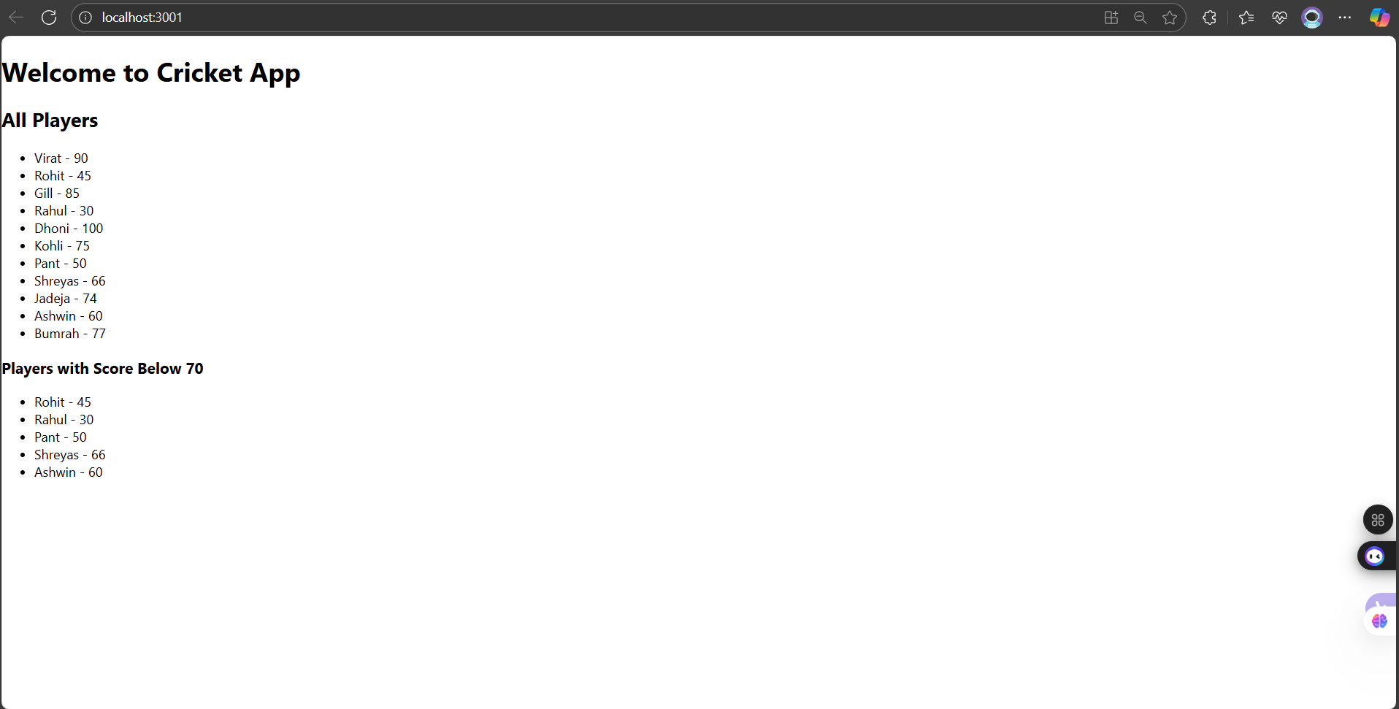

**Exercise - 10**

**Create a React Application named “officespacerentalapp” which uses React JSX to create elements, attributes and renders DOM to display the page.**

**App.js**

**import React from 'react';**

**function App() {**

**const headingStyle = {**

**textAlign: 'center',**

**margin: '20px 0',**

**color: '#2c3e50'**

**};**

**const officeImage = 'https://images.unsplash.com/photo-1600585154340-be6161a56a0c?auto=format&fit=crop&w=800&q=80';**

**// You can replace with a real image**

**const office = {**

**name: 'TechPark Building',**

**rent: 65000,**

**address: '123, Anna Salai, Chennai'**

**};**

**const officeList = [**

**{ name: 'Alpha Tower', rent: 55000, address: 'Guindy, Chennai' },**

**{ name: 'Beta Hub', rent: 75000, address: 'T Nagar, Chennai' },**

**{ name: 'Gamma Plaza', rent: 40000, address: 'Velachery, Chennai' }**

**];**

**return (**

**<div style={{ padding: '20px' }}>**

**{/* Heading */}**

**<h1 style={headingStyle}>Office Space Rental App</h1>**

**{/* Image */}**

**<img**

**src={officeImage}**

**alt="Office Space"**

**style={{**

**display: 'block',**

**margin: '20px auto',**

**width: '300px', // Make the image narrower**

**height: '180px', // Adjust the height proportionally**

**borderRadius: '10px'**

**}}**

**/>**

**{/* Single Object Display */}**

**<div style={{ marginTop: '20px' }}>**

**<h2>Featured Office</h2>**

**<p><strong>Name:</strong> {office.name}</p>**

**<p><strong>Rent:</strong> <span style={{ color: office.rent < 60000 ? 'red' : 'green' }}>{office.rent}</span></p>**

**<p><strong>Address:</strong> {office.address}</p>**

**</div>**

**{/* Office List */}**

**<div style={{ marginTop: '30px' }}>**

**<h2>Available Office Spaces</h2>**

**{officeList.map((off, index) => (**

**<div key={index} style={{ marginBottom: '15px', border: '1px solid #ccc', padding: '10px' }}>**

**<p><strong>Name:</strong> {off.name}</p>**

**<p><strong>Rent:</strong> <span style={{ color: off.rent < 60000 ? 'red' : 'green' }}>{off.rent}</span></p>**

**<p><strong>Address:</strong> {off.address}</p>**

**</div>**

**))}**

**</div>**

**</div>**

**);**

**}**

**export default App;**

**Output :**

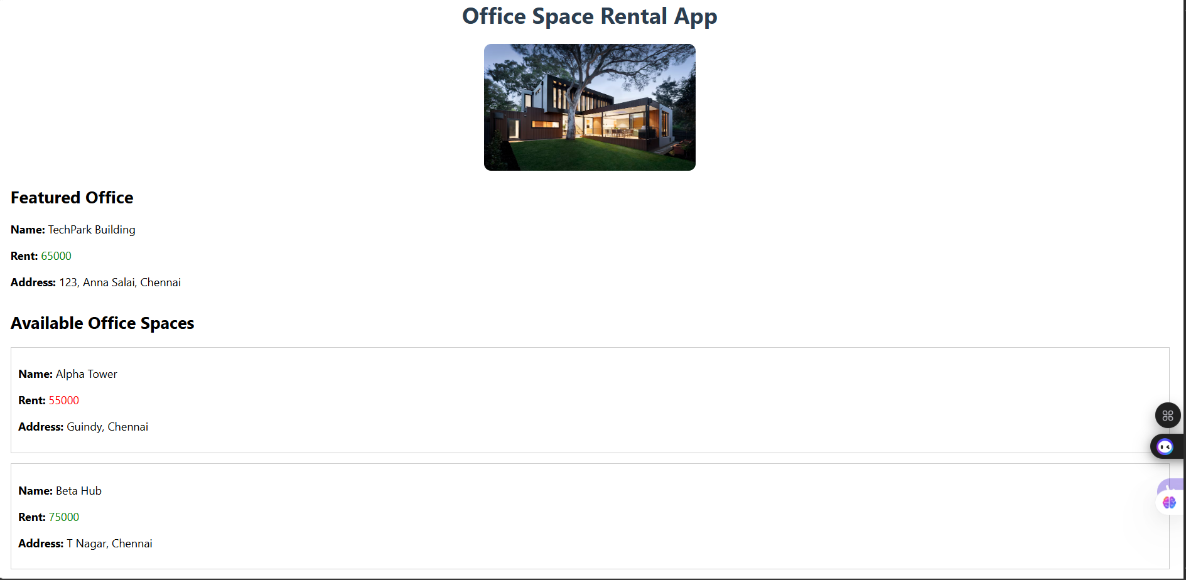

**Exercise - 11**

**Create a React Application “eventexamplesapp” to handle various events of the form elements in HTML.**

**CurrencyConvertor.js**

**import React, { Component } from 'react';**

**class CurrencyConvertor extends Component {**

**constructor() {**

**super();**

**this.state = {**

**rupees: '',**

**euro: ''**

**};**

**}**

**handleChange = (e) => {**

**this.setState({ rupees: e.target.value });**

**};**

**handleSubmit = (e) => {**

**e.preventDefault();**

**const euroValue = (this.state.rupees / 90).toFixed(2); // Assume 1 euro = 90 INR**

**this.setState({ euro: euroValue });**

**};**

**render() {**

**return (**

**<div>**

**<h2>Currency Converter</h2>**

**<form onSubmit={this.handleSubmit}>**

**<input**

**type="number"**

**placeholder="Enter amount in INR"**

**value={this.state.rupees}**

**onChange={this.handleChange}**

**required**

**/>**

**<button type="submit" style={{ marginLeft: '10px' }}>**

**Convert**

**</button>**

**</form>**

**{this.state.euro && (**

**<h4>{this.state.rupees} INR = {this.state.euro} Euro</h4>**

**)}**

**</div>**

**);**

**}**

**}**

**export default CurrencyConvertor;**

**App.js**

**import React, { Component } from 'react';**

**import CurrencyConvertor from './CurrencyConvertor';**

**class App extends Component {**

**constructor() {**

**super();**

**this.state = {**

**count: 0**

**};**

**}**

**increment = () => {**

**this.setState({ count: this.state.count + 1 });**

**this.sayHello();**

**};**

**decrement = () => {**

**this.setState({ count: this.state.count - 1 });**

**};**

**sayHello = () => {**

**alert("Hello! This is a static message.");**

**};**

**sayWelcome = (message) => {**

**alert(message);**

**};**

**handleClick = (e) => {**

**alert("I was clicked");**

**};**

**render() {**

**return (**

**<div style={{ padding: '30px', textAlign: 'center' }}>**

**<h1>Event Examples App</h1>**

**<h2>Counter: {this.state.count}</h2>**

**<button onClick={this.increment}>Increase</button>**

**<button onClick={this.decrement} style={{ marginLeft: '10px' }}>Decrease</button>**

**<div style={{ marginTop: '20px' }}>**

**<button onClick={() => this.sayWelcome("Welcome to React!")}>**

**Say Welcome**

**</button>**

**</div>**

**<div style={{ marginTop: '20px' }}>**

**<button onClick={this.handleClick}>**

**OnPress (Synthetic Event)**

**</button>**

**</div>**

**<div style={{ marginTop: '40px' }}>**

**<CurrencyConvertor />**

**</div>**

**</div>**

**);**

**}**

**}**

**export default App;**

**Output :**

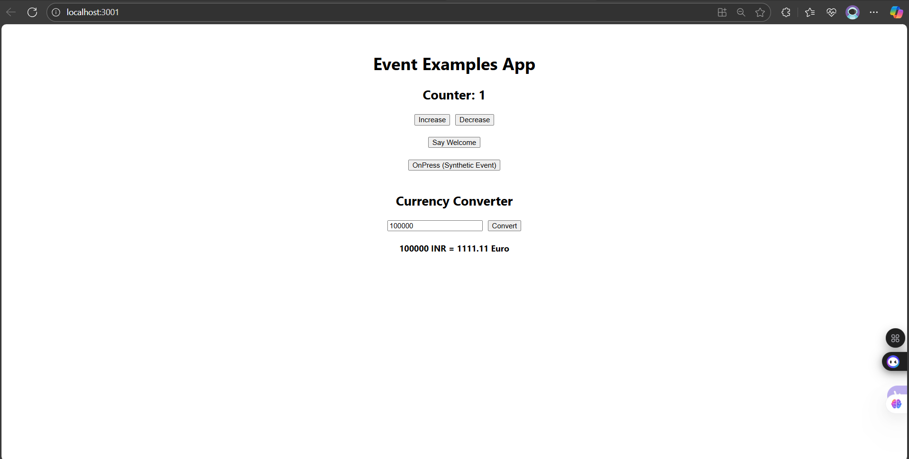

**Exercise - 12**

**Create a React Application named “ticketbookingapp” where the guest user can browse the page where the flight details are displayed whereas the logged in user only can book tickets.**

**UserPage.js**

**// src/UserPage.js**

**import React from 'react';**

**const UserPage = () => {**

**return (**

**<div>**

**<h2>Welcome, User!</h2>**

**<p>You can now book your tickets:</p>**

**<ul>**

**<li>**

**Chennai → Delhi - <button>Book Now</button>**

**</li>**

**<li>**

**Mumbai → Bangalore - <button>Book Now</button>**

**</li>**

**<li>**

**Hyderabad → Kolkata - <button>Book Now</button>**

**</li>**

**</ul>**

**</div>**

**);**

**};**

**export default UserPage;**

**GuestPage.js**

**// src/GuestPage.js**

**import React from 'react';**

**const GuestPage = () => {**

**return (**

**<div>**

**<h2>Welcome Guest!</h2>**

**<p>Here are the available flights:</p>**

**<ul>**

**<li>Chennai → Delhi – ₹5000</li>**

**<li>Mumbai → Bangalore – ₹4500</li>**

**<li>Hyderabad → Kolkata – ₹4800</li>**

**</ul>**

**<p><i>Login to book your tickets.</i></p>**

**</div>**

**);**

**};**

**export default GuestPage;**

**App.js**

**// src/App.js**

**import React, { Component } from 'react';**

**import GuestPage from './GuestPage';**

**import UserPage from './UserPage';**

**class App extends Component {**

**constructor() {**

**super();**

**this.state = {**

**isLoggedIn: false**

**};**

**}**

**handleLogin = () => {**

**this.setState({ isLoggedIn: true });**

**};**

**handleLogout = () => {**

**this.setState({ isLoggedIn: false });**

**};**

**render() {**

**let page;**

**let button;**

**if (this.state.isLoggedIn) {**

**page = <UserPage />;**

**button = <button onClick={this.handleLogout}>Logout</button>;**

**} else {**

**page = <GuestPage />;**

**button = <button onClick={this.handleLogin}>Login</button>;**

**}**

**return (**

**<div style={{ padding: '30px', textAlign: 'center' }}>**

**<h1>Ticket Booking App</h1>**

**{button}**

**<hr style={{ margin: '20px 0' }} />**

**{page}**

**</div>**

**);**

**}**

**}**

**export default App;**

**Output :**

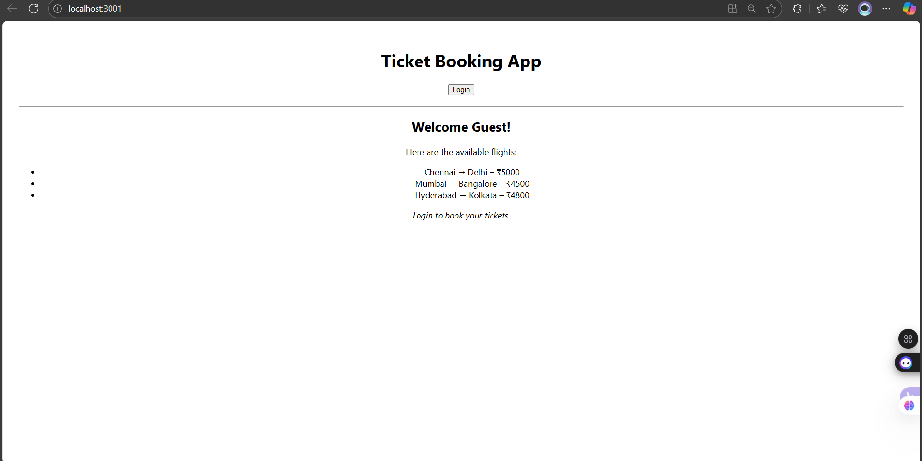

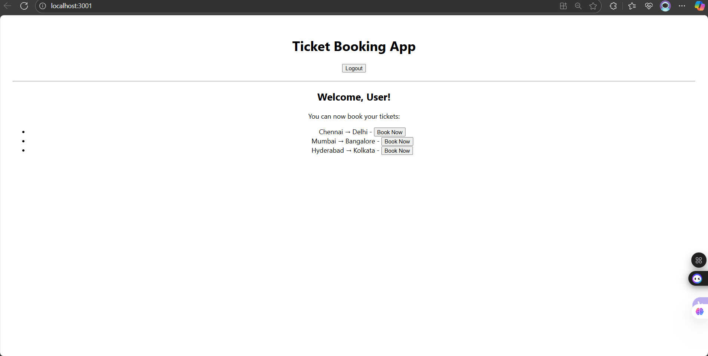

**Exercise - 13**

**Create a React App named “bloggerapp” in with 3 components.**

**1. Book Details**

**2. Blog Details**

**3. Course Details**

**Implement this with as many ways possible of Conditional Rendering.**

**BookDetails.js**

**import React from 'react';**

**const books = [**

**{ id: 1, title: "React in Action", author: "Mark T." },**

**{ id: 2, title: "Learning React", author: "Alex B." },**

**{ id: 3, title: "Fullstack React", author: "Anthony A." }**

**];**

**const BookDetails = () => {**

**return (**

**<div>**

**<h2>📚 Book Details</h2>**

**<ul>**

**{books.map(book => (**

**<li key={book.id}>**

**<strong>{book.title}</strong> by {book.author}**

**</li>**

**))}**

**</ul>**

**</div>**

**);**

**};**

**export default BookDetails;**

**BlogDetails.js**

**import React from 'react';**

**const BlogDetails = () => {**

**return (**

**<div>**

**<h2>📝 Blog Details</h2>**

**<p><strong>Title:</strong> Understanding React Hooks</p>**

**<p><strong>Author:</strong> Jane Doe</p>**

**<p><strong>Date:</strong> 31 July 2025</p>**

**</div>**

**);**

**};**

**export default BlogDetails;**

**CourseDetails.js**

**import React from 'react';**

**const CourseDetails = () => {**

**return (**

**<div>**

**<h2>🎓 Course Details</h2>**

**<p><strong>Course:</strong> React Fundamentals</p>**

**<p><strong>Trainer:</strong> John Smith</p>**

**<p><strong>Duration:</strong> 4 Weeks</p>**

**</div>**

**);**

**};**

**export default CourseDetails;**

**App.js**

**import React, { useState } from 'react';**

**import BookDetails from './BookDetails';**

**import BlogDetails from './BlogDetails';**

**import CourseDetails from './CourseDetails';**

**import './App.css';**

**function App() {**

**const [view, setView] = useState("book");**

**let content;**

**if (view === "book") content = <BookDetails />;**

**else if (view === "blog") content = <BlogDetails />;**

**else content = <CourseDetails />;**

**return (**

**<div className="app-container">**

**<h1>📘 Blogger App</h1>**

**<div>**

**<button className={view === "book" ? "active" : ""} onClick={() => setView("book")}>📚 Book</button>**

**<button className={view === "blog" ? "active" : ""} onClick={() => setView("blog")}>📝 Blog</button>**

**<button className={view === "course" ? "active" : ""} onClick={() => setView("course")}>🎓 Course</button>**

**</div>**

**<div className="section-card">{content}</div>**

**<p>**

**{view === "book" && "You are viewing Book Details"}**

**{view === "blog" && "You are viewing Blog Details"}**

**{view === "course" && "You are viewing Course Details"}**

**</p>**

**</div>**

**);**

**}**

**export default App;**

**Output :**

