# 6115-mahendra institute of engineering and technology

# Smart parking system

# innovation

**TEAM ID:­572**

**TEAM: PROJ_223289_TEAM_1**

|  |
| --- |
| Team members:  1. DEVAPRAKASH R 2. LOGESHWARAN G 3. MANIKANDAN K.A 4. ARUNKUMAR P 5. KAMALNATH A 6. GUNASEKARAN M   **FACULTY MENTOR NAME:**  SANTHANARAJ M |

**Developing a Smart Parking Management System Using the Internet of Things**:

* Searching for parking wastes significant amounts of time and effort and leads to substantial financial costs. This is particularly the case for people who are always pressured to be on time. Smart cities employ all kinds of modern technologies to manage and enhance resources effectively. Urban parking facilities are one of the essential assets that must be managed. We developed a smart parking management system (SPMS) as a modern solution to manage parking and save users time, effort and cost. In the context of today’s modern life, it has become necessary to improve search methods for available parking and minimize the congestion that occurs at the parking entrance. Searching or booking available parking online earlier is a better substitute than searching at a parking lot where there is a possibility of not being able to find parking. Our smart parking management system was developed to: • Manage parking and solve problems efficiently using technology • Apply technical solutions to improve the smart cities concept The proposed system uses a variety of technologies that help manage parking. It provides essential services for users, including searching for parking, reservations and payment. It is extended to cover more advanced services such as receiving notifications, statistics and monitoring the parking state. The system is connected to sensors to detect occupancy and an automatic number plate recognition (ANPR) camera to control access. The remainder of the paper is organized as follows.

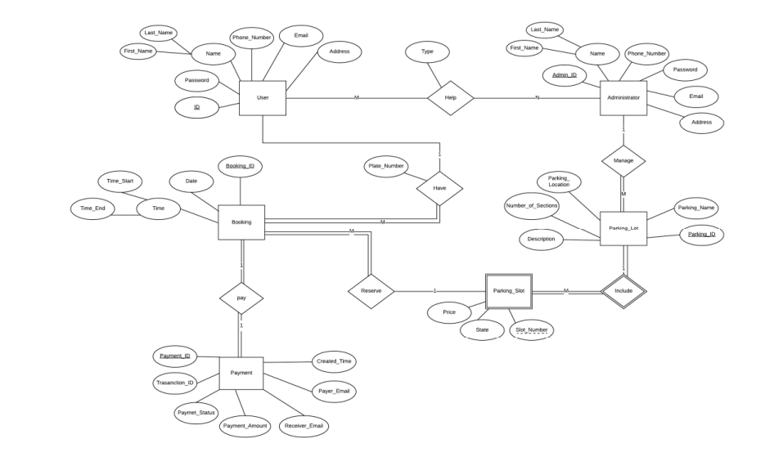

**An IoT-based E-Parking System for Smart Cities**

The huge proliferation in the number of vehicles on the road along with mismanagement of the available parking space has created parking related problems as well as increased the traffic congestion in urban areas. Thus, it is required to develop an automated smart parking management system that would not only help a driver to locate a suitable parking space for his/her vehicle, but also it would reduce fuel consumption as well as air pollution. It has been found that a drivers search for a suitable parking facility takes almost 15 minutes which increases the fuel consumption by the vehicle, traffic congestion and air pollution. A significant amount of research works exist in the area of design and development of smart parking system. Various features of smart parking system are listed below

• Inquiry on availability of parking space and reservation of parking lot

• Real-time parking navigation and route guidance

• Vehicle occupancy detection and management of parking lots . Most of the smart parking systems (SPS) proposed in literature over the past few years provides solution to the design of parking availability information system, parking reservation system, occupancy detection and management of parking lot, real-time navigation within the parking facility etc. However, very few works have paid attention to the real time detection of improper parking and automatic collection of parking charges. Thus, this paper presents an internet-of thing (IoT) based E-parking system that employs an integrated component called parking meter (PM) to address the following issues.

• Real-time detection of improper parking

• Estimation of each vehicles duration of parking lot usage

• Automatic collection of parking charges The E-parking system proposed in this paper also provides city-wide smart parking management solution via providing parking facility availability information and parking lot reservation system and it is named as parking meter (PM) based E-parking (PM-EP).

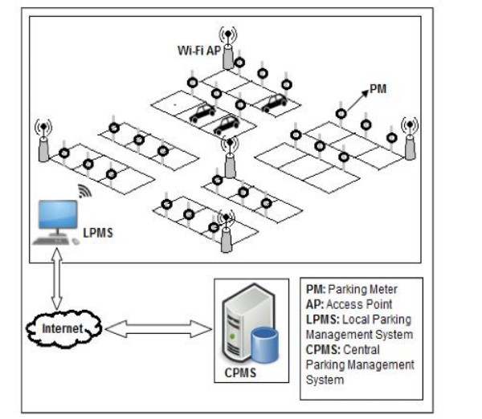

**Smart Parking based System for smarter cities**

India is getting motorized i.e. the rate of private vehicles is more as compared to public transports. As the rate of people owning their vehicles increases ,the need of parking slots to park vehicles also increases. But currently the scenario is that there are not sufficient parking slots available or there is also possibility that people are not now aware about the legal parking slots available in their locality. This situation leads to the unnecessary crowding of vehicles on the road and also results in inconveniency of people walking on the road. To overcome above problems, We are proposing the solution in the form of a multilingual android application which will be helpful for the people to find their parking slots digitally. By digitally we mean that this particular system will assign the parking slot based on the current location of the user and the parking slot which the user wants according to his/her ease. Ease in terms of finding the exact slot. The payments can be done digitally or through vending machines. The end user can register and login with his/her account which will help the system to find the location and displaying the nearest parking area and nearest parking slot ,whether it is available or not. If not then it will direct user to the next nearest slot and so on. The existing system comprises of both traditional and application based approach for parking. If we talk about the traditional approach it utilizes manual method of parking i.e user has to find the spot for parking by traveling to far distances and paying extra money. An application based approach consist of the applications which provides the parking slots for the particular locality for example .The application named ‘Parking Panda ’ provides the parking slots to the areas like stadium, sports leagues

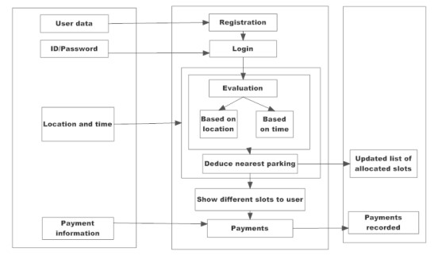

**SMART PARKING SYSTEM TO REDUCE TRAFFIC CONGESTION**

Transportation is the key-success for any of the country. Now a day, many people have options to use their own vehicle for travelling. This will surely increase the demand in trading but one of the problems created by road traffic is "parking". To park all these vehicles in the major metro cities is quite tedious and difficult task and it became problematic to park vehicles. Lot of research and development is being done all over the world to implement better and smarter parking management mechanisms. The current smart parking systems or Wireless Sensors Network Parking requires the combination of wireless sensor networks module, Embedded web-server, Central Web Server. Sensor networks make use of Infrared (IR) Sensor nodes to check the parking slot state and send this information to embedded web-server. It thereby displays the information on a LED screen with which the user can check for empty vehicle slots. These systems not guide the users to reach to the parking lot. If the slot is not available

**SMART PARKING SYSTEM TO REDUCE TRAFFIC CONGESTION**

Transportation is the key-success for any of the country. Now a day, many people have options to use their own vehicle for travelling. This will surely increase the demand in trading but one of the problems created by road traffic is "parking". To park all these vehicles in the major metro cities is quite tedious and difficult task and it became problematic to park vehicles. Lot of research and development is being done all over the world to implement better and smarter parking management mechanisms. The current smart parking systems or Wireless Sensors Network Parking requires the combination of wireless sensor networks module, Embedded web-server, Central Web Server. Sensor networks make use of Infrared (IR) Sensor nodes to check the parking slot state and send this information to embedded web-server. It thereby displays the information on a LED screen with which the user can check for empty vehicle slots. These systems not guide the users to reach to the parking lot. If the slot is not available parking. Then in search of parking space they have to again roam with their vehicle to find available parking.

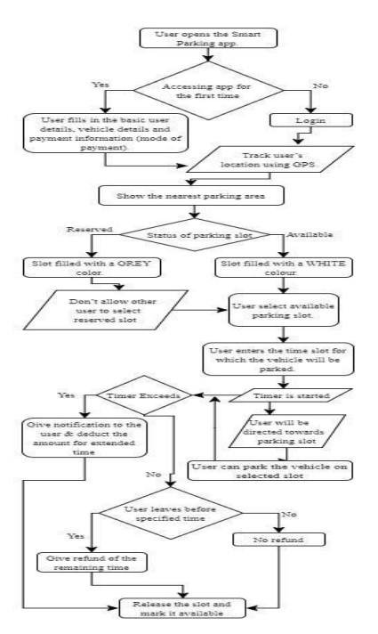

**Flow chart of Smart Parking System**

An IoT-Based Intelligent System for Real-Time Parking Monitoring and Automatic Billing today, the parking industry is being transformed by new technologies that are allowing cities to reduce rates of congestion significantly. Sensor networks that sense vehicle occupancy are providing the basic intelligence behind smart parking systems. Thanks to the Smart Parking technology, it is now possible to know in real-time the location of free parking spaces and to help drivers to get to their ultimate destination. A variety type of vehicle detectors has been used in parking information acquisition. These vehicle detectors mainly include the inductive loop , acoustic sensor , infrared sensor , or ultrasonic sensor . System using video camera sensor technologies have been proposed to collect the information in vehicle parking field. However, a video camera sensor is vulnerable to bad weather and night time operation. Furthermore, it is expensive, and can generate a large amount of data that can be difficult to transmit in a wireless network. The magneto-resistive based detection systems combined with a wireless area network are the most popular technique due to their high accuracy. Yet, this type of sensor is facing different issues, i.e. it can be bedeviled by electromagnetic interference, which affects the accuracy , the reading from sensor needs to be collected constantly which will result in wearing out the battery . To extend the battery lifetime and increase the vehicle detection accuracy, a parking sensor system has been proposed. While power management technique has been implemented to optimize energy consumption, high occupancy monitoring accuracy is achieved using two-fold sensing approach. It is a sequence of darkness and Signal Strength Indicator (RSSI) measurement based techniques. The wireless sensors are still intrusive, they are embedded in the pavement, or taped to the surface of each individual parking lot. Existing sensors, such as ground based parking sensors costs up to $200 per parking lot . As consequence, smart-parking technology using wireless sensors for outdoor parking is costly due to the large number of sensors units required to cover the entire parking lot . Although, parking occupancy monitoring systems have made a significant progress, smart parking payment is rarely studied in smart parking research . Yet, there are companies working on the patents of parking systems for payments. A first approach consists in using a camera or an RFID transceiver for vehicle detection and identification . A limitation of this solution lies in that the system is complex and its implementation is expensive when a detection device is installed on each parking lot. Furthermore, when only RFID transceiver is used for vehicle detection and identification, the system can be bedeviled by electromagnetic interference, which affects the accuracy. Moreover, this system is designed to detect a vehicle when entering a parking and seek payment, whereas information on vacant parking lots is not provided. A technique for monitoring vehicle parking using one camera to record the entrance of a vehicle and a second camera to record the vehicle leaving the parking has been proposed . Moreover, in a system and method for obtaining and displaying information on vacant parking space is described. When a user occupies a parking space designated with an individual ID, he enters this ID into a parking meter or via a smart phone mobile app., and pays the parking fees. The database processes the received data and changes the status of the parking space with its ID from unpaid to paid. These data are used as information on the occupation of a parking space. In this paper, we propose a smart sensor system allowing outdoor parking monitoring and payment without requiring any user/driver interaction. It will be deployed without having to install new components on each parking lot. The proposed sensor has benefits in terms of detection and payment reliability, and reduced expense by reducing the system complexity and installation, and extending batteries lifetime through the reduction of the system power consumption

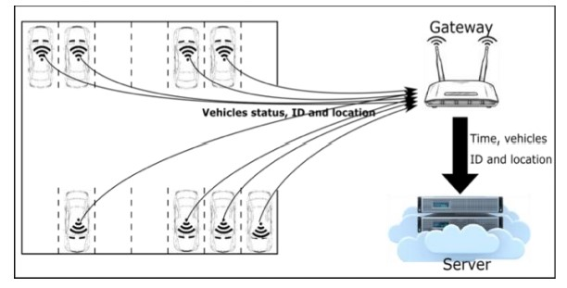

**Proposed system architecture; wireless occupancy sensor; wireless gateway; data storage and processing unit.**

SYSTEM REQUIREMENTS SPECIFICATION

Functional Requirement Functional Requirement defines a function of a software system and how the system must behave when presented with specific inputs/or conditions. These may include calculations, data manipulation and processing and other specific functionality. In these systems following are the functional requirements

• The application should not display in-appropriate message for valid conditions.

• The application must not stop working when kept running for even a long time.

• The application should process information for any kind of input case.

• The application should generate the output for a given input test case .

**Non-Functional Requirement**

Non-functional requirements are the requirements which are not directly concerned with the specific function delivered by the system. They specify the criteria that can be used to judge the operation of a system rather than specific behaviours.

Given below are the non-functional requirements:

• Product requirements

• Organizational requirements

• Basic operational requirements

**Hardware Specifications**

• ENODE MCU (ESP8266)

• JUMPER WIRES

• INFRARED SENSORS

• 16*2 LED DISPLAY

• DC MOTOR

**Software Specification**

• ARDUINO IDE