# 6115-mahendra institute of engineering and technology

# Smart parking system

# Problem Definition and Design Thinking

**TEAM: PROJ_223289_TEAM_1**

# Team members:

1. DEVAPRAKASH R
2. LOGESHWARAN G
3. MANIKANDAN K.A
4. ARUNKUMAR P
5. KAMALNATH A
6. GUNASEKARAN M

**FACULTY MENTOR NAME:**

SANTHANARAJ M

**DECLARATION:**

We, the students of Computer Science and Engineering,

MAHENDRA INSITUTE OF ENGINEERING AND TECHNOLOGY,

TAMIL NADU

that the work entitled " SMART PARKING SYSTEM " has been successfully completedunder the guidance

of Asst Prof. Ms. santhana raja M, Computer Science and EngineeringDepartment, mahendra institute of

engineering and techonology , namakkal. This dissertation work is submitted in partialfulfillment of the

requirements for the award of Degree of Bachelor of Engineering in ComputerScience and Engineering

during the academic year 2021-2025.

**ABSTRACTION**

* The project entitled SMART PARKING SYSTEM using Iot , the major motivation of this project is toreduce the traffic congestion in roads, multi-storeyed buildings and malls due to unavailability of parking spaces .
* The project displays the nearest empty slot if present with respect to user location. Ourproject aims to make efficient use of parking spaces. We track vacant slots in the parking space andassign that to the user.
* Smart parking system as described above can lead to an error-free , reliable,secure and fast management system.
* In recent times the concept of smart cities have gained greatpopularity. Thanks to the evolution of the Internet of things the idea of smart city now seems to beachievable.
* Consistent efforts are being made in the field of IoT in order to maximize the productivity and reliability of urban infrastructure.accordingly.
* The paper also describes a high-level view of the system architecture. Towards the end, the paper discusses the working of the systemin form of a use case that proves the correctness of proposed model.

**INTRODUCTION**

* The project entitled smart parking system is to manage all the parking facilities to an user.
* The recent growth in economy and due to the availability of low price cars in themarket, an every average middle-class individual can afford a car, which is good thing,
* however the consequences of heavy traffic jams, pollution, less availability of roadsand spot to drive the motor car.
* One of the important concerns, which is to be taken in accounting, is the problem of parking those vehicles .
* Though, if there is space forparking the vehicle but so much time is squandered in finding exact
* parking slotresulting in more fuel intake and not also environment friendly. It will be a great dealif in some way.
* we find out that the parking itself can provide the precise vacant position of a parking slot then it'll be helpful not limited to the drivers also for the environment
* Initially when the user is about to enter the location the LCD displays the number ofempty and filled spots and when the user is with its vehicle near to the parking detect
* sensor ,he/she would be thrown with a notification on their mobile app of the parking
* slot number ,where they should park there vehicle.

**Problem Statement**

* In recent research in metropolitan cities the parking management problem can be viewed from various angles such as high vehicle density on roads.
* This results in annoying issues for the drivers to park their vehicles as it is very difficult to find a parking slot.

* The drivers usually waste time and effort in finding parking space and end up parking their vehicles finding a space on the street which further leads to space congestion.
* In worst case, people fail to find any parking space especially during peak hours and festive season.

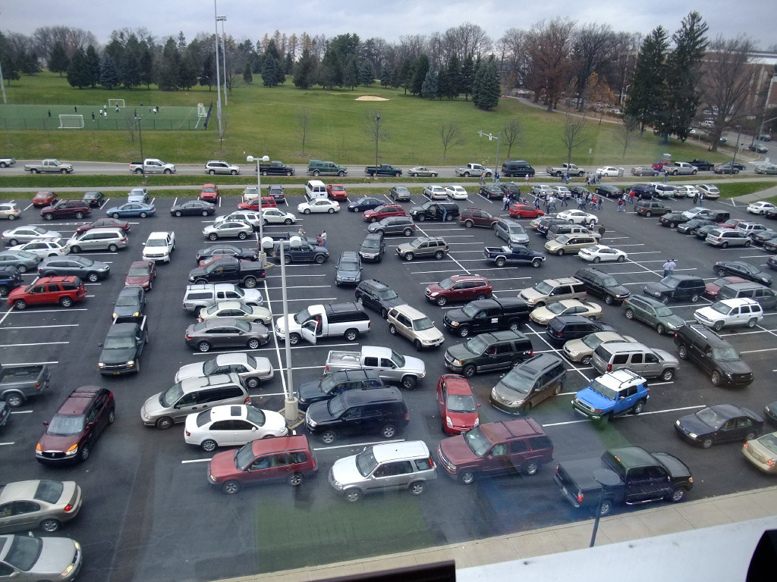

## Objective

* Smart Parking involves the use of low cost sensors, real-time data and applications thatallow users to monitor available and unavailable parking spots.
* The goal is to automateand decrease time spent manually searching for the optimal parking floor, spot andeven lot.

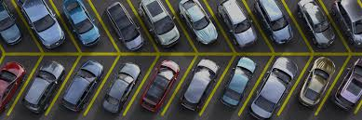

* Some solutions will encompass a complete suite of services such as onlinepayments, parking time notifications and even car searching functionalities for verylarge lots.
* A parking solution can greatly benefit both the user and the lot owner.

**Optimized parking**

* Users find the best spot available, saving time, resources and effort. The parking lot fills up efficiently and space can be utilized properly by commercial and corporate entities.

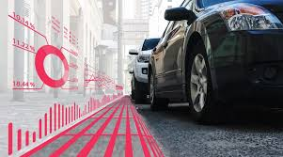

**Reduced traffic**

* Traffic flow increases as fewer cars are required to drive around in search of an open parking space.

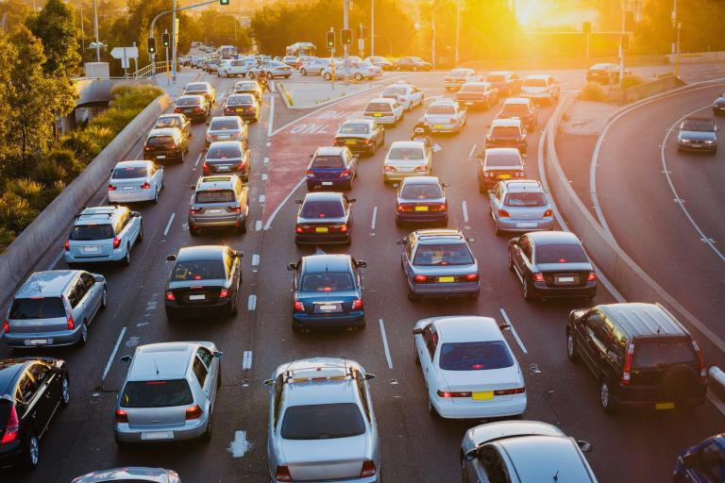

**Reduced pollution**

* Searching for parking burns around one million barrels of oil a day. An optimal parking solution will significantly decrease driving time, thus lowering the amount of daily vehicle emissions and ultimately reducing the global environmental footprint



**Increased Safety**

* Parking lot employees and security guards contain real-time lot data that can help prevent parking violations and suspicious activity.
* License plate recognition cameras can gather pertinent footage.
* Also, decreased spot-searching traffic on the streets can reduce accidents caused by the distraction of searching for parking.

**Decreased Management Costs**

* More automation and less manual activity saves on labor cost and resource exhaustion.

**Enhanced User Experience**

* A smart parking solution will integrate the entire user experience into a unified action. Driver’s payment, spot identification, location search and time notifications all seamlessly become part of the destination arrival process.

**ADVANTAGES**

1. Reduced traffic congestion
2. Reduced emissions
3. Improved driver experience
4. Increased revenue for parking managers
5. Improved security

**Scope of the project**

* At present some countries have portals which users can gain information about parking areas via the internet.
* This system can give users the information about parking space, but it won’t be able to give which parking slot is vacant and occupied. Hence, such a system cannot smartly handle the issue.
* Car lifts along with an automated robotic system, which automatically takes the car to a particular parking spot as soon as the car enters on a platform.
* This system cannot be installed by medium scale shopping malls, movie theatres as it can cost them a huge amount.
* At many public places, the system only shows the availability but it cannot show the exact slot and path to the slot available.
* Hence, there is the need to smartly find the path to the vacant spot.

THANK YOU