6115-MAHENDRA INSTITUTE OF ENGINEERING AND TECHNOLOGY

FLOOD MONITORING AND EARLY WARING

Team Id: 567

Team code: proj_223285_Team_1

Year: lll

|  |
| --- |
| Team members name:  1.Moses samsan. M  2.Mooventhan.L  3.Muthu prakash A  4.Manikandan.AR  5.Narendra moorthi.M  Menter name  SANTHANARAJ.M |

**Flood monitoring and early warning**

* In this document, we will explore the fascinating world of flood monitoring and early warning systems. From the implementation of smart sensors to the training of advanced algorithms, we will uncover the future of engineering and discuss the potential for future implementation in flood-prone areas.

**Project Implementation**

* Implementing a flood monitoring and early warning system requires careful planning and execution. It involves setting up sensors in strategic locations, establishing communication networks, and integrating data analysis algorithms. Effective project management and collaboration are essential for success.
* Step 1: Sensor Placement

Identify critical areas prone to flooding and strategically install sensors to monitor water levels.

* Step 2: Data Acquisition

Collect data from sensors in real-time and ensure its accuracy and reliability.

* Step 3: Communication Infrastructure

Establish a robust communication network to transmit data and alerts to relevant stakeholders.

Sensors for Flood Monitoring

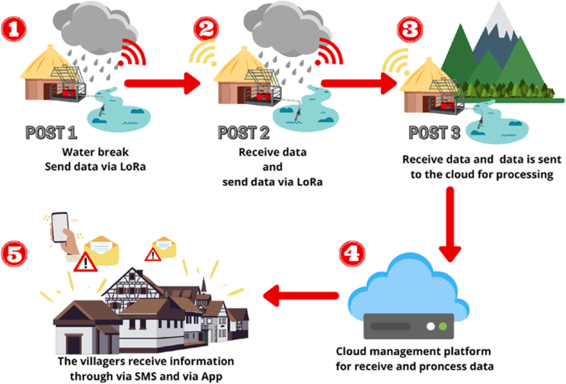

**River Level Sensor**

* Highly sensitive sensor that measures the water level in rivers and streams.

**Rainfall Sensor**

* Detects and measures the amount of rainfall in a specific

area, providing crucial data for flood prediction.

**Groundwater Sensor**

* Monitors the level of groundwater, which can contribute to flooding when it reaches critical levels.

**Algorithm**

* The algorithm used in flood monitoring systems plays a crucial role in accurately predicting and warning about potential flooding. By analyzing various data points, such as rainfall, water levels, and soil moisture, the algorithm processes the information to identify patterns and generate timely alerts.

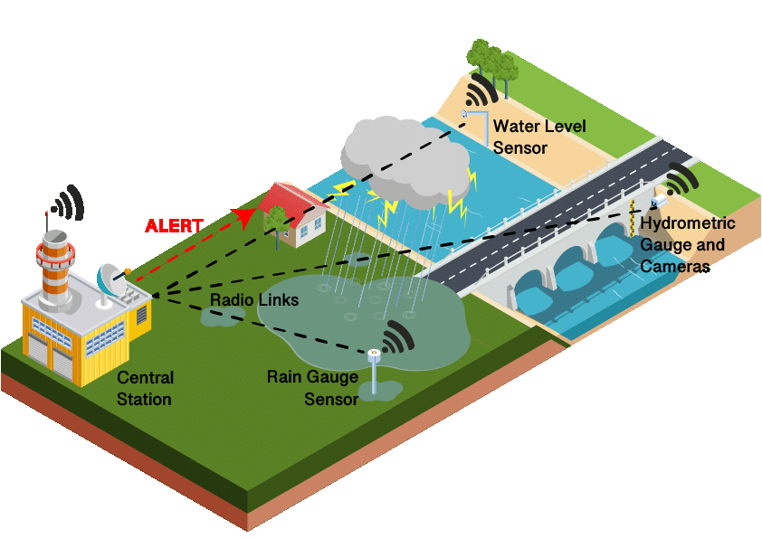

* This complex algorithm takes into account factors like historical data, weather patterns, and topographical information to provide accurate and reliable flood warnings.

**Model Training**

* To ensure the accuracy of the flood warning system, the algorithm must be trained and fine-tuned using extensive datasets. This training phase involves feeding the algorithm a wide range of historical flood data paired with corresponding weather conditions and water levels.

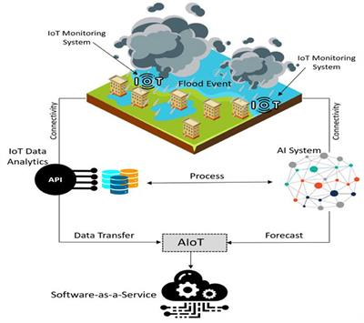

* By iteratively refining the model through training, the system can learn to recognize patterns and make more precise predictions, improving the overall effectiveness of the flood monitoring and early warning system.

**Evaluation**

* Evaluating the effectiveness of a flood monitoring and early warning system is a critical step in ensuring its reliability. Through comprehensive evaluations and tests, we can assess the system's accuracy, response time, and ability to provide timely and actionable alerts.
* Periodic evaluations help identify areas for improvement and allow for continuous refinement of the system, leading to enhanced flood preparedness and response.

**Future Implementation**

* The future implementation of flood monitoring and early warning systems holds immense potential. By leveraging advancements in technology and data analysis, we can further enhance the accuracy and efficiency of these systems.
* These improvements may include the integration of remote sensing technologies, the utilization of unmanned aerial vehicles for data collection, and the incorporatin of advanced predictive models.

**Data Set (Program in java)**

import java.util.Scanner;

public class FloodMonitoring

{

public static void main(String[] args)

{

Scanner scanner = new Scanner(System.in);

System.out.print("Enter the water level: ");

int waterLevel = scanner.nextInt();

if (waterLevel > 50)

{

System.out.println("Flood warning! Evacuate immediately!");

}

else if (waterLevel > 30)

{

System.out.println("Flood advisory! Prepare for potential flooding!");

}

else

{

System.out.println("No immediate flood threat. Stay vigilant!");

}

scanner.close();

}

}

OUTPUT

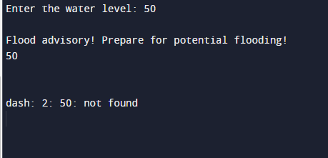

THANK YOU…