6115-MAHENDRA INSTITUTE OF ENGINEERING AND TECHNOLOGY
FLOOD MONITORING AND EARLY WARNING
Team Id:567
Team code:proj_223285_Team_1
Year:lll
Tearm members name:
1.Moses samsan.M
2.Mooventhan.L
3.Muthu prakash A
4.Manikandan.AR
5.Narendra moorthiL.M
Menter name:
Santhanaraj.M

Abstract
- To mitigate the impact of floods, it is essential to develop efficient flood monitoring and early warning systems. This abstract provides an overview of a comprehensive approach to flood monitoring and early warning, incorporating advanced technologies and data-driven strategies.
- The Flood Monitoring and Early Warning System (FMEWS) presented here leverages a combination of remote sensing, geographic information systems (GIS), weather forecasting, and real-time data analysis to provide accurate and timely flood alerts. Key components of this system include:
- Data Collection: FMEWS collects data from various sources, including weather stations, satellite imagery, river gauges, and soil moisture sensors. These sources provide real-time information on rainfall, river levels, soil saturation, and weather conditions.
- Data Integration: The system integrates data from multiple sources into a centralized database, allowing for the creation of a comprehensive flood risk assessment. GIS technology is used to map flood-prone areas and identify vulnerable communities.
- Real-time Monitoring: FMEWS continuously monitors key parameters, such as rainfall intensity, river levels, and soil moisture content, in real time. Advanced algorithms analyze this data to detect potential flood events.
- Early Warning Alerts: When the system detects conditions conducive to flooding, it generates early warning alerts. These alerts are disseminated through various channels, including mobile apps, SMS, social media, and sirens, ensuring that the information reaches affected communities promptly.
- Community Engagement: FMEWS emphasizes community involvement and education. It provides resources for community members to prepare for floods, including evacuation plans, emergency kits, and flood-resistant infrastructure guidelines.
- Forecasting and Prediction: The system incorporates advanced weather forecasting models to predict rainfall patterns and potential flood events with greater accuracy. This allows for proactive flood management and resource allocation.
- Continuous Improvement: FMEWS is a dynamic system that continually updates its algorithms and data sources to improve accuracy and reduce false alarms. Machine learning and artificial intelligence techniques are applied to enhance predictive capabilities.
- Implementing a Flood Monitoring and Early Warning System like FMEWS is crucial for minimizing the impact of floods on both human lives and infrastructure. By harnessing technology, data, and community engagement, this system offers an effective approach to mitigate the devastating effects of flooding and improve disaster resilience in vulnerable regions
Introduction
- In most countries in the world, flood had caused damages to properties and it involved a large amoun of loss to individuals and governments. During flood, it is important to have efficient flood response operation system to manage all activities among different related agencies.These last decades, lots of flooding risk technologies has been developed to minimize the danger of flood in inhabited areas. Currently, the Philippine government funded the Project NOAH of the Department of Science and Technology (DOST). They installed Automated Rain Gauges (ARG) and
- Water Level Monitoring Stations (WLMS) along the countrys major river basins (RBs) [1]. However,project NOAH is still under development in which some essential information are not yet available to view in their website.Most of these technologies being developed commonly apply in weather forecasting, flood detection and monitoring system using sensing devices, modeling software, Internet and mobile technology [2].
- However, these systems are usually for one-way communication only. In order to get an update or latest information, local communities need to access the website. And in accessing this website, it requires
Architectural Framework
- The two monitoring devices are composed of Ultrasonic sensor to measure the distance of the water level, Arduino micro-controller that process the signal from the sensor, GSM module to send the data or information from the micro-controller to the computer server and a power source using Solar Panel,Regulator and Battery. Once a sensor is triggered, an output signal will be relayed to the micro-controller which serves as a switch that triggers the connected GSM module to send an alert message or water level status to another GSM modem connected to a computer server.
- Then, the developed program installed in the computer server will interpret and analyze the message received then automatically send a text message to the concern agencies numbers stored in a database. Also, the developed program will then automatically relay the alert message or status by uploading to the developed website.
- Furthermore,concern agencies, local officials and the local communities could inquire about the current status by sending a message that contains keywords This paper presents the utilization of ultrasonic sensors because of its capability and reliability. Since the Philippines is considered among the most flood prone in the world due to variety of factors, the project NOAH relies on Ultrasonic sensors for water level monitoring. Ultrasonic sensors are deployedon hundreds of coastal tide gauge platforms that provide tsunami and tropical storm surge warning data.
- They are also deployed on similar platforms that monitor flooding on the different rivers. The newest flood warning system is being deployed to monitor flooding on urban street. And with continuesdevelopment in ultrasonic sensing, the researchers opted to use this sensor for the project.The use of GSM also presented in this paper for transmitting data and as mode of communication to the concern stakeholders of this project. Due to its simplicity and availability to the public now-a-days,it is very obvious that information dissemination can be easily achieved. Specifically, the study utilizes
- The researchers tested the developed prototype through a temporary basin to test the level of water. The inputs have several sub-parameters to obtain accurate data. In the designed prototype, water level is measured in inches. The input has four options to consider. When the water level exceed the threshold value set in the script that was uploaded in the Arduino Micro-controller, a notification message containing the level of water and the alert level will be sent to the computer server. The table below shows the different option as input for the monitoring system.

Table 1. Threshold Value Set for Prototype Testing

Water Level (Inches) | Alert Level | SMS Notification Delivery
5” and below | Normal | 10 minutes interval
6”-10” | Moderate | 5 minutes interval
11”-15” | Critical | 1 minute interval
16” and above | Emergency | 1 minute interval
1. UrbanFlood early warning system computational workflow

The Sensor Monitoring module receivesta streams from the sensors installed in the dike. Raw sensor data is filtered by the AI Anomaly Detector that identifies abnormalities in dike behavior or sensor malfunctions. The Reliability Analysis module calculates the probability of dike failure in case of abnormally high water levels or an upcoming storm and extreme rainfalls. If the failure probability is high then the Breach Simulator predicts the dynamics of a possible dike failure, calculates water discharge through the breach and estimates the total time of the flood. some 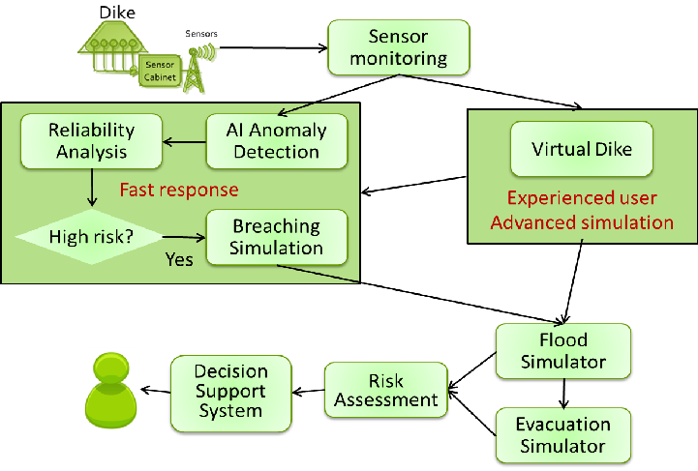
The primary user-interface to this DSS system runs on the Microsoft Surface interactive graphics device (further called Surface for short). The Surface is a multiǦtouch system, which means that multiple people can collaboratively work with the applications, using their hands and fingers as input devices. The combination of multiple people interacting with the application at the same time makes the use of this device very intuitive and helpful for crisis situations —exactly what Early Warning Systems are designed for. The simulation modules and visualization components are integrated into the Common Information Space. They are accessed from the interactive graphical environment of the multi-touch table or through a web-based application. Examples of decision support information modules accessed via the interactive multi-touch Microsoft Surface environment

2. Artificial Intelligence Anomaly Detector
Structurally stable dikes are considered to be in a normal state. For the real-life flood defense systems, there are no historical records of the abnormal sensor parameters in critical pre-failure conditions. For the abnormality detection, we use a one-side classification concept based on the Neural Clouds (NC) method [5]. NC approach allows detection of anomalies based on the historical measurements related to normal behavior used for training.
After the training phase, Artificial Intelligence (AI) component processes the measurements from sensors in realtime and calculates the anomaly probabilities. One of the main advantages of the AI methods in environmental data analysis is the possibility to apply a model-free data-driven approach, which requires only the measured data. The NC classification algorithm uses pre-processed data and/or a set of features extracted from the data as inputs.First, data is clustered by an advanced k-means clustering algorithm [5]. Second, the clustered data is encapsulated using an extended radial basis functions network approach (Fig. 3). These two operations are applied to the training V.V. Krzhizhanovskaya et al. / Procedia Computer Science 4 (2011) 106—115 109 data set forming an N-dimensional diagnostic parameter space. After training, a dike "normality" confidence value is calculated for each new set of measurements, by projecting it to the constructed data encapsulator The probability of normal behavior close or equal to 1 corresponds to the safe dike behavior (similar to the reference data), while values close to zero indicate a previously unknown and potentially abnormal behavior. The AI component is adaptive: in case the reported anomaly was not a critical issue and should be considered as normal, the AI component is retrained on the extended reference data set. The first version of the AI component has been developed and integrated in the UrbanFlood EWS via the Common Information Space as explained in Section 7. A set of classification agents forming a committee of classifiers is constructed for dike abnormality detection. In present prototype, the committee consists of NCs constructed for every sensor measuring more than 1 parameter. After that, the calculated probabilities are used to estimate the condition of the whole cross-section or the whole dike. Further plans for the AI component development include construction of more sophisticated committees and implementation of additional methods for signal pre-processing and feature extraction. Visualization of the AI component in operation and abnormality detection results are shown below

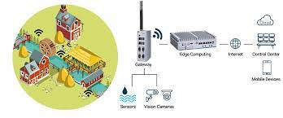

3. Dike reliability analysis
To trigger warnings and further computational flood simulations, exceedence thresholds are specified, based on the probability of structural failure for the monitored dikes. For flood dike structures, the probability of failure is often defined conditionally upon the hydraulic loading (i.e. flood water levels and wave action), the resulting probability distributions are known as fragility curves. These are typically developed using standard reliability analysis, see for example [6,7,8]. In traditional structural reliability analysis, failure of a structure arises when the loads acting upon the structure, exceed its bearing capacity, or resistance. The probability of failure is often presented in the following generalized form [9]:Pf P G X f dx G X X [ ( ) 0] .... ( ) ( ) 0³ ³≤= ≤ =
where G is the Limit State Function (LSF); X is the vector of random variables associated with the loads and resistance; and fX(x) is the multivariate probability density function of X. For the development of fragility curves, the probability of failure is derived, conditional on the loading conditions: P P[G(X ) 0 L l] f = ≤ = In some cases, the relationships between loads and the resistance are known explicitly and G (X) can be expressed in closed form or the problem can be suitably simplified such that this is the case. A range of methods can Fig. 3. Neural Cloud encapsulator visualized for two sensor parameters X1, X2. Dike "normality" confidence levels are shown by the colored 3D surface.normality confidence level calculated by the AI component for one of the sensors located in a selected cross-section 110 V.V. Krzhizhanovskaya et al. / Procedia Computer Science 4 (2011) 106—115 then be employed to solve the multi-dimensional integral. The most flexible and commonly applied approach is through Monte-Carlo simulation. Under the EU funded FLOODsite project (FP6) [10] we documented the limit state equations for a wide range of flood defense structures and their potential failure mechanisms. In other cases more complex models are required to describe the failure processes. When these models are com putationally intensive,
vanilla Monte-Carlo become impractical to implement. Response Surface methods can then be employed [9] toreduce the computational burden and implement the analysis. An example of this type of implementation in the context of flood defense is described in [11].Under the EU funded FLOODsite Project, a software tool RELIABLE was developed to analyze the reliability offlood defenses and generate fragility curves. The tool includes a total of 72 failure modes [10] represented as simpleLimit State Equations (LSEs), a flexible fault tree component, and a probabilistic failure analysis component based on Monte Carlo simulation (MCS). It is applicable to foreshores, dunes and banks; dikes and revetments; walls; and point structures, and accounts for hydraulic loading due to water level difference across a structure; wave loading; and lateral flow velocities. In the system described here, this software tool is being deployed in an online environment. Information from the sensor systems is used to determine values of parameters that are input to the LSEs. The reliability analysis is then conducted in real time and the threshold probability of failures monitored. Threshold exceedence then triggers downstream modeling and warning activities.
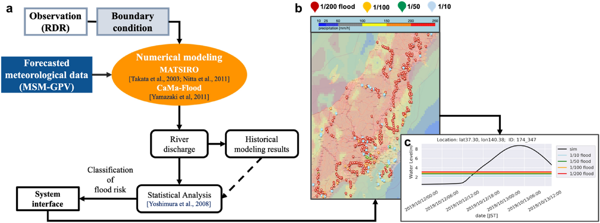

4. Dike breaching and flood simulations
The Flood Simulator module predicts the flood dynamics once a dike is considered failed. This involves two calculations: estimation of the discharge through the breach and computation of the flood spreading. These two calculations are currently done separately, and it is envisaged that those tools could be swapped for other models in the future without changing the functioning of the Flood Simulator module.
The breach discharge calculation is a simplified model based on the following concept: the breach initiates with a given width, this width is unchanged as the breach invert level decreases linearly with time until reaching the toe level of the dike, then the breach invert level stays unchanged and the breach width increases according to one of the two following empirical equations:0.145 67 logt Wsand = for a sand dike and 0.08 20logt Wsand = for a clay dike where W is the breach width (m) at time t. t is the time (hrs) after breach reached the lowest invert level. For all these stages, the discharge is calculated using the weir equation 1.5 Q = CLh , where C=1.7, L is the breach width (m), h is the head of water on eroding crest (m) and is calculated using the load on the dike (water level) and the breach invert. An example of the breach width dynamics and related water discharge through this breach is shown below
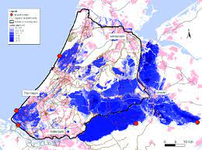
The flood spreading is computed by the rapid flood spreading model (RFSM), a simplified and computationally efficient model yet sufficiently robust for use in flood system risk models. The model was originally developed as a volume spreading approach with no temporal component [12,13]. This has however been extended to include the time domain (Dynamic RFSM or DRFSM). Time dependence of dike breach width and water discharge. Water levels used in this example are not linked to the possible flood conditions Simulated inundation of Amsterdam Science Park, the University of Amsterdam campus. Marked with the red cross X is the location of a hypothetical breach in the Ring Dike
V.V. Krzhizhanovskaya et al. / Procedia Computer Science 4 (2011) 106—115 111 In a pre-processing stage, the domain is discretised in irregular shaped computational elements. These so called impact zones (IZs) are delineated around depressions in the topography. Input to this pre-process is the floodplain topography in the form of a Digital Terrain Model (DTM). Each IZ captures the underlying topography by the means of a table giving the volume of water stored in the IZ for different flood levels. This mesh allows to speed up the simulation by reducing the number of computational elements compared to the initial number of cells in the input DTM. The use of the level-volume relation means that the computation of the water level in an IZ is more precise than the use of an averaged ground level for situations where the IZ is not entirely flooded. The model receives flood volumes discharged into floodplain areas from breached or overtopped defenses and then spreads the water over the floodplain according to the terrain topography (Fig. 7). Spreading of flood water isachieved by transferring water between IZs at each computational time-step. The discharge between IZs can be calculated by two methods, the Manning relationship (i.e. similar to diffusion wave models) or the weir relation. The computational time-step is constant. Water level, average discharge and average velocity are calculated in each IZ during the computation. This approach can be used in probabilistic flood risk analysis where multiple runs are required, or in real time situations (flood forecasting), where the model run time is critical. Flood Simulator has been validated against available flood data and more advanced models.
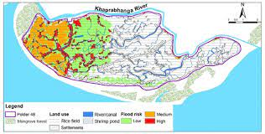
An interactive visualization application was designed for the Surface which allows a new simulation to be interactively defined: a breach can be added by simply touching on the desired location on a map, pop-up windows allow the characteristics of the dike to be defined, the hydrograph can be interactively adjusted and the total simulation time as well as simulation step length. Once defined, the simulation is delegated to the CIS by the touch of a button. The output of the flood simulator is visualized on the Surface represented as an animated time series of water level in each Impact Zone. The simulation results are visualized on top of a topological representation of the area which can be selected from a range of sources, including Google Maps, Bing Maps, Yahoo! Maps, and OpenStreetMap. Interaction methods allow the visualization to be navigated (zoom, scale, rotate) and introspected (such as a graph that reflects water level over time in the touched Impact Zone). In Fig. 7 the flooding of the Science Park area of Amsterdam is shown. For this experiment we obtained DTM data from Actueel Hoogtebestand Nederland of the Amsterdam Watergraafsmeer area. The total area used in the simulation measures 4.4 by 2.8 km with a resolution of 25 m2 per pixel.
5. Virtual Dike
Virtual Dike is an advanced multiscale multi-model simulation lab for expert users and model developers [18]. This virtual lab is used for validation of all the models involved in the modeling cascade, and serves as a research field for experiment planning and understanding the underlying physical processes influencing dike stability and features. In the first stage of the project, we have studied the structural stability of the LiveDike, a sea dike in Eemshaven. LiveDike is protecting a seaport in Groningen. This dike has been equipped with sensors, and data stream is available in real-time. Pore pressure and dike inclination sensors are placed in four dike cross-sections.These cross-sections have been simulated in 2D models under tidal water loading. Simulation results have beencompared with the pore pressure sensors data in order to calibrate model parameters.The modeling approach is based on a coupled fluid-structure interaction with non-linear dike material properties.At the land side, water stays at the constant average see level. A more detailed description of the Virtual Dike models and simulation results can be found in [18], and parallel performance results in [19]. The resulting transient fields of pore pressure, water content and structural deformations have been obtained. Structural displacements field in one moment in time is shown in Fig. 8. The displacements are composed of (a) the static soil settlement under gravity load (maximal at the top of the dike) and (b) transient displacements resulting from the tidal pressure at the seaside and volume pore pressure load. Total displacements are maximal at the top of the dike due to gravity settlement component.picture shown below
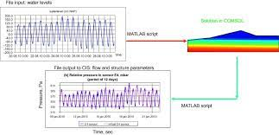

A comparison of real and simulated water pore pressures for one sensor location is shown in signal is shown with a bold line; a virtual (simulated) sensor signal is shown with a thin line. The amplitude of simulated pore pressure oscillations is higher than the real amplitude, which indicates that the soil permeability around this sensor must be reduced in the model. That would also make real and simulated pressure oscillations more synchronous in this point. Thus local inhomogeneities shall be included into the model in future simulations, in order to obtain good agreement of pore pressure dynamics for all sensors
Dynamic resource allocation service
(DyReAlla): a service for dynamic allocation of resources to running Early Warning Systems. Robustness is a key requirement for Early Warning Systems. Consequently, the current implementation of CIS relies on several mature and stable technologies. At the same time the framework does not impose any particular technology for developing Early Warning System components, therefore avoiding the risk of vendor lock-in. This is achieved by adopting the Service-Oriented Architecture (SOA) principles. EWS parts are loosely coupled services with well defined interfaces described in WSDL, which can be accessible through a variety of protocols including SOAP, REST, JMS or FTP. These services do not exchange data directly but through a message bus, therefore there are no direct dependencies between them. As a result, they can be developed independently using different technologies. For example, currently we support both Apache Camel and OpenESB / BPEL for component integration and workflow orchestration. Apache ActiveMQ, a JMS implementation, is used as the message bus.
To increase robustness even further, the same mechanics of the CIS are used to create an EWS that instead of having sensors in an embankment, has sensors in the other EWSs, thereby monitoring the state of the appliances,workflows and data streams in an EWS. This sensor data is part of the four step process mentioned at the start of this section. After it has been fed into the self-monitoring EWS, it is processed by the AI to provide anomaly detection in the various signals. If anything is out of the ordinary, the DyReAlla component is notified and action can be taken.Specific models that take into account the behavior of the appliances are an ongoing research.The EWS components have been deployed in a distributed manner across three partner sites, and some modules have been ported to the SARA Supercomputing Center Clouds [15]. The cloud is hosted on a 128-core cluster with the following characteristics: 16 compute nodes; CPU dual quad-core 2.2 GHz; 24 GB RAM per node; 500 GB local hardisk; 100 TB backup storage, network 1 Gb/s per node; 20 Gb/s aggregated connection from the cluster to storage. SARA uses OpenNebula open source cloud computing management toolkit and KVM virtual machines.
6. Performance results of the interactive flood simulation and visualization system
Despite the complexity of the system architecture, simulations are computed and visualized within a timeframe of less than one minute. This allows the system to be used for interactive testing of different flooding scenarios (whatif experiments). Table 1 illustrates this for two scenarios that used the same simulation parameters but the hydrograph in the second scenario generates more water influx than the first, as illustrated at the bottom of the table.
Fig. 10. Flood EWS implementation: EWS components are deployed in the Cloud as
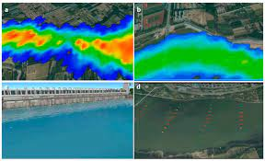
virtualized appliances. The Common Information Space Integration Platform invokes the components and implements workflows to orchestrate data- and control-flows between them. Additional CIS services: DyReAlla and UFoReg manage dynamic resource allocation and metadata.
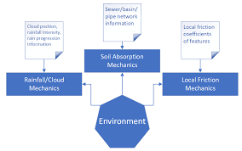

114 V.V. Krzhizhanovskaya et al. / Procedia Computer Science 4 (2011) 106—115
The hydrograph affects the flooded area and consequently the size of the simulation output data that needs to be transmitted every time step. The table shows that the time for each simulation is well below one minute and the time between updates is within seconds, even for scenarios in which the demand for computational resources is significantly higher.
Installation

Implementing a successful flood monitoring and early warning system requires careful planning and execution. In this section, we will discuss the necessary steps for installing the infrastructure, such as sensor networks, data collection systems, and communication channels. Additionally, we will explore best practices for system integration and maintenance.
VCC of Ultrasonic Sensor to 5v of Arduino.
GND of Ultrasonic Sensor to GND of Arduino.
Echo of Ultrasonic Sensor to Digital Pin '8' of Arduino.
Trig of Ultrasonic Sensor to Digital Pin '9' of Arduino.
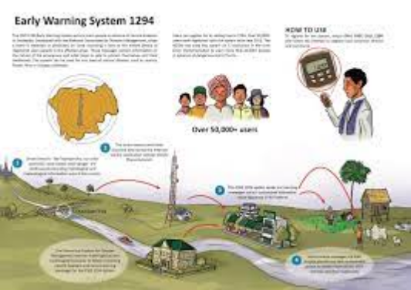
Planning Execution

Needs Assessment
Before embarking on a flood monitoring and early warning project, a comprehensive needs assessment must be conducted. This evaluation includes identifying vulnerable areas, analyzing historical flood data, and determining key stakeholders.
Technology Selection
Choosing the right technology is crucial for an efficient flood monitoring system. This section covers the evaluation and selection process for sensors, data acquisition systems, and real-time monitoring platforms.
Network Design
Designing an effective network architecture is essential for seamless data flow and communication. We will discuss network topology, data transmission protocols, and redundancy strategies.
Managing a project is no easy feat, no matter what the scale and scope are. From planning the minutia to handling the ever-changing demands of clients to shipping the deliverables on time, theres a lot that can go wrong. When you divide the project into manageable stages, each with its own goals and deliverables, its easier to control the project and the quality of the output.
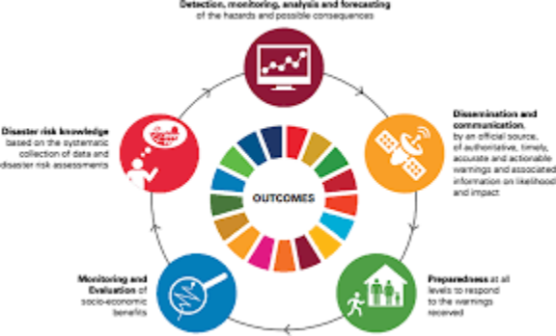

In a project management guide, if you are somehow in a position where you are expected to manage projects for your organization and are feeling overwhelmed, its better to start learning the basic stages of the project life cycle phases.

According to the PMBOK Guide (Project Management Body of Knowledge) by the Project Management Institute (PMI), a project management life cycle consists of 5 distinct phases including initiation, planning, execution, monitoring, and closure that combine to turn a project idea into a working product.

Controlling
Real-Time Data Analysis
Continuous monitoring of data streams allows for timely identification of critical flood events. We will explore various data analysis techniques, including anomaly detection and predictive modeling.
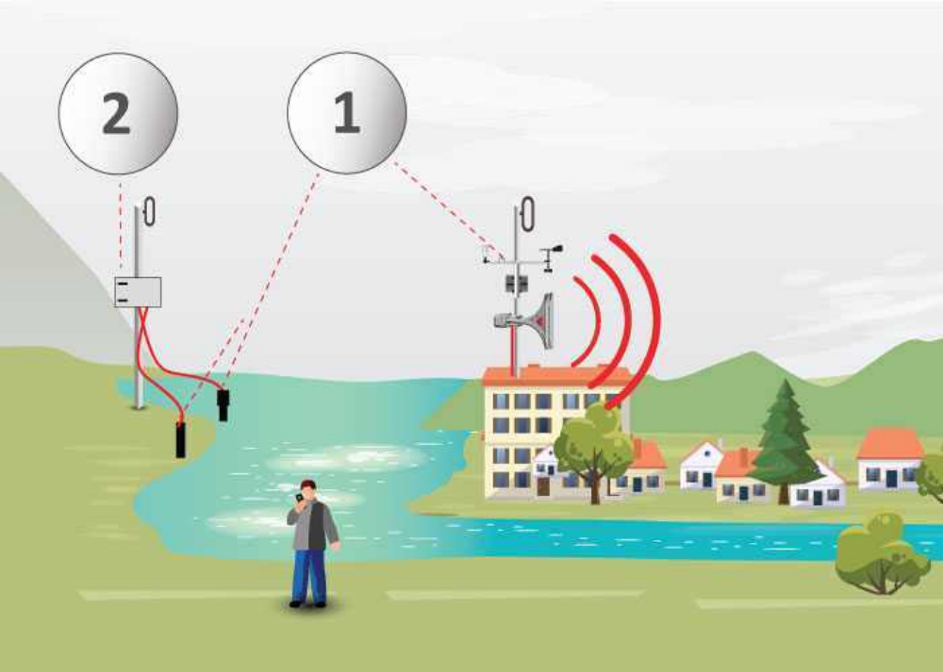
Effective communication and timely dissemination of warnings are critical in ensuring that people at risk receive and understand the necessary information. This involves using various channels, such as mobile alerts, sirens, social media, and community outreach programs, to reach the affected population and provide clear instructions on evacuation procedures and safety measures.

Benefits and Challenges of Flood Monitoring and Early Warning Systems

Alert Systems
An efficient alert system is vital for notifying at-risk communities and triggering early evacuation procedures. We will discuss the design and implementation of multi-channel alert mechanisms.
ENVIRA IoT's system controls the flow and its behavior in real time, detects possible water courses and alerts about the flood risk with real and accurate data. It includes autonomous stations located at strategic points, equipped with a datalogger that reads the data captured by the sensors.
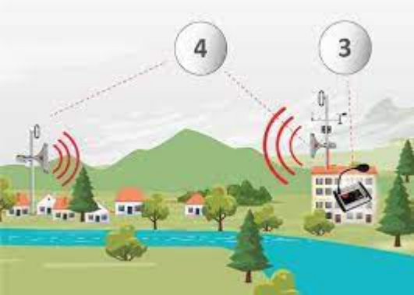

Emergency Response
Coordinating emergency response efforts is essential during a flood event. This section will focus on establishing effective communication channels, resource allocation, and community engagement.

Benefits
Improved Safety
A robust flood monitoring and early warning system enables timely evacuation procedures, reducing the risk to human life and minimizing injuries during flood events.
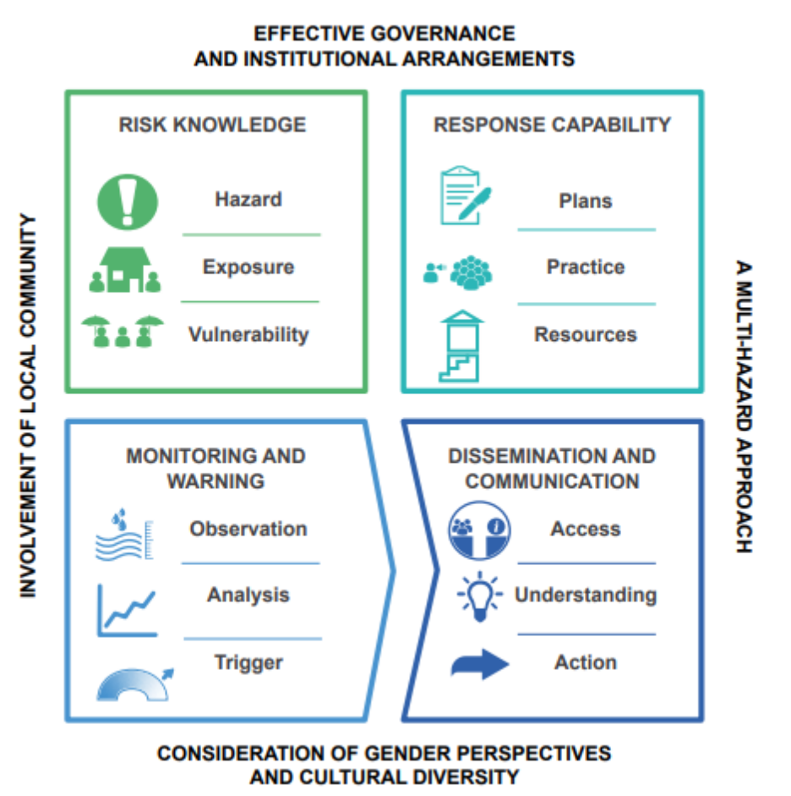

Reduced loss of life and injuries
Improved emergency response and rescue operations
Enhanced community preparedness and resilience
Challenges
Costly implementation and maintenance
Availability and reliability of data
Integration of different data sources and technologies
Community awareness and response to warnings

Enhanced Preparedness
By providing real-time information on flood conditions, these systems empower communities and authorities to make informed decisions, improving their preparedness and response capabilities.

Cost Reduction
Investing in flood monitoring and early warning systems can help minimize expensive post-flood recovery efforts. Early action and preparedness lead to significant cost savings in infrastructure damage and emergency services.

Closing
As we conclude this guide on flood monitoring and early warning systems, it is evident that these solutions are crucial for effective flood management. By implementing state-of-the-art technology, following best practices, and fostering collaboration among stakeholders, we can create safer and more resilient communities.
Flood monitoring and early warning
- In this document, we will explore the fascinating world of flood monitoring and early warning systems. From the implementation of smart sensors to the training of advanced algorithms, we will uncover the future of engineering and discuss the potential for future implementation in flood-prone areas.
Project Implementation
- Implementing a flood monitoring and early warning system requires careful planning and execution. It involves setting up sensors in strategic locations, establishing communication networks, and integrating data analysis algorithms. Effective project management and collaboration are essential for success.
- Step 1: Sensor Placement
Identify critical areas prone to flooding and strategically install sensors to monitor water levels.
- Step 2: Data Acquisition
Collect data from sensors in real-time and ensure its accuracy and reliability.
- Step 3: Communication Infrastructure
Establish a robust communication network to transmit data and alerts to relevant stakeholders.
Sensors for Flood Monitoring
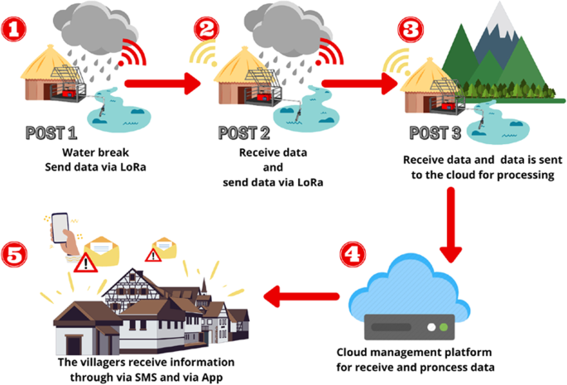
River Level Sensor
- Highly sensitive sensor that measures the water level in rivers and streams.
Rainfall Sensor
- Detects and measures the amount of rainfall in a specific
area, providing crucial data for flood prediction.
Groundwater Sensor
- Monitors the level of groundwater, which can contribute to flooding when it reaches critical levels.
Algorithm
- The algorithm used in flood monitoring systems plays a crucial role in accurately predicting and warning about potential flooding. By analyzing various data points, such as rainfall, water levels, and soil moisture, the algorithm processes the information to identify patterns and generate timely alerts.
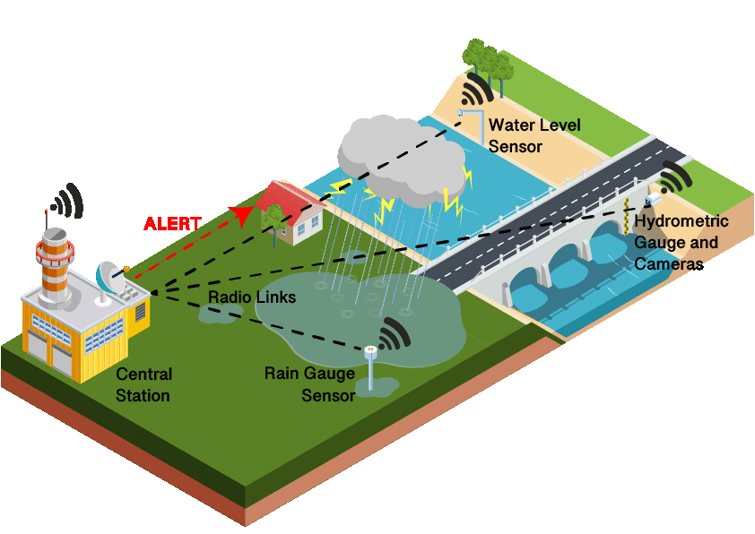

- This complex algorithm takes into account factors like historical data, weather patterns, and topographical information to provide accurate and reliable flood warnings.

Model Training
- To ensure the accuracy of the flood warning system, the algorithm must be trained and fine-tuned using extensive datasets. This training phase involves feeding the algorithm a wide range of historical flood data paired with corresponding weather conditions and water levels.
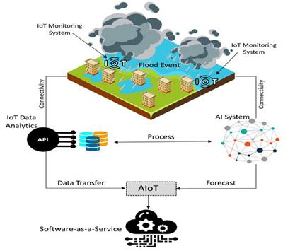
- By iteratively refining the model through training, the system can learn to recognize patterns and make more precise predictions, improving the overall effectiveness of the flood monitoring and early warning system.
Evaluation
- Evaluating the effectiveness of a flood monitoring and early warning system is a critical step in ensuring its reliability. Through comprehensive evaluations and tests, we can assess the system's accuracy, response time, and ability to provide timely and actionable alerts.

- Periodic evaluations help identify areas for improvement and allow for continuous refinement of the system, leading to enhanced flood preparedness and response.

Future Implementation
- The future implementation of flood monitoring and early warning systems holds immense potential. By leveraging advancements in technology and data analysis, we can further enhance the accuracy and efficiency of these systems.
- These improvements may include the integration of remote sensing technologies, the utilization of unmanned aerial vehicles for data collection, and the incorporatin of advanced predictive models.
Data Set (Program in java)
import java.util.Scanner;
public class FloodMonitoring
{
public static void main(String[] args)
{
Scanner scanner = new Scanner(System.in);
System.out.print("Enter the water level: ");
int waterLevel = scanner.nextInt();
if (waterLevel > 50)
{
System.out.println("Flood warning! Evacuate immediately!");
}
else if (waterLevel > 30)
{
System.out.println("Flood advisory! Prepare for potential flooding!");
}
else
{
System.out.println("No immediate flood threat. Stay vigilant!");
}
scanner.close();
}
}

OUTPUT
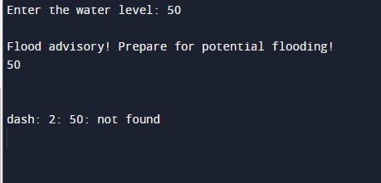

Conclusion
In this comprehensive document, we have explored the world of flood monitoring and early warning systems. From understanding the importance of installation and planning to the benefits they provide, we have gained valuable insights into the effective management of floods. By leveraging cutting-edge technology and embracing a proactive approach, we can mitigate the impacts of flooding and protect lives and property.

THANK YOU

