6115-MAHENDRA INSTITUTE OF ENGINEERING AND TECHNOLOGY

FLOOD MONITORING AND EARLY WARING
Team Id:567
Team code:proj_223285_Team_1
Year:lll
Tearm members name:
1.Moses samsan.M
2.Mooventhan.L
3.Muthu prakash A
4.Manikandan.AR
5.Narendra moorthi.M
Menter name
Santhanaraj.M

Introduction

Floods are natural disasters that pose significant threats to human life and property. In this section, we will delve into the causes and impacts of floods, highlighting the need for effective monitoring and early warning systems. By understanding these key aspects, we can lay the foundation for comprehensive flood management strategies
MoAs the name indicates, Flood Early Warning System (FLEWS) is a system by which flood induced hazards can be minimized and prevented. Currently different organizations are working on flood forecasting and early warning at national, continental and global scale

Flood monitoring and early warning systems play a vital role in reducing the impact of floods on communities and infrastructures. By providing timely information and alerts, these systems help authorities and individuals take necessary precautions and actions to minimize damage and ensure the safety of people in flood-prone areas.
Importance of Flood Monitoring and Early Warning Systems of flood monitoring and early warning systems cannot be overstated. These systems enable us to anticipate and respond effectively to floods, reducing the loss of lives and properties. Additionally, they provide valuable data for research and analysis, aiding in the development of more resilient and sustainable flood management strategies.
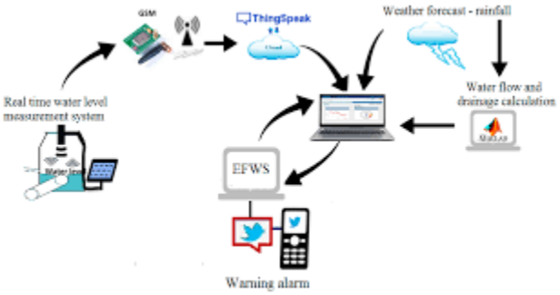
Installation

Implementing a successful flood monitoring and early warning system requires careful planning and execution. In this section, we will discuss the necessary steps for installing the infrastructure, such as sensor networks, data collection systems, and communication channels. Additionally, we will explore best practices for system integration and maintenance.
VCC of Ultrasonic Sensor to 5v of Arduino.
GND of Ultrasonic Sensor to GND of Arduino.
Echo of Ultrasonic Sensor to Digital Pin '8' of Arduino.
Trig of Ultrasonic Sensor to Digital Pin '9' of Arduino.
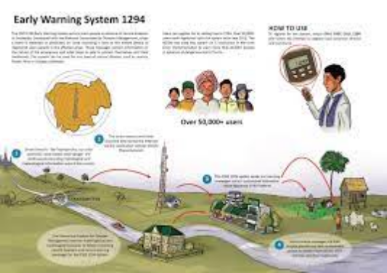
Planning Execution

Needs Assessment
Before embarking on a flood monitoring and early warning project, a comprehensive needs assessment must be conducted. This evaluation includes identifying vulnerable areas, analyzing historical flood data, and determining key stakeholders.
Technology Selection
Choosing the right technology is crucial for an efficient flood monitoring system. This section covers the evaluation and selection process for sensors, data acquisition systems, and real-time monitoring platforms.
Network Design
Designing an effective network architecture is essential for seamless data flow and communication. We will discuss network topology, data transmission protocols, and redundancy strategies.
Managing a project is no easy feat, no matter what the scale and scope are. From planning the minutia to handling the ever-changing demands of clients to shipping the deliverables on time, theres a lot that can go wrong. When you divide the project into manageable stages, each with its own goals and deliverables, its easier to control the project and the quality of the output.
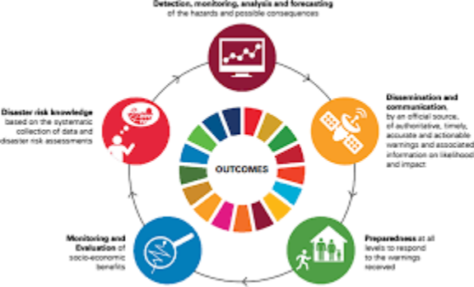

In a project management guide, if you are somehow in a position where you are expected to manage projects for your organization and are feeling overwhelmed, its better to start learning the basic stages of the project life cycle phases.

According to the PMBOK Guide (Project Management Body of Knowledge) by the Project Management Institute (PMI), a project management life cycle consists of 5 distinct phases including initiation, planning, execution, monitoring, and closure that combine to turn a project idea into a working product.

Controlling
Real-Time Data Analysis
Continuous monitoring of data streams allows for timely identification of critical flood events. We will explore various data analysis techniques, including anomaly detection and predictive modeling.
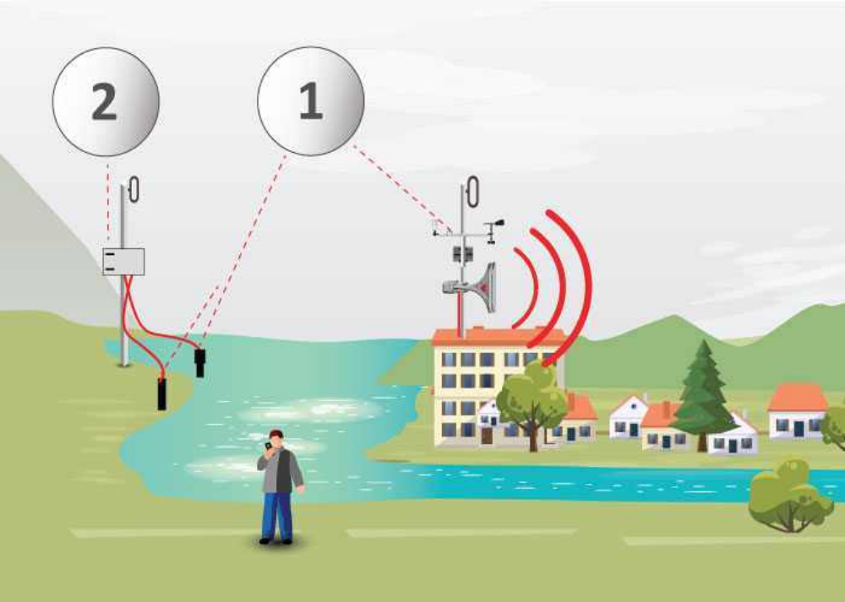
Effective communication and timely dissemination of warnings are critical in ensuring that people at risk receive and understand the necessary information. This involves using various channels, such as mobile alerts, sirens, social media, and community outreach programs, to reach the affected population and provide clear instructions on evacuation procedures and safety measures.

Benefits and Challenges of Flood Monitoring and Early Warning Systems

Alert Systems
An efficient alert system is vital for notifying at-risk communities and triggering early evacuation procedures. We will discuss the design and implementation of multi-channel alert mechanisms.
ENVIRA IoT's system controls the flow and its behavior in real time, detects possible water courses and alerts about the flood risk with real and accurate data. It includes autonomous stations located at strategic points, equipped with a datalogger that reads the data captured by the sensors.
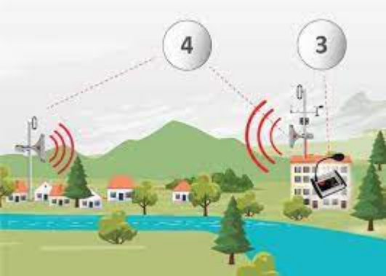

Emergency Response
Coordinating emergency response efforts is essential during a flood event. This section will focus on establishing effective communication channels, resource allocation, and community engagement.

Benefits
Improved Safety
A robust flood monitoring and early warning system enables timely evacuation procedures, reducing the risk to human life and minimizing injuries during flood events.
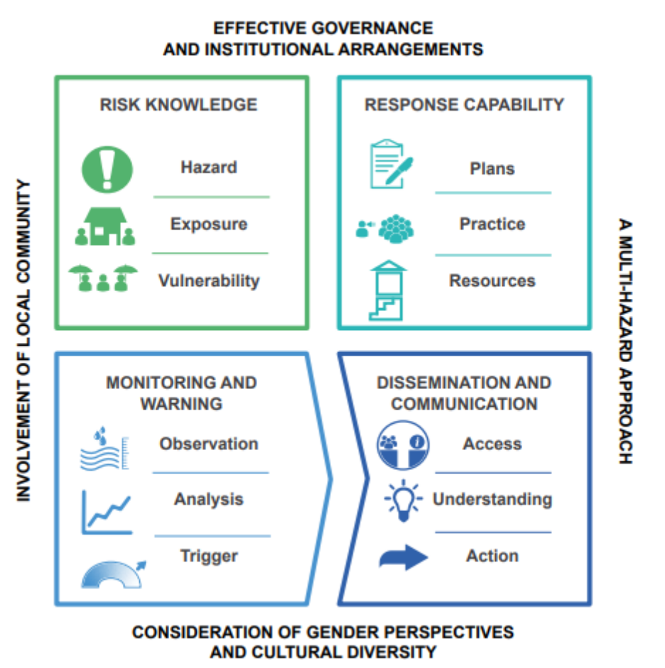

Reduced loss of life and injuries
Improved emergency response and rescue operations
Enhanced community preparedness and resilience
Challenges
Costly implementation and maintenance
Availability and reliability of data
Integration of different data sources and technologies
Community awareness and response to warnings

Enhanced Preparedness
By providing real-time information on flood conditions, these systems empower communities and authorities to make informed decisions, improving their preparedness and response capabilities.

Cost Reduction
Investing in flood monitoring and early warning systems can help minimize expensive post-flood recovery efforts. Early action and preparedness lead to significant cost savings in infrastructure damage and emergency services.

Closing
As we conclude this guide on flood monitoring and early warning systems, it is evident that these solutions are crucial for effective flood management. By implementing state-of-the-art technology, following best practices, and fostering collaboration among stakeholders, we can create safer and more resilient communities.

Conclusion
In this comprehensive document, we have explored the world of flood monitoring and early warning systems. From understanding the importance of installation and planning to the benefits they provide, we have gained valuable insights into the effective management of floods. By leveraging cutting-edge technology and embracing a proactive approach, we can mitigate the impacts of flooding and protect lives and property.

THANK YOU

