**Technical Exercise** 

**Name:** Manikandan Ganesh

**Email:** [karthickgm27@gmail.com](mailto:karthickgm27@gmail.com)

**Phone:** 312-874-8660

**LinkedIn:** <https://www.linkedin.com/in/manikandan-ganesh-02919963>

**GitHub:** <https://github.com/manikandanganesh2791>

**Objective**

The purpose of this task is to create a clean attendance record dataset which is likely to be loaded into a new sole system.

The word” clean” indicates four things here:

1. The final data set must be simple and all the department in the organization should find it easy to use.
2. The structure of my design must be flexible so that, if the business logic changes, the design can be changed easily.
3. The solution must open doors for more data.
4. The data set must be consistent across all the regions.

Taking these factors into consideration, I decided to work on the given unclean data set from three different systems (c, k, s) and transform them into a single clean data set satisfying all the above given factors.

**Data Cleaning**

I first started off by looking at the data set of all the given three different systems and I first observed the presence of duplicate records in all the provided csv files.

**Removing Duplicates in attendance_s.csv file**

I observed the presence of duplicate values in attendance_s.csv file.

For instance, I could observe the presence of redundant data (like the one given below) carrying the same ID value in the attendance_s.csv file.

|  |  |  |  |  |  |  |  |
| --- | --- | --- | --- | --- | --- | --- | --- |
| **ID** | **CardSourceID** | **CardHolderID** | **DateIn** | **ReportField1** | **ReportField2** | **DateOut** | **HoursWorked** |
| 4071 | 73 | 218696326 | 2/27/2017 10:38 |  |  | NULL | 0 |
| 4071 | 73 | 218696326 | 2/27/2017 10:38 |  |  | NULL | 0 |
| 4072 | 73 | 201706009 | 2/27/2017 10:39 |  |  | NULL | 0 |
| 4072 | 73 | 201706009 | 2/27/2017 10:39 |  |  | NULL | 0 |

So, I removed these duplicate entries from the data set. Also, I restructured the table format by having separate fields for Date and Time and having only those records for which the value of CardSourceID is 73. My final table after cleaning the entire data set had the following structure:

|  |  |  |  |  |  |  |  |  |  |
| --- | --- | --- | --- | --- | --- | --- | --- | --- | --- |
| **ID** | **CardSourceID** | **CardHolderID** | **DateIn** | **InTime** | **ReportField1** | **ReportField2** | **DateOut** | **Out Time** | **HoursWorked** |
| 4839 | 73 | 226730190 | 3/21/2017 | 9:09 |  |  | NULL | NULL | 0 |
| 4838 | 73 | 223198193 | 3/21/2017 | 9:05 |  |  | 3/23/2017 | 15:48 | 54.717 |
| 7045 | 73 | 221142714 | NULL | NULL |  |  | 4/6/2017 | 15:54 | 0 |

I used Python to scrap and cleanse the data set to obtain a new clean source record from the “s” system, in the prescribed format. The code I used to clean the set is given below:

**Python Code:**

1. target_file = open('attendance_s_clean.csv', 'w')
2. attendance_s = open('attendance_s.csv', 'r')
3. row_s = attendance_s.read().splitlines()
4. row_list = []
5. record_dict = {}
6. date_split_list = []
7. date_val = ""
8. target_line = ""
10. #Method list_val is used to clean the attendance_s.csv file by returning only
11. #the set of rows having unique Id and eliminates the redundant Id values.
12. #Also, this method parses the datein and dateout column values by stripping
13. #the date of the format mm/dd/yyyy and removing the time values from it.
15. **def** list_val(row_list):
16. result = []
17. **for** i **in** range(len(row_list)):
18. date_val = ""
19. time_val = ""
20. date_split_list = []
21. **if**(i != 0):
22. **if**(i==3):
23. **if**(row_list[i] != 'NULL'):
24. date_split_list=row_list[i].split(" ")
25. date_val=date_split_list[0]
26. time_val=date_split_list[1]
27. result.append(date_val)
28. result.append(time_val)
29. **else**:
30. result.append(row_list[i])
31. result.append(row_list[i])
32. **elif**(i==6):
33. **if**(row_list[i] != 'NULL'):
34. date_split_list=row_list[i].split(" ")
35. date_val=date_split_list[0]
36. time_val=date_split_list[1]
37. result.append(date_val)
38. result.append(time_val)
39. **else**:
40. result.append(row_list[i])
41. result.append(row_list[i])
42. **else**:
43. result.append(row_list[i])
44. **return** result
46. #Loop that forms the dictionary 'record_dict' to store the records from
47. #attendance_s.csv file having the key as Id and values as a list carrying
48. #CardSourceId, CardHolderId, DateIn, DateOut and HoursWorked values
49. #for CardSourceId '73'
50. **for** line **in** row_s[1:]:
51. row_list = line.split(",")
52. **if**(row_list[1] == '73'):
53. **if**(row_list[0] **in** record_dict):
54. **continue**
55. record_dict[row_list[0]] = list_val(row_list)
56. column_header = 'ID'+','+'CardSourceID'+','+"CardHolderID"+','+"DateIn"+','+"InTime"+','+"ReportField1"+','+"ReportField2"+','+"DateOut"+','+"OutTime"+','+"HoursWorked"
57. target_file.write(column_header)
58. target_file.write("\n")
59. **for** key, value **in** record_dict.items():
60. target_line = ""
61. target_line+=key
62. **for** i **in** range(len(value)):
63. target_line+=","+value[i]
64. target_file.write(target_line)
65. target_file.write("\n")
66. target_file.close()

After cleaning the data set, I decided to dump the entries into a MySQL table exclusively for attendance_s.csv entries. Before creating a table, I first created a database named “**attendance**” inside the MySQL engine using the script –

**CREATE DATABASE attendance;**

The purpose of creating the database is to have a common store and easy accessibility for all the tables I will be creating in this exercise.

I created a table exclusive for attendance_s.csv file entries inside the **attendance** database using the script,

**drop table if exists attendance_s;**

**create table attendance_s(**

**ID int,**

**CardSourceID int,**

**CardHolderID int,**

**DateIn varchar(12),**

**InTime varchar(5),**

**ReportField1 varchar(100),**

**ReportField2 varchar(100),**

**DateOut varchar(12),**

**OutTime varchar(5),**

**HoursWorked int);**

I dumped the values from the attendance_s_clean.csv (cleaned version of attendance_s.csv) into the MySQL table using the following command:

**LOAD DATA LOCAL INFILE '~/attendance_s_clean.csv' INTO TABLE attendance_s**

**FIELDS TERMINATED BY ','**

**ENCLOSED BY '"'**

**LINES TERMINATED BY '\n'**

**IGNORE 1 LINES;**

**attendance_c** and **attendance_k** files structure was more appropriate than the **attendance_s** file. So, I decided to first dump the entire contents of **attendance_c.csv** file into **attendance_c** table and **attendance_k.csv** file into **attendance_k** table using the following queries.

**drop table if exists attendance_c;**

**create table attendance_c(**

**ID int not null auto_increment,**

**CardHolderID int,**

**Date varchar(12),**

**Status varchar(25),**

**PRIMARY KEY(ID));**

**LOAD DATA LOCAL INFILE '/vagrant_data/attendance_c.csv'**

**INTO TABLE attendance_c**

**FIELDS TERMINATED BY ','**

**ENCLOSED BY '"'**

**LINES TERMINATED BY '\n'**

**(@col1,@col2,@col3) set CardHolderID=@col1,Date=@col2,Status=@col3;**

One unique criteria to be noted down while dumping the contents from attendance_c.csv into the table is, unlike the attendance_s.csv file, attendance_c.csv file did not have a primary key field. To overcome this problem, I used an **AUTO INCREMENTED** primary key field and customized the process of dumping using temporary variables (@col1, @col2, @col3).

**drop table if exists attendance_k;**

**create table attendance_k(**

**ID int not null auto_increment,**

**CardHolderID int,**

**Date varchar(12),**

**Status varchar(25),**

**PRIMARY KEY(ID));**

**LOAD DATA LOCAL INFILE '/vagrant_data/attendance_k_clean.csv'**

**INTO TABLE attendance_k**

**FIELDS TERMINATED BY ','**

**ENCLOSED BY '"'**

**LINES TERMINATED BY '\n'**

**(@col1,@col2,@col3,@col4) set CardHolderID=@col1,Status=@col2,Date=@col4;**

I also created an additional using the following script to create a date dimension having records loaded from List of school days .csv file to allow flexibility for the final table design.

**create table date_dimension(**

**Id int not null auto_increment,**

**Date varchar(12),**

**PRIMARY KEY(Id));**

**LOAD DATA LOCAL INFILE '~/List of school days .csv' INTO TABLE date_dimension LINES TERMINATED BY '\n'**

**IGNORE 1 LINES**

**(@col1) set Date=@col1;**

Once I dumped all the records from the csv files into the corresponding database tables, I decided to design the system which is consistent and at the same time, flexible to any additional business logic.

**System Design**

After reading the business requirement documentation, I decided to integrate the data from three different systems (c, k, s) and load them together into a single table that can hold relationship with all the system entities as well as be flexible to new business logic/ideas. I gave the name **attendance_main** to my final table and decided on having five columns. The structure of my final table is given below:

|  |  |  |  |  |
| --- | --- | --- | --- | --- |
| **attendance_main** | | | | |
| **Column Name** | **Data Type** | **Primary Key** | **Auto Increment** | **Description** |
| ID | int | YES | YES | Primary Key field |
| CardHolderID | Int | NO | NO | Identifies the name of the person for whom the event is logged |
| Date | varchar(12) | NO | NO | Event date field |
| Status | varchar(35) | NO | NO | The attendance status field |
| Comments | varchar(100) | NO | NO | Comments field |

The final table will be loaded from the three given source tables. But before loading the entries directly, I decided to further break down the records from attendance_s table into three separate dimension tables having records based on DateIn and DateOut entries. The reason I chose to move ahead with this step is because of the given business logic which inferred,

* if cardsourceid = 73 and there is a value for datein then the event should be labeled “tardy”
* if cardsourceid = 73 and there is a value for dateout then the event should be labeled “Early departure”

However, the main type of inconsistency or uncertainty that I could observe from the given logic was, there were entries having values in both datein and dateout fields. In such cases, I decided to label the event status as “**tardy and Early departure**” with respect to the following conditions:

* if the values in datein and dateout fields are equal, then the event status can be labelled “**tardy and Early departure**”
* if the value in datein field is not equal to the value in dateout field, then the event status for the specific date (datein value) can be labelled “**tardy**” and the even status for the corresponding dateout value can be labelled “**Early departure**”

The breakdown structure of attendance_s into different dimension tables is given below:

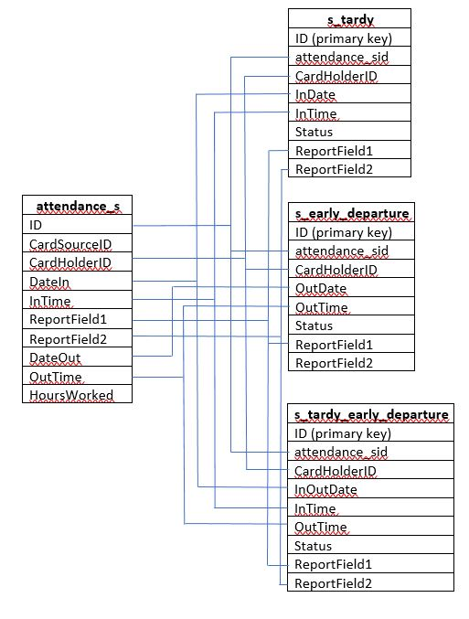

The first table **tardy_s** will be carrying all the records corresponding to the status “**tardy**”. **s_early_departure** table will be carrying records pointing to “**Early departure**”. The final table **s_tardy_early_departure** will contain records corresponding to both “**tardy and Early departure**”.

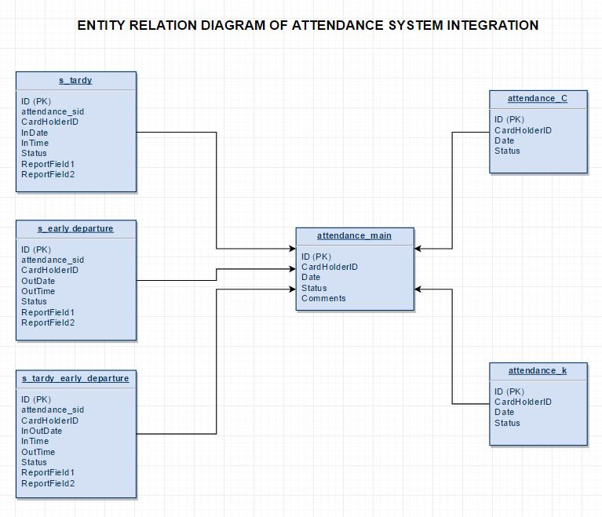

**IMPLEMENTATION**

The first step of in the implementation of my design is creating the dimension tables from the attendance_s.

The SQL queries that I used to create the tables are:

**drop table if exists s_tardy;**

**create table s_tardy(**

**ID int not null auto_increment,**

**attendance_sid int,**

**CardHolderID int,**

**InDate varchar(12),**

**InTime varchar(5),**

**Status varchar(5),**

**ReportField1 varchar(100),**

**ReportField2 varchar(100),**

**PRIMARY KEY(ID));**

**drop table if exists s_early_departure;**

**create table s_early_departure(ID int not null auto_increment,**

**attendance_sid int,**

**CardHolderID int,**

**OutDate varchar(12),**

**OutTime varchar(5),**

**Status varchar(15),**

**ReportField1 varchar(100),**

**ReportField2 varchar(100),**

**PRIMARY KEY(ID));**

**drop table if exists s_tardy_early_departure;**

**create table s_tardy_early_departure(ID int not null auto_increment,**

**attendance_sid int,**

**CardHolderID int,**

**InOutDate varchar(12),**

**InTime varchar(5),**

**OutTime varchar(5),**

**Status varchar(25),**

**ReportField1 varchar(100),**

**ReportField2 varchar(100),**

**PRIMARY KEY(ID));**

I used the following SQL queries with the specific conditions (as mentioned earlier) to load the data from **attendance_s** table into the corresponding dimension tables:

**insert into s_tardy (attendance_sid, CardHolderID, InDate, InTime, Status, ReportField1, ReportField2)**

**SELECT ID, CardHolderID, DateIn, InTime, "tardy", ReportField1, ReportField2**

**from attendance_s**

**where (DateIn IS NOT NULL and DateOut IS NULL) || ((DateIn IS NOT NULL and DateOut IS NOT NULL) and (DateIn != DateOut));**

**insert into s_early_departure(attendance_sid, CardHolderID, OutDate, OutTime, Status,ReportField1,ReportField2)**

**select ID, CardHolderID, DateOut, OutTime, "Early departure", ReportField1, ReportField2**

**from attendance_s**

**where (DateOut IS NOT NULL and DateIn IS NULL) || ((DateOut IS NOT NULL and DateIn IS NOT NULL) and (DateOut != DateIn));**

**insert into s_tardy_early_departure(attendance_sid,CardHolderID, InOutDate, InTime, OutTime, Status,ReportField1,ReportField2)**

**select ID, CardHolderID, DateIn, InTime, OutTime, "tardy and Early departure", ReportField1, ReportField2**

**from attendance_s**

**where (DateOut IS NOT NULL and DateIn IS NOT NULL) and (DateIn = DateOut);**

After loading the data from the “s” system based on the three categories (tardy, early departure and tardy & early departure), I decided to check for inconsistencies in the integrated data set.

For inconsistency check I looked out for data that are repetitive or that are negating each other in terms of attendance status. For example, let us consider the records given in the table below:

|  |  |  |  |  |  |  |  |  |  |
| --- | --- | --- | --- | --- | --- | --- | --- | --- | --- |
| **ID** | **CardSourceID** | **CardHolderID** | **DateIn** | **InTime** | **Report Field1** | **Report Field2** | **DateOut** | **OutTime** | **Hours Worked** |
| 4359 | 73 | 201706009 | 3/15/2017 | 12:33 |  |  | NULL | NULL | 0 |
| 4303 | 73 | 201706009 | NULL | NULL |  |  | 3/15/2017 | 11:35 | 0 |

If you closely observe the records given above, it is uncertain under which category the record comes under. It apparently appears in both s_tardy table with attendance_sid as 4359 and in s_early_departure table with attendance_sid as 4303. The status in s_tardy table will remain as **tardy** and the status s_early_departure table will remain as **Early departure**. So, while loading this data into the main table, the attendance status for a specific person for a specific day will be both **tardy** and **Early departure** which by itself is highly inconsistent. To overcome this problem, I decided to have an intermediate bridge table to clean the highly inconsistent records within the table and load it into the final main table. I named the intermediate bridge table as **attendance_s_intermediate.** I created and loaded the records into the intermediate table using the following queries:

**drop table if exists attendance_s_intermediate;**

**create table attendance_s_intermediate(**

**ID int not null auto_increment,**

**CardHolderID int,**

**Event_Date varchar(12),**

**Status varchar(25),**

**PRIMARY KEY(ID));**

**insert into attendance_s_intermediate(CardHolderID, Event_Date, Status)**

**select CardHolderID, InDate, Status from s_tardy**

**union all**

**select CardHolderID, OutDate, Status from s_early_departure**

**union all**

**select CardHolderID, InOutDate, Status from s_tardy_early_departure;**

From the intermediate table, I was also able to calculate error percentage in the **s** system using the following query,

**select (select count(*)**

**from**

**(select CardHolderID, Date, count(*)**

**from attendance_main**

**group by CardHolderID, Date**

**having count(*) >= 2) as A)/**

**(select count(*)**

**from**

**attendance_main) * 100 as Error_Percentage;**

The result that I obtained was **3.4731%** which means the success rate of **s** system was **96.52%**.

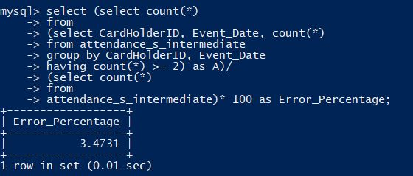

My first step in cleaning the intermediate table is identifying the inconsistent records using the following query:

**select CardHolderID, Event_Date, count(*)**

**from attendance_s_intermediate**

**group by CardHolderID, Event_Date having count(*) >= 2;**

I could identify 29 records that were inconsistent in the table.

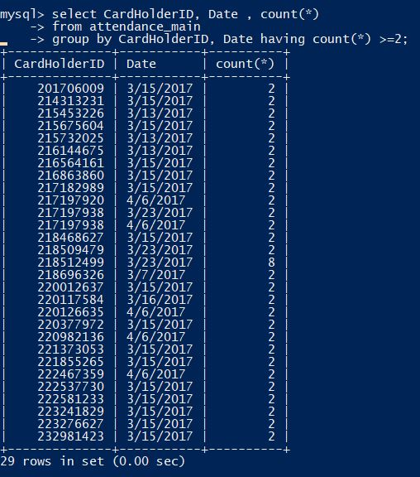

To clean all the 29 records and tag them to an appropriate attendance status, I created an additional table called **combined_name** to update the intermediate table inconsistent records. To flag the rows of inconsistent entries, I added an additional column called **duplicate_check** in my intermediate table and update it with **True** in rows where inconsistent records were present and update it with **False** in rows where there is no sight of inconsistent records.

**alter table attendance_s_intermediate**

**add column duplicate_check varchar(5);**

**create table combined_name**

**(ID int not null auto_increment,**

**name varchar(250),**

**PRIMARY KEY(ID));**

**insert into combined_name(name)**

**select concat(CardHolderID,'|',Event_Date) from attendance_s_intermediate;**

**update attendance_s_intermediate**

**set duplicate_check = 'True'**

**where concat(CardHolderID, '|', Event_Date)in**

**(select name**

**from combined_name**

**group by name**

**having count(*) >=2);**

**update attendance_s_intermediate**

**set duplicate_check = 'False'**

**where concat(CardHolderID, '|', Event_Date) not in**

**(select name**

**from combined_name**

**group by name**

**having count(*) >=2);**

After updating the flag column, I exported the inconsistent entries (entries having duplicate_check column value as **True**) into a separate csv file called **intermediate_inconsistent.csv**. The consistent entries (entries having duplicate_check column value as **False**) on the other hand were exported into another csv file called **intermediate_consistent.csv**. The queries used to export the values are:

**select * from attendance_s_intermediate where duplicated_check = 'True'**

**into outfile '/var/lib/mysql-files/intermediate_inconsistent.csv'**

**fields terminated by ','**

**enclosed by '"'**

**lines terminated by '\n';**

**select * from attendance_s_intermediate where duplicate_check = 'False'**

**into outfile '/var/lib/mysql-files/ intermediate_consistent.csv'**

**fields terminated by ','**

**enclosed by '"'**

**lines terminated by '\n';**

I again switched back to Python for tagging the datasets to a relevant status and writing them back into a more cleaner intermediate table. I used the following Python code to clean the intermediate set:

1. target_file= open('attendance_s_consistent.csv', 'w')
2. inconsistent_main = open('intermediate_inconsistent.csv','r')
3. consistent_main = open('intermediate_consistent.csv','r')
4. row_inconsistent = inconsistent_main.read().splitlines()
5. row_consistent = consistent_main.read().splitlines()
6. row_inconsistent_list = []
7. row_consistent_list=[]
8. row_inconsistent_add_list=[]
9. row_inconsistent_result=[]
10. id_date_set=set()
11. flag = False
12. line_string = ""
13. **for** i **in** row_inconsistent:
14. row_inconsistent_list.append(i.split(","))
15. row_inconsistent_result=[]
16. **for** i **in** range(len(row_inconsistent_list)-1):
17. **if** row_inconsistent_list[i][1]+'|'+row_inconsistent_list[i][2] **not** **in** id_date_set:
18. date_val=row_inconsistent_list[i][2]
19. id_val=row_inconsistent_list[i][1]
20. status_val = row_inconsistent_list[i][3]
21. j=i+1
22. **while**(j<len(row_inconsistent_list)):
23. flag = False
24. **if** row_inconsistent_list[j][1] == id_val **and** row_inconsistent_list[j][2] == date_val:
25. **if** row_inconsistent_list[j][3] != status_val:
26. flag = True
27. row_inconsistent_add_list=[]
28. row_inconsistent_add_list.append(row_inconsistent_list[j][1])
29. row_inconsistent_add_list.append(row_inconsistent_list[j][2])
30. row_inconsistent_add_list.append('tardy and Early departure')
31. row_inconsistent_result.append(row_inconsistent_add_list)
32. id_date_set.add(row_inconsistent_list[j][1]+'|'+row_inconsistent_list[j][2])
33. **break**
34. **else**:
35. j+=1
36. **else**:
37. flag = True
38. row_inconsistent_add_list=[]
39. row_inconsistent_add_list.append(row_inconsistent_list[j-1][1])
40. row_inconsistent_add_list.append(row_inconsistent_list[j-1][2])
41. row_inconsistent_add_list.append(row_inconsistent_list[j-1][3])
42. row_inconsistent_result.append(row_inconsistent_add_list)
43. id_date_set.add(row_inconsistent_list[j-1][1]+'|'+row_inconsistent_list[j-1][2])
44. **break**
45. **if** flag == False:
46. row_inconsistent_add_list=[]
47. row_inconsistent_add_list.append(id_val)
48. row_inconsistent_add_list.append(date_val)
49. row_inconsistent_add_list.append(status_val)
50. row_inconsistent_result.append(row_inconsistent_add_list)
51. id_date_set.add(id_val+'|'+date_val)
52. **break**
54. column_header = 'CardHolderID' + ',' + 'Event_Date' + ',' + 'Status'
55. target_file.write(column_header)
56. target_file.write('\n')
57. **for** i **in** row_consistent:
58. line_string = ""
59. row_consistent_list=i.split(",")
60. **for** j **in** range(len(row_consistent_list)):
61. **if** j **not** **in** (0,3,4):
62. line_string+=row_consistent_list[j]+','
63. **elif** j == 3:
64. line_string+=row_consistent_list[j]
65. target_file.write(line_string)
66. target_file.write('\n')
67. **for** i **in** row_inconsistent_result:
68. line_string = ""
69. **for** j **in** range(len(i)):
70. **if** j != 2:
71. line_string+=i[j]+','
72. **else**:
73. line_string+=i[j]
74. target_file.write(line_string)
75. target_file.write('\n')
76. target_file.close()
77. inconsistent_main.close()
78. consistent_main.close()

After cleaning the set, I decided to dump the entries from the csv file into a cleaner MySQL table for **s** system called **attendance_s_consistent**.

**drop table if exists attendance_s_consistent;**

**create table attendance_s_consistent(**

**ID int not null auto_increment,**

**CardHolderID int,**

**Event_Date varchar(12),**

**Status varchar(25),**

**PRIMARY KEY(ID));**

**LOAD DATA LOCAL INFILE '/vagrant_data/attendance_s_consistent.csv'**

**INTO TABLE attendance_s_consistent**

**FIELDS TERMINATED BY ','**

**LINES TERMINATED BY '\n'**

**IGNORE 1 LINES**

**(@col1,@col2,@col3) set CardHolderID=@col1,Event_Date=@col2,Status=@col3;**

Now, the data from the **“s”** system became highly consistent, clean and they are resting inside the table **attendance_s_consistent**.

Now the next step in my implementation phase is to check for the consistency of records in the **attendance_c** table.

In this step, I used the same methodology as I used for the consistency check in **attendance_s_intermediate** table.

First, I checked for entries which had multiple recordings for the same card holder ID for a specific date using the following query. I could observe **2665** records that were inconsistent.

From this, I calculated the error percentage in the **c** system using the following query:

**select (select count(*) from**

**(select combined_name, count(*)**

**from attendance_c**

**group by combined_name**

**having count(*) >= 2) as A)/(select count(*) from attendance_c) * 100 as Error_Percentage;**

The error percentage was recorded as 4.5223% and that means, the success rate of the **c** system was **95.47%**.

To remove the inconsistency and make the Error Percentage as 0, I used a slightly different approach from **attendance_s_intermediate**. The SQL queries are given below:

**alter table attendance_c**

**add column combined_name varchar(100);**

**update attendance_c**

**set combined_name = concat(CardHolderID, '|', Date);**

**drop table if exists combined_name_c;**

**create table combined_name_c (name varchar(100));**

**insert into combined_name_c(name)**

**select combined_name**

**from attendance_c**

**group by combined_name**

**having count(*) >= 2**

**select * from attendance_c**

**where combined_name in**

**(select name from combined_name_c)**

**limit 1**

**into outfile '/var/lib/mysql-files/attendance_c_inconsistent.csv'**

**fields terminated by ','**

**lines terminated by '\n';**

**select * from attendance_c**

**where combined_name not in**

**(select * from combined_name_c)**

**into outfile '/var/lib/mysql-files/attendance_c_consistent.csv'**

**fields terminated by ','**

**lines terminated by '\n';**

On executing the above queries, I was able to obtain two separate csv files named **attendance_c_inconsistent** and **attendance_c_consistent** carrying records that are inconsistent and consistent respectively.

I used the following python code to clean the inconsistent records by tagging them to an appropriate attendance status and integrating them with the already existing consistent records from attendance_c system.