Linux Mastery Document

Day 1-Linux Server Provisioning (Production level understanding)

- Objective
The objective of Day 1 was to build a Linux Server Lab environment and to understand the fundamental components required for operating a Linux system in a production environment.

Task I have performed is:
- Setting up visualization
- Installing Linux operating system
- Configuration network connectivity
- Configuring system hostname
- Synchronizing stem time
- Enabling secure remote access using ssh for vs code
- Managing servers remotely through development tools

- Linux na enna?
Linux na open-source , unix like operating sytem family ku base ah irukura oru core part
Simple ah sonna:
Linux= OS oda heart (kernel)
Father of linux: Linux Benedict Torvalds
Created first linux: 1991

- OS (operating system na enna?
Operating system (OS) na oru system software
OS oda main work:
** Computer hardware ah manage pannum
** Programs run aagura madhiri help pannum

OS Responsibilites:
** CPU management
** Memory management (RAM)
** Disk and file system
** Device (keyboard, mouse, disk, network)
** Users and security

Examples:
** Linux
** Windows
** Macos
** Unix

- Kernel na enna ?
Kernal na OS oda core part.

Kernal enna pannum?
** Hardware oda direct ah pesum
** Pesi Manage pannum edha manage pannum?
** CPU
** Memory
** Disk
** Network
** Devices

Kernel enna Panandhu?
** LS , cp commands kudkkadhu
** Bash shell kudukadhu
** GUI kukudkahdu

******* Idhu elam Users space tools.

- Linux Kernel Enna manage pannum?
Area | Kernel role
CPU | Process scheduling
Memory | RAM, Paging
Disk | Block Devices
Network | TCP/IP
Devices | Drives
Security | System calls

- Kernel features in containers?
Feature –purpose
- Namespace-isolatalted container
- Cgroups-control cpu and memory
- Overlays FS- container filesystem
- Network stack-container networking

- Commands used to inspect kernel –debug system issues
- Uname –r – kernel version
- Uname –a –full kernel info
- Ls mod-loaded kernel module
- Dmesg-kernel log
- Cat /proc/version – kernel details
- Cat /pro/cpu info – cpu details
- Cat /pro/meminfo –memory info
- Cat /proc /modules- loaded modules

- GNU Project na enna?
GNU stands for
** GNU’s Not Unix
**started by Richard Stallman-1983

- GNU enna Provide pannum?
GNU Kernel Kudukathu
GNU enna Kudukum na?
** Bash (shell)
** ls, cp, mv
** Grep, awk, sed
** gcc complier
** glibc library
** core utilites

** GNU illa na ‘Linux Kernel Use panna mudiyadhu”

- GNU+linux= GNU/Linux

Part | Provided
Kernel | Linux
Shell | GNU
Commands | GNU
Libraries | GNU
License | GPL

- Linux Boot process (concept)
Boot flow
- Power on
- Bios /uefi = its check hardware after power on, and slect boot device – hdd, ssd, network
- Bootloader (GRUB) = its load os and start = /boot/grub/grub.cfg
- Linux kernel = dectect cpu, memory, load dirver,
- Initramfs = initial ram file system i.e.e hard disk
- Systemd = init service manager eg: network, sshd, cron
- System Services= system start all services .
- Login shell= finally user login

Simple words :
Bios- hardware check pannum
GRUB- os load pannum
Kernel- system start pannum
Initramfs – drivers load pannum
System services- services start pannum
User- login pannum
- Bash & Linux CLI na enna?
Bash na:
Bash (Borune Again Shell) oru command interpreter.

Bash enna Pannum?
** User command edukkum
** Parse pannum
** Kernel Ku request anuppum

User → Bash → System Call → Kernel → Hardware

Ex: ls
** Bash Command parse pannum
** Kernel disk la irukkura files read pannum
** Output user ku show pannum

- Linux Distributions na enn?
Linux Distributions (Distro) na:
Linux Kernel +GNU Tools +Package manager + Configs + extra software
Idhellam serndhu create pannia complete operating system

Simple ah:
Linux kernel mattum OS illa
Distribution- Usable os

- Linux Distribution oda components
Oru distro la irukka Main parts:

- Linux Kernel- core
- GNU tools- bash, ls, cp, gep
- Package manager- Software install/update
- Init System : system
- Config files : OS behavior
- Extra tools: Networking, security

- Main 3 types of linux distrbutions
- Red hat Family (RHEL-Based)
**Ex: Red hat enterprise linux (RHEL)-paid
** Rocky Linux- free (RHEL compartibale)
** Almalinux –free
** Centos strem- rolling

Package manager :
** dnf , rpm

Use case:
** Enterprises server
** Production data center
** Banking, telecom, corporate

- Debian Family
Ex: Debian, Ubunut, Linux Mint
Package manager:
** apt, dpkg
Use cases:
** Cloud
** Devops
**Containers
** Automation

- Arch Family
Ex: Arch linux, Manjaro
Package manager:
** Pacman
Use case:
** Advanced users
** Custom setups

- Linux run panna many common ways irukku?
- Virutal box linux run panradhu

Steps (simple)
- Install VirtualBox (Oracle)
- Download Linux ISO
  - Ubuntu (ubuntu-22.04.iso)
  - Rocky Linux (rocky-10.1.x.iso)
- VirtualBox → New VM
- OS Type: Linux
- Version: Ubuntu / RedHat (Rocky-ku RedHat select pannalaam)
- Allocate:
  - RAM: 4 GB
  - CPU: 2 cores
  - Disk: 50 GB
- ISO attach panni Install OS
- Boot → Linux ready

- Oracle VirutalBox- Latest version Install (windows)
Step 1: System requirements check
- Windows 10 / 11 (64-bit)
- Virtualization enabled (Intel VT-x / AMD-V)
- Admin access
BIOS la virtualization enable pannina irukkanum
(Check pannala na VM start aagathu)

Step 2: Download VirtualBox (Official way)
- Browser google or edge- Orcale virtualbox download
- Click- windows host .exe file
- If needed virutalbox extension pack install that too.
Step3: Install Virtual Box
- Downloaded .exe. file right click- run as administrator
- Nex-next-next
- Networking warning varum-yes
- Install and finsh
- Open virutalbox.
Step4: if issue happends
Error: “VT-x is disabled
How to fix:
**Bios-enabled – Intel VT-x/AMD-V
Windos la :
** Turn off Hyper V
** Turn off virtual machine platform
Turn off Windows hypervisor platform

- Steps to install Rocky Linux
- Virtual Box VM creation
- Virtual Box –New
- Name- dev-k8s-rockylinux-01
- Type: Linux
- Version: Redhat linux
- RAM-4096 MB
- CPU—2 Core
- Disk-50 GB (VDI-Dynamic)
- Attach Rocky Linux ISO
- Start VM-Install Rocky.
- Software selection: Minimal Install
- Network: Enable
- Hostname: dev-k8s-rockylinux-01
- User: mani
- Password: *****
- Finish and reboot
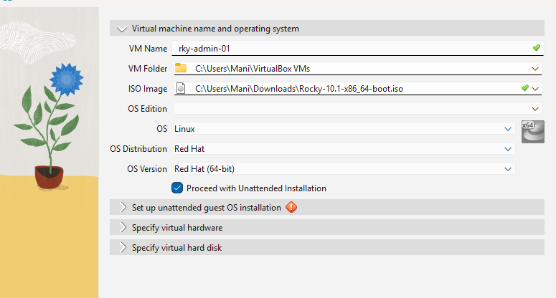

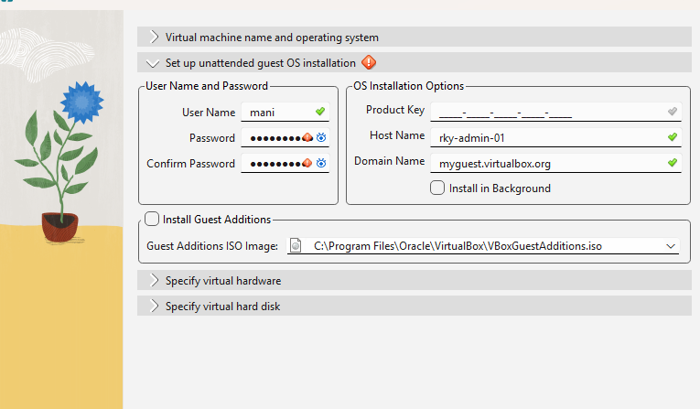

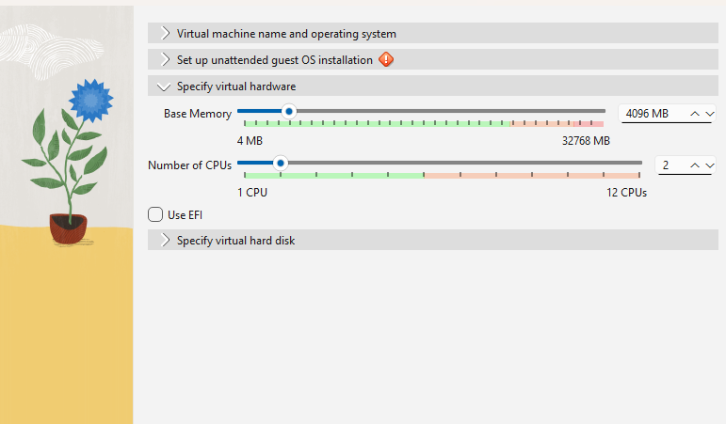

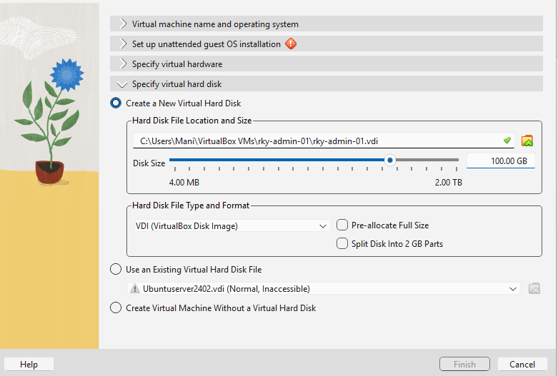

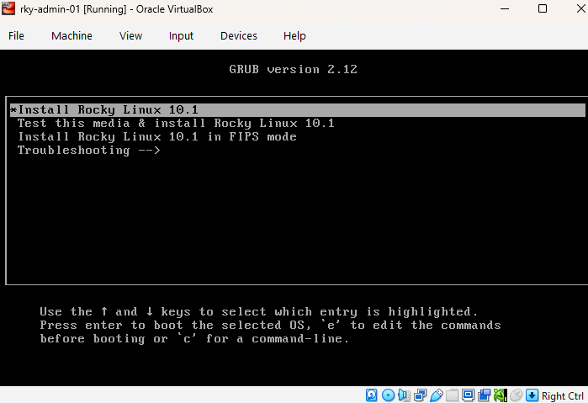

During Installation Steps:
- Select Language –English –English India
- Software Selection: Currently Server with GUI
Change to: Minimal Install-click Done
- Network & Hostname: Connected
Hostname: dev-k8s-rockylinux-01
Click Apply =Done
- Root Account- Currently account is disabled
Click Root-enable root
Set strong Password-done
- User Creation: No user will be created
Click user creation: mani
Make as Administrator-Password-Done

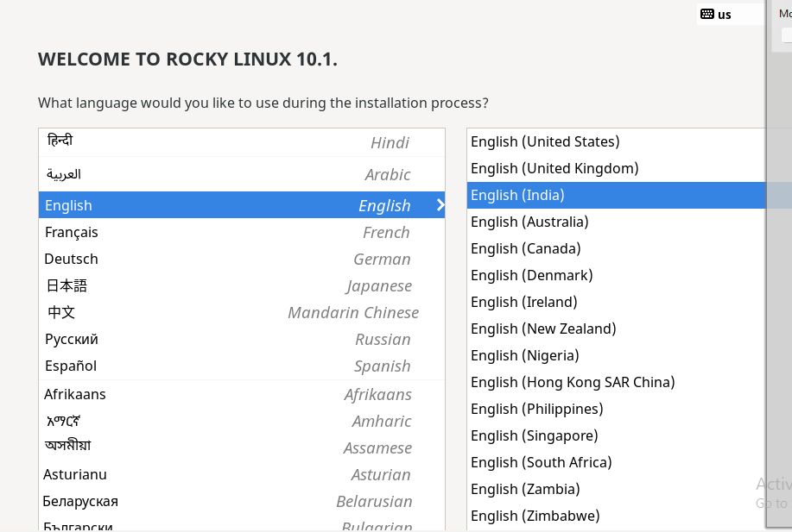

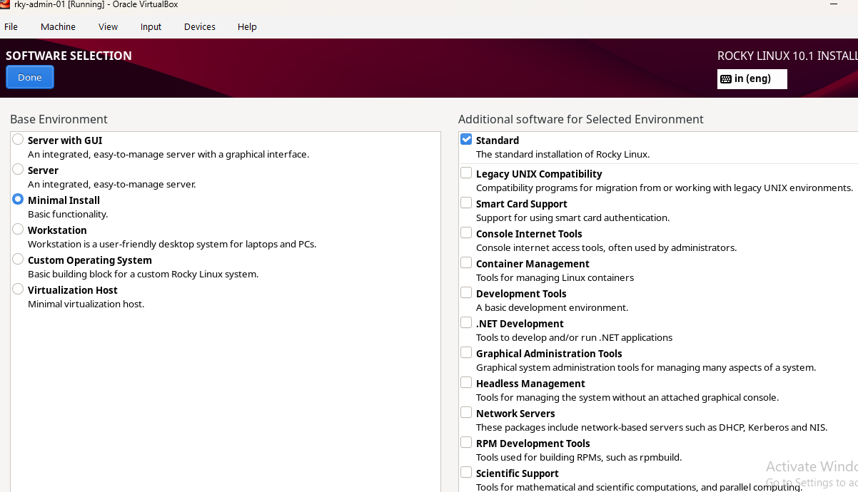

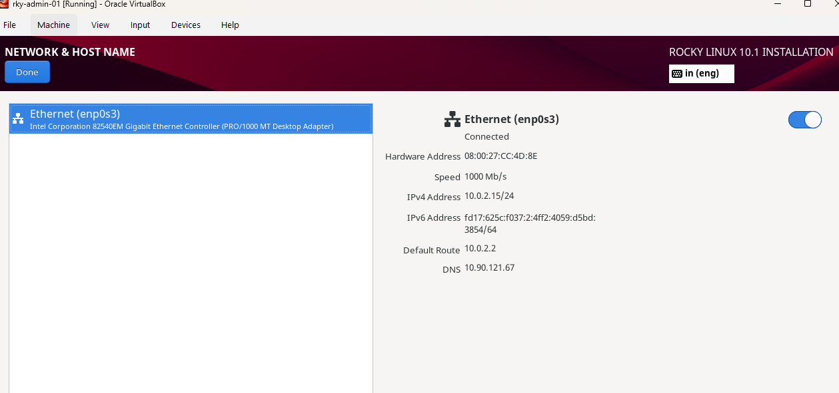

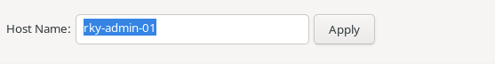
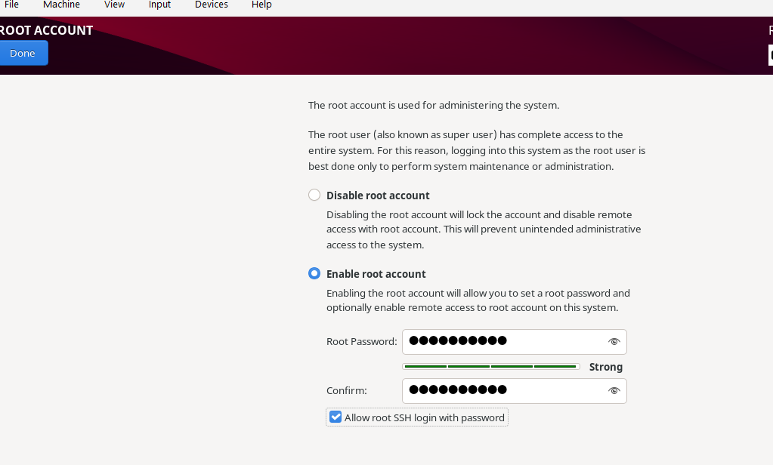

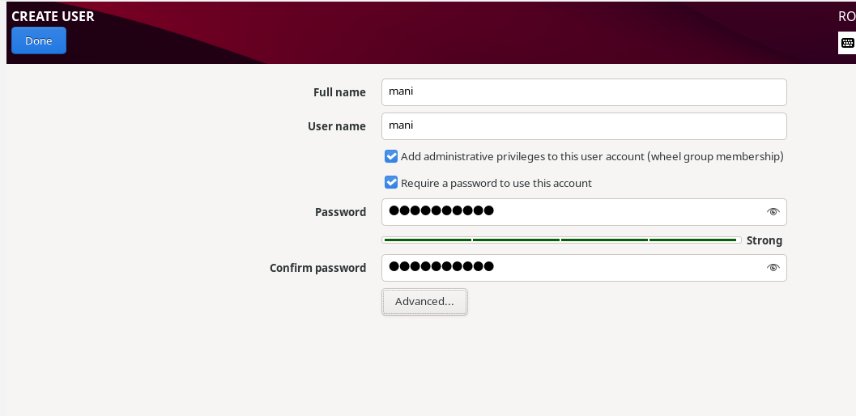

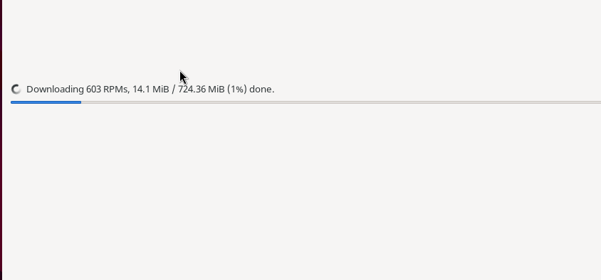

Post Installation VM checks:
1.hostnamectl
2. ip a
3. df-h
4. free –m
5. update : sudo dnf update –y

- Install Ubunut vm – ubu-cli-01
- Virutalbox-new
- Name: dev-k9s-ubuntulinux-01
- Type: Linux
- Version: Ubuntu (64 bit)
- Ram-4096MB
- CPU-2 cores
- Disk-50 GB
- Ubuntu ISO
- Start-install Ubuntu
- Sudo apt update
- Sudo apt upgrade

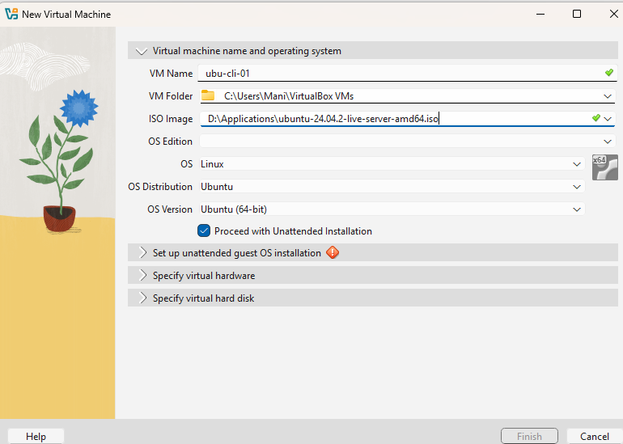

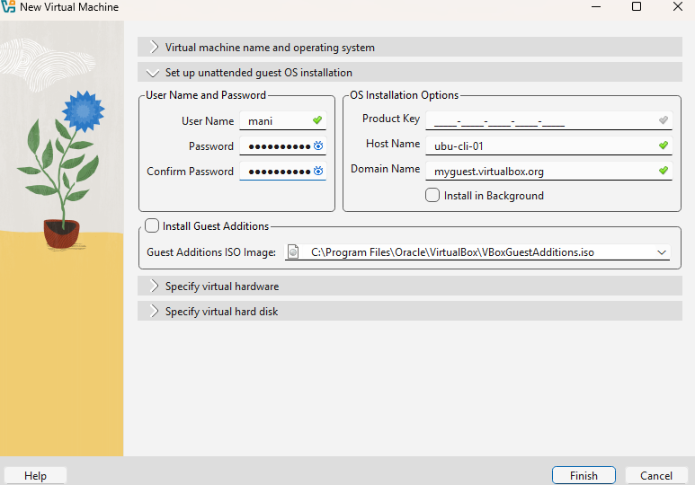

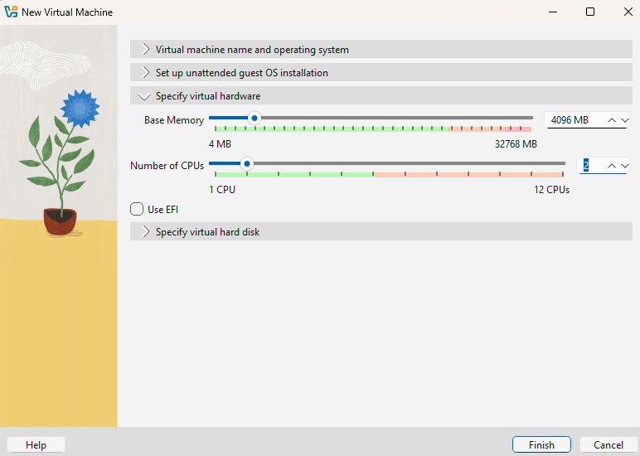

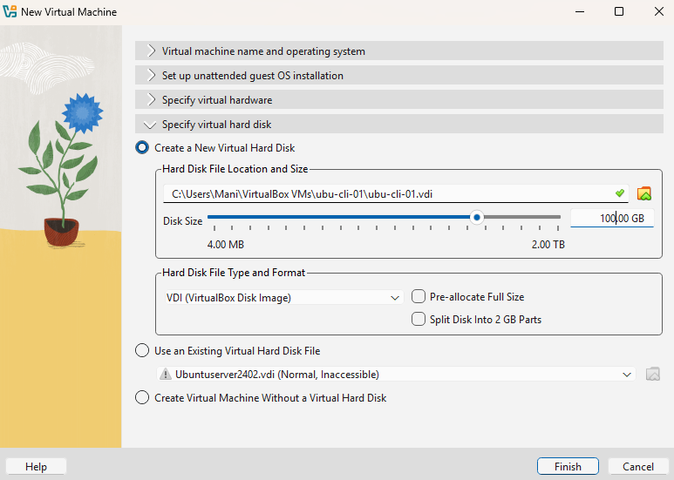

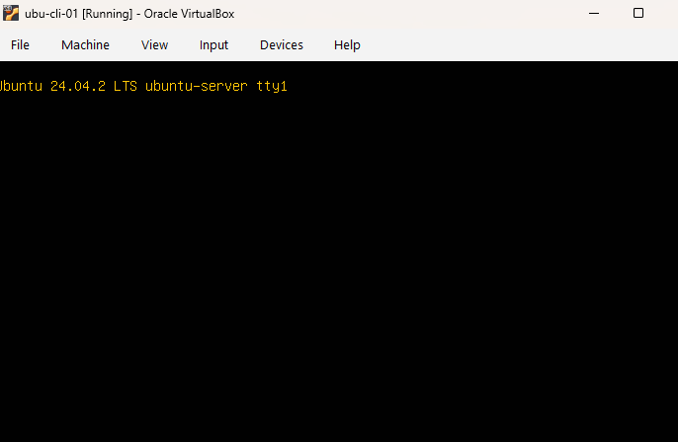

- Sever hostname configuration done
For 1. Dev-k8s-ubuntulinux-01

Command Used : Sudo hostnamectl set-hostname dev-k8s-ubuntulinux-01
To verify command used : hostnamectl

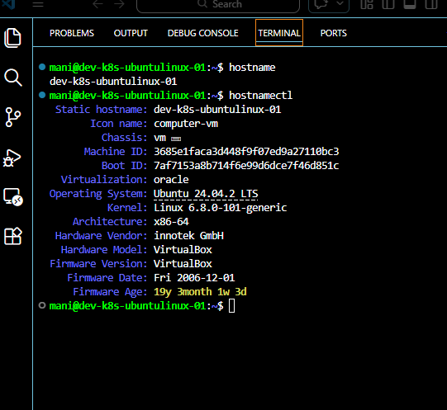

- For dev-k8s-rockylinux -01

Command Used : Sudo hostnamectl set-hostname dev-k8s-rockylinux-01
To verify command used : hostnamectl

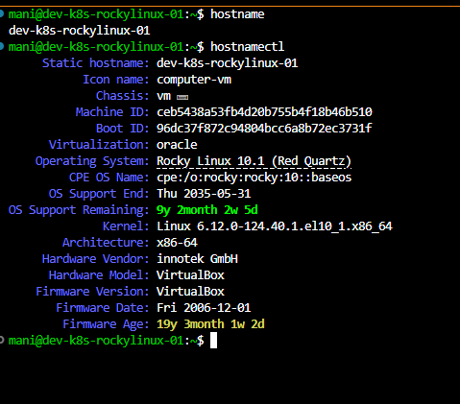

- Network configuration on both vms
Initially while checking I have both vms same ip, 10.0.2.15/24
Cause: Virtual box by default is connected to network mode of NAT

Nat Behavior :
VM- internet works
Host-cannot connect directly

So I have changed the network adapater to : Bridge Adapator.
Now I go the ip address for both vms is
- Dev-k8s-rockylinux-01- ip addresss = ip a= 10.90.121.214/24

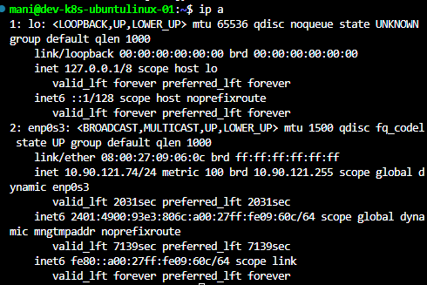

- Dev-k8s-ubuntulinux-01 ip address – ip a = 10.90.121.74/24
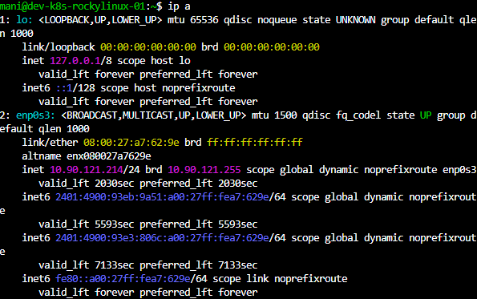

- Time Syncronization

Correct time is ciritical in distributed system.

Time will ensusures:
- Accurate logging
- Authenciation validity
- Certificate validation
- Cluster coordination

To check timedate : command used is : timedatectl

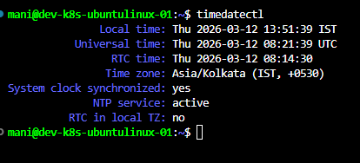

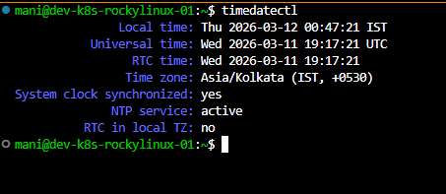

For ntp sync:

We use command : sudo timedatectl set-ntp ture

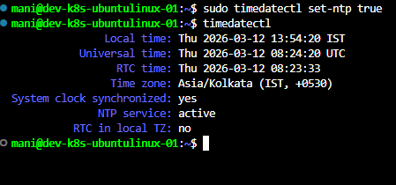

System-timesyncd
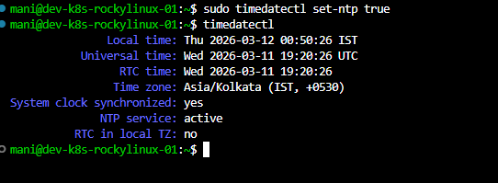

- SSH Remote Access
Linux server are managed by remotely using ssh

- Ssh Provides
. Encyrpted remote login
- Secure file transfer
- Remote command execution

- To install ssh server in Ubuntu:

- Command used : sudo apt install openssh-server
- To start a service : sudo systemctl start ssh
- To enable a service : sudo systemctl enable ssh
- To check status: systemctl status ssh – should be active and running

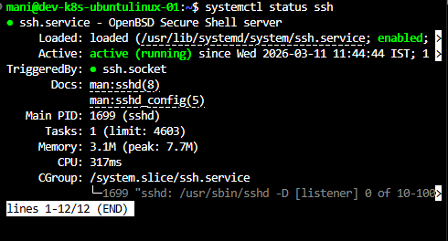

- To install ssh server in rocky linux :
Command used :

- To install – sudo dnf install opensshd-server
- To start a service : sudo systemctl start sshd
- To enable service : sudo systemctl enable sshd
- To check status : systemctl status sshd

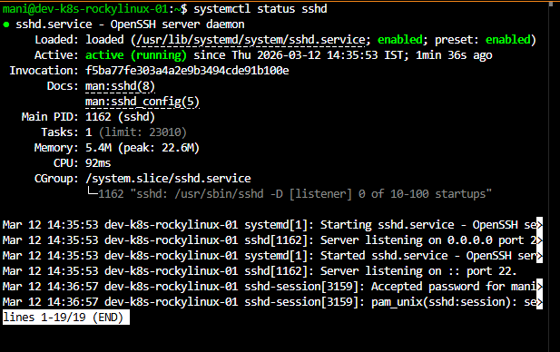

- Remote development using VS code:

I have managed to take remote via visual studio code with remote ssh extension.

Advantages:
- Remote file editing
- Intergrated terminal
- Server management
- Development workflows

SSH configuration files

Ctrl+Shift+P or ~/.ssh/config

Host ubuntu-lab
HostName 10.90.121.74
User mani
Port 22

Host rocky-lab
HostName 10.90.121.214
User mani
Port 22
- Troubleshooting issues Encountered:

Issue 1: Disk not dected
Causes: virtual disk not attached:
Solution: Attach disk in vm settings

Issue 2: same ip address
Causes: nat networking
Solution: Changed to briged adapter

Issue 3: SSH connection failure
Causes: Incorrect ssh configuration
Solution: Correct ssh config

Issue 4: Rocky linux sleep issue
Cause: power management enabled
Solution: Disabled suspended target

Sudo systemctl mask sleep.target suspend.target hibernate.target hybrid-sleep.target

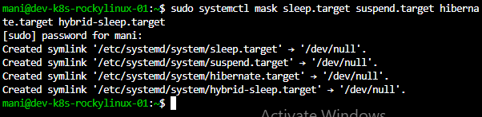

- Day 1 commands revision practice in both Ubuntu and Rocky linux

- Commands: Uname : To show kernel name
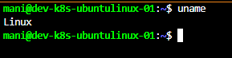

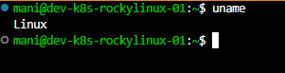

- Command : uname –a : To show all system information

- Command : uname - r : to show kernel version

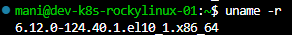

- Command : uname –n : to show hostname
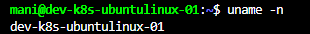
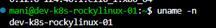

- Command : uname –m : to show cpu architecture

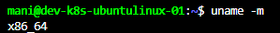

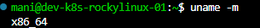

- Command : uname –o : to show operating system

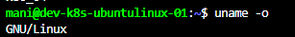
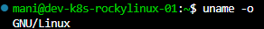
- Command : uname –p : to show processor type

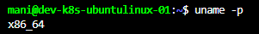

- Command : uname –i : to show hardware platform



- Command : cat /etc/os-release : to check os distribution
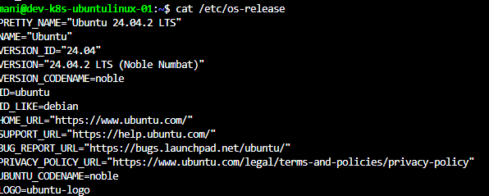

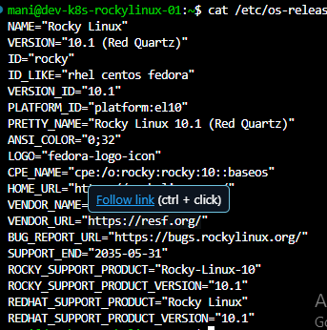

- Command : hostnamectl : to check os info using hostnamectl

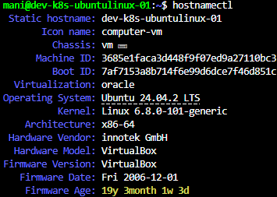

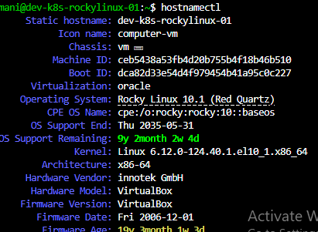

- Command : lsb_release –a : to show linux distribution legacy
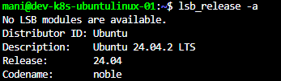

- Command : cat/etc/issue : to check os release file

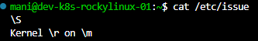

- Command : ip a : to check ip address
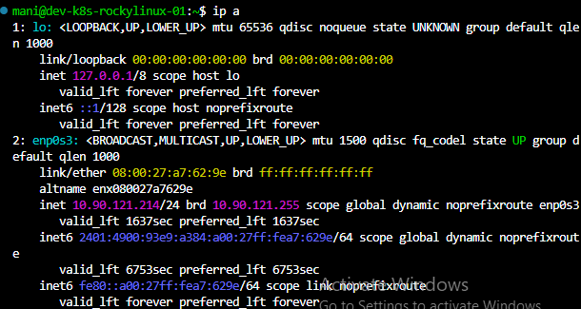

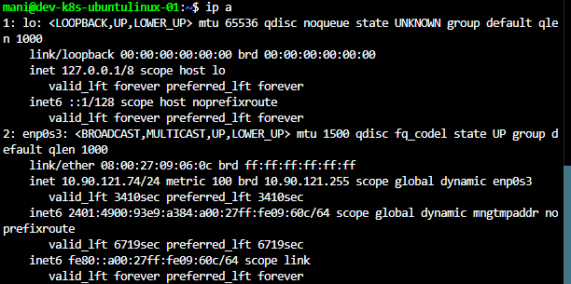

24. command : ip link : to check network interfaces

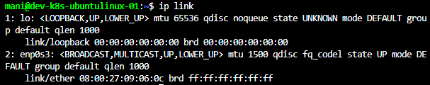

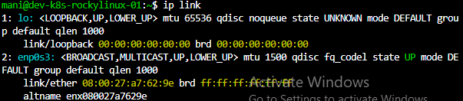

25. Command : ip route : to check routing table

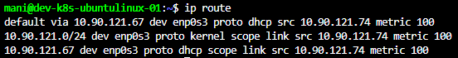

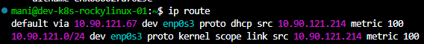

- Command : ip neigh : to check ARP neighbor table
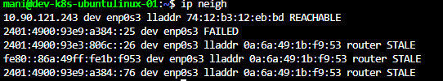

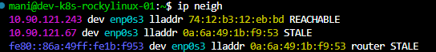

- Command : ip –s link : to Show interface statistics
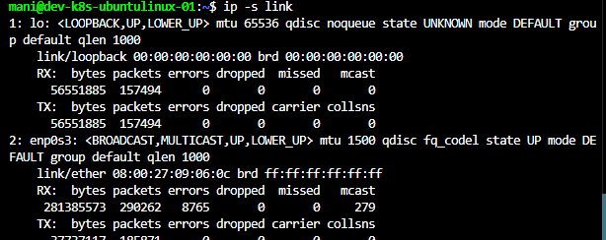

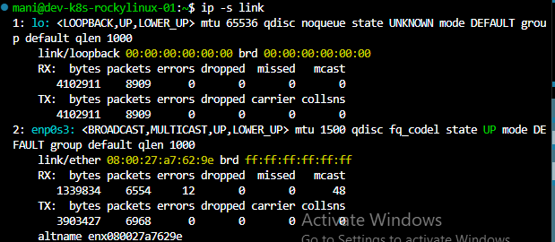

- Command : date : to check date and time
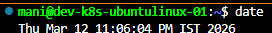

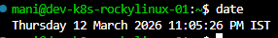

- Command : timedatectl : to show detailed time configuration
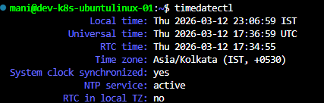

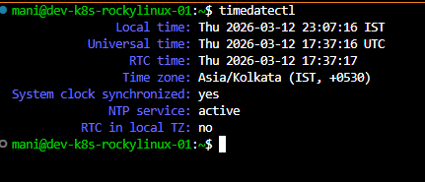

- Command : timedatectl set-ntp true : to enable ntp synchronization
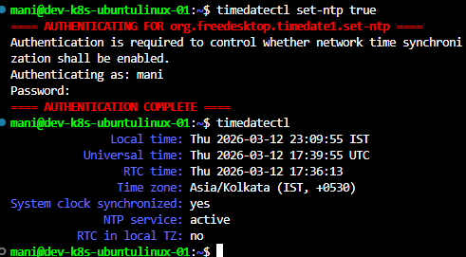

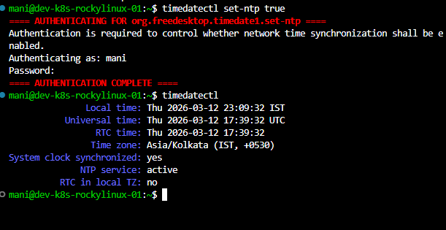

- Command : uptime : to show uptime of system

- Command : systemctl status ssh : to check ssh service
- To install ssh server in Ubuntu:

- Command used : sudo apt install openssh-server
- To start a service : sudo systemctl start ssh
- To enable a service : sudo systemctl enable ssh
- To check status: systemctl status ssh – should be active and running



- To install ssh server in rocky linux :
Command used :

- To install – sudo dnf install opensshd-server
- To start a service : sudo systemctl start sshd
- To enable service : sudo systemctl enable sshd
- To check status : systemctl status sshd



- Command : lsblk : to check and show disk devices
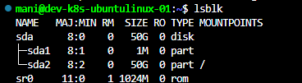

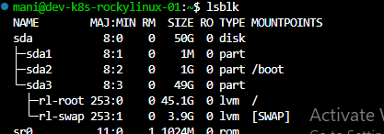

- Command : df –h : show disk usage
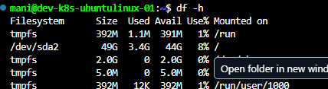

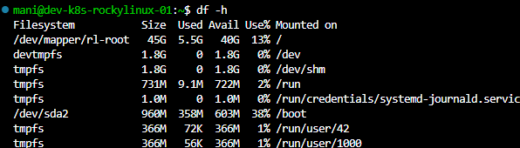

- Command : du –sh : show directory disk usage
