Day 1:

- What is Programming
Giving instructions to computer to perform task

Ex:
- Calculate ill
- Store customer data
- Build websites
- Build API apps

- What is python?
Python is a programming language used for
- Build software
- Build websites
- Build API
- Work with data
- Build AI applications

- Where python is used
- Web development (backend)
- AI and Machine learning
- Automation
- Devops
- Cyber security tools

- Benefits of python
- Easy for beginner
- Less code, more work
- Work with ai libraries

- Python installation
Step 1: open python official website -https://www.python.org
Step 2: Click Downloads
Step 3: Download python latest version
Step 4: python 3.14.amd64.exe will download and open the file
Step 5: ☑ Add Python to PATH
Step 6: install now
Step 7: setup was successful
Step 8: cmd- python –version-you will see latest version installed

- VS code setup + Workspace creation
Step 1: Download vs code-https://code.visualstudio.com
Step 2: Download for windows- download will start
Step 3: click install-next-next-next and ✔ Add to PATH
✔ Add "Open with Code"
✔ Add to right click menu
Step 4: Install and finish
Step 5: open main learning fodler
Step 6: file –open folder-D:\Manikandan Backend Journey
Step 7: Select folder
Step 8: verify folder visible as D:\Manikandan Backend Journey
Inside later we will keep:
- Python files
- Project files
- Notes
- Experiments
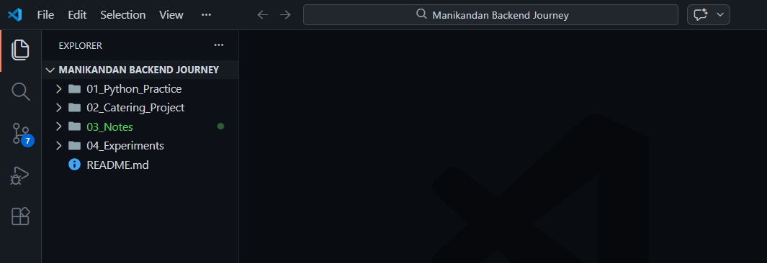

Step 9: Create learning folder structure
From D:\Manikandan Backend Journey create 4 folders as
01_python_Practice
02_Catering_project
03_notes
04_experiments
Step 10: Install python extension
In vs code left side : extension icon (4 small boxes)-search-python-python by Microsoft

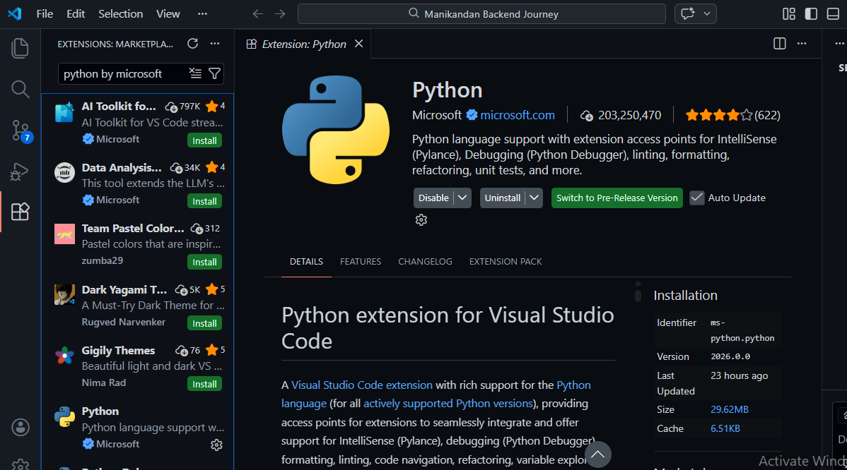

Step 11: open terminal in vs code
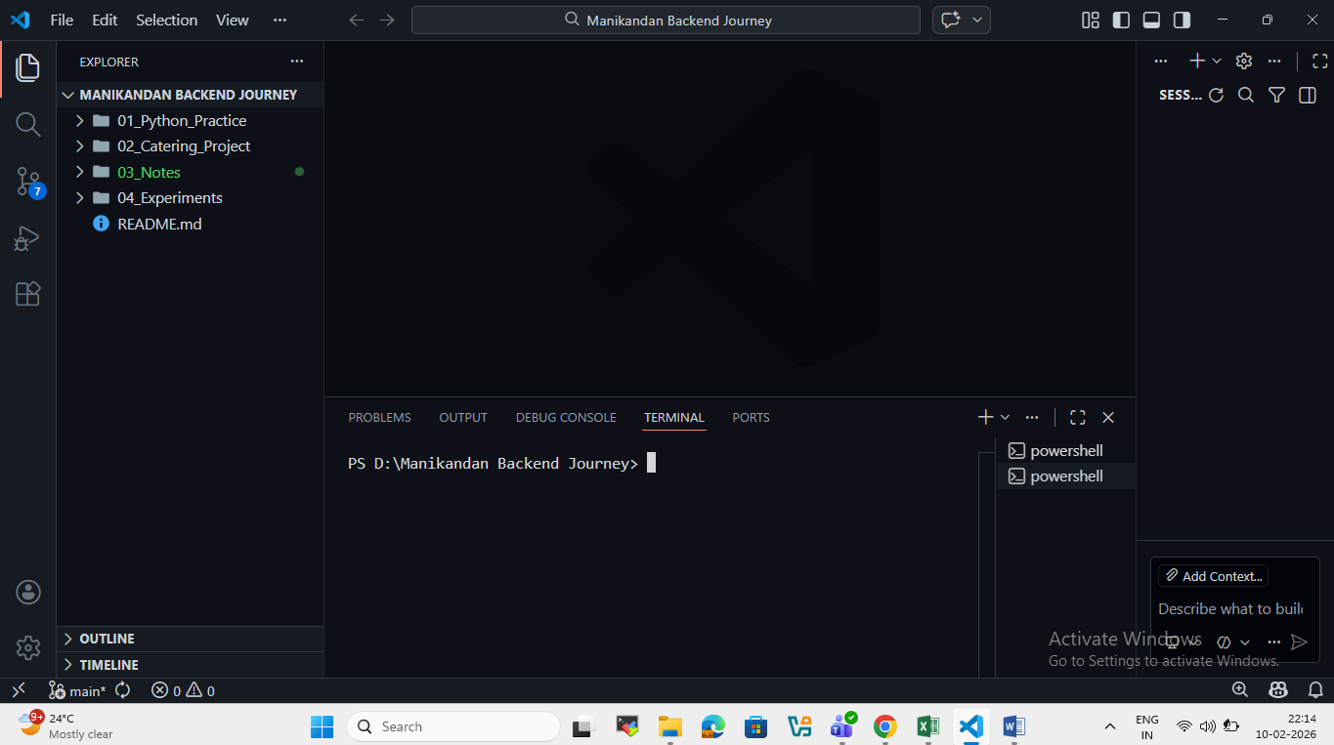

- Create first python file
Step 1: Inside vs code open file: new file-name as – day1_hello.py
Step 2: Inside day1_hello.py type below
print("Hello World")
print("My Name is Manikandan")
print("Day 1 of Python Start")

Step 3: save
Step 4: run python program
Run python file : in terminal

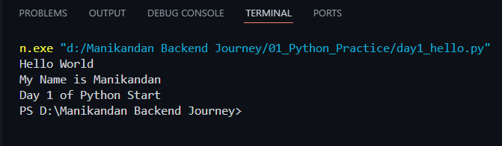

- What is a .py file?
A .py file is a python program file
Ex: day1_hello.py
- Here: ** day1_hello –file name
- .py-tells system this is a python file

- Why we create .py file?
Because:
- Python code must be saved somewhere
- Computer run code form this file
Process Is Write code → Save in .py → Run it

- What is print () in python:
Print() is most basic command in python
Purpose: show output on the screen

print("Hello World")-input
Hello World-output

- How program runs behind:
- Python read file: day1 _hello.py
- Reads line by line
- Execute each print ()
- Show output in terminal

- Connect by local project to github and upload code
Step1: Check git installed –git –version (purpose- confirm git installed in system )

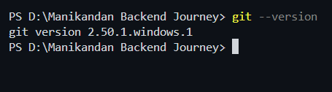

Step 2: get init (purpose: Start tracking files and convert folder into git project)

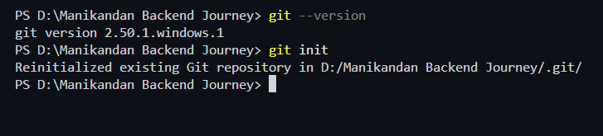

Step 3: Create github repository
in browser : github -https://github.com/manikandangopi
Create repo-new- https://github.com/manikandangopi/manikandan-backend-journey

Step 4: Connect local folder to github : (purpose ) link local project to github

Command --- git remote add origin https://github.com/manikandangopi/manikandan-backend-journey.git

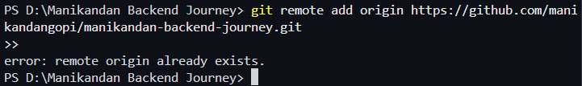

Git add .
Meaning : add all files in folder (. Dot) is important
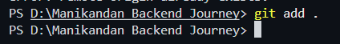

Step 5: First commit :

Command : git commit -m "Day 1: Python journey started"
Purpose: save current version of code
Meaning : taking a snapshot
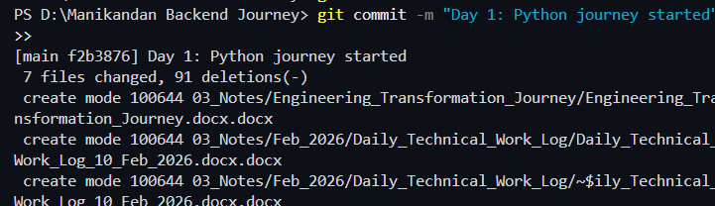

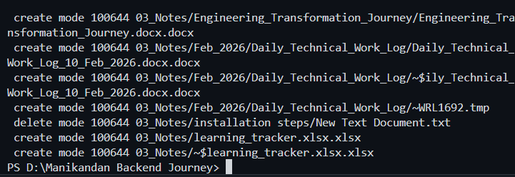

Git pull before bush: command git pull origin main --allow-unrelated-histories
Meaning : combine local files +Github files
Learning: Sometimes need to pull befor push

Step 6: final push
Command: git push -u origin main
Meaning: files uploaded successfully
Github connected

