**Implementation of Odoo Version 11.0 at SODANCA**

**FUNCTIONAL SPECIFICATION DOCUMENT**

|  |  |
| --- | --- |
| **#** | **Details** |
| 1 | Customer Payment – Tree View |
| 2 | Customer Payment Form view |
| 3 | Supplier Payment Tree view |
| 4 | Supplier Payment Form view |
| 5 | Restrict users on Accounting Dashboard |

|  |  |  |  |
| --- | --- | --- | --- |
| **Document Number** | **Date** | **Prepared by** | **Approved By** |
| Sodanca_0001 | 11-Jun-2018 | Ms. Kiruthika (Itara) | Ms. Fabiana |

Version Details

|  |  |  |
| --- | --- | --- |
| Document Number | Date | Version Details |
| Sodanca_0001 | 11-Jun-2018 | Ver_1.0 |
|  |  |  |
|  |  |  |
|  |  |  |
|  |  |  |

# Customer Payments – Tree View

The below mentioned details are the current fields in the Payment menu in Odoo Version 11.0 enterprise:

**Menu Details**

* Menu > Accounting > Sales > Payment

**Tree View – Currently in Odoo 11.o Enterprise:**

|  |  |  |  |  |  |  |
| --- | --- | --- | --- | --- | --- | --- |
| Payment Date | Name | Payment Journal | Payment Method Type | Customer | Payment Amount | Status |

**Customization Details:**

The tree view has to be customized to the layout / details as mentioned in the below columns:

|  |  |  |  |  |  |  |
| --- | --- | --- | --- | --- | --- | --- |
| Payment Date | Number | Reference | Partner | Journal | Total | Status |

* + 1. **Fields to be Renamed:**
    - Name > Number
    - Memo >Reference
    - Customer > Partner
    - Payment Journal > Journal
    - Payment Amount > Total
    1. **Fields to be Removed from list view**
    - Payment Method Type
    - Company

# Customer Payments – Form View

The customization has to be carried out based on the form view as per the Version 7.0 of Sodanca

**Need information from Sodanca for the customized fields**

The below mentioned details are the current fields in the Payment menu in Odoo Version 11.0 enterprise:

**Menu Details**

* Menu > Accounting > Sales > Payment

Current:

The below mentioned screen shot is the form view of Odoo Enterprise version 11.0

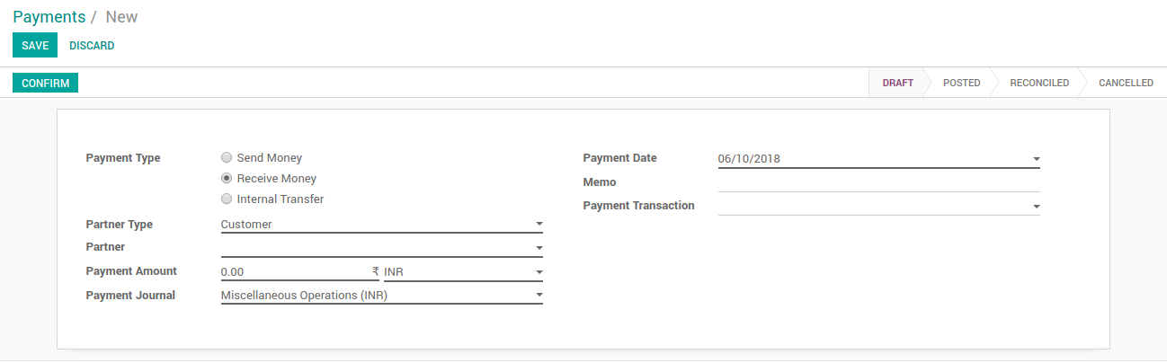

Customization:

**Need information from Sodanca**

# Supplier Payments – Tree View

The below mentioned details are the current fields in the Payment menu in Odoo Version 11.0 enterprise:

**Menu Details**

* Menu > Accounting > Purchase > Payment

**Tree View – Currently in Odoo 11.o Enterprise:**

Current:

|  |  |  |  |  |  |  |
| --- | --- | --- | --- | --- | --- | --- |
| Payment Date | Name | Payment Journal | Payment Method Type | Vendor | Payment Amount | Status |

Customization Details:

The tree view has to be customized to the layout / details as mentioned in the below columns:

|  |  |  |  |  |  |  |
| --- | --- | --- | --- | --- | --- | --- |
| Payment Date | Number | Reference | Partner | Journal | Total | Status |

* + 1. **Fields to be Renamed:**
* Name > Number
  + - Memo >Reference
* Vendor > Partner
* Payment Journal > Journal
* Payment Amount > Total
  + 1. **Fields to be Removed from list view**
* Payment Method Type
* Company

# Supplier Payments –Form View

The customization has to be carried out based on the form view as per the Version 7.0 of Sodanca

**Need information from Sodanca for the customized fields**

The below mentioned details are the current fields in the Payment menu in Odoo Version 11.0 enterprise:

**Menu Details**

* Menu > Accounting > Purchase> Payment

Current:

The below mentioned screen shot is the form view of Odoo Enterprise version 11.0

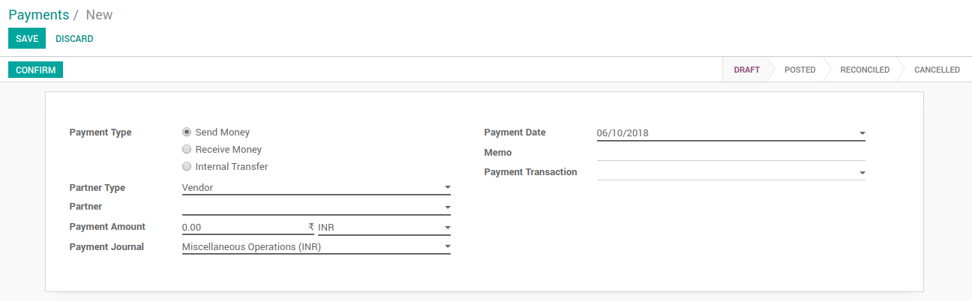

New:

**Need information from Sodanca**

# Accounting Dashboard

**Requirement:**

In version 7 when you click on the accounting module, the system lands on the customer invoice tree view. In version 11, it takes you to an accounting dashboard.

We need to eliminate the accounting dashboard or at least block almost all users from viewing it as the dashboard contains confidential information. It would best for the system to emulate version 7 and have the landing page for the accounting module be the tree view of the customer invoice.

**Solution:**

* Create a Group to access Accounting Dashboard.
* The list of user in that particular hat group can able to see the menu as mentioned below

**Menu Details:**

**Accounting > Dashboard** menu.

**Technical Information:**

1. **Group to be added:**
   * + - * Accounting Dashboard Controller
2. **Access Rights to be modified**
   * + - * Dashboard should be visible to the Accounting Dashboard Controller group users