**Encryption structure**

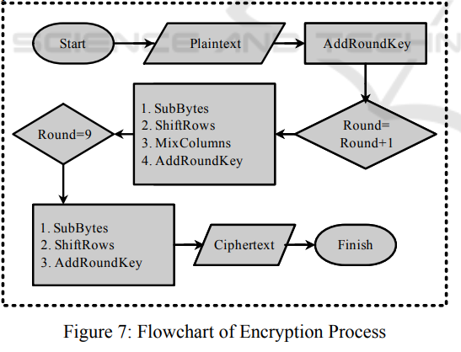

**ALGORITHM**

### **AES-based encryption algorithms**

In this method, multi-step bitwise permutation operations are performed with a round of propagation to obtain better cryptographic results. The main purpose of the method introduced in is to design a dynamic S-box to achieve nonlinear properties and low automatic correlation. In this study, they introduced a dynamic sub-key-dependent S-box to overcome the stagnant S-box weaknesses.

In the image encryption by AES, which is a block encryption approach, since the adjacent pixels have high correlation, a shadow of the original image is left in the encrypted image after the encryption. To overcome this problem, in a key stream generator has been introduced in [[12](https://link.springer.com/article/10.1007/s11227-019-02878-7#ref-CR12)]. There are two kinds of the stream generators including the A5/1 and W7 key stream generators. These generators are made of some register shifts and a series of functions, and W7 shows a better encryption performance rather than A5/1.

The chaotic AES encryption algorithm is explained in , in which a chaotic S-box is used which is highly random and sensitive to the initial conditions. Sensitivity to the initial conditions enables the algorithm to use the initial conditions as another key to provide more security and confidentiality.