What is Meteor?
Meteor is a full-stack JavaScript platform for developing modern web and mobile applications. Meteor includes a key set of technologies for building connected-client reactive applications, a build tool, and a curated set of packages from the Node.js and general JavaScript community.
- Meteor allows you to develop in one language, JavaScript, in all environments: application server, web browser, and mobile device.
- Meteor uses data on the wire, meaning the server sends data, not HTML, and the client renders it.
- Meteor embraces the ecosystem, bringing the best parts of the extremely active JavaScript community to you in a careful and considered way.
- Meteor provides full stack reactivity, allowing your UI to seamlessly reflect the true state of the world with minimal development effort.

Meteor resources
- The place to get started with Meteor is the official tutorial.
- Once you are familiar with the basics, the Meteor Guide covers intermediate material on how to use Meteor in a larger scale app.
- Stack Overflow is the best place to ask (and answer!) technical questions. Be sure to add the meteor tag to your question.
- Visit the Meteor discussion forums to announce projects, get help, talk about the community, or discuss changes to core.
- Atmosphere is the repository of community packages designed especially for Meteor.
- Awesome Meteor is a community-curated list of packages and resources.

Meteor Installation Process

Installation
To get you started quickly we want to provide you with a step by step guide of the whole installation process. We are using a plain Ubuntu 13.04 image.
# ----------------
# Lastest version of NodeJS and NPM
# ----------------
sudo apt-get install python-software-properties
sudo apt-add-repository ppa:chris-lea/node.js
sudo apt-get update
sudo apt-get install nodejs

# ----------------
# Meteor, Meteorite and Laika installation
# ----------------
sudo apt-get install curl
curl https://install.meteor.com | /bin/sh
sudo npm install -g meteorite
sudo npm install -g laika

# ----------------
# JSHint, CSSLint
# ----------------
sudo npm install -g jshint
sudo npm install -g csslint

# ----------------
# PhantomJS 1.8.1
# ----------------
cd /usr/local/share/
sudo wget http://phantomjs.googlecode.com/files/phantomjs-1.8.1-linux-x86_64.tar.bz2
sudo tar jxvf phantomjs-1.8.1-linux-x86_64.tar.bz2
sudo ln -s /usr/local/share/phantomjs-1.8.1-linux-x86_64/ /usr/local/share/phantomjs
sudo ln -s /usr/local/share/phantomjs/bin/phantomjs /usr/local/bin/phantomjs

# ----------------
# MongoDB
# ----------------
sudo apt-get install mongodb

# ----------------
# Latest version of Jenkins
# ----------------
wget -q -O - http://pkg.jenkins-ci.org/debian/jenkins-ci.org.key | sudo apt-key add -
sudo sh -c 'echo deb http://pkg.jenkins-ci.org/debian binary/ > /etc/apt/sources.list.d/jenkins.list'
sudo apt-get update
sudo apt-get install jenkins

# ----------------
# Git
# ----------------
sudo apt-get install git

Meteor Project Run Within Jenkins

Open the Jenkins->New Item-> Enter an Item Name(Project name:Meteor-Project)->Ok

Set the configure for Meteor-Project

The Following page will open like this

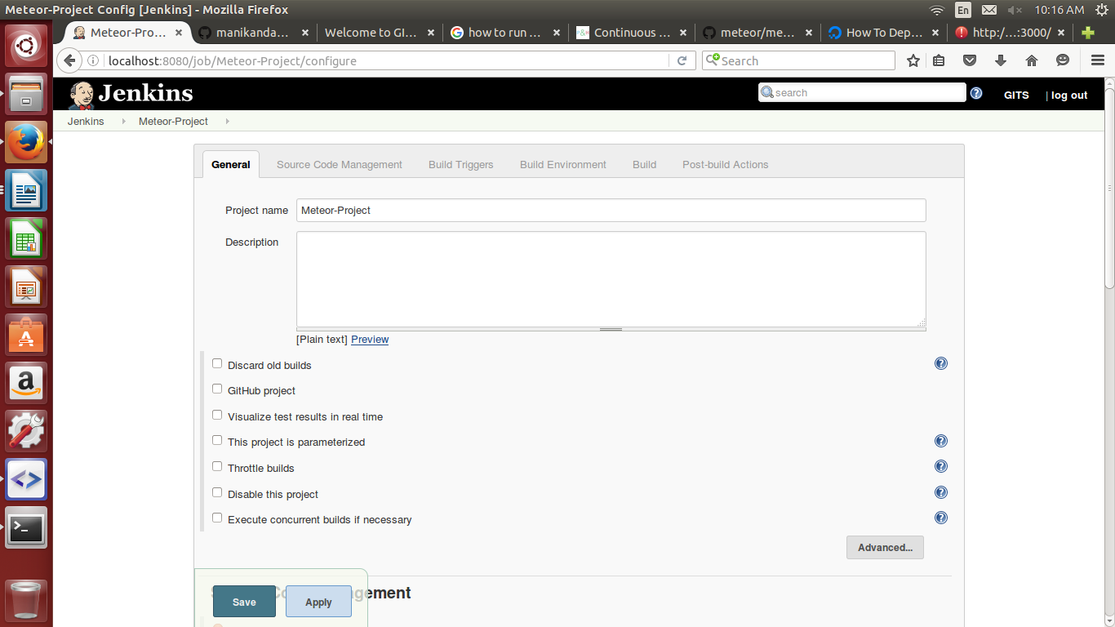

fill the corresponding fields are applicable.

