**Hungry Zone**

**Software Requirements Specification**

Version 1.0

**REVISION HISTORY**

|  |  |  |  |
| --- | --- | --- | --- |
| **Date** | **Version** | **Description** | **Author** |
| 17-05-2013 | 1.0 | Hungry Zone | Manikanta A C |

**Table of Contents**

**1. Introduction**

1.1 Purpose 4

1.2 Scope 4

1.3 Definitions, Acronyms and Abbreviations 5

1.4 References 5

1.5 Technologies used 6

1.6 Overview 6

**2. Overall Description**

2.1 Product perspective 6

2.2 Software Interface 8

2.3 Hardware Interface 8

2.4 Product Function 8

2.5 Architecture Design 9

2.6 Use Case Model Description 10

2.7 Class diagram 11

2.8 Activity Diagram 12

2.9 Sequence Diagram 13

2.10 Database Design

i.ER Diagram 16

ii.Schema diagram 17

2.11 Assumptions and Dependencies 18

**3. Specific Requirements**

3.1 Use Case Reports 18

**Software Requirements Specification**

**1.0 Introduction**

**Hunger Zone**– is a web based platform for ordering any dish online from different restaurants to your door step. Just login and order, and get what you need. Frequently ordering users will get discounts. Ordered dish details will be e-mailed.

**1.1Purpose**

Herewe have provided a facility where visitor can access the required information about restaurant and various dishes according to the categories by logging into the website. Besides this, an additional facility is also provided in the form of email invoicing after an ordering is done. Theusers can also query for the information which is unavailable in the website which is nothing but discussion forum.

1.2 **Scope**

* Create different system users and assign different roles with related permissions.
* Maintain a centralized database to provide security to information which can be accessed only by the admin.
* Rating by the customers on various dishes.
* Supervision of restaurants is carried out by admin.
* All users are authenticated to avail the service.
* Users can login once at the time of ordering or at the home page.
* Facilitate communication between user, admin and restaurants.
* Local language support at user-interface and database level .
* Track all the customers, registered users and their contact details.
  1. **Definitions, Acronyms and Abbreviations**

**Admin** – Administrator (super user), he is the controller of all the employees, users and maintain all records of the users and employees.

**Customers**- He logins and orders the dishes.

**Users** – Registered and non-registered users .

**HTML** – Hypertext Markup Language is to create static websites.

**J2EE** – Java 2 Enterprise Edition is a programming platform and it is the part of the java platform for developing and running distributed java applications.

**UML-** Unified Modeling Language, an object modeling and specification language used in software engineering.

**Spring-** **Spring Framework** is an open source application framework and inversion of control container for the Java platform.

**JMS- Java Message Service** (**JMS**) API is a Java Message Oriented Middleware (MOM) API for sending messages between two or more clients.

**SQL-** is a special-purpose programming language designed for managing data held in a relational database management system (RDBMS).

**XML** - Extensive Markup Language used for data transfer and XML is stored naturally.

**HTTP** – Hypertext transfer protocol is a transaction oriented client/server protocol between web browser and a web server.

**HTTPS** – Secure hypertext transfer protocol is a hypertext transfer protocol over secure socket layer.

**JQuery**- is a multi-browser JavaScript library designed to simplify the client-side scripting of HTML.

* 1. **References**

IEEE SRS format

Project specification requirement.

* 1. **Technologies used**

**UML** – Unified Modeling Language

**XML** – Extensive Mark Up Language

**JMS –** Java Message Service

**JQuery -** JQuery is open source multi-browser JavaScript library designed to simplify the client-side scripting of HTML.

**Spring – Spring Framework** is an open source application framework and inversion of control container for the Java platform.

**SQL – Structure Query Langauge** is a special-purpose programming language designed for managing data held in a relational database management system (RDBMS).

**Hibernate - Hibernate** is an object-relational mapping (ORM) library for the Java language, providing a framework for mapping an object-oriented domain model to a traditional relational database**.**

**J2EE** – Application architecture

**AJAX** – Asynchronous Java script And XML

**1.6 Tools used**

**Eclipse** **-** EclipseIndigo for project development as middle-ware.

**Apache Tomcat –** Web Server 7.0

**MySql** - RDBMS as backend.

**SVN –** Sub Version tool

**1.7 Overview**

SRS includes two sections overall description and specific requirements

Overall description will describe major role of the system components and

interconnections.

Specific requirements will describe roles & functions of the actors.

**2. Overall description**

**2.1 Product perspective**

Hungry Zone, being a web-based platform provides the overall information of different restaurants and various dishes of various categories. One can access the restaurant information from anywhere in the world.

|  |
| --- |
| Web Application  Data Base  Hungry Zone |

**Smart city system diagram**

Hungry Zone is composed of three main components, as illustrated in the above figure. The user interface component handles all of the input or requests from the user. The Web Application deals with retrieving data from the database. Management of the data includes adding, deleting, and modifying restaurants/categories/dishes. The database component stores all of the web link data and status. Hunger Zone system communicates with the Internet to update the web links that are stored in the database.

**2.2 Hardware interface**

|  |  |  |  |  |  |
| --- | --- | --- | --- | --- | --- |
| minimum Hardware requirements:  ***Client Side*** | | | | | |
| ***Internet Explorer6.0 &above, Mozilla Firefox, Chrome*** | ***Processor***  *Pentium III at 500 MHz* | | ***RAM***  *128MB* | | ***Disk Space***  *1 GB* |
|  | |  | |  | |
| ***Server Side*** | | | | | |
| ***Apache Web server v6.1*** | *Pentium IV at 1.3 GHz* | | *512MB* | | *2GB* |
| **MySQL v5.0** | *Pentium IV at 1.3 GHz* | | *512MB* | | *1GB(Excluding data size)* |

**2.3 Software Interface:**

**Client on Internet:** Web Browser, Operating System (any)

**Client on Intranet:** Client Software, Web Browser, Operating System (any)

**Web Server:** Apache Tomcat, Operating System (any)

**Data Base Server:** MySQL, Operating System (any)

**Development End:** RAD (J2EE, Java, Java Bean, Springs, Hibernate Template ), MySQL, Web Server

**2.5 Architecture diagram:**

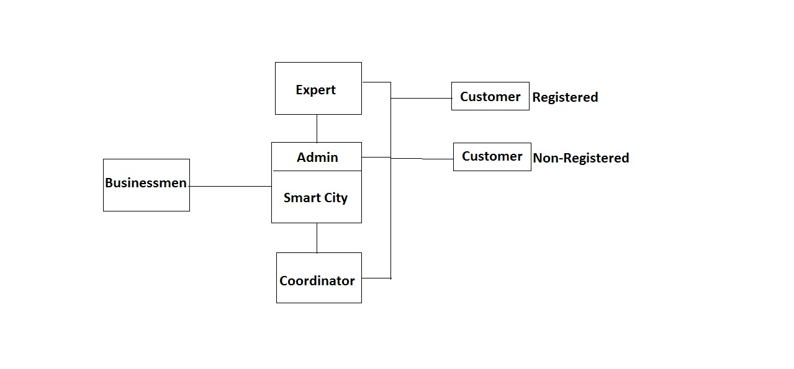

**2.6 Use-case diagram:**

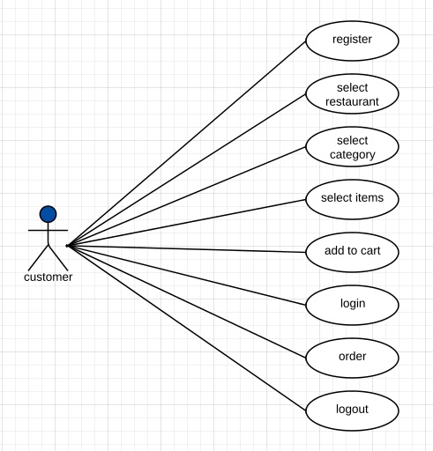

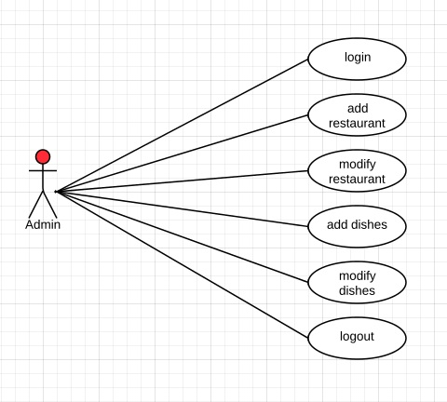

**2.7 Class diagram**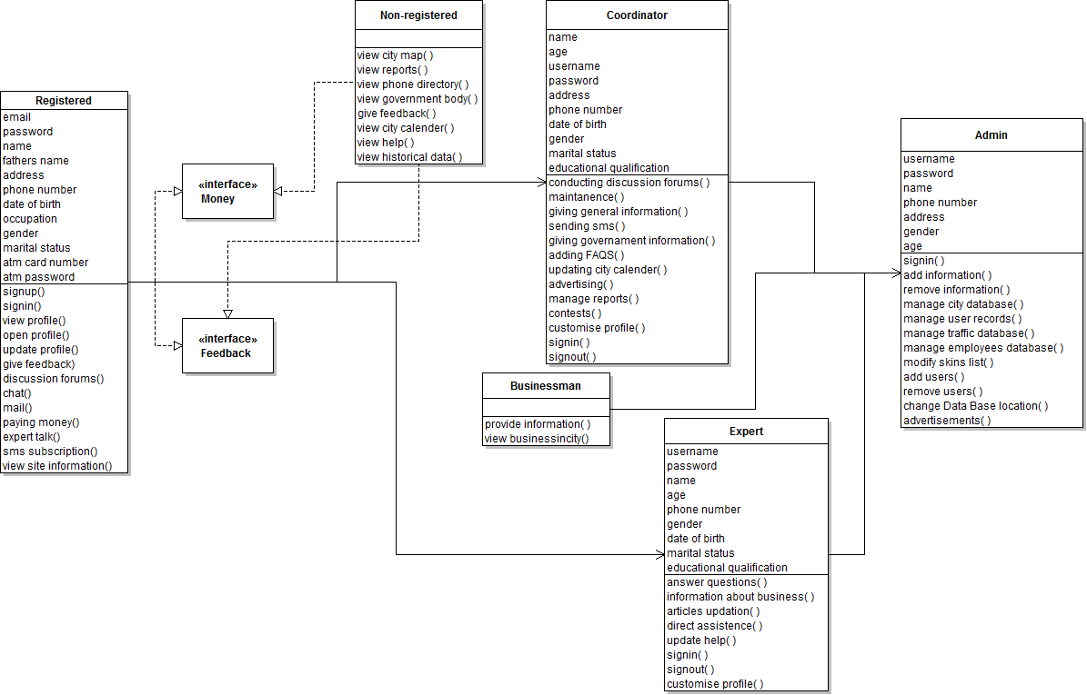

**2.8 Activity diagram:**

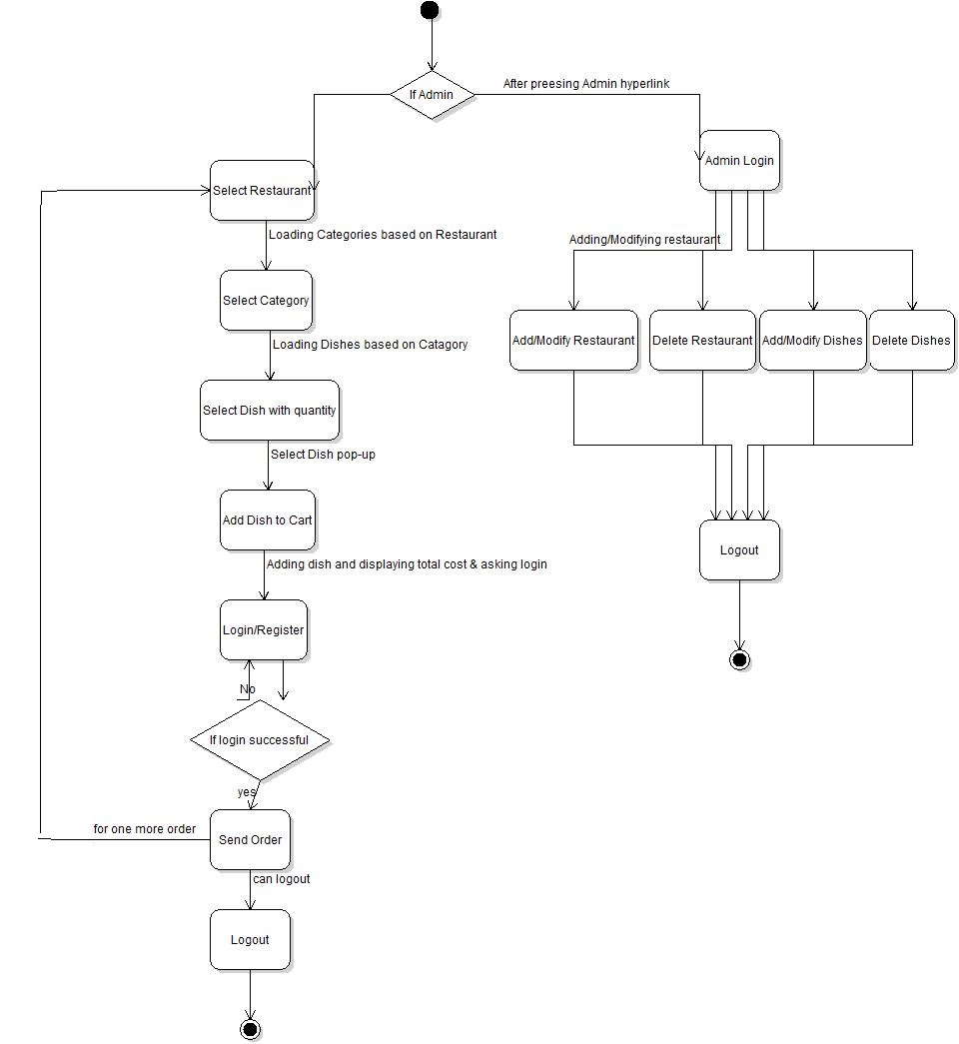

**2.9 Sequence diagram:**

**Case 1:** UnregisteredUser accessing the web site.

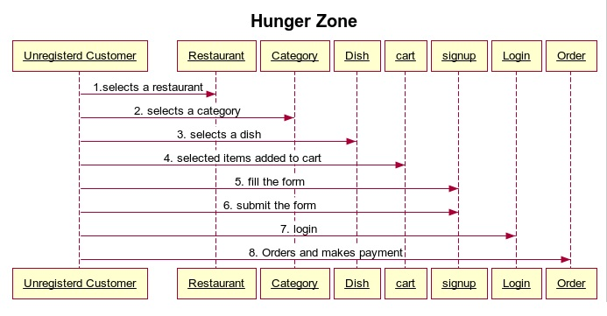

**Case 2:**  Registered User accessing the site.

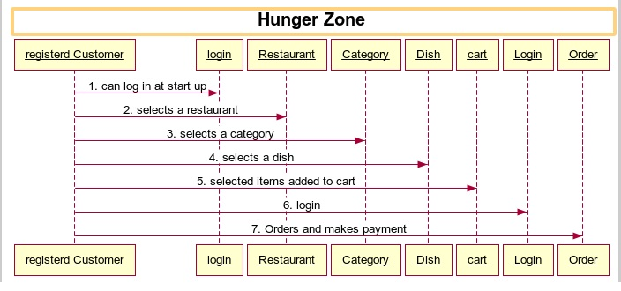

**Case 3:** Admin accessing the site

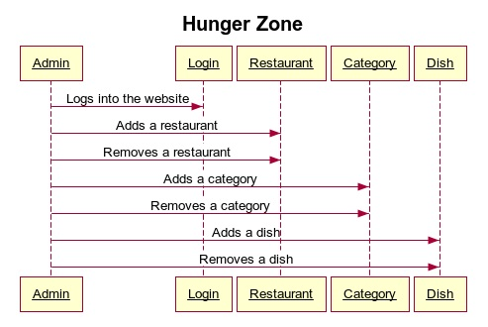

**2.10 Data base design :**

**ii. Schema diagram:**

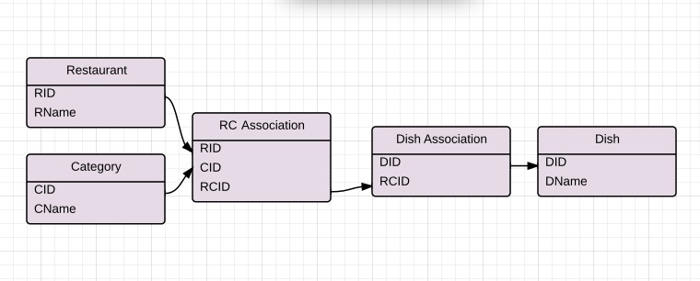

Schema diagram

**i.ER Diagram:**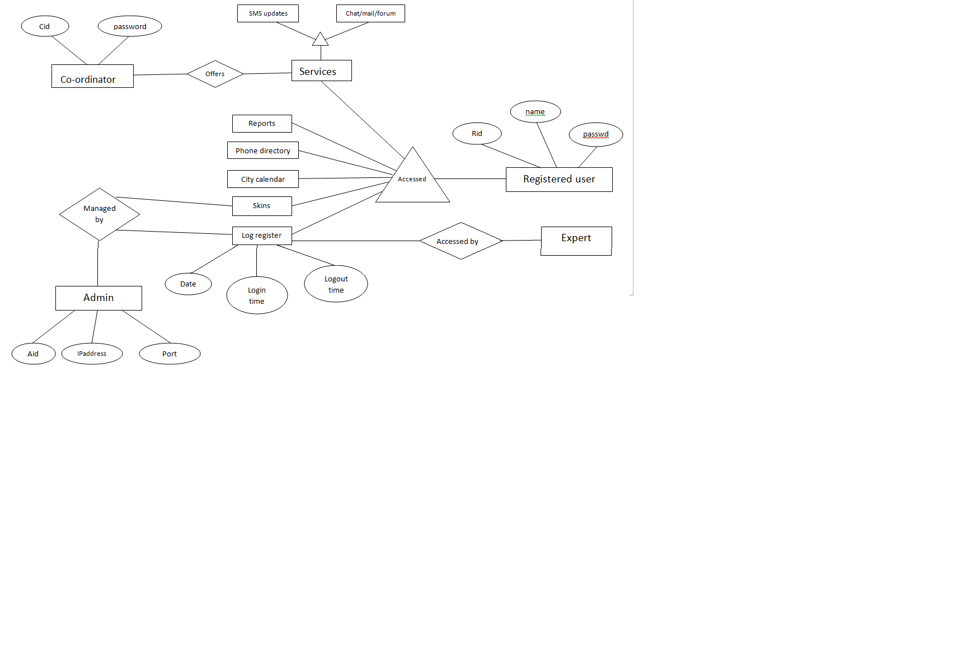

**2.11 Assumptions and dependencies**

* End users should have a basic knowledge of English and Computer usage.
* End user can view the information provided by the site and can update his profile.
* Admin will access at any time.

**3.0 Specific Requirements**

**3.1 Use-case reports**

**Registered user:**

**Sign up**

In order to access the additional services provided in the portal, user must sign up by filling the sign up form and get it approved by admin.

**Sign in**

After getting the username and password, registered users can log on to their account and can access the website.

**Customise profile**

Registered users can personalize their profiles. An additional facility named skins (themes) is also provided for the same.

**Change password**

Registered users can change their password.

**Services payment**

He / She can pay for the services such as SMS/mail/forum. They can subscribe for SMS alerts regarding local news, daily market rates, transport facilities etc.,

**Feedback**

Registered user can give his valuable feedback on this portal.

**Access FAQ’S**

FAQ section is also accessed by this user.

**Non-registered user:**

**Access city-calendar**

Non-registered user can access city calendar. It contains daily events.

**View reports**

This user can view analysis reports areawise, sexwise, city health, business & agriculture growth etc.

**View historical data**

This user can view complete history of the city both socially and politically.

**View citymap**

. Complete Map of the city with key markets and places to see marked, has a privilege to use static map and live Map option.

**Local government body information**

Complete government body information such as government officials details along with their contact information is provided.

**Co-ordinator:**

**Sign up**

In order to communicate with the registered users, co-ordinator must sign up by filling the sign up form and get it approved by admin.

**Sign in**

Co-ordinator can log on to his account and access the website.

**Customise profile**

Co-ordinator can personalize his profile. He can access customizable color schemes, can also change his password.

**Send SMS updates**

Co-ordinator send SMS updates to the subscribed users and can charge accordingly.

**Manage reports**

Co-ordinator manage reports by updating it regularly.

**Add FAQ’s**

FAQ’s are updated by the co-ordinator.

**Manage phone directory**

Co-ordinator manages phone directory which includes emergency numbers along with contact information of government officials.

**Expert:**

**Query response**

Expert responds to the queries posed by the users by giving his valuable suggestions.

**Write articles**

Expert write articles on the current business trends of the city .

**Sign up**

In order to communicate with the registered users, expert must sign up by filling the sign up form and get it approved by admin.

**Sign in**

Expert can log on to his account and access the website.

**Customise profile**

Expert can personalize his profile. He can access customizable color schemes, can also change his password.

**Businessmen:**

**Provide information to admin**

Businessmen provide information to be kept in the site by admin.

**View business in city**

Businessmen can view the city’s business information provided in the portal.

*If needed, businessmen can get registered to access the additional services present in the site.

**Admin:**

**Verify details**

Admin authenticates all the registered users and site officials by checking their username and password.

**Provides login account**

After getting the sign up details from the end user, Admin provides the username and password to the registered user that should be kept for future login and also admin checks for uniqueness.

**Maintains database**

Admin maintains the entire database and he is the only authorized person for maintenance.

**Add/Remove users**

Admin add and remove the users.

**Modify skins**

Admin modify and update various colour schemes(skins).

**Manage portal traffic**

Admin manages the traffic on portal. That is, number of users currently logged into the site can be known.

**Organise advertisements**

Admin advertise for other businesses in this portal and charges accordingly.

**Sign in**

Admin can log into his account and maintains log files.

**Customise profile**

Admin personalizes his account which is authenticated.