**Assisted Practice: 3.1 Components**

This lab has three subsections, namely:

1.Creating a new project

2. Creating Angular components

**Step 1:** Creating a new project

* Create a new project using the command:

*ng new angular-app*

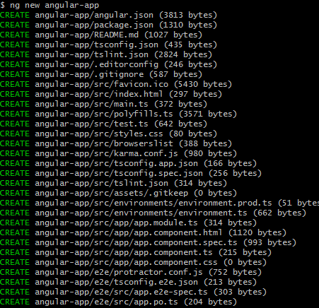

* Move the code to the application folder and start the server.

*cd angular-app*

*ng serve*

**Step 2:** Creating Angular components

* Open Visual Studio Code
* Navigate to the created angular-app project folder.

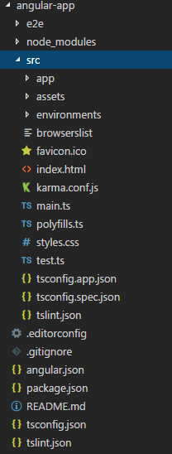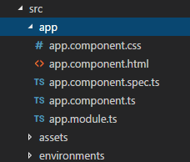

* Add the following code in *app.module.ts*.

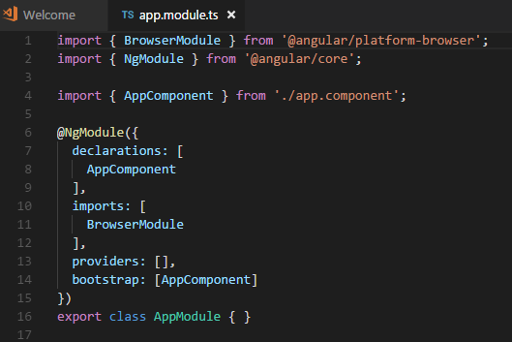

* Create a folder called *products* inside the *src/app* folder.
* Create a *product-list.component.html* file in the *products* folder.
* Add the following code to *product-list.component.html*.

*<h1> Product List Page </h1>*

* Create a file called *product-list.component.ts*.

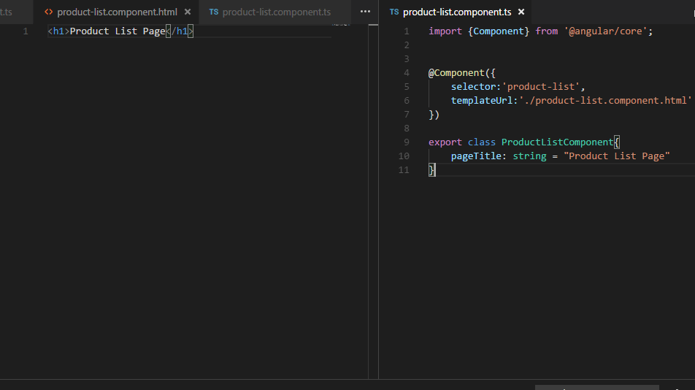

* Add the following code in *app.module.ts*.

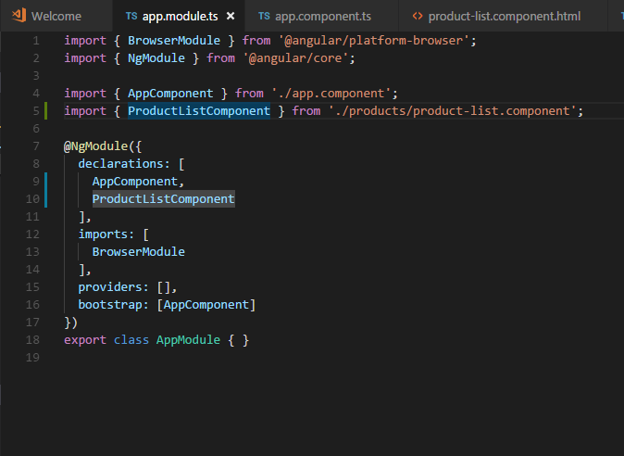

* Add the following code in *app.component.ts*.

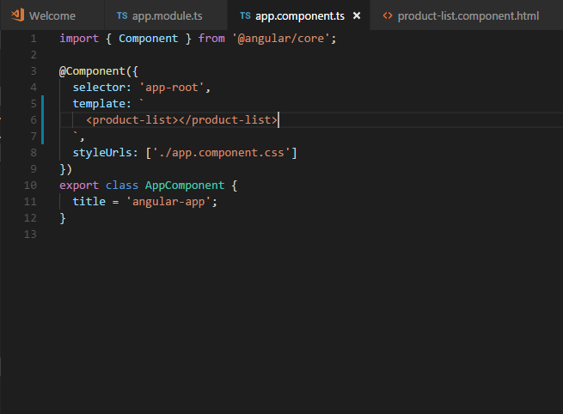

* By saving the above changes and starting the server, you will be able to see the following screen:

