VisionAI Studio - Project Proposal

1. Executive Summary
VisionAI Studio is an AI-powered web platform built with Django that combines conversational AI, image generation, image editing, and professional image conversion (TIFF/BMP/PNG/JPG/WebP) into a single application.

2. Objectives
- AI Chat Assistant
- Text-to-Image Generation
- Image Editing
- TIFF/BMP Conversion
- User Gallery
- History & Downloads
- Admin Dashboard

3. System Architecture
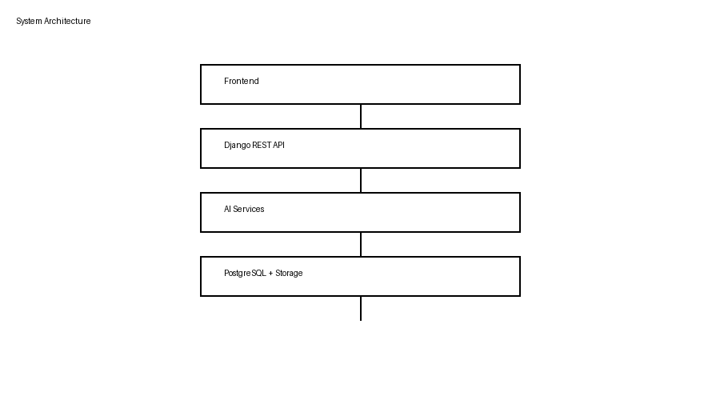

4. Workflow
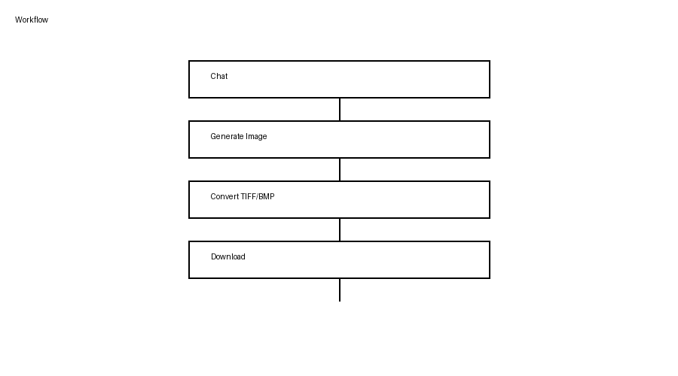

5. Technology Stack
Layer | Technology
Frontend | React/Vite
Backend | Django + DRF
Database | PostgreSQL
AI | GPT Image/FLUX/SDXL
Processing | Pillow/OpenCV
Queue | Redis/Celery

6. Django Apps
accounts, chatbot, image_generator, image_converter, image_editor, gallery, history, dashboard

7. Database
Users, ChatSession, ChatMessage, GeneratedImage, ConvertedImage, PromptHistory, DownloadHistory, ApiLog.

8. Future Scope
OCR, Batch Processing, Video Generation, API Marketplace, Subscription Plans, S3 Storage, Kubernetes Deployment.

