Configure Git Repository

Step 1: **Right Click** on the Project Name and Select **Team >> Share Project**

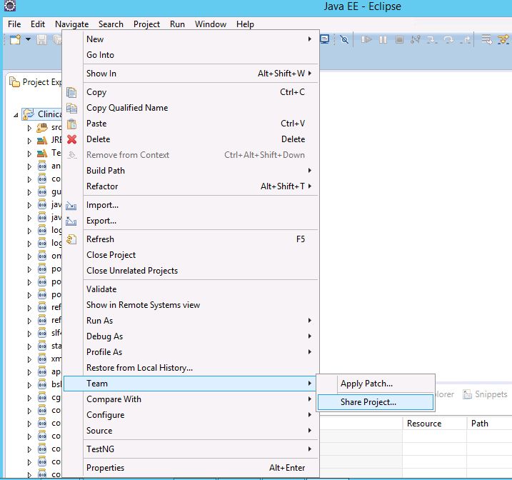

Step 2: Create new Git repository and Click Finish button. (say) “LocalClinicalLibrary”.

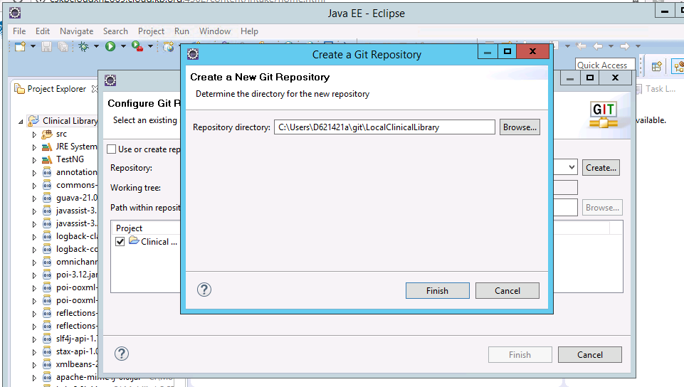

Step3: Click Finish button.

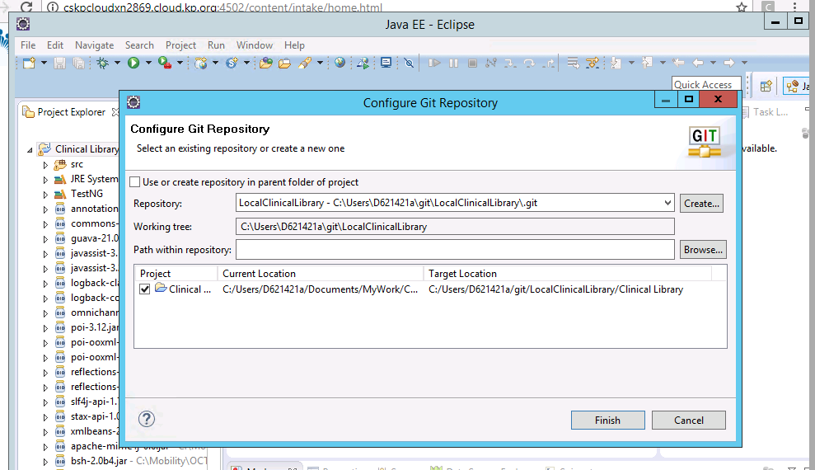

**Step 4**: If **Git Repositories** section is not there on the UI then Go to **Window >> Show View >> Other…**

Select **Git Repositories** and **Git Staging** and **Click OK.**

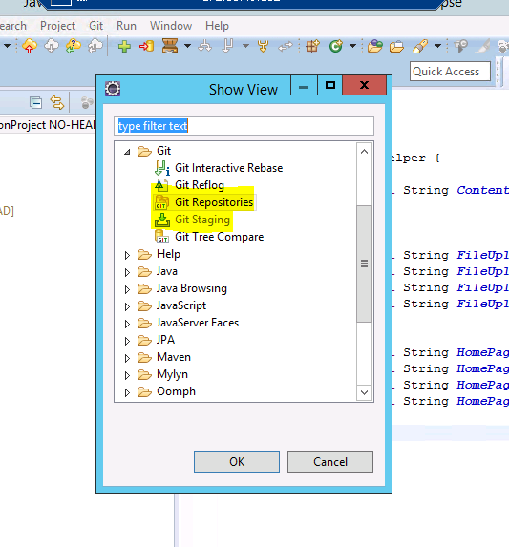

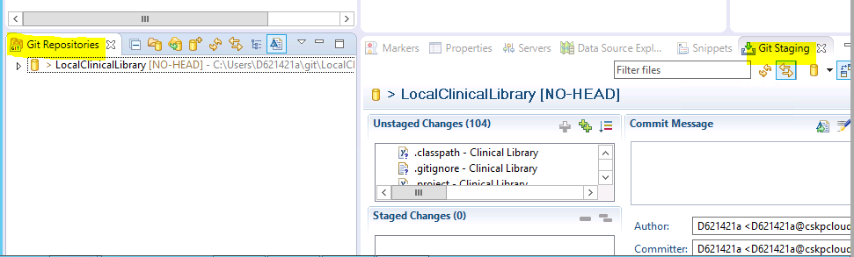

**Step 5:** **Right-Click** on the Project name or Package Names and Select **Team >> Add to Index.**

**Use Team >> Remove from Index** option to remove any file from commit.

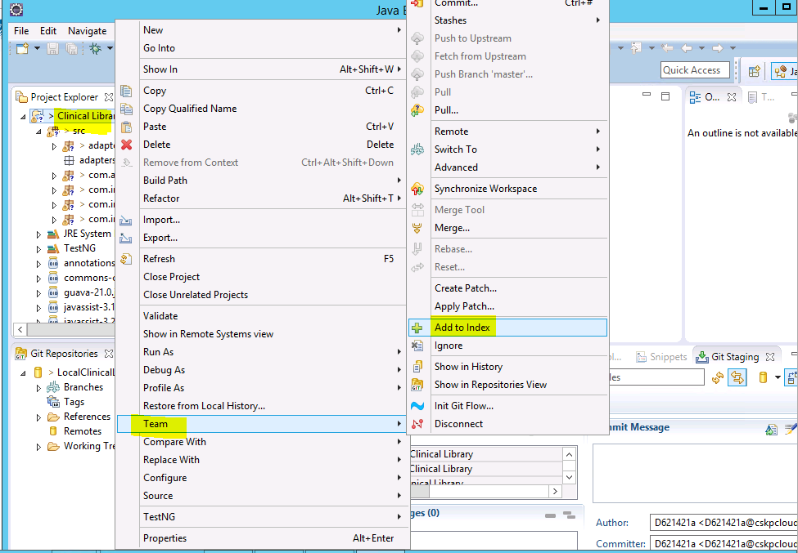

Step 6: Notice the Git-Staging section.

Click Commit.

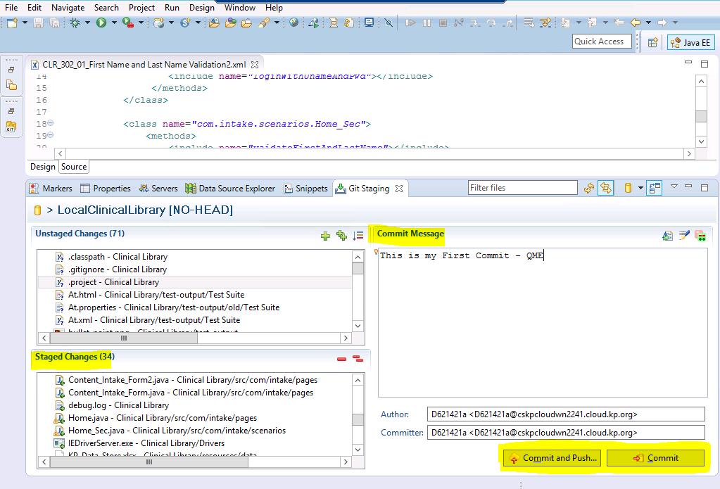

Step 7: Right Click on the Remotes and click OK.

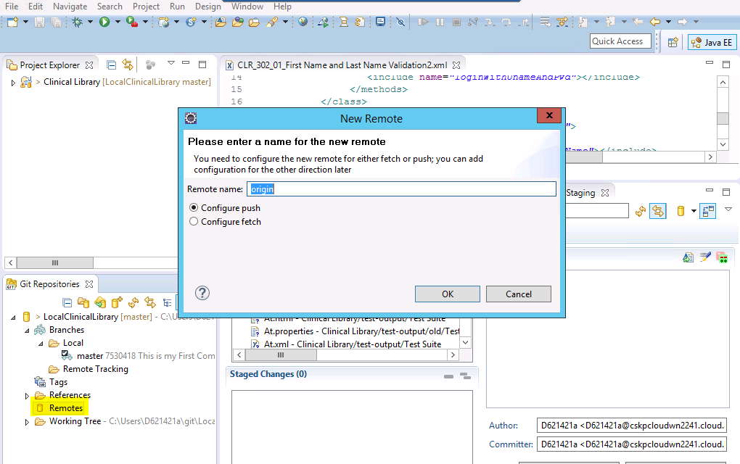

Step 8: Click **Change** to select URI.

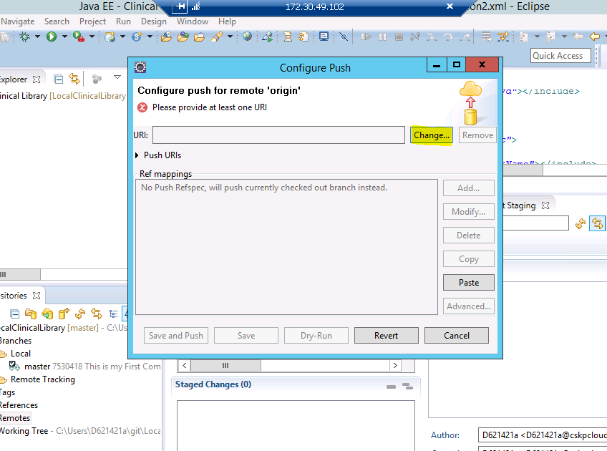

Step 9: Provide URI (Bit Bucket – URI) and all other fields will be auto filled.

Provide your Bitbucket credentials and Click Finish Button.

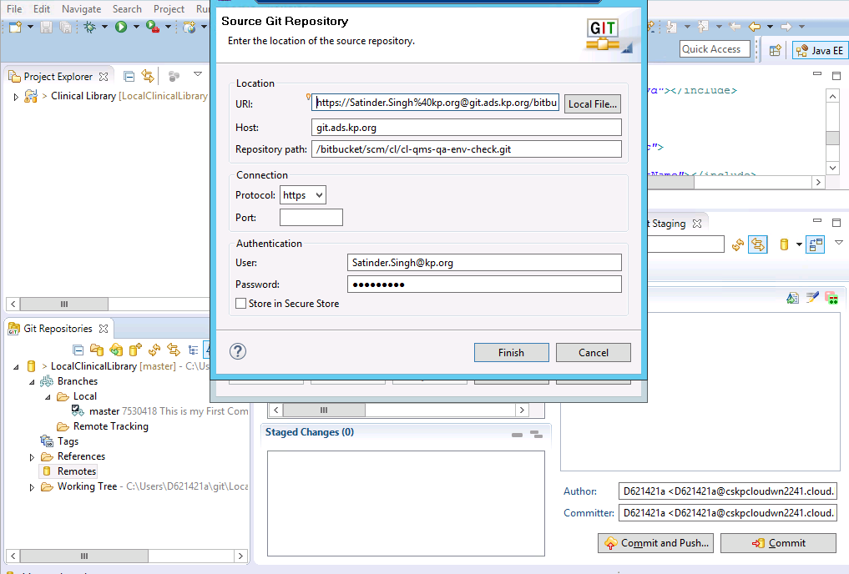

Step 10: Click on Advanced Button.

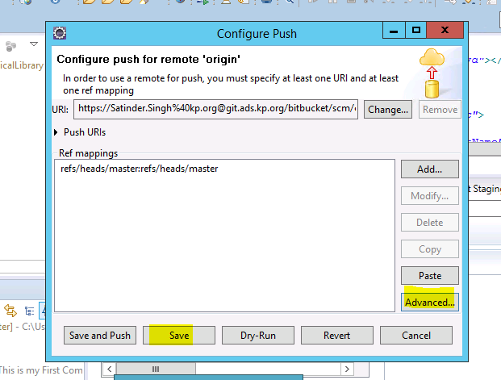

Fill Source ref and Destination ref and click add Spec button

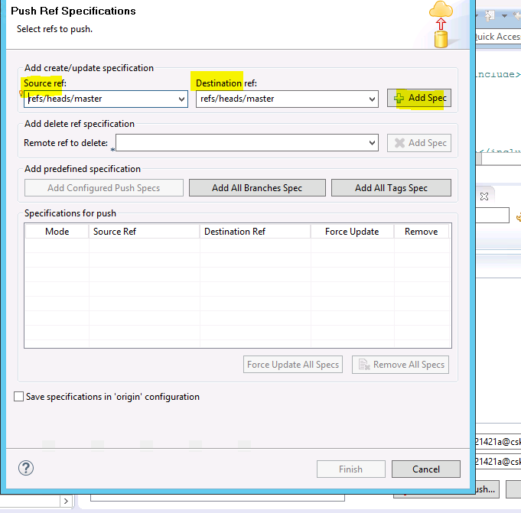

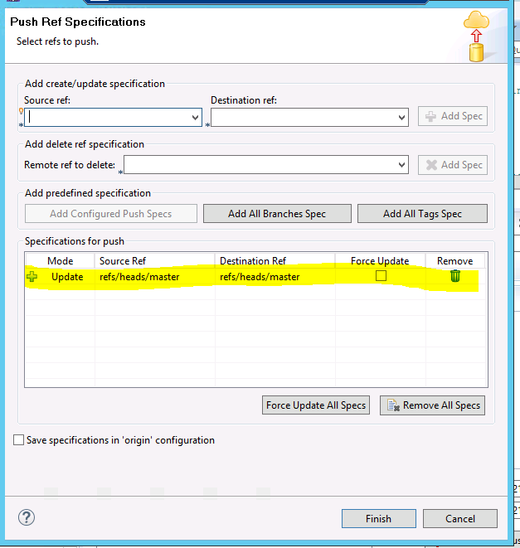

Click Finish Button.



Click Save Button.

Step 11: Right Click on the Remotes >> Origin and Select Push.

