MUTUAL FUNDS DATA CLEANING AND -EXPLORATORY DATA ANALYSIS

Prepared by: MANIKANTA KOTA
Project: Mutual Funds Analysis
Submission: Week 1 – Core Data Analytics Foundation

1.PROJECT DESCRIPTION:
This project focuses on building fundamental data analytics skills by acquiring, cleaning, validating, and analyzing mutual fund data. The analysis includes data preprocessing, missing-value checks, duplicate detection, data validation, basic statistical analysis, KPI calculation, exploratory data analysis, and visualization. The project also presents key business insights through Excel and Power BI dashboards.

2.Project Objective:
The objective of this project is to prepare a clean and reliable mutual fund dataset and perform exploratory data analysis to identify important patterns related to fund houses, scheme categories, expense ratios, exit loads, risk categories, and minimum SIP amounts. The project also aims to calculate important business KPIs and present the findings through data visualizations, an Excel dashboard, and a Power BI business performance dashboard.

3. Dataset Description:
The project uses a collection of mutual fund datasets stored in CSV format. These datasets contain information related to mutual fund schemes, NAV history, assets under management, SIP inflows, category inflows, investor transactions, portfolio holdings, scheme performance, and benchmark indices. The datasets were used for data cleaning, exploratory analysis, statistical analysis, KPI calculation, and dashboard development.

01_fund_master.csv — Mutual fund scheme master information
02_nav_history.csv — Historical NAV information
03_aum_by_fund_house.csv — Assets under management by fund house
04_monthly_sip_inflows.csv — Monthly SIP inflows
05_category_inflows.csv — Category-wise inflows
06_industry_folio_count.csv — Industry/fund folio information
07_scheme_performance.csv — Scheme performance information
08_investor_transactions.csv — Investor transaction information
09_portfolio_holdings.csv — Portfolio holdings information
10_benchmark_indices.csv — Benchmark index information

4. Data Cleaning and Preprocessing:
The raw mutual fund data was inspected and prepared for analysis using Python and Pandas. The data cleaning process focused on understanding the structure of the dataset, checking data types, identifying missing values, checking duplicate records, validating important fields, and preparing the data for exploratory analysis and visualization.

1. Data structure inspection — Checked the shape, column names, data types, and sample records of the dataset.
2.Missing-value checking — Inspected important columns for missing or null values.
3. Duplicate checking — Checked the dataset for duplicate records.
4.Data type validation — Verified that numerical and categorical columns were suitable for analysis.
5.Data validation — Checked important mutual fund fields such as expense ratio, exit load, SIP amounts, and scheme information.
6.Cleaned dataset creation — Prepared the cleaned dataset and saved it as cleaned_fund_master.csv.

Processed Dataset:
data/processed/cleaned_fund_master.csv

5. Exploratory Data Analysis:
Exploratory Data Analysis (EDA) was performed to understand the characteristics, distribution, and relationships within the mutual fund dataset. Key numerical and categorical variables were analyzed to identify useful patterns and trends that can support business decision-making.

Key areas analyzed:
1. Scheme Distribution — Analyzed the total number of mutual fund schemes and their distribution across different categories and fund houses.
2. Fund House Analysis — Examined the number of schemes managed by different fund houses.
3. Expense Ratio Analysis — Analyzed expense ratios to understand the cost structure of mutual fund schemes.
4. Exit Load Analysis — Examined exit-load values across the available schemes.
5. Risk Category Analysis — Studied the distribution of schemes across different risk categories.
6.Minimum SIP Analysis — Analyzed minimum SIP amounts across mutual fund categories.
7.Basic Statistics — Used measures such as average values to summarize important numerical variables.

Key KPI Results:
Total Schemes | : 40

Average Expense Ratio | : 1.237%

Average Exit Load | : 0.81%

Number of Fund Houses: 10

6. Data Visualizations:
Several visualizations were created to understand the distribution and characteristics of the mutual fund schemes. The charts were developed using the analyzed dataset and were later incorporated into the Excel and Power BI dashboards.

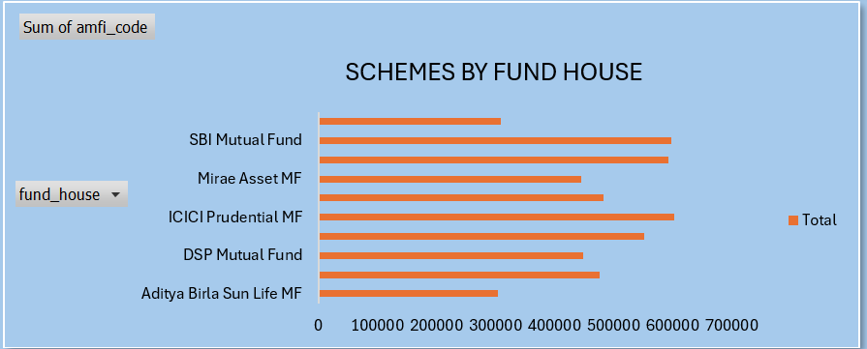
Figure 1: Distribution of mutual fund schemes across fund houses.

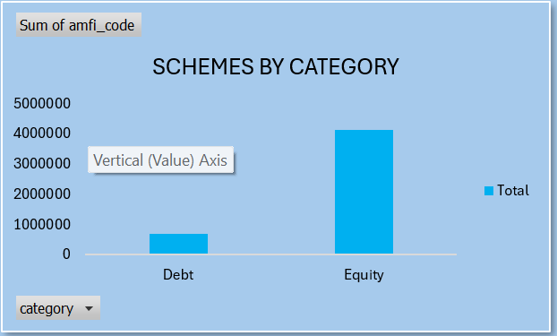
Figure 2: Distribution of mutual fund schemes across different categories.
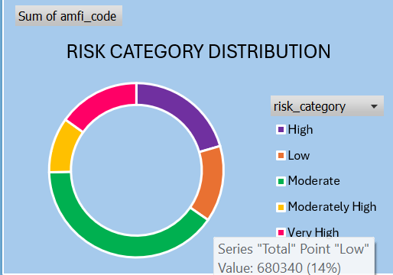Figure 3: Risk category distribution of mutual fund schemes.

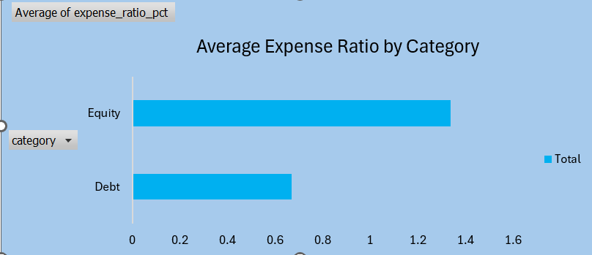
Figure 4: Average expense ratio across mutual fund categories.

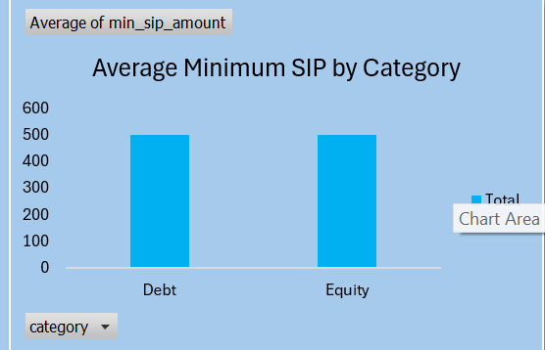
Figure 5: Average minimum SIP amount across mutual fund categories.

7. Business Dashboards:
To present the analysis in a business-friendly format, dashboards were developed using Microsoft Excel and Microsoft Power BI. The dashboards summarize important KPIs and provide visual insights into mutual fund schemes, fund houses, categories, risk levels, expense ratios, and SIP amounts.

7.1 Excel Business Performance Dashboard:
An Excel dashboard was developed using KPI values, PivotTables, charts, and interactive visual summaries. The dashboard provides a consolidated view of mutual fund business performance

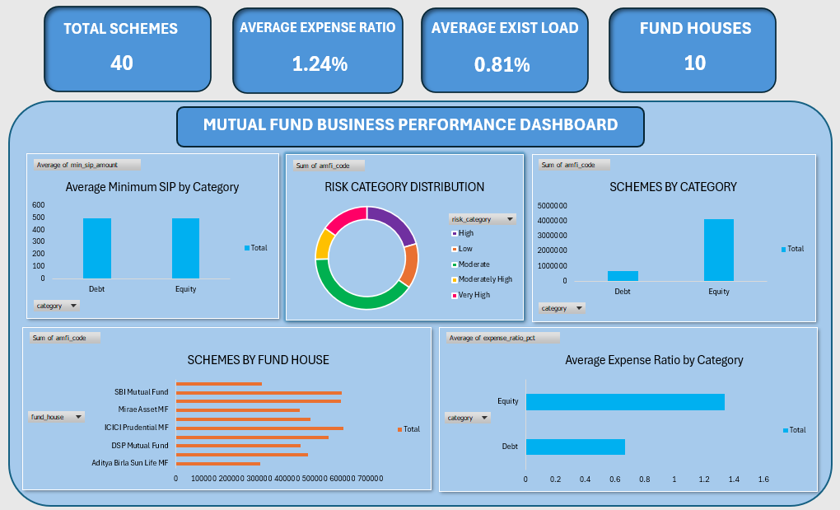
Figure 6: Mutual Fund Business Performance Dashboard developed in Microsoft Excel.

7.2 Power BI Business Performance Dashboard:
A Power BI business performance dashboard was developed to provide interactive analysis of mutual fund data. The dashboard uses KPIs, charts, filters, and visual summaries to support business-oriented analysis and decision-making.

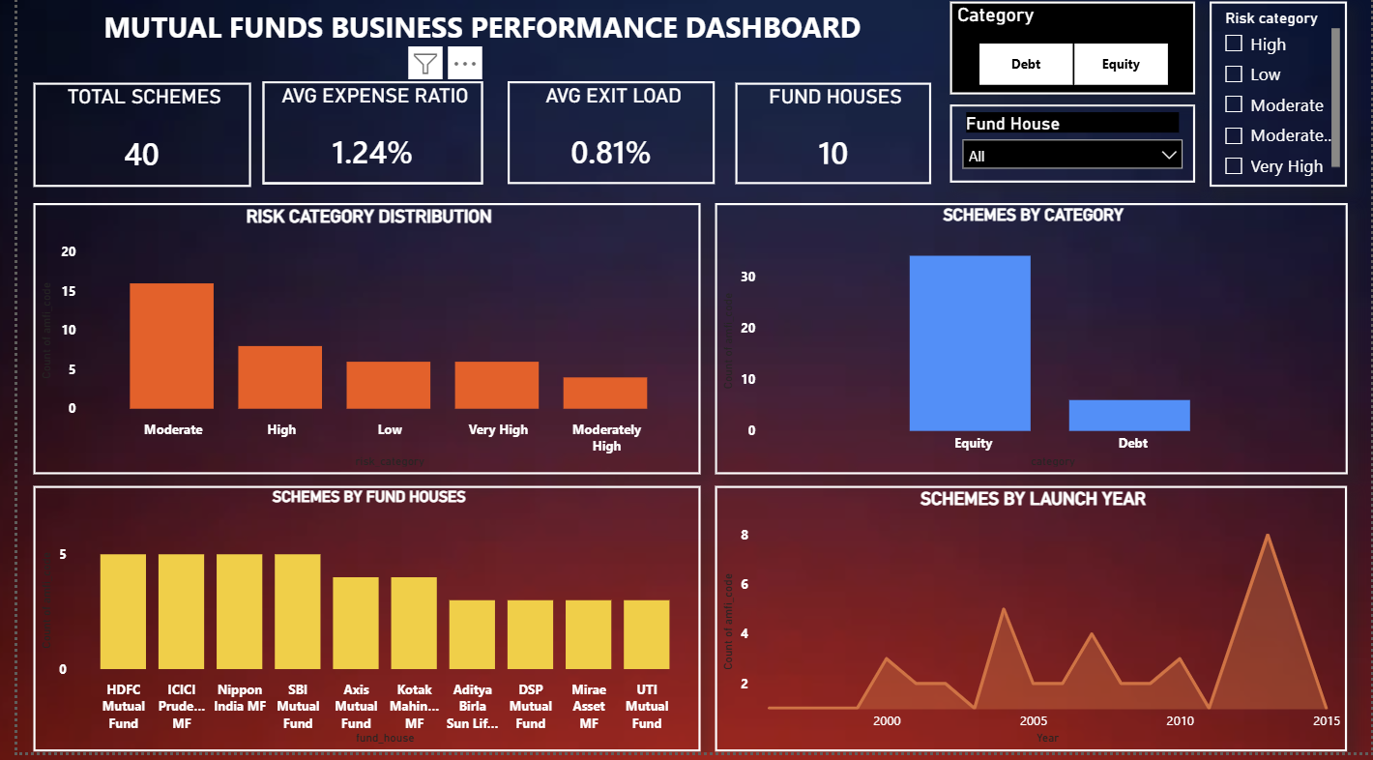
Figure 7: Mutual Fund Business Performance Dashboard developed using Power BI.

8. Key Business Insights:
The exploratory analysis and dashboard visualizations provided several useful insights into the mutual fund dataset. The following observations were identified from the KPI analysis and visualizations.

1.Scheme Coverage: The dataset contains 40 mutual fund schemes, providing a useful sample for analyzing scheme distribution and characteristics.
2. Fund House Distribution: The schemes are distributed across multiple fund houses, allowing comparison of the number of schemes offered by different fund houses.
3. Category Distribution: Mutual fund schemes are distributed across different categories, helping identify the relative presence of various investment categories.
4.Expense Ratio: The analysis of expense ratios helps compare the cost associated with different mutual fund categories and schemes.
5.Risk Distribution: The risk category analysis provides an overview of how schemes are distributed across different levels of investment risk.
6. SIP Analysis: The minimum SIP analysis helps compare the investment entry requirements across different mutual fund categories.
7. Business Reporting: The Excel and Power BI dashboards provide a consolidated and visual way to communicate the results and support business-oriented decision-making.
9. Conclusion:
This project provided practical experience in the core areas of data analytics, including data acquisition, data cleaning, exploratory data analysis, statistical analysis, KPI calculation, data visualization, and business reporting. The mutual fund datasets were analyzed using Python and Pandas, and the results were presented through visualizations and business dashboards developed in Microsoft Excel and Microsoft Power BI. The analysis helped identify important patterns related to fund houses, scheme categories, risk categories, expense ratios, and minimum SIP amounts. Overall, the project strengthened the practical skills required for working with real-world business data and communicating analytical findings effectively.

