Guide – Prof Sheela Jayachandran ,Department of Computer Science ,VIT-AP UNIVERSITY
^{Akash Jonnalagadda}
^{Department of Computer Science}
Vellore Institute of Technology-AP
^{Vijayawada, India}
^{jonnalagaddaakash779@gmail.com}
^{Garlapati Manikanta Anirudh}
^{Department of Computer Science}
Vellore Institute of Technology-AP
^{Vijayawada, India}
manikantaanirudh2004@gmail.com
^{Javvaji Maneeshwar}
^{Department of Computer Science}
Vellore Institute of Technology-AP
^{Vijayawada, India}
maneeshwarvnsj16@gmail.com

Abstract-

This research paper aims to categorize music genres. This is an example of content-based analysis of music signals. Here we propose a new method that combines classification of music genres with knowledge from investigating human perceptions in the neurophysiology of audit systems. This approach utilizes a deep neural network to classify short sections of music audio. A CNN-based deep learning model is trained to take spectrograms as input and determine the genre of the audio segments. This approach uses manual functions for both time and frequency ranges. This paper aims to the properties that contribute most to this classification task. This study applied digital signal processing methods and neural network models to extract musical features and carry out music genre classification. Used GTZAN data set for data analysis and modelling.

Keywords: CNN, KNN, MFCC, Spectrogram, Mel-Spectrograms

INTRODUCTION
The rapid growth of digital music platforms has created an urgent need for efficient and automated methods of organizing vast audio libraries. One crucial task in this domain is music genre classification—the process of identifying the genre of a music track based on its audio features [7].This project aims to develop an intelligent system which can be capable of classifying music files into predefined genres using machine learning and deep learning techniques [13].We utilize the GTZAN dataset, which includes a diverse collection of audio samples spanning genres like classical, pop, jazz, metal, reggae, and more [7].To get important patterns from the audio, we employ Mel spectrograms—a visual representation of sound that captures both frequency and time-based information [8].These spectrograms serve as input to a deep learning model trained to recognize genre-specific features [1].
To enhance the performance, various data warehousing and data mining techniques such as data cleaning, transformation, and reduction are applied. These steps ensure that the input data is consistent, noise-free, and optimized for processing [6].The end goal is to build a reliable genre classification model that can be used in music recommendation systems, content organization, and digital music analysis, improving user experience across streaming platforms [4].
LITERATURE
The categorization of music genres as a pattern recognition complication was first introduced by Tzanetakis and Cook in 2002 [7]. They approached the task using various musical features such as rhythm, timbre, and pitch, and also developed the well-known GTZAN dataset [7]. This dataset comprises 100 audio tracks for each of 10 distinct music genres and remains a foundational benchmark in the field. Throughout the years, the GTZAN dataset along with other music datasets has played a crucial role in driving progress within music genre classification research.
Initially, machine learning algorithms were predominantly used for genre classification. But, due to the transition of technology and the increase in accessibility of GPUs have enabled the applications of deep learning techniques, offering major improvements in performance [3]. Convolutional Neural Networks (CNNs) was initially applied to this domain around 2018, have shown exceptional accuracy in identifying musical genres [6].
Bello and Humphrey also introduced enhancements using the K-Nearest Neighbors (KNN) algorithm to tackle limitations found in previous models, particularly in chord recognition [4].Further innovations were made by Zhang et al., who designed two CNN models with architectural enhancements like average and max pooling, and shortcut connections similar to those proposed by He et al. [3].
These changes led to better results on the GTZAN dataset. Nanni et al. They also investigated the fusion of conventional audio feature extraction techniques with deep learning models, discovering that this integrated approach enhanced the accuracy of genre classification [6]. Classical supervised methods like Gaussian Mixture Models (GMM) and Hidden Markov Models (HMM) have also been examine using features such as pitch, rhythm, and timbre to classify musical genres effectively.Labels for musical genres help to categorize songs, albums and actors from large groups with common musical characteristics. People find it very difficult to segregate the songs they listen with the expansion of their music albums and easy access to music information. This genre is an impressive feature of musical elements and a way of classifying and organizing songs. From the starting of the listening to songs in the internet, classification of music has been subject to intensive testing throughout this genre. Music genres have no particular definitions or limitations, as they are caused by complex interactions between general audiences, marketing, and historical and cultural variables.A method was proposed by Li, Chan and Chun, which focused on the music classification with the Blend Neuron Frame Method of Music [5].
Their experiments showed that neural networks (CNNs) with foldable parts have the powerful ability to recognize supportive elements from different musical patterns than standard when conveying information that does not provide relevant information. They have developed techniques to efficiently separate music samples from background music. The element extractor uses CNN. CNNs are moved from the field of image data [8]. This means there is less previous learning. They rated that CNN is a practical choice for programmed highlight mining. This information confirmed the claim that the properties of different melodic data are similar to those of visual data [8].
Your CNN approach is highly adaptable.Many studies have used deep neural network approaches to analyze language and other types of audio data in light of recent successes of these systems [1].
Due to the high sampling rate of the audio signal, presenting audio in the time area to enter a neural network is not easy [9]. Spectrograms of signals that record both temporal and frequency information are typical alternative representations [9]. Spectrograms can be used to train folding fish networks (CNNs) and are comparable to photographs [8]. The Raw-MFCC matrix was used as input for CNNs created to predict musical genres [14].

METHODOLOGY
The project workflow comprises four key phases: data preprocessing, feature extraction, classification, and recommendation. Both preprocessing and feature extraction are efficiently handled using the Librosa library in Python, which is well-suited for audio signal processing. Librosa transforms raw audio data into structured, usable formats by cleaning, segmenting, and extracting features such as Mel spectrograms and MFCCs. These features capture essential patterns and characteristics of the sound, making them suitable for classification. The processed features are then passed to a Convolutional Neural Network (CNN), which classifies the audio into specific genres. Finally, a recommendation system suggests related content based on the predicted genre, enhancing user experience and music discovery.

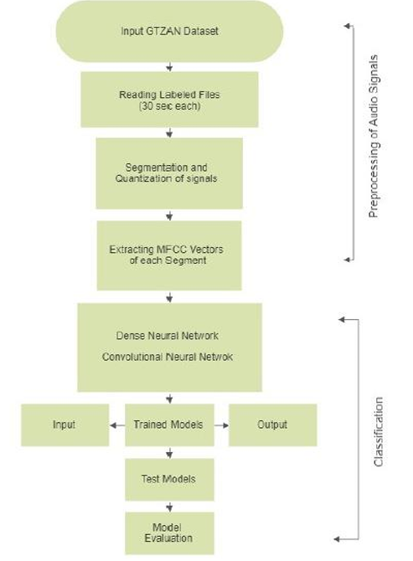
Figure 1: Flowchart

Dataset
The GTZAN dataset containing the original genre is a collection of 10 genres each with 100 audio files, each of which is found every 30 seconds (famous GTZAN data records, MNIST from audio). Original photos, photos represent all audio files. One of the way to classify data is to use neural networks. Neuronal networks such as CNNs usually use a kind of image display, so audio files were converted to MEL spectra to enable this. And finally, two CSV files containing the properties of the audio file. Files with averages for each song (30 seconds duration) and computational variances based on some characteristics can be extracted from the audio file. Other files have a similar structure, but the song was previously split into 3-second audio files (which increases the amount of data inserted into the classification model by 10 times). There are 10 genres, each containing 100 tracks. These are all 16-bit 22050hz mono audio files in .wav format. The genres are blues, classical, rand, disco, hip hop, jazz, metal, pop, reggae, and rock.

Librosa Library
The audio and music analysis tool within Python toolkit is known as Librosa. Librosa provides all needed components that developers need to construct music information retrieval systems [4]. Librosa is a Python library used for analyzing and processing music and audio. It provides a set of functions that assist developers in handling audio data, extracting key features, and carrying out tasks such as visualization and categorization. When working with The music age uses Automatic Speech Recognition where sound data processing occurs through this Python package for music and sound. analysis is mostly used. Programmers find the platform user-friendly, capable of handling both simple and advanced tasks related to sound and music management. The software is available to users under the ISC License as an open-source resource, free to access. A few features in the library enable the extraction and handling of sound recordings including the acquisition of burden sounds. From a circular representation, a collection of different spectrogram visualizations, harmonic source separation, and traditional methods. The sound processing functions include spectrogram decay with stacks and translation as well as time-space sound operation and successive demonstrations. The library includes coordinating consonant percussive partition, beat-simultaneous and other functionality typploes [4].
Pre-processing Techniques
Data Preprocessing Mel-spectrograms and the split songs functions are both invoked by the split convert function. The musical compositions are split into workable portions by employing the split convert method. The Librosa Python library gets these few pieces. The spectrograms are identified using the Librosa package [4].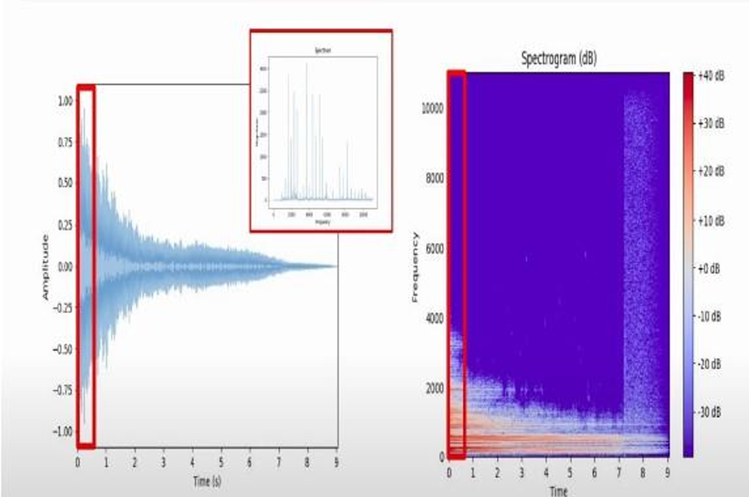
Figure3: Short Time Fourier Transform

Fast Fourier Transform (FFT) technology is used internally by the Librosa package to analyze the audio entrance of the frequency domain time domain and transformation spectrograms. A small section of the song is converted to a spectrogram using two Melspectrograms tools and given a name. Hot coding and feature scaling are performed prior to feature extraction. The process of standardizing data to a range between 0 and 1 is known as feature scaling. The technology for converting category data into numerical data is called 1-hot coding. The proposed system architecture is presented in the proposed system. Audio recording is used as input for functional extraction, data preprocessing, and model construction. The implementation of the recommended system follows the classification.
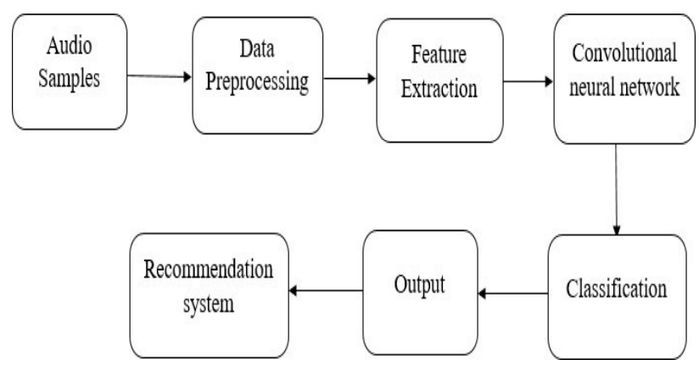
Figure 2: Proposed System

Feature Extraction Techniques
Audio signal processing relies significantly on feature extraction methods to capture key information from audio signals, which is essential for various applications. This technique is widely adopted across industries for tasks like speech recognition, music analysis, and sound classification. The content reviews multiple standard techniques used for extracting features.
Time-domain Features
Analyzing audio signal amplitude data through time-domain features allows researchers to investigate the temporal properties of the signals. One common feature is the zero-crossing rate, which counts sign changes in the signal, offering insights into frequency content and waveform variations. Another key feature is the Root Mean Square (RMS) energy, which calculates the mean of the squared waveform amplitudes. RMS energy enables the detection of sound presence and allows for the measurement of its intensity based on the squared amplitudes. The central point of the energy distribution within time is referred to as the temporal centroid. This measurement helps track the signal's temporal balance, providing insights into the distribution over time. The centroid effectively measures the position of mass along the time axis, distinguishing between transient and sustained sounds. [5]
Time-Frequency Features
The frequency characteristics of audio signals change over time, leading to the creation of time-frequency features. These features integrate information from both the time and frequency domains, providing a more comprehensive understanding of the signal's behavior across different time intervals and frequency ranges.. Several illustrative instances of time-frequency . The Short-Time Fourier Transform (STFT) analyzes audio signals by examining different time intervals to determine the signal's frequency content. The Constant-Q Transform (CQT) offers frequency analysis using a logarithmically spaced scale, which is particularly useful for musical signals. Additionally, wavelet transform methods provide multiscale analysis, allowing for a more detailed examination of the signal at different resolutions across time and frequency. [5]
Mel-frequency Cepstral Coefficients (MFCCs)
The application of MFCCs serves fundamental roles when achieving success in music genre classification as well as speech recognition tasks. The Mel-frequency spectrum representation of audio signals mimics human hearing by emphasizing frequency components in a way that aligns with our perception. By applying cepstral coefficients, the Mel-frequency cepstral coefficients (MFCCs) are derived, resulting in a lower-dimensional representation of the spectrum. This transformation reduces computational complexity. As a result, the analysis system becomes both efficient and accurate for audio signal classification. MFCCs are widely used in various applications for tasks such as classification and recognition. [5]
Music Genre Classification Algarithms
Music genre classification is a crucial task in the field of music information retrieval. It involves automatically assigning predefined genre categories to music tracks, enabling efficient organization and access to music based on genre. This process plays a key role in recommendation systems, music libraries, and various other music-related applications. Due to the increasing amount of digital music available, genre classification algorithms have become essential for a variety of applications, such as music recommendation systems, content organizations, and music streaming services. This section examines the most important algorithms and their applications used in the genre of music

Support Vector Machines (SVM)
Support Vector Machines (SVM) are widely used supervised learning algorithms for music genre classification. They map input data to higher-dimensional spaces and identify the optimal hyperplane that separates different genres. SVMs are known for their robustness against noise and their ability to handle complex decision boundaries. However, they can face challenges related to computational complexity, especially when dealing with large datasets. [6].
K-Nearest Neighbors (K-NN)
k-NN is a non-parametric classification algorithm used in classifying music genres. Determine the class of audio files by laying most of the K Neighbor barn in the license plate in the functional area. This approach assumes that similar audio files are likely to belong to the same genre. The value of K determines the impact of local influences on classification.
Decision Trees create a tree-like structure where each node represents a decision based on a particular attribute. These algorithms work well with features that have many dimensions. Random Forests, a variant of decision trees, combine multiple decision trees to improve classification accuracy and reduce the risk of overfitting, making them more robust for tasks like music genre classification.[7]
Naive Bayes
Naive Bayes is yet another probabilistic classifier used frequently in music genre classification. Naive Bayes assumes independence of features and establishes the likelihood of feature occurrences across different genres. Through the computation of the probabilities of an audio By comparing the feature associated with each genre, the Naive Bayes algorithm decides on the most likely genre associated with the file.[7]
Ensemble Algorithms
Ensemble methods use multiple base classifiers to improve classification performance. Bagging techniques, like Random Forests, create a group of independently trained classifiers and combine their outputs to enhance accuracy. In contrast, boosting methods, such as AdaBoost, train weak classifiers in sequence, placing more emphasis on misclassified instances to boost overall performance. Both bagging and boosting contribute significantly to the accuracy of music genre classification by utilizing the collective strength of several classifiers.[8]
Neural Networks
Neural networks, specifically feed-forward neural networks, have been widely used for music genre classification. These networks consist of multiple layers of interconnected artificial neurons, allowing them to establish complex relationships between input features and output genres. The hidden layers within the network help capture more abstract representations of the audio data, which aids in accurate genre classification.

Recurrent Neural Networks (RNNs)
Recurrent neural networks (RNN), and in particular those with an LSTM architecture, are very suitable for identify the patterns in audio signals RNNs manage information in sequence by keeping some hidden state remembers history regarding past inputs. LSTM networks, which are a form of RNNs, are especially good to learn. LSTMs allow for powerful modeling of music genre classification with long-term dependencies modeling capacity .Of sound information in relation to time. [9]
Convolutional Neural Network
In building a model, a 2D CNN is built from the Keras library available in the TensorFlow library to construct every layer. The input utilized to construct the CNN is a binary form of spectrogram features. Instead of three RGB channels, there's only one. Build a convolutional layer with the input shape 128x128x1 as a result. The convolutional layer is a 2D convolutional layer that processes a 2D input, such as a NumPy array, by sliding a mask (filter) over the matrix to produce a smaller matrix. The process of max pooling further reduces the matrix size by selecting the maximum value from each segment of the input matrix. For example, with an input size of (128x128x1) and applying max pooling with a (2,2) filter, the output would be (64x64x1). If max pooling is applied again to an input of (64x64x1), the output would be (32x32x1).In the described architecture, five convolutional layers are used, each with a (2x2) kernel, a stride of 2, followed by a max pooling layer after every convolutional operation. This setup progressively reduces the spatial dimensions of the input while extracting higher-level features from the audio or image data. After the CNN layers, there is a completely connected layer, where all outputs from the previous layer are fed to its input. The matrix size reduces with every convolutional block.[10]
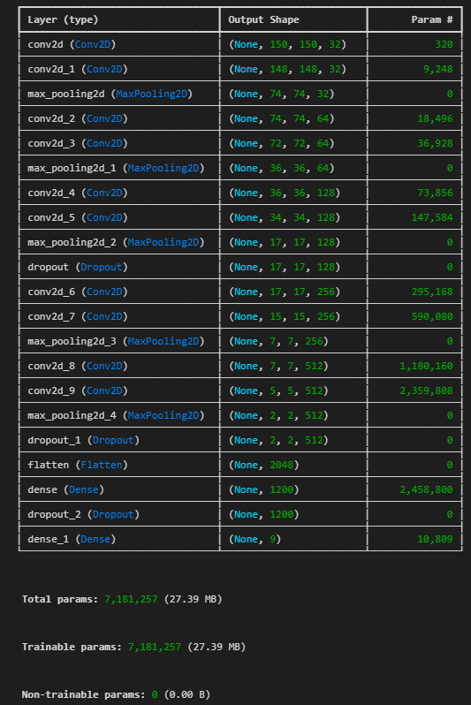
Figure 4: Model Summary

Results and Discussion
Using the GTZAN dataset, which comprises 100 audio samples representing 10 different genres, the effectiveness of the Convolutional Neural Network (CNN) model for music genre categorization was evaluated. To better capture the frequency and temporal aspects of music, the audio files were transformed into Mel spectrograms, which made them appropriate for CNN input.
The model successfully mastered the distinctive patterns in the training samples, as evidenced by its 99.83% accuracy on the training dataset. It demonstrated remarkable generalization skills with a high accuracy of 92.11% on the unseen test dataset. This degree of precision demonstrates that Mel spectrograms may accurately describe and categorize audio data when used with CNN architectures. Even though the model is robust, the minor decrease in accuracy from training to testing raises the possibility of overfitting because of the intricacy of genre boundaries and the similarities between some classes, such as pop and rock. To further increase performance and mitigate any overfitting, future developments might employ ensemble approaches, regularization, or data augmentation techniques. The outcomes confirm that CNNs are appropriate for handling audio classification tasks related to musical genres.
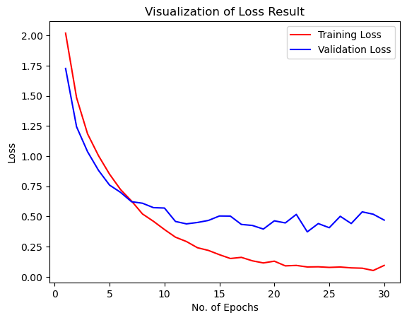
Figure 5:Visualization of Loss Result
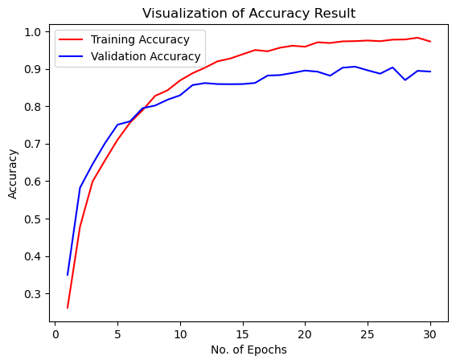
Figure 6:Visualization of Accuracy Result

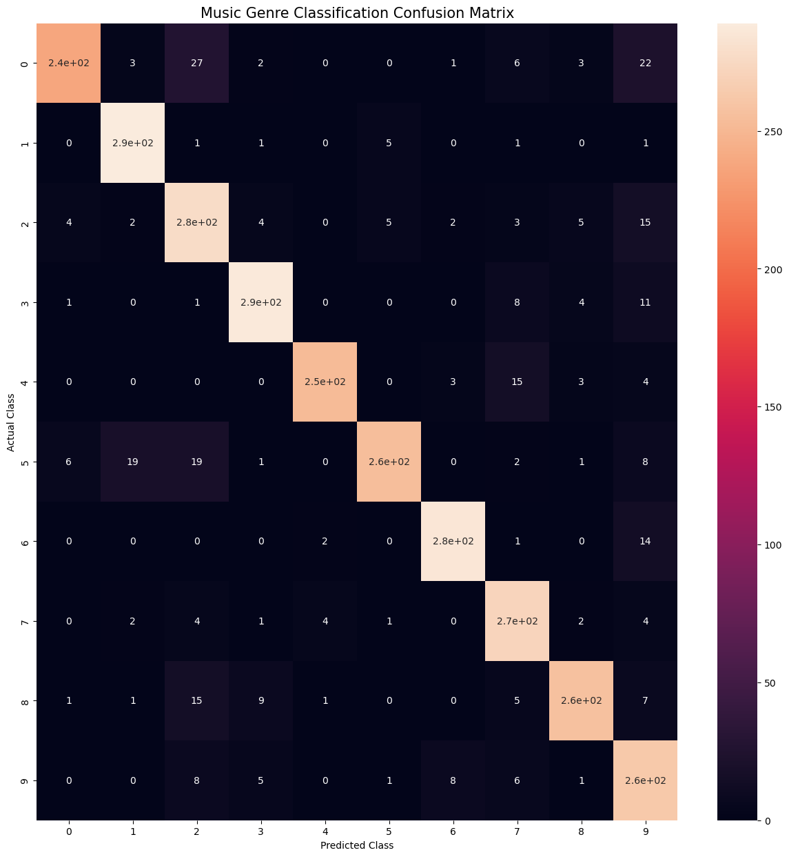
Figure7:Confusion Matrix
With the majority of predictions accurately aligning along the diagonal, the confusion matrix shows that the model does a good job of classifying different genres of music. Blues, classical, disco, and metal are among the genres that have low errors and high classification accuracy. Nonetheless, certain acoustically related genres, including pop, rock, and country, are misclassified, suggesting minor overlaps in sonic characteristics. The matrix highlights areas where further refinement could enhance genre distinction, while also demonstrating strong and consistent model performance, confirming the test accuracy of 92.1%.

Table 1:Evaluation Metrics
Genres | precision | recall | f1-score | support
blues | 0.95 | 0.79 | 0.86 | 302
classical | 0.91 | 0.97 | 0.94 | 298
country | 0.79 | 0.87 | 0.83 | 317
disco | 0.93 | 0.92 | 0.92 | 312
hiphop | 0.97 | 0.91 | 0.94 | 277
jazz | 0.96 | 0.82 | 0.88 | 311
metal | 0.95 | 0.94 | 0.95 | 302
pop | 0.85 | 0.94 | 0.89 | 289
reggae | 0.93 | 0.87 | 0.90 | 296
rock | 0.75 | 0.90 | 0.82 | 291
accuracy |  |  | 0.89 | 2995
macro avg | 0.90 | 0.89 | 0.89 | 2995
weighted avg | 0.90 | 0.89 | 0.89 | 2995

Table 2: Accuracy of different models
S.No | Model | Accuracy (Without Tuning) | Accuracy (After Tuning)
1 | K-Nearest Neighbour (K-NN) | 60.4% | 66.4%
2 | Support Vector Machine (SVM) | 73.2% | 76.4%
3 | Logistic Regression | 62.4% | 67.2%
4 | Random Forests | 66.8% | 69.6%
5 | Proposed CNN Model | 89.3% | 92.1%

Conclusion
The primary goal of this project was to develop an effective and accurate system for music genre classification using deep learning techniques. We investigated the GTZAN dataset, which comprises 100 recordings in 10 different genres. We were able to treat these audio tracks as image data and successfully use Convolutional Neural Networks (CNNs) for classification once they were converted into Mel spectrograms. In order to record the crucial timbral and frequency-related aspects of every audio sample, MFCC features were also collected.At first, a number of conventional machine learning techniques were used, including Random Forests, Support Vector Machines (SVM), Logistic Regression, and K-Nearest Neighbors (K-NN). The deep learning method surpassed these models, despite their respectable performance. Through careful hyperparameter tuning, our CNN model achieved a test accuracy of 92.1% and a training accuracy of 99.8%. The precision, recall, and F1-score values demonstrated the best performance across all genres, further validating these results. The confusion matrix highlighted the model's ability to accurately differentiate between most genres with minimal misclassification. This experiment underscores the powerful combination of audio signal processing and deep learning models in music genre classification, emphasizing the effectiveness of neural networks in handling complex audio data, particularly when using spectrogram-based visual representations. Overall, our approach provides a scalable and reliable solution suitable for automatic tagging services, music categorization tools, and real-world music recommendation systems.

References
[1] Abdel-Hamid, O., Mohamed, A. R., Jiang, H., & Penn, G. (2014). Convolutional neural networks for speech recognition. IEEE/ACM Transactions on Audio, Speech, and Language Processing, 22(10), 1533–1545.
[2] Gemmeke, J. F., Ellis, D. P., Freedman, D., Jansen, A., Lawrence, W., Moore, R. C., & Ritter, M. (2017). Audio set: An ontology and human-labeled dataset for audio events. In 2017 IEEE International Conference on Acoustics, Speech and Signal Processing (ICASSP) (pp. 776–780).
[3] He, K., Zhang, X., Ren, S., & Sun, J. (2016). Deep residual learning for image recognition. In Proceedings of the IEEE conference on computer vision and pattern recognition (pp. 770–778).
[4] Humphrey, E. J., & Bello, J. P. (2015). Four timely insights on deep learning for music modeling. In Proceedings of the 17th International Society for Music Information Retrieval Conference (ISMIR) (pp. 123–130).
[5] Li, T., Chan, A., & Chun, S. A. (2010). Automatic musical pattern feature extraction using convolutional neural networks. Journal of Information Science and Engineering, 26(6), 1923–1939.
[6] Nanni, L., Costa, Y. M. G., Lumini, A., & Koerich, A. L. (2018). Accurate music genre classification with a combination of visual and audio features. Neurocomputing, 218, 170–177.
[7] Tzanetakis, G., & Cook, P. (2002). Musical genre classification of audio signals. IEEE Transactions on Speech and Audio Processing, 10(5), 293–302.
[8] Wyse, L. (2017). Audio spectrogram representations for processing with convolutional neural networks. In Proceedings of the First International Workshop on Deep Learning and Music (DLM 2017) (pp. 37–41).
[9]Van Den Oord, A., Dieleman, S., Zen, H., Simonyan, K., Vinyals, O., Graves, A., & Kavukcuoglu, K. (2016).

WaveNet: A generative model for raw audio. arXiv preprint arXiv:1609.03499.
[10] Zhang, Y., Jin, R., & Zhou, Z. H. (2016). Understanding deep learning requires rethinking generalization. arXiv preprint arXiv:1611.03530.
[11] Abadi, M., Barham, P., Chen, J., Chen, Z., Davis, A., Dean, J., ... & Zheng, X. (2016). TensorFlow: A system for large-scale machine learning. In 12th {USENIX} Symposium on Operating Systems Design and Implementation ({OSDI} 16) (pp. 265–283).
[12] J.K. Bhatia, R. D. Singh and S. Kumar, "Music Genre Classification," 2021 5th International Conference on Information Systems and Computer Networks (ISCON), 2021, pp. 1-4,
[13] Mounika, K. S., S. Deyaradevi, K. Swetha, and V. Vanitha. "Music genre classification using deep learning." In 2021 International Conference on Advancements in Electrical, Electronics, Communication, Computing and Automation (ICAECA), pp. 1-7. IEEE, 2021.
[14] Hossan, Md Afzal, Sheeraz Memon, and Mark A. Gregory. "A novel approach for MFCC feature extraction." In 2010 4th International Conference on Signal Processing and Communication Systems, pp. 1-5. IEEE, 2010.
[15] Jean-Julien Aucouturier and Francois Pachet. Improving timbre similarity : How high’s the sky. Journal of Negative Results in Speech and Audio Sciences, 1(1), 2004

