USER MANUAL

**Manikanta Bhagavatula**

**ID: 800976594**

1.There are two kinds of users for Online Course Registration System project. They are students and admin.

2.There are some common pages for both the users.

3.The first page that is displayed when the project is executed is as follows:

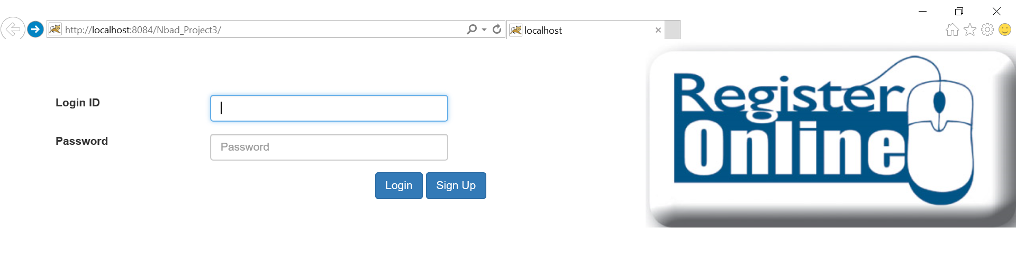

***Figure 1: Login page***

-This page is common for both the users.

4.When admin logins:



***Figure 2: After Admin logins***

-The above page is for admin.

5.When admin clicks Add Course button; the following page is displayed:

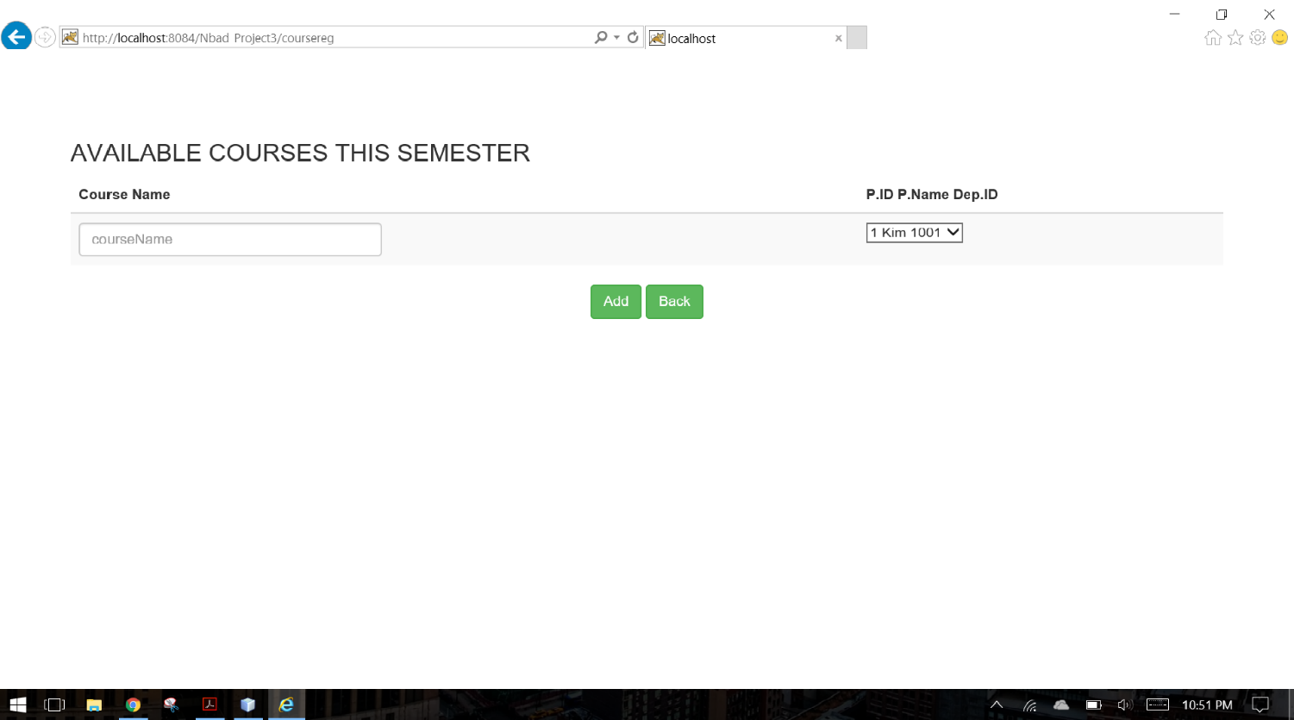

***Figure 3: Add Course Page***

-The above page is designed for admin.

6.When admin clicks Add Professor button; the following is displayed

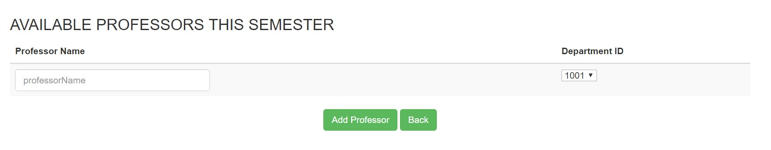

***Figure 4: Add Professor Page***

7.When admin clicks on View Courses button; the following page is displayed

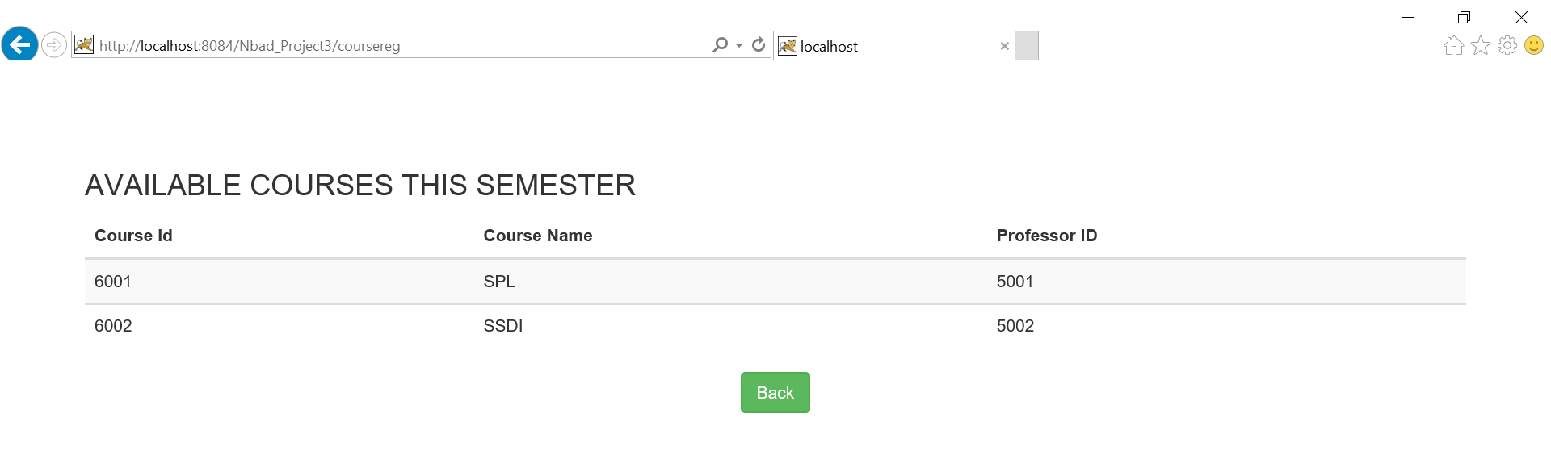

***Figure 5: View Courses Page***

8.When student logins, the following page is displayed:



***Figure 6: After Student logins***

9.When student clicks on view courses button; the following page is displayed:



***Figure 7: View Courses***

10.When student tries to add courses; the following webpage is displayed

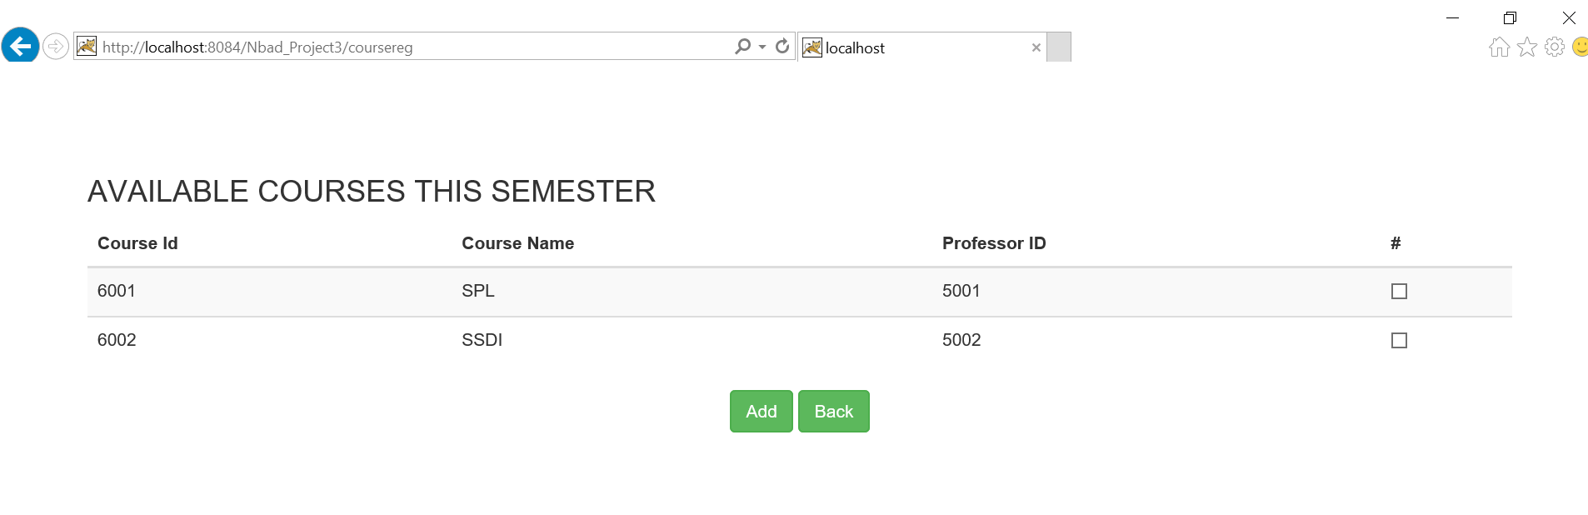

***Figure 8: Add Courses***

11. The total functionality discussed above can be viewed in the link provided below.

## [Sample-env-1.xmnwqv6uxg.us-west-2.elasticbeanstalk.com](http://sample-env-1.xmnwqv6uxg.us-west-2.elasticbeanstalk.com/)