SELF DECLARATION REGARDING ANY PENDING CASE/ NONCONVICTION

To, Date: 23-Jan-2023

**Robosoft Technologies Private Limited,**

**217, N.H.17, Santhekatte,**

**New Udupi – 576 105**

Dear Sir/Madam,

Subject: Self declaration

**Mr. Nagamanikanta Ayyala S/O Mr. Ayyala Nageswar Rao, 7 /192, Balijapalli, Chinnamandem, Beside Police Station, Chinnamandem, Rayachoti, Andhra Pradesh – 516214** declare that no proceedings is pending against me by any of my previous employer. I further declare that no civil, arbitration and/or criminal case is pending against me before any tribunal/court/government investigating agencies. I have never been found guilty/convicted of any legal proceedings in any of my previous employers and/or crime by any court of law, organisation or government investigating agencies in the past. I declare that the above information given by me is true to the best of my knowledge.

In case the above information furnished by me is found to be false or incorrect, Robosoft Technologies Private Limited has the right to terminate my employment without assigning any further reason/intimation apart from initiating any action as you deemed fit.

Signature: 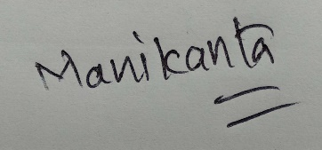

Name of the Employee **Nagamanikanta Ayyala**